
Reliable news for healthy living, saving money, and having fun!




Dear friends,
March is the month when everything starts to shift—longer days, warmer sunshine, and the first signs of spring remind us that change is in the air. It’s a great time to shake off the winter chill and start thinking about fresh ideas for your home.
At [Name of flooring store], we love helping our customers welcome the new season with updates that make their space feel lighter, brighter, and more inviting. Whether you're planning a project soon or just gathering inspiration, we’re here to help whenever you’re ready.
Wishing you a refreshing and hopeful start to spring!
Warmly,
[Name of flooring store owner]

World Down’s Syndrome
Day
First Day of Spring
St. Patrick’s Day
Intl.
Women’s Day

Daylight Savings Begins
Jimbo’s Floors
Suzie Smith!
You are this month’s
Mystery Winner!
We have a
$10.00 Starbucks
gift card
reserved just for you!
Come by our store to
claim your prize!

Inside This Issue…
- Are you this month’s Mystery Winner?
- Month at a Glance
- Spring Starts at the Front Door
- Did You Know
- Mega Trivia Contest
- Why Cheap Costs More
- Thank you for the Kind Words
- Client of the Month
- Brain Teasers
- Thank You to our clients

“You’ll love your new floors or I’ll replace them free!”
~Jim Armstrong & Mick
www.JimbosFloors.com
Scan to visit our website
March 2026
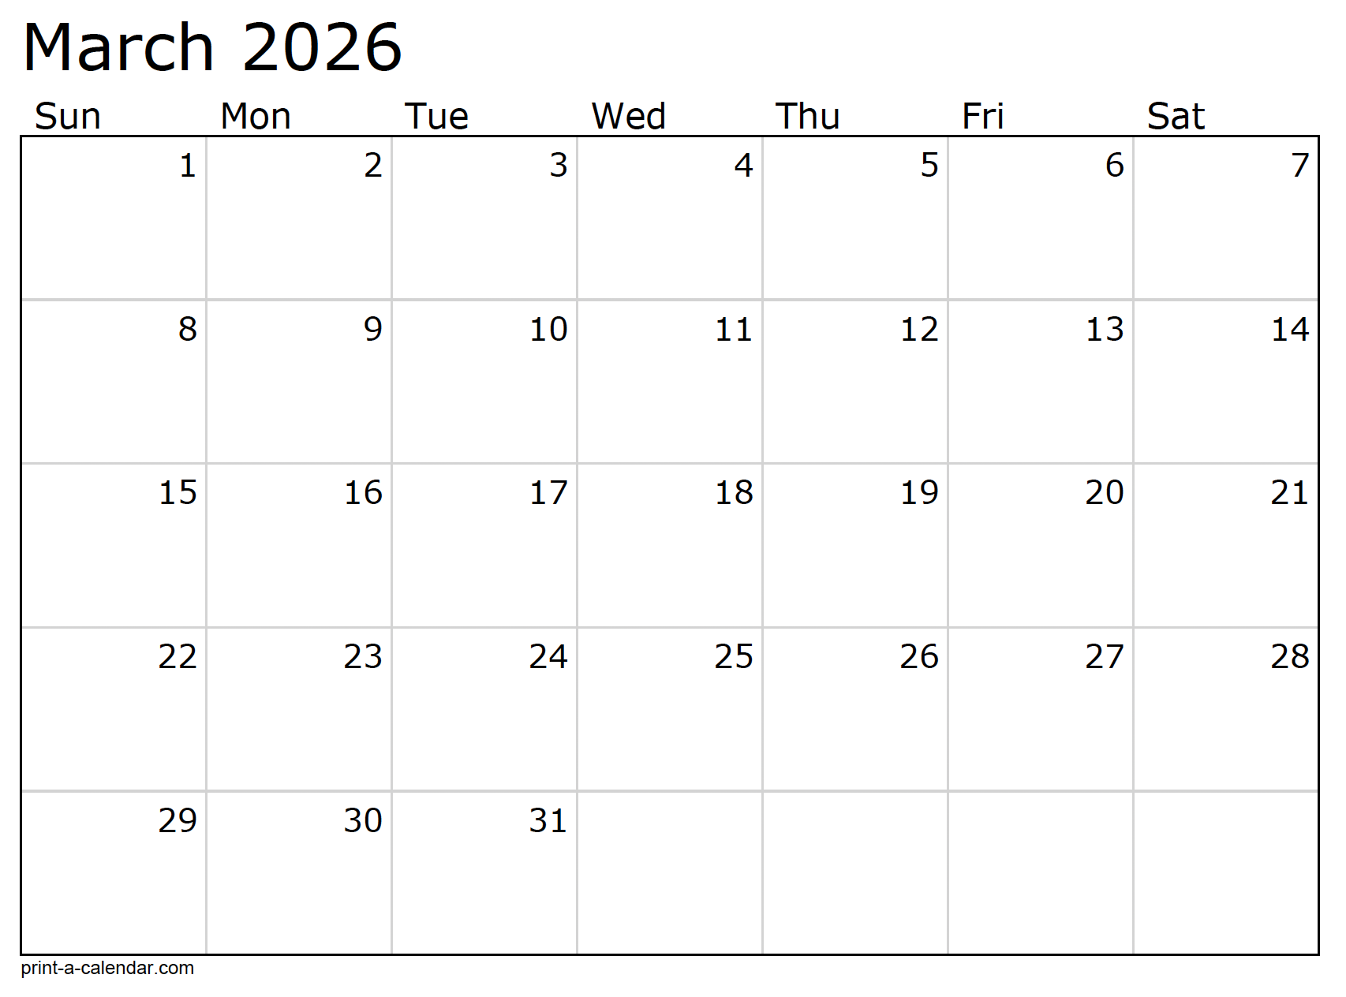
Month at a Glance!
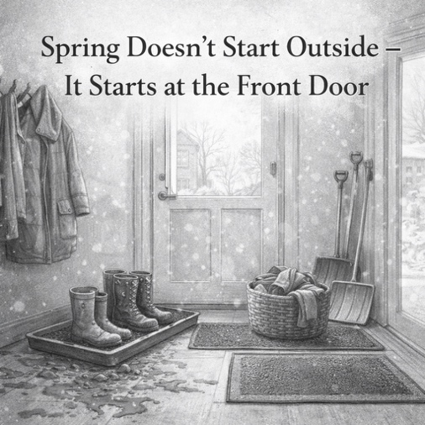




When people think of spring, they picture blooming flowers and warmer days. But in many parts of the country, March is still unpredictable. One day feels like spring, the next brings rain, wind, or muddy shoes by the door. That’s why the real start of spring doesn’t happen in the yard, it happens at the front door.
After a long winter, entryways tend to collect everything the season throws at us. Heavy coats linger, boots pile up, and floors take the brunt of tracked-in moisture and grit. March is the perfect time for a simple reset, even if winter hasn’t fully let go yet.
Start by clearing out what you no longer need. Store the heaviest coats and boots you’re not reaching for anymore, and make room for lighter layers. This small step instantly makes the space feel less crowded and more functional.
Next, focus on floor protection. March often brings rain and mud instead of snow, which can be just as hard on floors. A sturdy doormat outside and another just inside the door can catch moisture before it spreads. Boot trays or washable rugs help contain the mess and make cleanup easier on busy days.
Take a moment to clean and inspect the floor in this high-traffic area. Grit and debris act like sandpaper underfoot, so a thorough sweep or vacuum goes a long way toward protecting surfaces as foot traffic increases in spring.
Finally, think about flow. The front door sets the tone for the rest of the home. When it’s organized and easy to use, everything else feels smoother too.
Spring doesn’t arrive all at once. But resetting your entryway now helps your home handle whatever March brings, and prepares it for the brighter days ahead.

Who Else Wants to Win

Dinner for Two at the City Café!

Take our Trivia Challenge and you could win too!
This month’s Mega Trivia question:
Last month’s question: (Answer is in bold print)
What room in the home typically has the highest resale value return after a renovation?
A) Kitchen B) Bathroom C) Bedroom D) Basement

Congratulations to last month’s winner:
Client Name
Come by our store to claim your prize!

(NOTE: see the HA instructions for this month if you don’t have the Jim Armstrong Marketing Website to direct them to.)
Where would you be if you were standing on the Spanish Steps?
A) Spain B) Mexico
C) Las Vegas D) Rome
To enter, email Support@JimbosFloors.com and enter “Mega Trivia Contest” as the subject line. Take your best guess…your chances of winning are better than you think!
We’d be happy to send you our electronic newsletter!

The same combination of useful tips and offbeat stories you read here, but with these differences:
- The e-Advisor will arrive in your email account once you give us permission
- We send it once a week
- The e-Advisor does not have the same content as the print Home Advisor – you’ll read all new stories, from helpful advice to items that give you a smile
Simply let us know which email account you’d like us to use for the e-Advisor.
Spring Starts at the Front Door


Why “Cheapest” Usually Costs More in the Long Run



When making a purchase for the home, it’s natural to look at price first. Whether it’s tools, appliances, furniture, or home improvements, the cheapest option can feel like the smartest move in the moment. But over time, many homeowners learn the same lesson the hard way: the lowest price often comes with the highest long-term cost.
Cheaper products tend to wear out faster, break sooner, or need to be replaced more often. What looks like savings upfront can quietly turn into repeated repairs, wasted time, and added frustration. In many cases, buying twice ends up costing far more than buying right the first time.
There’s also the cost of inconvenience. Replacing something that fails early means rearranging schedules, dealing with messes, and living with disruption. All things that don’t show up on a price tag but definitely affect daily life.
Quality doesn’t always mean “most expensive,” but it does mean paying attention to durability, materials, and workmanship. Products made to last are designed to handle real life: foot traffic, kids, pets, spills, and everyday wear. They’re built with the expectation that they’ll be used, not just looked at.
Experience matters too. Advice from professionals who work with these products every day can help homeowners avoid common mistakes and unrealistic expectations. That guidance often saves money by steering people toward choices that fit their lifestyle instead of chasing the lowest price.
In the end, value is about more than what you pay at checkout. It’s about how long something lasts, how well it performs, and how much peace of mind it provides.
Sometimes, the smartest investment isn’t the cheapest option, it’s the one that holds up when life happens.

Congratulations to our

Susan Johnson!
Susan is a 3rd time returning client, and she recently purchased new laminate for her kitchen and dining room. She always has a big smile on her face and is a lot of fun to work with. Thanks, Susan!
As always, our clients of the month receive 2 movie passes for Movies-8!
Watch for your name here in a coming month!
Come by our store to
claim your prize!

“My new laminate floors in my kitchen and dining room are beautiful. I was treated with respect and courtesy as a single woman raising a daughter. I genuinely felt that Jim Armstrong and his staff display concern for my flooring needs and were a guiding light for me. I recommend his service to anyone looking for a supportive, positive experience.”
~Marsha Avalos, School Teacher, Yuba City

“We Recently went to Jimbo’s Floors for new tile for our bathroom, and we’re thrilled with the results! This is our third time using Jimbo’s. Jim will never make you feel uncomfortable for asking questions and he’ll do anything in his power to accommodate your needs. When you do business with Jim and the staff at Jimbo’s Floors, you will be treated like royalty. Our experience was painless and very professional. Jim is not only our flooring expert, he’s a friend. That’s how he makes you feel.”
~Marvin and Sandy Moeller, owners of Sierra Landscaping, Yuba City

Thank You for the Kind Words!




From our families to yours, have a great month!


Welcome to our new and returning clients!

Click on the text box and Insert names

A gigantic THANK YOU to all who referred us last month…

Insert names
Get a

with my
Referral Rewards Program
As you probably know, advertising is very expensive. Instead of paying the newspaper or another place to advertise, we’d rather reward you. So we’ve assembled the Referral Rewards Program.
Every time you refer someone who becomes a client, we will send you a gift certificate for two passes to the Movies-8 Cinema.
And Hey! What’s a movie without popcorn? The gift certificate will also cover a big box of hot, buttered popcorn and sodas!
Come by our store to
claim your prize!

Your Company Name
123 Address, Someplace, ZZ 555555
555.555.5555 Phone 555.555.5555 Fax
email@yourcompanyname.com
YourCompanyWebsite.com

