
Reliable news for healthy living, saving money, and having fun!




Random Acts of Kindness Day
Valentine’s Day
Jimbo’s Floors
Suzie Smith!
You are this month’s
Mystery Winner!
We have a
$10.00 Starbucks
gift card
reserved just for you!
Come by our store to
claim your prize!

Inside This Issue…
- Are you this month’s Mystery Winner?
- Month at a Glance
- Love Where You Live
- Did You Know
- Mega Trivia Contest
- Heart-Healthy Living Tips
- Thank you for the Kind Words
- Client of the Month
- Brain Teasers
- Thank You to our clients

“You’ll love your new floors or I’ll replace them free!”
~Jim Armstrong & Mick
www.JimbosFloors.com
Scan to visit our website
Dear friends,
February may be the shortest month of the year, but it’s packed with moments that remind us how important it is to feel connected. Whether it’s celebrating Valentine’s Day, gathering with loved ones, or simply enjoying the comfort of home during the last stretch of winter.
At [Name of flooring store], we’re grateful for the connection we’ve built with you. Helping you make your home more beautiful, comfortable, and uniquely yours is what we love most. Whether you're planning a big project or just dreaming for now, we're here whenever you're ready.
Wishing you a February filled with warmth, kindness, and a little extra love.
Warm regards,
[Name of flooring store owner]

February 2026
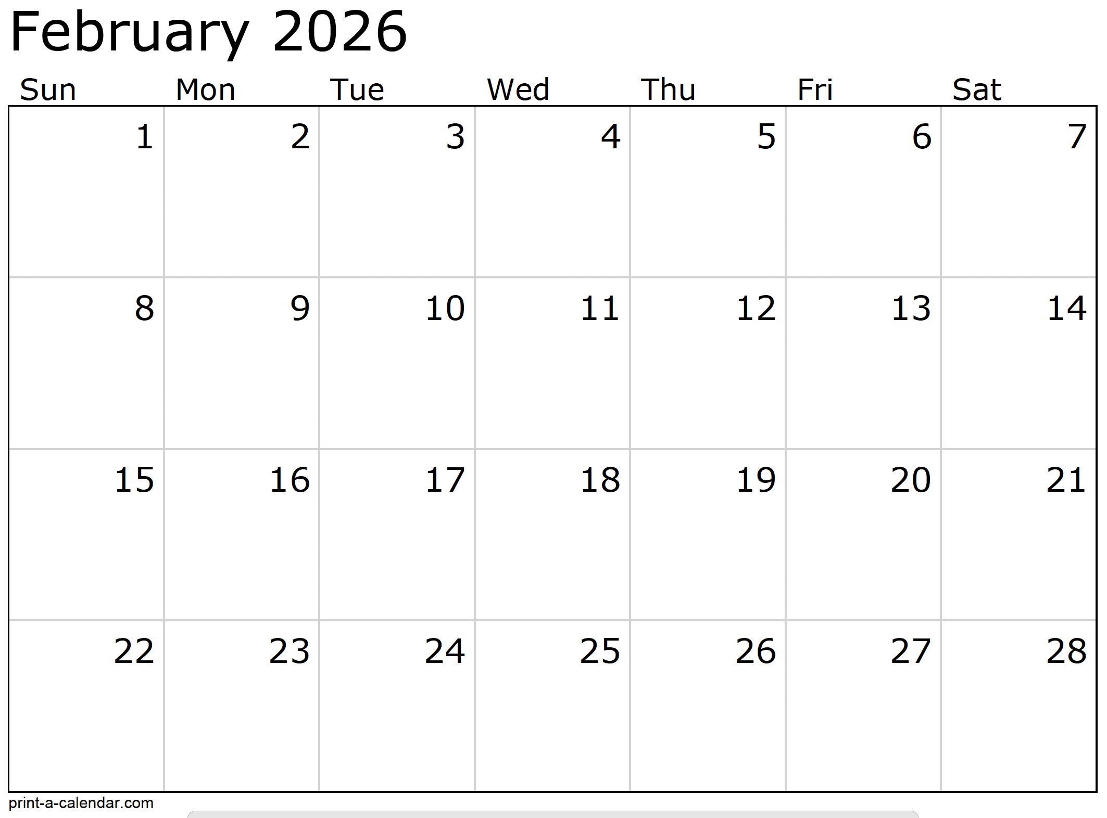
Month at a Glance!
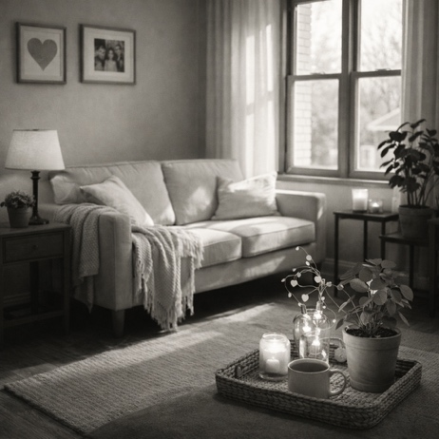



February is often associated with love, but not just the romantic kind. It’s also a great time to reconnect with the place where so much of daily life happens: your home.
“Loving where you live” doesn’t mean a major remodel or a picture-perfect house. More often, it’s about how a space feels. Small changes can make a big difference in comfort, mood, and pride of ownership.
Start with the senses. Lighting plays a huge role in how welcoming a home feels, especially during winter. Swapping harsh bulbs for warmer light in living areas instantly creates a calmer atmosphere. Soft lamps, candles, or even string lights can make evenings feel more relaxed and intentional.
Next, look at the surfaces you interact with every day. Floors, furniture, and countertops quietly shape how a room feels underfoot and at rest. Keeping floors clean, protected, and well cared for doesn’t just preserve them, it makes the entire home feel more inviting. A well-placed rug, runner, or entry mat can add warmth while also protecting high-traffic areas.
Clutter is another common mood-stealer. You don’t have to tackle the whole house. Choose one small space: an entryway, coffee table, or nightstand, and give it a reset. Clear surfaces create a sense of calm that carries into the rest of the home.
Finally, personalize your space. Photos, meaningful objects, plants, or artwork help a house feel like yours. These touches tell your story and create comfort far beyond what trends can offer.
Loving where you live isn’t about perfection. It’s about care, intention, and creating a space that supports you every day. This February, a little attention to your home can go a long way toward making it a place you truly enjoy coming back to.

Last month’s question: (Answer is in bold print)
Where does the name “January” come from?
A) The Roman god of new beginnings B) The Latin word for “frost”
C) The Greek moon goddess D) The Norse god of winter

Who Else Wants to Win

Dinner for Two at the City Café!

Take our Trivia Challenge and you could win too!
This month’s Mega Trivia question:
Congratulations to last month’s winner:
Client Name
Come by our store to claim your prize!

(NOTE: see the HA instructions for this month if you don’t have the Jim Armstrong Marketing Website to direct them to.)
What room in the home typically has the highest resale value return after a renovation?
A) Kitchen B) Bathroom C) Bedroom D) Basement
To enter, email Support@JimbosFloors.com and enter “Mega Trivia Contest” as the subject line. Take your best guess…your chances of winning are better than you think!
We’d be happy to send you our electronic newsletter!

The same combination of useful tips and offbeat stories you read here, but with these differences:
- The e-Advisor will arrive in your email account once you give us permission
- We send it once a week
- The e-Advisor does not have the same content as the print Home Advisor – you’ll read all new stories, from helpful advice to items that give you a smile
Simply let us know which email account you’d like us to use for the e-Advisor.
Love Where You Live

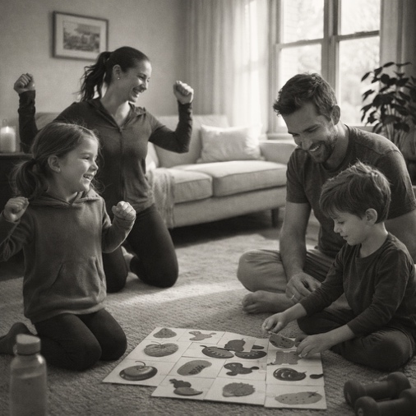
Heart-Healthy Living Tips for the Whole Family


February is American Heart Month, which makes it a great time to think about heart health. Not as a short-term goal, but as a set of everyday habits the whole family can share.
The good news is that heart-healthy living doesn’t require dramatic changes. Small, consistent choices add up, especially when everyone participates.
Start with movement that feels natural.
You don’t need a gym membership to get hearts pumping. Family walks, bike rides, dancing in the living room, or even shoveling snow together all count. The key is finding movement that feels enjoyable rather than forced.
Make meals heart-smart without making them boring.
Focus on adding good things rather than restricting everything. More fruits, vegetables, whole grains, and lean proteins naturally crowd out less-healthy options. Involving kids in meal planning or cooking can make healthier choices feel empowering instead of limiting.
Pay attention to stress and rest.
Stress affects heart health just as much as diet and exercise. Create routines that encourage calm, like shared meals without screens, consistent bedtimes, and moments of quiet after busy days. Even ten minutes of winding down together can make a difference.
Create a home that supports healthy habits.
When healthy choices are the easy choices, families stick with them. Keep water visible and accessible. Make space for movement indoors during colder months. Design cozy areas that encourage rest, reading, or conversation instead of constant screen time.
Most importantly, remember that heart health isn’t about perfection. It’s about progress and consistency. When families support one another and build habits together, healthy living becomes part of everyday life, not something you only think about once a year.
This February, a few thoughtful changes can help keep hearts strong, happy, and connected all year long.
Congratulations to our

Susan Johnson!
Susan is a 3rd time returning client, and she recently purchased new laminate for her kitchen and dining room. She always has a big smile on her face and is a lot of fun to work with. Thanks, Susan!
As always, our clients of the month receive 2 movie passes for Movies-8!
Watch for your name here in a coming month!
Come by our store to
claim your prize!

“My new laminate floors in my kitchen and dining room are beautiful. I was treated with respect and courtesy as a single woman raising a daughter. I genuinely felt that Jim Armstrong and his staff display concern for my flooring needs and were a guiding light for me. I recommend his service to anyone looking for a supportive, positive experience.”
~Marsha Avalos, School Teacher, Yuba City

“We Recently went to Jimbo’s Floors for new tile for our bathroom, and we’re thrilled with the results! This is our third time using Jimbo’s. Jim will never make you feel uncomfortable for asking questions and he’ll do anything in his power to accommodate your needs. When you do business with Jim and the staff at Jimbo’s Floors, you will be treated like royalty. Our experience was painless and very professional. Jim is not only our flooring expert, he’s a friend. That’s how he makes you feel.”
~Marvin and Sandy Moeller, owners of Sierra Landscaping, Yuba City

Thank You for the Kind Words!




1) Make the shape of the word ONE. 2) All points A, B, and C are the same shade of grey. It is an optical illusion. 3) Place the numbers as such – 2 – 7 – 6, 9 – 5 – 1, 4- 3 – 8 4) Cut the word in half horizontally, then flip it upside down. You will see the month July. 5) The 9 letter word is abilities. 6) The answer is a glove.

Welcome to our new and returning clients!

Click on the text box and Insert names

A gigantic THANK YOU to all who referred us last month…

Insert names
Get a

with my
Referral Rewards Program
As you probably know, advertising is very expensive. Instead of paying the newspaper or another place to advertise, we’d rather reward you. So we’ve assembled the Referral Rewards Program.
Every time you refer someone who becomes a client, we will send you a gift certificate for two passes to the Movies-8 Cinema.
And Hey! What’s a movie without popcorn? The gift certificate will also cover a big box of hot, buttered popcorn and sodas!
Come by our store to
claim your prize!

Answers:
From our families to yours, have a great month!

Your Company Name
123 Address, Someplace, ZZ 555555
555.555.5555 Phone 555.555.5555 Fax
email@yourcompanyname.com
YourCompanyWebsite.com

