
Reliable news for healthy living, saving money, and having fun!




Martin Luther King, Jr. Day
New Year’s Day
Jimbo’s Floors
Suzie Smith!
You are this month’s
Mystery Winner!
We have a
$10.00 Starbucks
gift card
reserved just for you!
Come by our store to
claim your prize!

Inside This Issue…
- Are you this month’s Mystery Winner?
- Month at a Glance
- A Fresh Start For Your Floors
- Did You Know
- Mega Trivia Contest
- 2026 Home Improvement Budget
- Thank you for the Kind Words
- Client of the Month
- Brain Teasers
- Thank You to our clients

“You’ll love your new floors or I’ll replace them free!”
~Jim Armstrong & Mick
www.JimbosFloors.com
Scan to visit our website
Dear friends,

Welcome to 2026! A new year always brings fresh energy, new goals, and a renewed focus on the things that matter most—like making your home a place you truly love spending time in.

At [Name of flooring store], we’re excited for all that’s ahead and honored to be part of your plans for the year. Whether it’s a small refresh or a big transformation, we’re here to help you create a space that reflects your style and supports your life.

Wishing you a bright, peaceful, and inspiring start to the new year!

Warm regards,
[Name of flooring store owner]
January 2026
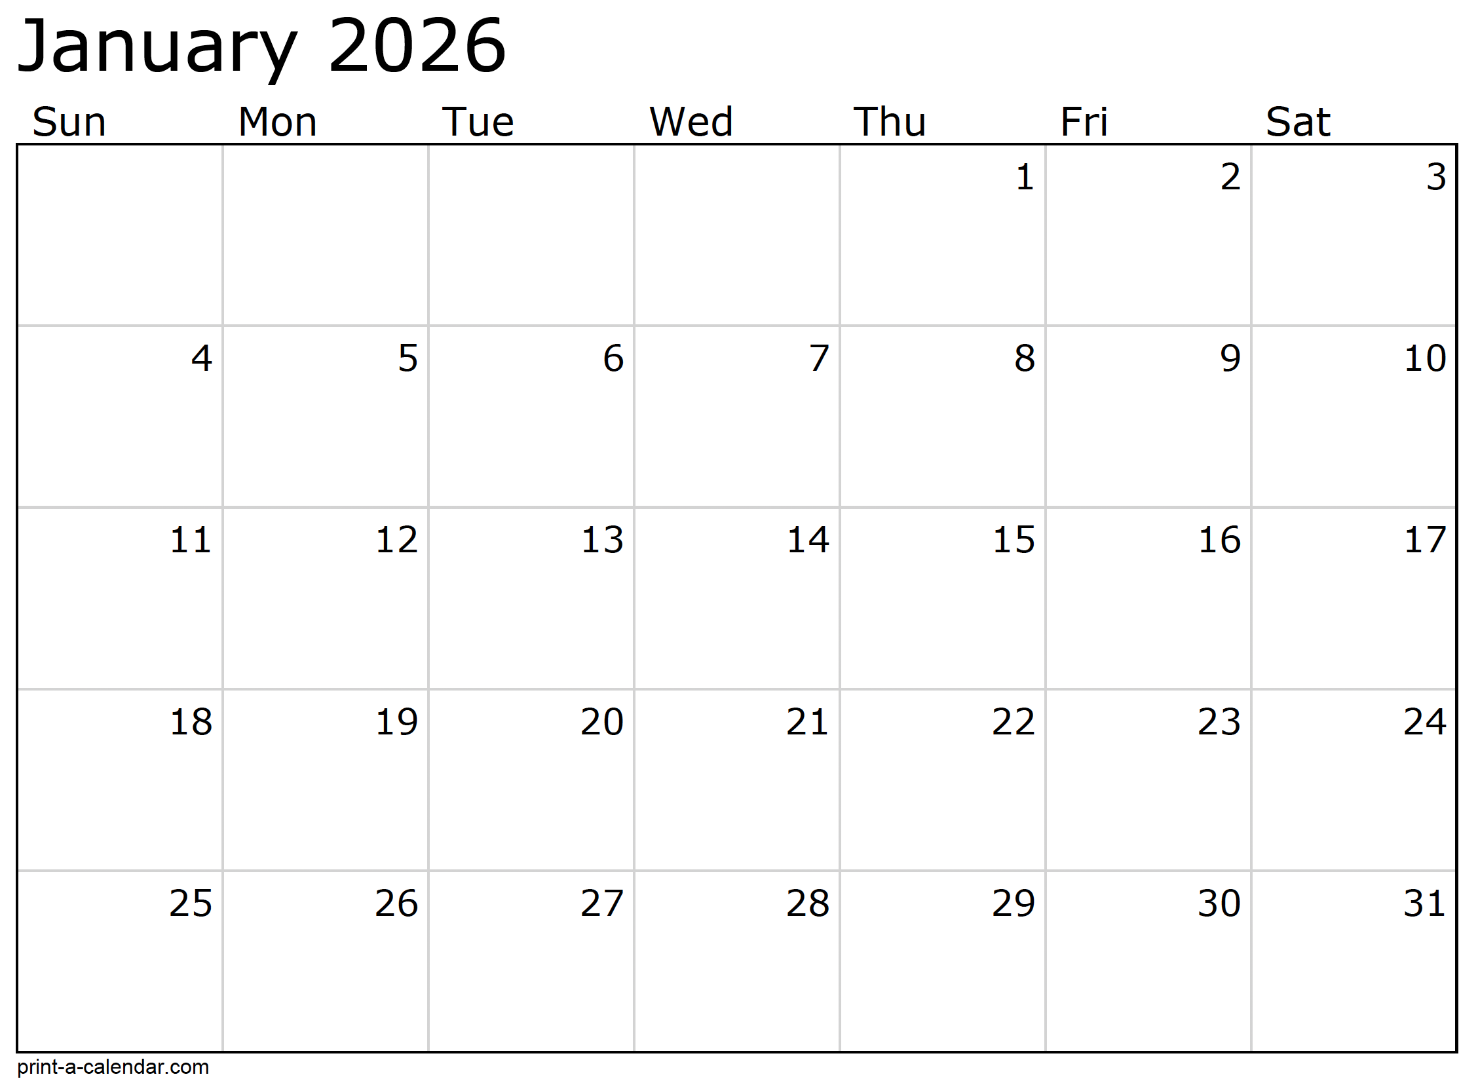
Month at a Glance!

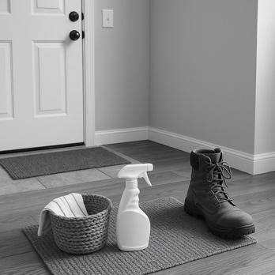


(NOTE: see the HA instructions for this month if you don’t have the Jim Armstrong Marketing Website to direct them to.)
Last month’s question: (Answer is in bold print)
How many French hens does the true love give in the “Twelve Days of Christmas”?
A) 12 B) 6 C) 3 D) 7

Who Else Wants to Win

Dinner for Two at the City Café!

Take our Trivia Challenge and you could win too!
This month’s Mega Trivia question:
Where does the name “January” come from?
A) The Roman god of new beginnings B) The Latin word for “frost”
C) The Greek moon goddess D) The Norse god of winter
To enter, email Support@JimbosFloors.com and enter “Mega Trivia Contest” as the subject line. Take your best guess…your chances of winning are better than you think!
Congratulations to last month’s winner:
Client Name
Come by our store to claim your prize!

We’d be happy to send you our electronic newsletter!

The same combination of useful tips and offbeat stories you read here, but with these differences:
- The e-Advisor will arrive in your email account once you give us permission
- We send it once a week
- The e-Advisor does not have the same content as the print Home Advisor – you’ll read all new stories, from helpful advice to items that give you a smile
Simply let us know which email account you’d like us to use for the e-Advisor.
If you’re like most families, January brings that familiar urge to reset. Once the holiday decorations are tucked away and the last pine needle has been vacuumed up, the house suddenly feels ready for a fresh start. It’s the perfect moment to take a look at one part of the home that works especially hard this time of year: your floors.

Winter is the toughest season on flooring. Snow, salt, mud, and extra foot traffic can take a toll on surfaces of every kind. But with a few simple habits: nothing expensive or time-consuming, you can protect your floors and help them look their best all year long.

1. Start with the entryway. A good doormat is one of the most effective defenses against winter wear. Place one outside and one inside each frequently used door. The goal is to catch as much moisture and debris as possible before it spreads throughout the home.

2. Keep a “quick-response” towel handy. Spills happen, especially in homes full of kids, pets, and hot cocoa. Wiping up moisture right away prevents staining, warping, or dulling on both hard-surface floors and carpets.

3. Watch your home’s humidity. Dry winter air can cause hardwood to shrink slightly and create small gaps. Running a humidifier in the colder months helps the wood stay stable and reduces static in carpeted rooms.

4. Add small weekly habits. A light sweep or vacuum once or twice a week keeps grit from acting like sandpaper on your floors. It only takes a few minutes, but makes a big difference over time.

As you settle into the new year, these little routines can help your home feel cleaner, calmer, and more comfortable, and your floors will thank you for it. After all, they support you every step of the way.
A Fresh Start For Your Floors: Easy Winter Care Tips

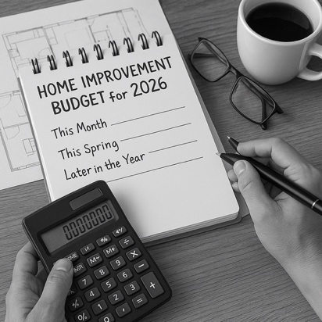
How to Plan a Smart Home Improvement Budget for 2026


Congratulations to our

Susan Johnson!
Susan is a 3rd time returning client, and she recently purchased new laminate for her kitchen and dining room. She always has a big smile on her face and is a lot of fun to work with. Thanks, Susan!
As always, our clients of the month receive 2 movie passes for Movies-8!
Watch for your name here in a coming month!
Come by our store to
claim your prize!

“My new laminate floors in my kitchen and dining room are beautiful. I was treated with respect and courtesy as a single woman raising a daughter. I genuinely felt that Jim Armstrong and his staff display concern for my flooring needs and were a guiding light for me. I recommend his service to anyone looking for a supportive, positive experience.”
~Marsha Avalos, School Teacher, Yuba City

“We Recently went to Jimbo’s Floors for new tile for our bathroom, and we’re thrilled with the results! This is our third time using Jimbo’s. Jim will never make you feel uncomfortable for asking questions and he’ll do anything in his power to accommodate your needs. When you do business with Jim and the staff at Jimbo’s Floors, you will be treated like royalty. Our experience was painless and very professional. Jim is not only our flooring expert, he’s a friend. That’s how he makes you feel.”
~Marvin and Sandy Moeller, owners of Sierra Landscaping, Yuba City

Thank You for the Kind Words!

A new year always brings fresh ideas for improving the home.
Maybe you’re dreaming of new flooring, better storage, a refreshed kitchen, or finally tackling that bathroom that’s been patiently waiting its turn. Whatever’s on your list, January is the perfect time to create a home improvement budget that actually works! One that helps you move forward without feeling overwhelmed.
A smart budget begins with a simple walk-through of your home. Grab a notepad and list areas that need attention, separating them into two groups: must-do projects and nice-to-have upgrades. Must-dos are things that protect your home, like fixing a leak, replacing worn flooring, or addressing safety issues. Nice-to-haves are improvements that make daily life easier or more enjoyable.
Next, outline your estimated costs. You don’t need exact numbers yet; even ballpark ranges help you see what’s realistic. Many homeowners find it helpful to plan larger projects: flooring, kitchen updates, or bathroom remodels. Once every few years, while handling smaller improvements seasonally.
If you’re unsure what something should cost, this is where local experts can save you time, money, and stress. A quick conversation with a professional flooring dealer, contractor, or designer can help you avoid common budgeting mistakes, surprise expenses, and low-quality materials that don’t last.
Once you’ve listed your projects, assign each one a timeline: this month, this spring, later in the year, or save for 2027. This simple step turns your wish list into an actionable plan.
Finally, build a small “unexpected expenses” cushion into your home budget. Even a little wiggle room makes future decisions easier and keeps projects on track.
Planning ahead now gives you clarity, saves money, and helps you enjoy each improvement instead of feeling rushed. A thoughtful budget today sets the stage for a home you’ll love all year long.




From our families to yours, have a great month!

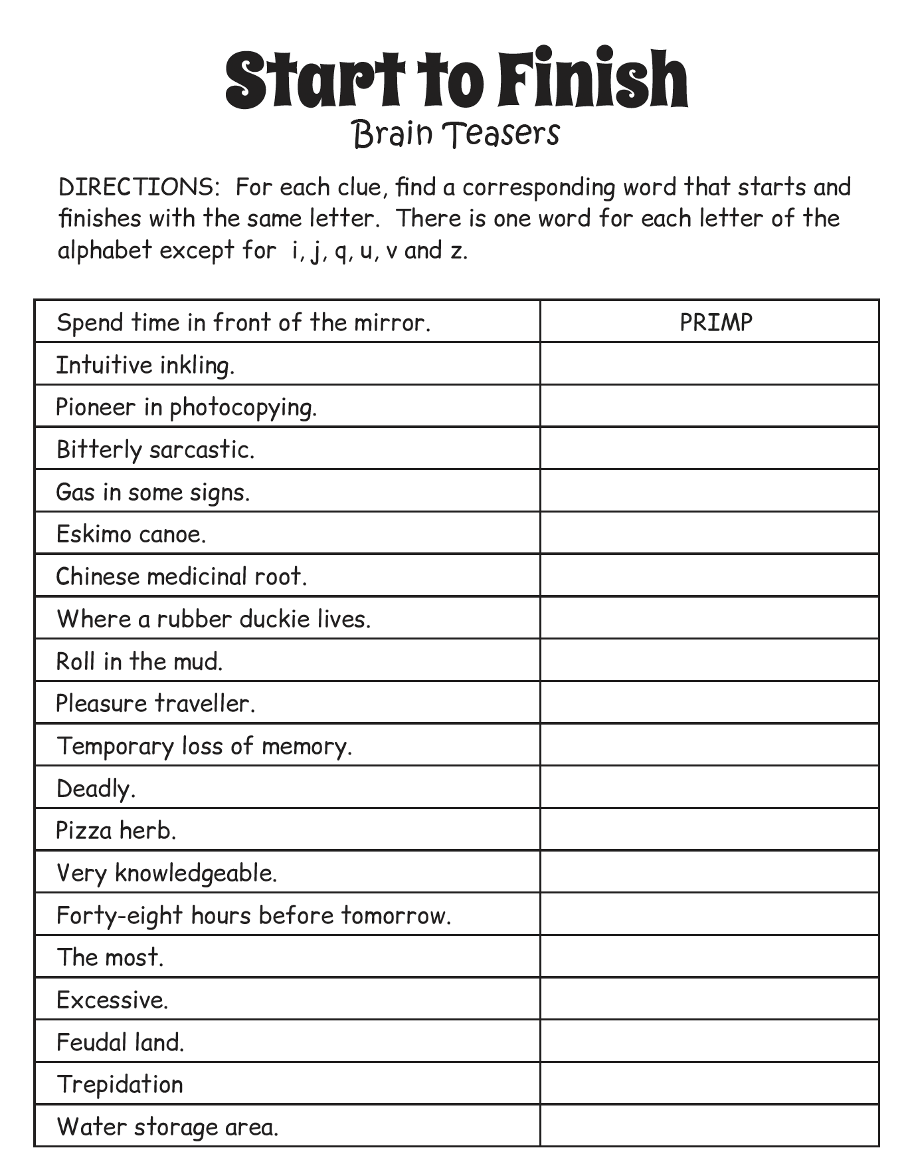
Welcome to our new and returning clients!

Click on the text box and Insert names

A gigantic THANK YOU to all who referred us last month…

Insert names
Get a

with my
Referral Rewards Program
As you probably know, advertising is very expensive. Instead of paying the newspaper or another place to advertise, we’d rather reward you. So we’ve assembled the Referral Rewards Program.
Every time you refer someone who becomes a client, we will send you a gift certificate for two passes to the Movies-8 Cinema.
And Hey! What’s a movie without popcorn? The gift certificate will also cover a big box of hot, buttered popcorn and sodas!
Come by our store to
claim your prize!

PRIMP, HUNCH, XEROX, CAUSTIC, NEON, KAYAK, GINSENG, BATHTUB, WALLOW, TOURIST, AMNESIA, LETHAL, OREGANO, ERUDITE, YESTERDAY, MAXIMUM, SUPERFLUOUS, FIEF, DREAD, RESERVOIR
Answers:
Your Company Name
123 Address, Someplace, ZZ 555555
555.555.5555 Phone 555.555.5555 Fax
email@yourcompanyname.com
YourCompanyWebsite.com

