
Reliable news for healthy living, saving money, and having fun!




Inside This Issue…
- Are you this month’s Mystery Winner?
- Month at a Glance
- How Homeowners Can Prepare for Winter
- Did You Know
- Mega Trivia Contest
- Tips for a Healthy Holiday Season
- Thank you for the Kind Words
- Client of the Month
- Brain Teasers
- Thank You to our clients

Festivus
Kwanzaa
Hanukkah Ends
Hanukkah Begins
New Year’s Eve
Christmas Eve
Christmas Day
First
Day of Winter
Jimbo’s Floors
Suzie Smith!
You are this month’s
Mystery Winner!
We have a
$10.00 Starbucks
gift card
reserved just for you!
Come by our store to
claim your prize!

“You’ll love your new floors or I’ll replace them free!”
~Jim Armstrong & Mick
www.JimbosFloors.com
Scan to visit our website
Dear Friends,
Your personal message goes here.
The personal message is important because it allows you to connect in a very personal way with your clients. This personal connection is sorely lacking in most businesses. Topic ideas:
Your hobbies
Something interesting happening this month. Wish them “Merry Christmas” or “Happy Thanksgiving.”
A thought from your heart
Appreciation for your clients and their referrals. Remind them that you will bend over backwards to provide their referrals with World Class Service.
Mention that month’s “special offer” insert
Your Friend,
Your Signature
Your Name
December 2025
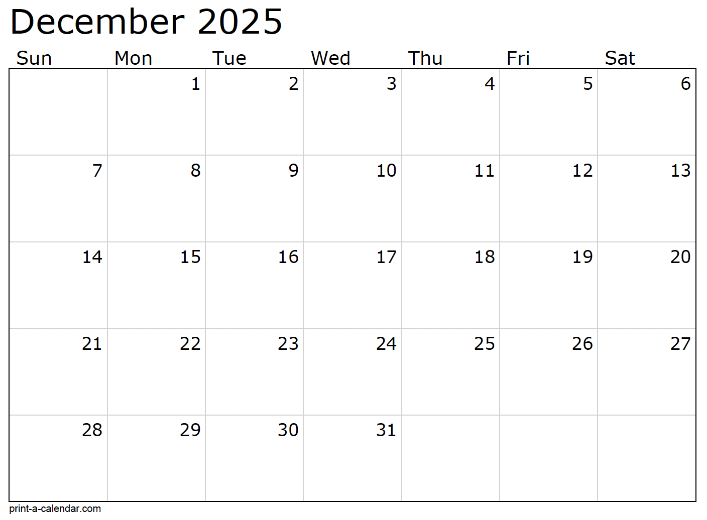
Month at a Glance!
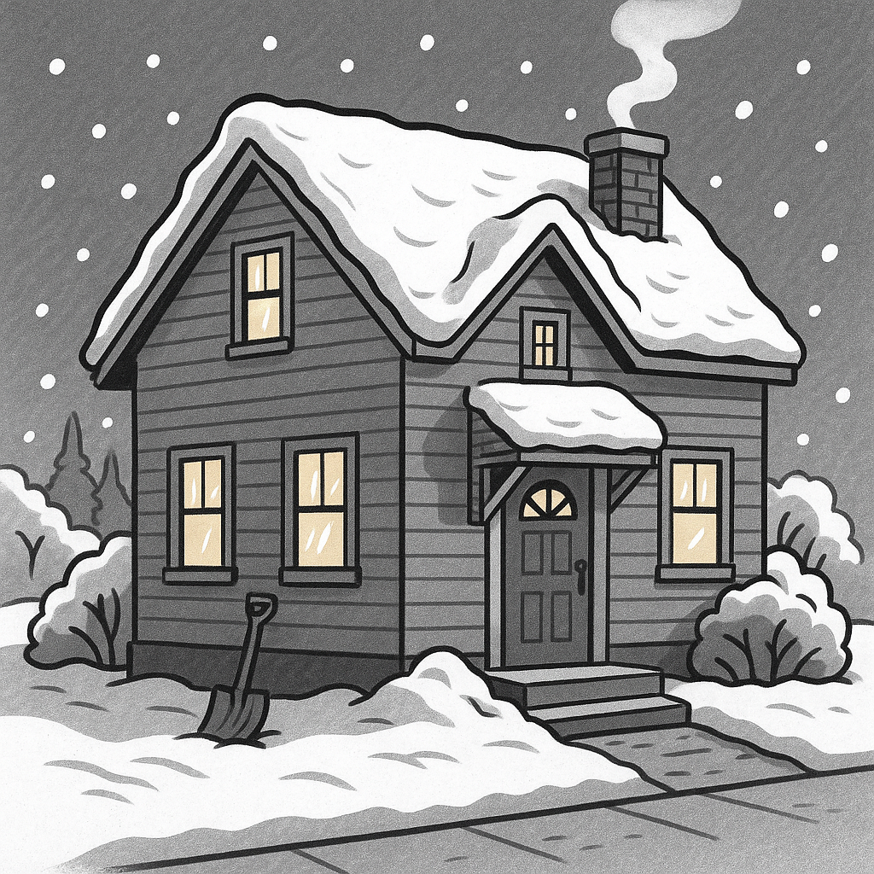



(NOTE: see the HA instructions for this month if you don’t have the Jim Armstrong Marketing Website to direct them to.)

Who Else Wants to Win

Dinner for Two at the City Café!

Take our Trivia Challenge and you could win too!
This month’s Mega Trivia question:
Last month’s question: (Answer is in bold print)
Where did the word ‘November’ come from?
A) A Roman emperor’s name B) An old Celtic festival
C) The Latin word for “nine” D) The Greek goddess of harvest

Congratulations to last month’s winner:
Client Name
Come by our store to claim your prize!

How many French hens does the true love give in the “Twelve Days of Christmas”?
A) 12 B) 6 C) 3 D) 7
To enter, email Support@JimbosFloors.com and enter “Mega Trivia Contest” as the subject line. Take your best guess…your chances of winning are better than you think!
We’d be happy to send you our electronic newsletter!

The same combination of useful tips and offbeat stories you read here, but with these differences:
- The e-Advisor will arrive in your email account once you give us permission
- We send it once a week
- The e-Advisor does not have the same content as the print Home Advisor – you’ll read all new stories, from helpful advice to items that give you a smile
Simply let us know which email account you’d like us to use for the e-Advisor.
As the temperature drops and the days grow shorter, it’s time to make sure your home is ready to face the challenges of winter. A few proactive steps in early December can help you stay warm, prevent costly repairs, and enjoy the season in comfort.
Start outside. Clean gutters and downspouts to prevent ice dams and water damage. Check your roof for missing shingles and trim back any tree branches that hang over your home. While you’re at it, make sure outdoor faucets and sprinkler systems are drained and insulated. Frozen pipes are one of winter’s most common (and expensive) surprises.
Next, focus on keeping the heat where it belongs: inside. Inspect windows and doors for drafts and seal gaps with weatherstripping or caulk. Consider adding insulation to attics, basements, or crawl spaces to keep your heating system from working overtime. If you use a fireplace, have the chimney cleaned and inspected before lighting the first fire of the season.
Inside, replace furnace filters and schedule a quick maintenance check to ensure everything runs efficiently. It’s also a good time to test smoke and carbon monoxide detectors and stock up on emergency supplies, such as batteries, flashlights, and bottled water.
And don’t forget your floors! Snow, salt, and slush can take a toll on your home’s surfaces. Place durable mats at every entryway and use area rugs in high-traffic zones to protect your flooring and make cleanup easier.
Tree sap can be surprisingly sticky and difficult to remove, and it may damage certain flooring finishes. Place a waterproof tree mat or tray beneath your Christmas tree stand to catch water and sap drips, and sweep up fallen needles regularly to prevent scratches.
With a little preparation now, you’ll stay cozy, save money on energy bills, and avoid mid-winter headaches later. Then you can sit back, sip something warm, and truly enjoy the season knowing your home is ready for whatever winter brings.

How Homeowners Can Prepare for Winter

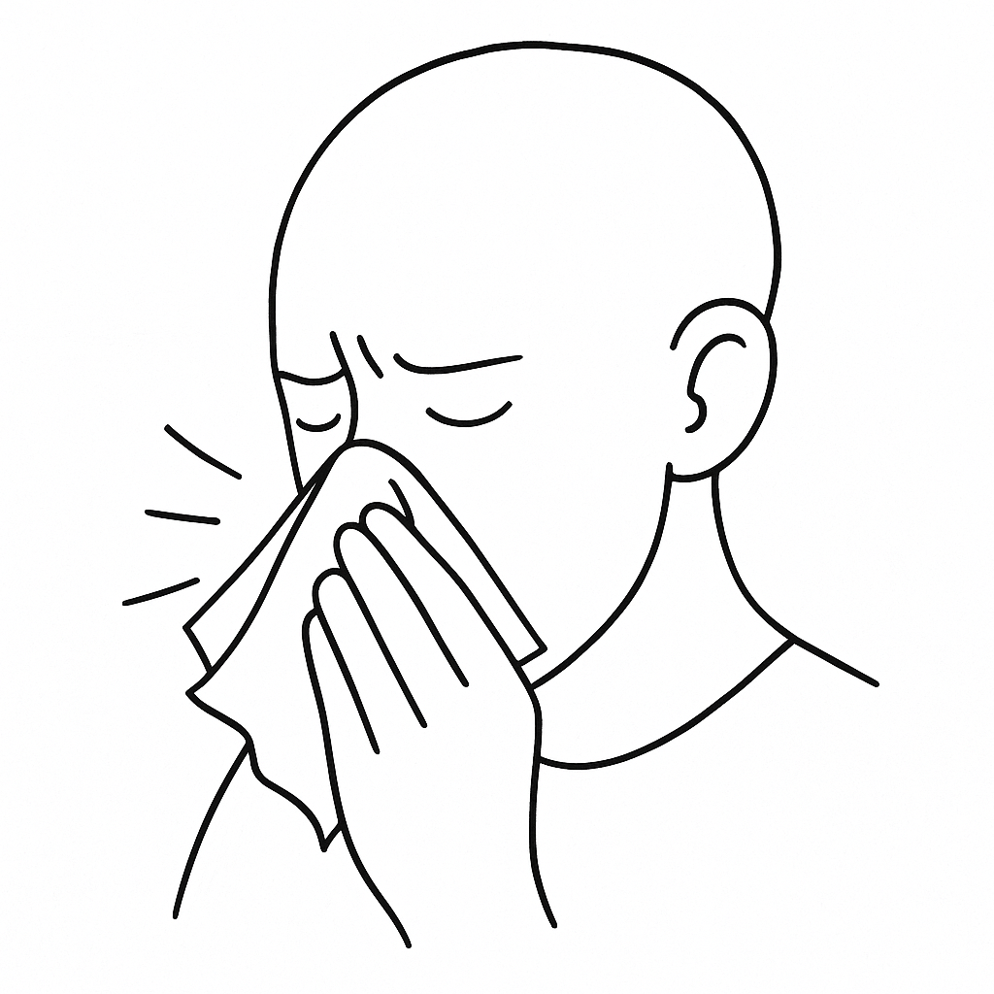
The holidays are a time for celebration, connection, and comfort, but they can also bring stress, exhaustion, and more than a few late nights. This year, give yourself the gift of balance with a few simple ways to keep your body and mind feeling their best all season long.
Start with rest. The holiday rush makes it easy to burn the candle at both ends, but getting enough sleep is one of the best ways to boost your immune system and reduce stress. Try winding down each evening with soft lighting, a warm drink, or quiet music instead of screens. Your body will thank you.
Stay active, your way. Whether it’s a brisk walk through the neighborhood lights, a weekend hike, or a few minutes of stretching between gatherings, movement helps offset rich meals and keeps energy levels steady. You don’t need to hit the gym; consistency matters more than intensity, and every little bit adds up.
Eat smart (most of the time). Holiday treats are part of the joy, so enjoy them! Just balance them with colorful fruits and vegetables when you can. Staying hydrated also helps fight fatigue, supports digestion, and keeps skin looking healthy through the dry winter air.
Keep your air, and home, fresh. Between guests, cooking, candles, and heating systems running around the clock, indoor air can get stuffy. Crack a window for a few minutes each day or use an air purifier to help everyone breathe easier and stay comfortable.
And don’t forget your home’s floors. A quick sweep after gatherings helps prevent spills, crumbs, and grit from dulling your surfaces. Clean floors, clean mind!
With a few mindful habits, you’ll glide into the new year with more energy, less stress, and a home that feels peaceful and inviting.
Tips for a Healthy Holiday Season


Congratulations to our

Susan Johnson!
Susan is a 3rd time returning client, and she recently purchased new laminate for her kitchen and dining room. She always has a big smile on her face and is a lot of fun to work with. Thanks, Susan!
As always, our clients of the month receive 2 movie passes for Movies-8!
Watch for your name here in a coming month!
Come by our store to
claim your prize!

“My new laminate floors in my kitchen and dining room are beautiful. I was treated with respect and courtesy as a single woman raising a daughter. I genuinely felt that Jim Armstrong and his staff display concern for my flooring needs and were a guiding light for me. I recommend his service to anyone looking for a supportive, positive experience.”
~Marsha Avalos, School Teacher, Yuba City

“We Recently went to Jimbo’s Floors for new tile for our bathroom, and we’re thrilled with the results! This is our third time using Jimbo’s. Jim will never make you feel uncomfortable for asking questions and he’ll do anything in his power to accommodate your needs. When you do business with Jim and the staff at Jimbo’s Floors, you will be treated like royalty. Our experience was painless and very professional. Jim is not only our flooring expert, he’s a friend. That’s how he makes you feel.”
~Marvin and Sandy Moeller, owners of Sierra Landscaping, Yuba City

Thank You for the Kind Words!




From our families to yours, have a great month!

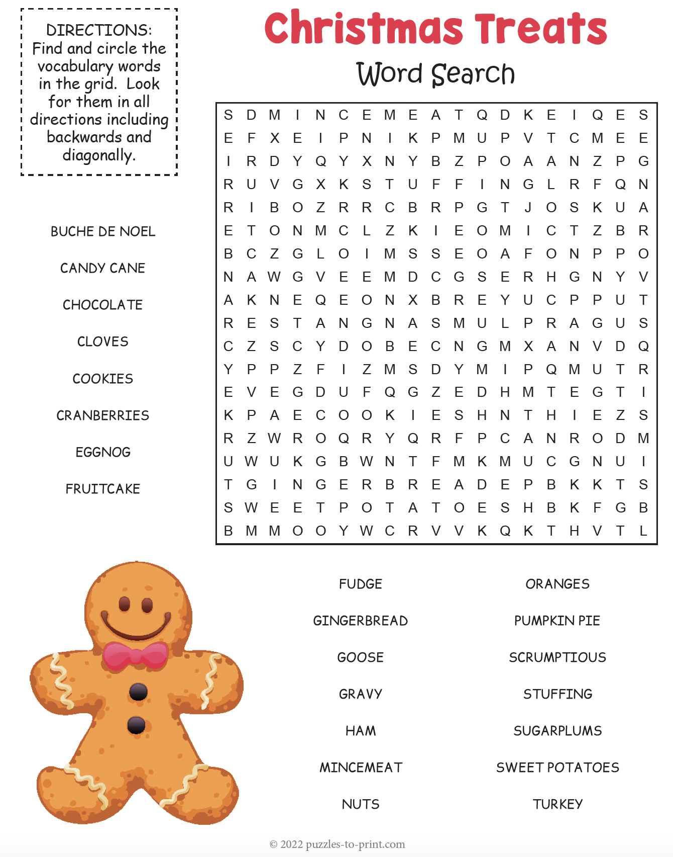
Welcome to our new and returning clients!

Click on the text box and Insert names

A gigantic THANK YOU to all who referred us last month…

Insert names
Get a

with my
Referral Rewards Program
As you probably know, advertising is very expensive. Instead of paying the newspaper or another place to advertise, we’d rather reward you. So we’ve assembled the Referral Rewards Program.
Every time you refer someone who becomes a client, we will send you a gift certificate for two passes to the Movies-8 Cinema.
And Hey! What’s a movie without popcorn? The gift certificate will also cover a big box of hot, buttered popcorn and sodas!
Come by our store to
claim your prize!

Your Company Name
123 Address, Someplace, ZZ 555555
555.555.5555 Phone 555.555.5555 Fax
email@yourcompanyname.com
YourCompanyWebsite.com

