
Reliable news for healthy living, saving money, and having fun!




Sept. 1 Labor Day Sept. 7 Grandparent’s Day
Sept. 11 Patriot Day

September 2025
Jimbo’s Floors
Suzie Smith!
You are this month’s
Mystery Winner!
We have a
$10.00 Starbucks
gift card
reserved just for you!
Come by our store to
claim your prize!

Inside This Issue…
- Are you this month’s Mystery Winner?
- Month at a Glance
- Get Ready for Fall: Home Prep Checklist
- Did You Know
- Mega Trivia Contest
- Celebrating Grandparents
- Thank you for the Kind Words
- Client of the Month
- Brain Teasers
- Thank You to our clients

“You’ll love your new floors or I’ll replace them free!”
~Jim Armstrong & Mick
www.JimbosFloors.com
Scan to visit our website
Dear Friends,
Your personal message goes here.
The personal message is important because it allows you to connect in a very personal way with your clients. This personal connection is sorely lacking in most businesses. Topic ideas:
Your hobbies
Something interesting happening this month. Wish them “Merry Christmas” or “Happy Thanksgiving.”
A thought from your heart
Appreciation for your clients and their referrals. Remind them that you will bend over backwards to provide their referrals with World Class Service.
Mention that month’s “special offer” insert
Your Friend,
Your Signature
Your Name
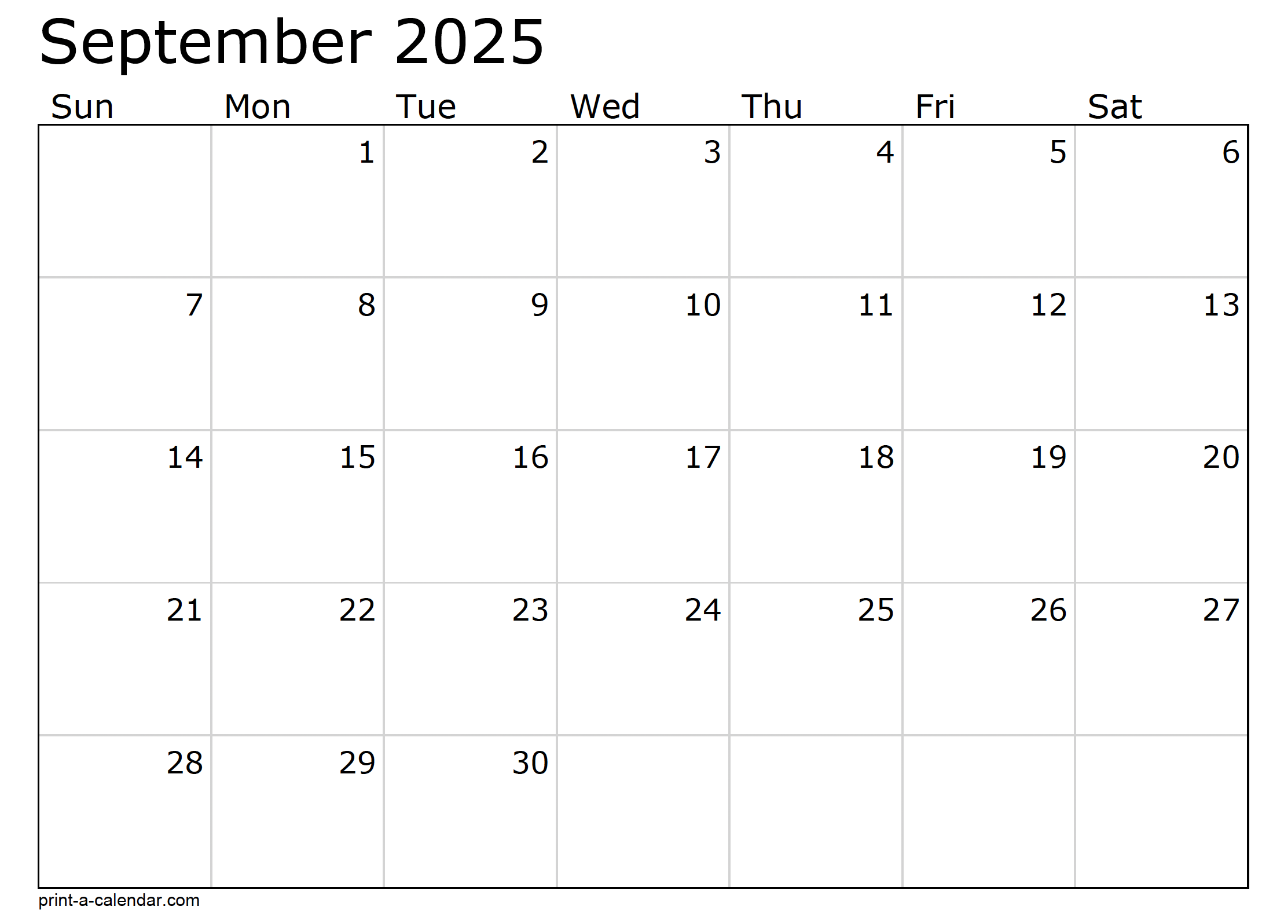
Month at a Glance!




What is the name of the first Disney movie?
A) Snow White & the Seven Dwarfs B) The Reluctant Dragon
C) Bambi D) Pinocchio
To enter, email Support@JimbosFloors.com and enter “Mega Trivia Contest” as the subject line. Take your best guess…your chances of winning are better than you think!
Last month’s question: (Answer is in bold print)
What are the Birth Flowers for August?
A) Poppy & Tulip B) Sunflower & Daisy
C) Gladiolus & Poppy D) Rose & Oleander

Congratulations to last month’s winner:
Client Name
Come by our store to claim your prize!

Who Else Wants to Win

Dinner for Two at the City Café!

Take our Trivia Challenge and you could win too!
This month’s Mega Trivia question:
(NOTE: see the HA instructions for this month if you don’t have the Jim Armstrong Marketing Website to direct them to.)
As summer winds down and the first crisp mornings start to roll in, it's the perfect time to give your home a little TLC before autumn fully arrives. A few smart steps now can help you avoid costly repairs later—and keep your home cozy and efficient all season long.
1. Clean Your Gutters
Leaves are beautiful... until they clog your gutters. Prevent water damage by clearing out debris and making sure downspouts are directing water away from your foundation.
2. Check Weatherstripping
Feel a draft around your windows or doors? Worn weatherstripping lets warm air escape and cold air sneak in. Replacing it is inexpensive—and can cut your heating bill.
3. Inspect Your Roof
Grab a pair of binoculars and do a visual check for missing shingles, cracked flashing, or signs of moss. If anything looks off, call in a pro before the rain (or snow) arrives.
4. Furnace Tune-Up
Before you need to crank up the heat, schedule a quick maintenance check. A clean, inspected furnace runs more efficiently and lasts longer.
5. Test Smoke and CO Detectors
Colder months mean more time indoors—and more use of fireplaces and heating systems. Make sure your detectors are working and replace batteries if needed.
6. Prep Outdoor Spaces
Put away or cover patio furniture, shut off outdoor faucets, and bring in any plants that can’t handle the chill.
Knocking out this checklist now means you can relax later—hot cocoa in hand, knowing your home is ready for the season ahead.

We’d be happy to send you our electronic newsletter!

The same combination of useful tips and offbeat stories you read here, but with these differences:
- The e-Advisor will arrive in your email account once you give us permission
- We send it once a week
- The e-Advisor does not have the same content as the print Home Advisor – you’ll read all new stories, from helpful advice to items that give you a smile
Simply let us know which email account you’d like us to use for the e-Advisor.
Get Ready for Fall: Your Home Prep Checklist 🍁


Celebrating Grandparents: Wisdom, Cookies & Everything in Between


Congratulations to our

Susan Johnson!
Susan is a 3rd time returning client, and she recently purchased new laminate for her kitchen and dining room. She always has a big smile on her face and is a lot of fun to work with. Thanks, Susan!
As always, our clients of the month receive 2 movie passes for Movies-8!
Watch for your name here in a coming month!
Come by our store to
claim your prize!

“My new laminate floors in my kitchen and dining room are beautiful. I was treated with respect and courtesy as a single woman raising a daughter. I genuinely felt that Jim Armstrong and his staff display concern for my flooring needs and were a guiding light for me. I recommend his service to anyone looking for a supportive, positive experience.”
~Marsha Avalos, School Teacher, Yuba City

“We Recently went to Jimbo’s Floors for new tile for our bathroom, and we’re thrilled with the results! This is our third time using Jimbo’s. Jim will never make you feel uncomfortable for asking questions and he’ll do anything in his power to accommodate your needs. When you do business with Jim and the staff at Jimbo’s Floors, you will be treated like royalty. Our experience was painless and very professional. Jim is not only our flooring expert, he’s a friend. That’s how he makes you feel.”
~Marvin and Sandy Moeller, owners of Sierra Landscaping, Yuba City

Thank You for the Kind Words!

Every September, we get a chance to celebrate a truly special group of people—our grandparents. Grandparents Day falls on the first Sunday after Labor Day (September 7th in 2025), and while it might not come with fireworks or confetti, it’s the perfect opportunity to honor the folks who’ve given us so much—stories, hugs, life lessons, and maybe a few extra cookies when Mom wasn’t looking.
Grandparents play a unique role in many families. They're part-history keepers, part-storytellers, and often part-time babysitters, garden gurus, and garage tinkerers. They’ve lived through decades of change and usually have a few good tales to tell (and some strong opinions about how things “used to be done”).
Whether your grandparents are still with you or fondly remembered, this month is a great time to reflect on their impact and maybe find a small way to show your appreciation. A phone call, handwritten note, or even a shared walk down memory lane with old photo albums can mean the world. If you have little ones, consider encouraging them to create handmade cards or drawings to gift to their grandparents—or to a local senior who could use a little cheer.
And if you’re a grandparent yourself? Take a bow! You’re a living legend in your family. Your stories, patience, and love are shaping a new generation—whether you’re teaching them how to bake, fish, sew, or just how to slow down and enjoy a good laugh.
So this Grandparents Day, let’s celebrate the laughter lines, the wisdom, and the unconditional love that only grandparents can offer.




From our families to yours, have a great month!

1 Turn the glass upside down or inverted. Move the 1 horizontal match either left or right so only its end touches the bottom vertical match. Then take one of the top vertical matches and move it down (up) to make the other side of the glass. 2 The word spot appears twice in the question. 3 Switch the middle full glass with the middle empty glass. 4 A crab is camouflaged in the sand and pebbles around the middle left area. 5 Post Office. 6 INT. Each letter comes from the first letter in the question. WAT = what are the, NTL = next three letters, and INT in this puzzle.

Answers:

Welcome to our new and returning clients!

Click on the text box and Insert names

A gigantic THANK YOU to all who referred us last month…

Insert names
Get a

with my
Referral Rewards Program
As you probably know, advertising is very expensive. Instead of paying the newspaper or another place to advertise, we’d rather reward you. So we’ve assembled the Referral Rewards Program.
Every time you refer someone who becomes a client, we will send you a gift certificate for two passes to the Movies-8 Cinema.
And Hey! What’s a movie without popcorn? The gift certificate will also cover a big box of hot, buttered popcorn and sodas!
Come by our store to
claim your prize!

Your Company Name
123 Address, Someplace, ZZ 555555
555.555.5555 Phone 555.555.5555 Fax
email@yourcompanyname.com
YourCompanyWebsite.com

