
Reliable news for healthy living, saving money, and having fun!




Memorial Day
Armed Forces Day
Mother’s Day
Cinco De Mayo
Kentucky Derby
National Day of Prayer
Jimbo’s Floors
Suzie Smith!
You are this month’s
Mystery Winner!
We have a
$10.00 Starbucks
gift card
reserved just for you!
Come by our store to
claim your prize!

Inside This Issue…
- Are you this month’s Mystery Winner?
- Month at a Glance
- Boost Your Home’s Curb Appeal
- Did You Know
- Mega Trivia Contest
- The Science of a Perfect Backyard BBQ
- Thank you for the Kind Words
- Client of the Month
- Brain Teasers
- Thank You to our clients

“You’ll love your new floors or I’ll replace them free!”
~Jim Armstrong & Mick
www.JimbosFloors.com
Scan to visit our website
Dear Friends,
Your personal message goes here.
The personal message is important because it allows you to connect in a very personal way with your clients. This personal connection is sorely lacking in most businesses. Topic ideas:
Your hobbies
Something interesting happening this month. Wish them “Merry Christmas” or “Happy Thanksgiving.”
A thought from your heart
Appreciation for your clients and their referrals. Remind them that you will bend over backwards to provide their referrals with World Class Service.
Mention that month’s “special offer” insert
Your Friend,
Your Signature
Your Name
May 2025
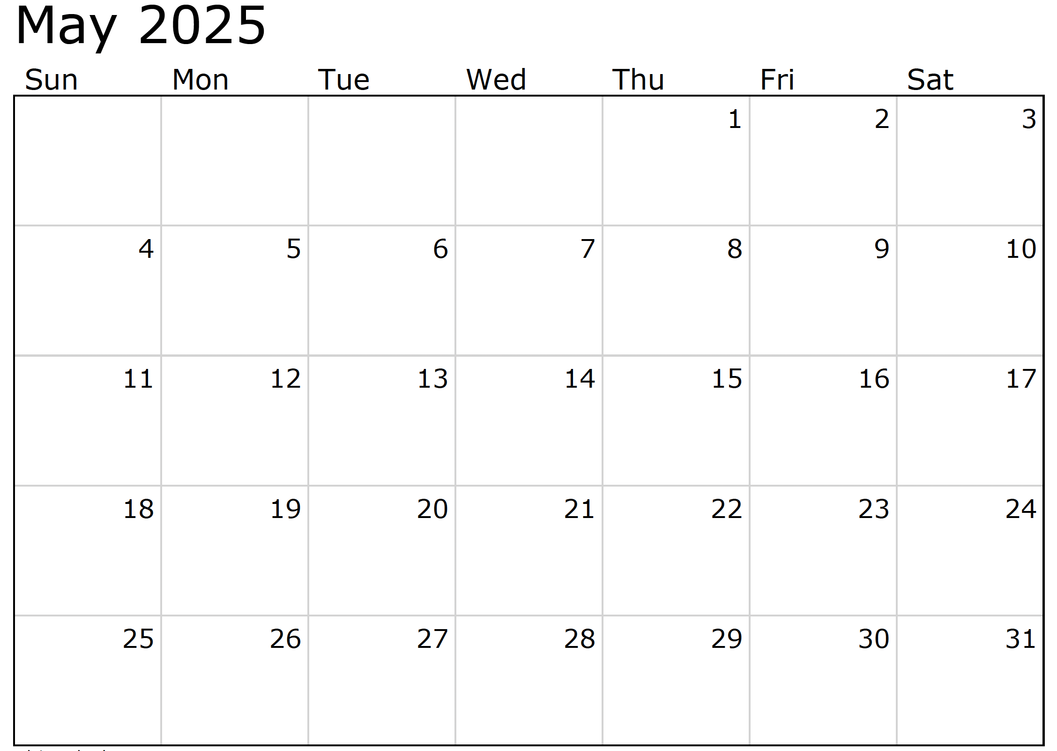
Month at a Glance!




(NOTE: see the HA instructions for this month if you don’t have the Jim Armstrong Marketing Website to direct them to.)
Last month’s question: (Answer is in bold print)
When was Earth Day first celebrated?
A) 1970 B) 1895 C) 2021 D) 1907

On May 1 of what year did the Empire State Building officially open for the first time?
A) 1930 B) 1920 C) 1942 D) 1931
To enter, email Support@JimbosFloors.com and enter “Mega Trivia Contest” as the subject line. Take your best guess…your chances of winning are better than you think!

Who Else Wants to Win

Dinner for Two at the City Café!

Take our Trivia Challenge and you could win too!
This month’s Mega Trivia question:
Congratulations to last month’s winner:
Client Name
Come by our store to claim your prize!

We’d be happy to send you our electronic newsletter!

The same combination of useful tips and offbeat stories you read here, but with these differences:
- The e-Advisor will arrive in your email account once you give us permission
- We send it once a week
- The e-Advisor does not have the same content as the print Home Advisor – you’ll read all new stories, from helpful advice to items that give you a smile
Simply let us know which email account you’d like us to use for the e-Advisor.
Spring is here, making it the perfect time to refresh your home’s curb appeal! Whether you’re looking to impress guests, increase your home’s value, or simply enjoy a more inviting exterior, these small but impactful updates will do the trick.

1. Freshen Up Your Front Door
A new coat of paint can work wonders for your front door. Choose a bold color to make a statement or a classic shade for timeless appeal. Don’t forget to clean or replace hardware for a polished look!
2. Add Seasonal Plants
Potted flowers, hanging baskets, or a small garden bed bursting with spring blooms can instantly brighten your home’s exterior. Focus on vibrant, hardy plants like petunias or marigolds for easy upkeep.

3. Update Your House Numbers
Swapping outdated house numbers for sleek, modern ones is a quick upgrade that enhances your home’s overall style. Look for finishes that complement your home’s aesthetic, like brushed nickel or matte black.

4. Light It Up
Install or update outdoor lighting to highlight your home’s best features. Pathway lights, porch sconces, or string lights can create a welcoming glow and improve safety.

5. Power Wash for a Fresh Start
Over the winter, dirt and grime can build up on siding, walkways, and driveways. A good power wash will restore your home’s exterior and make everything look cleaner and brighter.

These small changes can make a big difference, ensuring your home looks as fresh and inviting as the new season ahead. A little effort goes a long way in creating that "wow" factor before anyone even steps inside.

Here’s to a beautiful spring!

🌸

Boost Your Home’s Curb Appeal 🌸


The Science of a Perfect Backyard BBQ


Congratulations to our

Susan Johnson!
Susan is a 3rd time returning client, and she recently purchased new laminate for her kitchen and dining room. She always has a big smile on her face and is a lot of fun to work with. Thanks, Susan!
As always, our clients of the month receive 2 movie passes for Movies-8!
Watch for your name here in a coming month!
Come by our store to
claim your prize!

“My new laminate floors in my kitchen and dining room are beautiful. I was treated with respect and courtesy as a single woman raising a daughter. I genuinely felt that Jim Armstrong and his staff display concern for my flooring needs and were a guiding light for me. I recommend his service to anyone looking for a supportive, positive experience.”
~Marsha Avalos, School Teacher, Yuba City

“We Recently went to Jimbo’s Floors for new tile for our bathroom, and we’re thrilled with the results! This is our third time using Jimbo’s. Jim will never make you feel uncomfortable for asking questions and he’ll do anything in his power to accommodate your needs. When you do business with Jim and the staff at Jimbo’s Floors, you will be treated like royalty. Our experience was painless and very professional. Jim is not only our flooring expert, he’s a friend. That’s how he makes you feel.”
~Marvin and Sandy Moeller, owners of Sierra Landscaping, Yuba City

Thank You for the Kind Words!

May marks the unofficial start of grilling season, and whether you’re a backyard barbecue pro or just getting started, there’s a science to cooking up the perfect meal on the grill. From mastering flavors to creating the right atmosphere, here’s how to make your next cookout a sizzling success.

1. The Perfect Grill Setup
Gas or charcoal? The age-old debate comes down to preference. Gas grills offer convenience and quick heating, while charcoal gives that unbeatable smoky flavor. If you’re using charcoal, let the coals turn ashy white before cooking to ensure even heat.

2. Marinade Magic
Marinades and rubs don’t just add flavor—they also help tenderize meat. Acidic ingredients like lemon juice or vinegar break down proteins, making meats juicier. For the best flavor infusion, let meats marinate for at least 4 hours (or overnight for tougher cuts like brisket).

3. The Science of the Sear
For that perfect grill mark and a delicious crust, sear meats over direct high heat for a minute or two per side before moving them to a lower heat area to finish cooking. This locks in juices and gives that restaurant-quality finish.

4. BBQ Beyond Meat
Grilling isn’t just for steak and burgers! Try throwing vegetables, pineapple, or even pizza on the grill. Corn on the cob, zucchini, and portobello mushrooms take on fantastic smoky flavors.

5. Set the Scene
A great BBQ isn’t just about food—it’s about the experience. String up some outdoor lights, set up comfy seating, and create a playlist with easygoing tunes to keep guests entertained.

Master these BBQ basics, and your backyard will be the place everyone wants to gather all season long.

Fire up the grill and enjoy! 🍔🔥



Your Company Name
123 Address, Someplace, ZZ 555555
555.555.5555 Phone 555.555.5555 Fax
email@yourcompanyname.com
YourCompanyWebsite.com

From our families to yours, have a great month!

Welcome to our new and returning clients!

Click on the text box and Insert names

A gigantic THANK YOU to all who referred us last month…

Insert names
Get a

with my
Referral Rewards Program
As you probably know, advertising is very expensive. Instead of paying the newspaper or another place to advertise, we’d rather reward you. So we’ve assembled the Referral Rewards Program.
Every time you refer someone who becomes a client, we will send you a gift certificate for two passes to the Movies-8 Cinema.
And Hey! What’s a movie without popcorn? The gift certificate will also cover a big box of hot, buttered popcorn and sodas!
Come by our store to
claim your prize!

