

Reliable news for healthy living, saving money, and having fun!

****

**Dec 21** First Day of Winter **Dec 25** Christmas Day,

**Dec 26** KwanzaaHanukkah starts

**Dec 31** New Year’s Eve

**Jimbo’s Floors**

Suzie Smith!

You are this month’s   
Mystery Winner!

We have a   
**$10.00 Starbucks   
gift card**   
reserved just for you!

Come by our store to   
claim your prize!

Inside This Issue…

* Are you this month’s Mystery Winner?
* Month at a Glance
* Heated Holiday Conversations
* Did You Know
* Mega Trivia Contest
* ‘24’s Best Home Budgeting Apps
* Thank you for the Kind Words
* Client of the Month
* Brain Teasers
* Thank You to our clients

*“You’ll love your new floors or I’ll replace them free!”*

~Jim Armstrong & Mick  
[www.JimbosFloors.com](http://www.JimbosFloors.com)

Scan to visit our website

Dear Friends,

Your personal message goes here.

The personal message is important because it allows you to connect in a very personal way with your clients. This personal connection is sorely lacking in most businesses. Topic ideas:

Your hobbies

Something interesting happening this month. Wish them “Merry Christmas” or “Happy Thanksgiving.”

A thought from your heart

Appreciation for your clients and their referrals. Remind them that you will bend over backwards to provide their referrals with World Class Service.

Mention that month’s “special offer” insert

Your Friend,

Your Signature

Your Name

December 2024

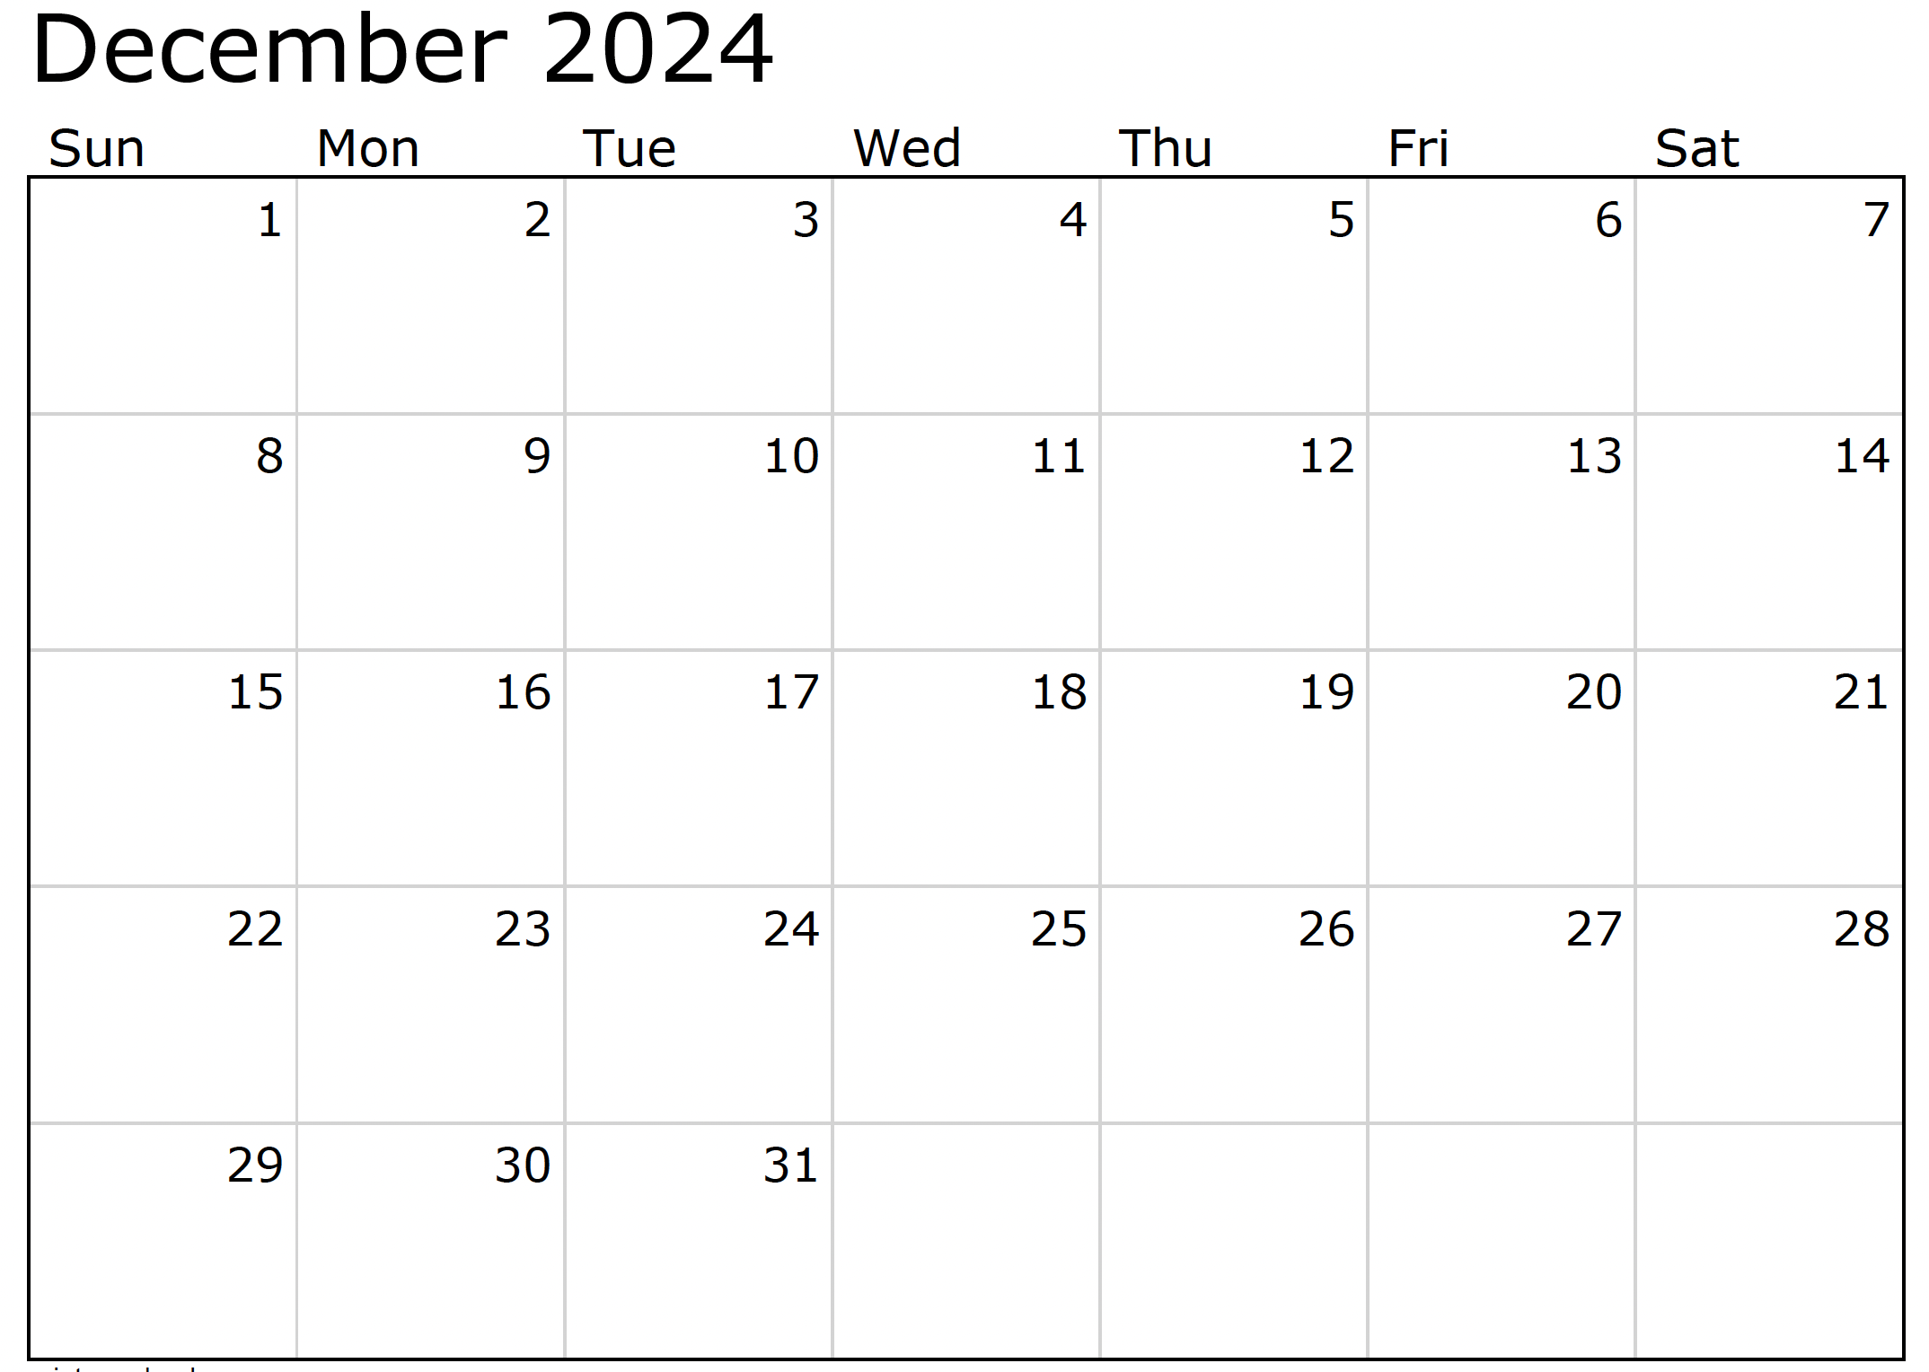

Month at a Glance!

*****

***Last month’s question: (Answer is in bold print)*** *Which state is known for producing the most turkeys for Thanksgiving?*

*A) Texas* ***B) Minnesota*** *C) California  D) Georgia*

What’s the name of Rudolph’s girlfriend in the “Rudolph the Red-Nosed Reindeer” television special?

A) Karen B) Clarice C) Zoe D) Mrs. Clause

To enter, email [Support@JimbosFloors.com](mailto:Support@JimbosFloors.com) and enter “Mega Trivia Contest” as the subject line. Take your best guess…your chances of winning are better than you think!

### Who Else Wants to Win

### Dinner for Two at the City Café!

### Take our Trivia Challenge and *you could win too!*

This month’s Mega Trivia question:

Congratulations to last month’s winner: **Client Name**

Come by our store to claim your prize!

(NOTE: see the HA instructions for this month if you don’t have the Jim Armstrong Marketing Website to direct them to.)

**We’d be happy to send you our electronic newsletter!**

The same combination of useful tips and offbeat stories you read here, but with these differences:

* The e-Advisor will arrive in your email account once you give us permission
* We send it once a week
* The e-Advisor does not have the same content as the print Home Advisor – you’ll read all new stories, from helpful advice to items that give you a smile

Simply let us know which email account you’d like us to use for the e-Advisor.

The holidays can be a joyful time, but sometimes conversations take an unexpected turn toward confrontation. Knowing how to exit gracefully from these situations is key to maintaining peace and enjoying the celebration.

**1. Acknowledge and Redirect:**  
If you sense a conversation heating up, try acknowledging the topic briefly, then steer the conversation to a lighter subject. For example, “That’s an interesting point, but let’s not dive too deep tonight. I’d love to hear about your recent trip!”

**2. Take a Strategic Pause:**  
If redirecting doesn’t work or the conversation is escalating, excuse yourself calmly. Say something like, “I’m going to grab a refill” or “Excuse me, I need to check on something in the kitchen.” This gives you a graceful exit without confrontation.

**3. Practice Mindful Breathing:**  
Once you’ve stepped away, take a few moments to breathe deeply. Count to four as you inhale, hold for four, and exhale for four. This simple exercise helps calm the nervous system and prevent reactive emotions from taking over.

**4. Reframe and Reset:**  
After calming down, remind yourself why you’re at the event: to enjoy the company of loved ones and celebrate. Reframe your mindset to focus on the positive aspects of the gathering.

**5. Re-enter With Grace:**  
Once you’ve taken a moment to calm down, return to the party with a positive attitude. Reconnect with someone who is light-hearted and easy to talk to. This will help ease you back into the celebration and keep the mood enjoyable.

**‘Bonus Redirect’** options for you:

**Compliment and Shift:**  
“You always have a unique perspective. By the way, I meant to ask—where did you get that amazing dessert recipe?”

**Use Humor Lightly:**  
“Uh oh, I think this conversation just hit ‘holiday debate mode’! Let’s hit pause before we start sounding like the dinner table version of a reality show!”

Here's to maintaining the festive spirit and ensure a memorable holiday gathering.

Skillfully Exiting A Heated Holiday Conversation



2024’s Best-Ranked Apps for Home Budgeting



Congratulations to our

**Susan Johnson!**

Susan is a 3rd time returning client, and she recently purchased new laminate for her kitchen and dining room. She always has a big smile on her face and is a lot of fun to work with. *Thanks, Susan!*

As always, our clients of the month receive **2 movie passes for Movies-8!**

*Watch for your name here in a coming month!*

Come by our store to   
claim your prize!

“My new laminate floors in my kitchen and dining room are beautiful. I was treated with respect and courtesy as a single woman raising a daughter. I genuinely felt that Jim Armstrong and his staff display concern for my flooring needs and were a guiding light for me. I recommend his service to anyone looking for a supportive, positive experience.”

~Marsha Avalos, School Teacher, Yuba City

“We Recently went to Jimbo’s Floors for new tile for our bathroom, and we’re thrilled with the results! This is our third time using Jimbo’s. Jim will never make you feel uncomfortable for asking questions and he’ll do anything in his power to accommodate your needs. When you do business with Jim and the staff at Jimbo’s Floors, you will be treated like royalty. Our experience was painless and very professional. Jim is not only our flooring expert, he’s a friend. That’s how he makes you feel.”

~Marvin and Sandy Moeller, owners of Sierra Landscaping, Yuba City

Thank You for the Kind Words!

Keeping track of household finances can be challenging, but using the right budgeting app can make it easier to manage your money. Here are some of *NerdWallet’s* best-rated budgeting apps for 2024, each catering to different needs and preferences:

**You Need A Budget (YNAB)**  
YNAB uses a zero-based budgeting system, encouraging users to plan ahead for every dollar. It’s ideal for those looking to be more hands-on with their finances.  
**Cost**: $14.99/month or $109/year  
**Best For**: Zero-based budgeting and financial planning.

**Goodbudget**  
This app follows the “envelope budgeting” method, where you assign portions of your income to different spending categories. Goodbudget is excellent for couples and families who want to budget together.  
**Cost**: Free basic version; $10/month or $80/year for Premium  
**Best For**: Hands-on budgeters and shared budgeting.

**EveryDollar**  
Offering a simpler approach to zero-based budgeting, EveryDollar is perfect for beginners. The free version is basic, but the premium version includes bank sync and custom reports.  
**Cost**: Free basic version; Premium at $79.99/year or $17.99/month  
**Best For**: Beginners looking for simplicity.

**Empower Personal Dashboard**  
Formerly known as Personal Capital, Empower focuses on tracking wealth and investments alongside budgeting. It’s perfect for those who want to see the bigger picture of their financial health.  
**Cost**: Free  
**Best For**: Wealth tracking and investment management.

These apps each offer unique features to suit various budgeting styles, making it easier for anyone to find the right fit for their financial goals​. Download the one that best suits your needs and start 2025 out with a solid budget that you’ll be able to stick to!



Answers:

 (**1)** coal, (**2**) sleigh, (**3**) Tannenbaum, (**4**) Orthodox, (**5**) bright, (**6**) Nativity, (**7**) population.

**Be sure to stop by to pick out and schedule   
your new floor installation, and   
from our families to yours have a great month!**

**Welcome to our new and returning clients!**

Click on the text box and Insert names

**A gigantic THANK YOU to all who referred us last month…**

Insert names

Get a

with my

**Referral Rewards Program**

As you probably know, advertising is very expensive. Instead of paying the newspaper or another place to advertise, we’d rather reward you. So we’ve assembled the Referral Rewards Program.

Every time you refer someone who becomes a client, we will send you a gift certificate for two passes to the **Movies-8 Cinema.**

And Hey! What’s a movie without popcorn? The gift certificate will also cover a big box of hot, buttered popcorn and sodas!

*Come by our store to   
claim your prize!*

Happy Brain Teaser Month!

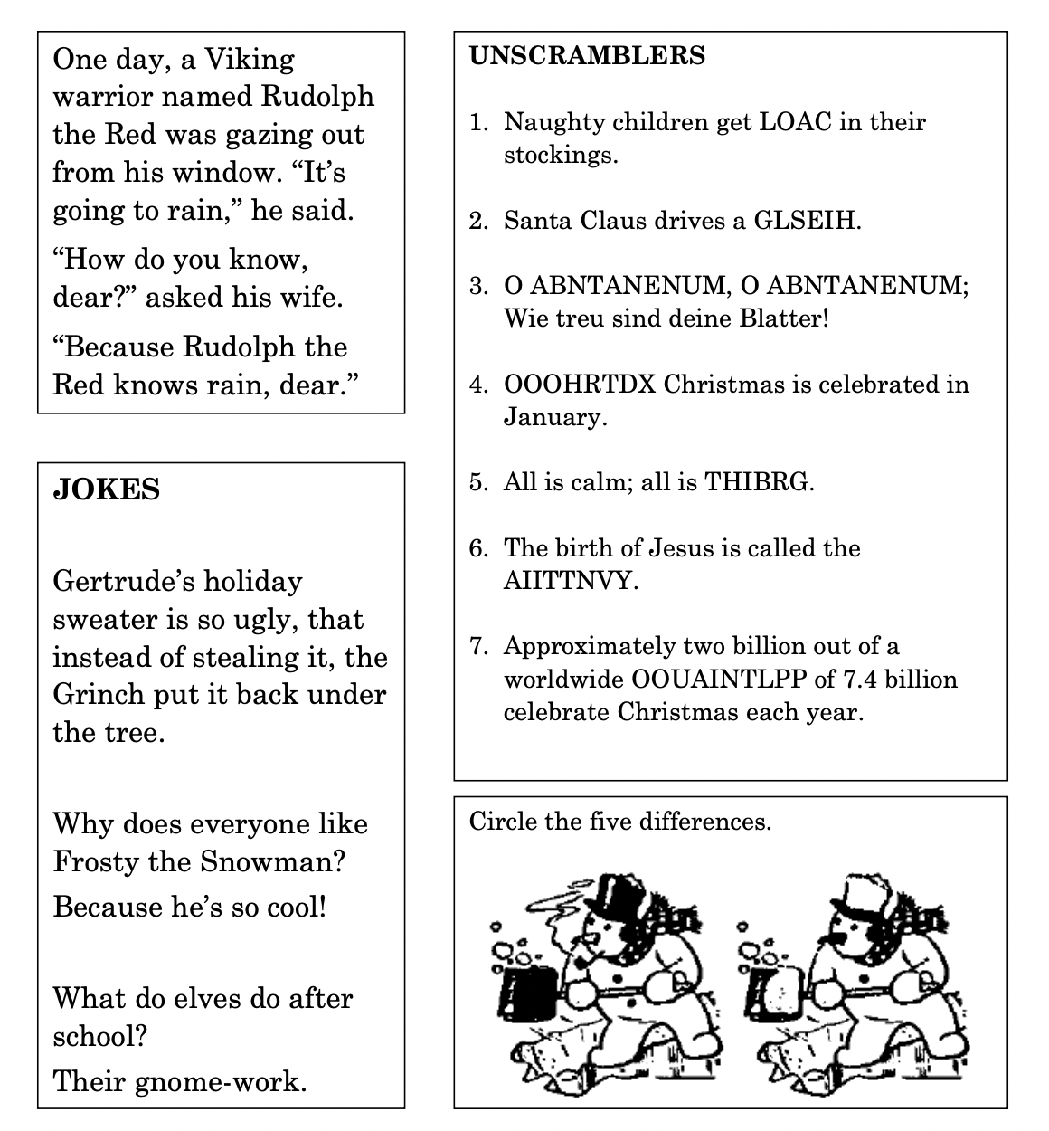

**Your Company Name**

123 Address, Someplace, ZZ 555555

555.555.5555 Phone ⚫ 555.555.5555 Fax

email@yourcompanyname.com

**YourCompanyWebsite.com**