

Reliable news for healthy living, saving money, and having fun!

********

**I VOTED**

**November 3** Daylight Savings Time ends

**November 5** Election Day **November 11** Veteran’s Day

**November 28** Thanksgiving

**Turn your**

**clocks back!**

**Jimbo’s Floors**

Suzie Smith!

You are this month’s   
Mystery Winner!

We have a   
**$10.00 Starbucks   
gift card**   
reserved just for you!

Come by our store to   
claim your prize!

Inside This Issue…

* Are you this month’s Mystery Winner?
* Month at a Glance
* Honoring Veteran’s Day
* Did You Know
* Mega Trivia Contest
* Eco-Friendly Living Made Easy
* Thank you for the Kind Words
* Client of the Month
* Thanksgiving Crossword
* Thank You to our clients

*“You’ll love your new floors or I’ll replace them free!”*

~Jim Armstrong & Mick  
[www.JimbosFloors.com](http://www.JimbosFloors.com)

Scan to visit our website

Dear Friends,

Your personal message goes here.

The personal message is important because it allows you to connect in a very personal way with your clients. This personal connection is sorely lacking in most businesses. Topic ideas:

Your hobbies

Something interesting happening this month. Wish them “Merry Christmas” or “Happy Thanksgiving.”

A thought from your heart

Appreciation for your clients and their referrals. Remind them that you will bend over backwards to provide their referrals with World Class Service.

Mention that month’s “special offer” insert

Your Friend,

Your Signature

Your Name

November 2024

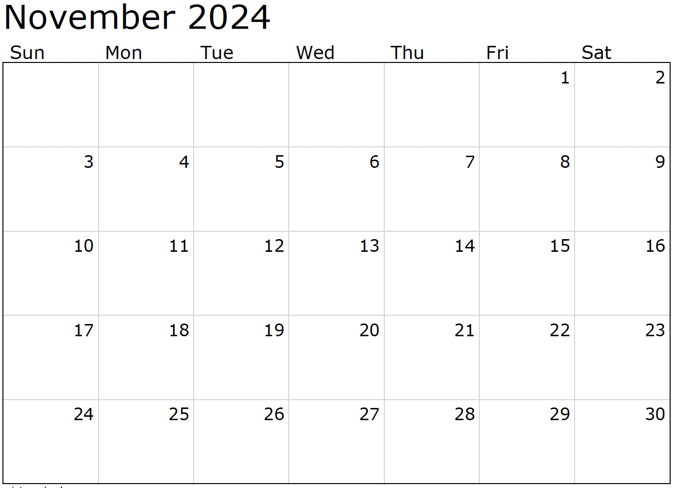

Month at a Glance!

*****

(NOTE: see the HA instructions for this month if you don’t have the Jim Armstrong Marketing Website to direct them to.)

**We’d be happy to   
send you our electronic newsletter!**

The same combination of useful tips and offbeat stories you read here, but with these differences:

* The e-Advisor will arrive in your email account once you give us permission
* We send it once a week
* The e-Advisor does not have the same content as the print Home Advisor – you’ll read all new stories, from helpful advice to items that give you a smile

Simply let us know which email account you’d like us to use for the e-Advisor.

**Which state is known for producing the most turkeys for Thanksgiving?**

A) Texas  B) Minnesota  C) California  D) Georgia

To enter, email [Support@JimbosFloors.com](mailto:Support@JimbosFloors.com) and enter “Mega Trivia Contest” as the subject line. Take your best guess…your chances of winning are better than you think!

Veterans Day is a time to honor the brave men and women who have served in the U.S. military, protecting our freedoms and ensuring the safety of our nation. In 2024, this important day falls on **Monday, November 11**, offering an opportunity for all of us to show our appreciation for the sacrifices these veterans have made.

Here are some meaningful ways to honor Veterans Day this year:

**1. Attend a Veterans Day Event**

Many communities host parades, ceremonies, or special gatherings to honor veterans. Check your local listings to find an event near you. Attending with family or friends is a simple yet powerful way to show support and gratitude.

**2. Visit a Veterans Memorial or Museum**

Take time to visit a veterans memorial, military cemetery, or museum dedicated to the history of the U.S. Armed Forces. These locations offer a tangible way to reflect on the sacrifices made by those who served. Many museums will have special Veterans Day exhibits and programs.

**3. Reach Out to a Veteran**

If you know a veteran personally, reach out to them on Veterans Day to express your gratitude. Whether it’s a phone call, text, or card, letting them know their service is valued can make a big difference. Small acts of kindness can go a long way in showing appreciation.

**4. Volunteer for Veterans Organizations**

Many veterans face challenges after their service, from finding employment to accessing healthcare. Consider volunteering with organizations that support veterans, such as the VA, Wounded Warrior Project, or local veterans groups. Offering your time can be a meaningful way to give back.

**5. Fly the American Flag**

One of the simplest ways to show respect is by flying the American flag on Veterans Day. Displaying the flag at your home is a visible sign of patriotism and a reminder of the sacrifices made to protect our country.

This Veterans Day, take a moment to reflect on the freedoms we enjoy and the individuals who made them possible. By honoring those who served, we acknowledge their courage, dedication, and sacrifice, ensuring their contributions are never forgotten.

### Who Else Wants to Win

### Dinner for Two at the City Café!

### Take our Trivia Challenge and *you could win too!*

This month’s Mega Trivia question:

***Last month’s question: (Answer is in bold print)*** *What does the acronym “URL” stand for when talking about the internet?:* ***A) Uniform Resource Locator*** *C) Unique Resource Locator  
 B) User Request Link D) Universal Reference Library*

Congratulations to last month’s winner: **Client Name**

Come by our store to claim your prize!

Honoring Veterans Day: Ways to Show Your Appreciation

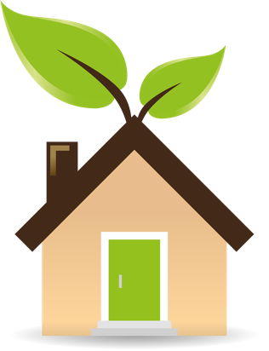

Eco-Friendly Living Made Easy



Congratulations to our

**Susan Johnson!**

Susan is a 3rd time returning client, and she recently purchased new laminate for her kitchen and dining room. She always has a big smile on her face and is a lot of fun to work with. *Thanks, Susan!*

As always, our clients of the month receive **2 movie passes for Movies-8!**

*Watch for your name here in a coming month!*

Come by our store to   
claim your prize!

“My new laminate floors in my kitchen and dining room are beautiful. I was treated with respect and courtesy as a single woman raising a daughter. I genuinely felt that Jim Armstrong and his staff display concern for my flooring needs and were a guiding light for me. I recommend his service to anyone looking for a supportive, positive experience.”

~Marsha Avalos, School Teacher, Yuba City

“We Recently went to Jimbo’s Floors for new tile for our bathroom, and we’re thrilled with the results! This is our third time using Jimbo’s. Jim will never make you feel uncomfortable for asking questions and he’ll do anything in his power to accommodate your needs. When you do business with Jim and the staff at Jimbo’s Floors, you will be treated like royalty. Our experience was painless and very professional. Jim is not only our flooring expert, he’s a friend. That’s how he makes you feel.”

~Marvin and Sandy Moeller, owners of Sierra Landscaping, Yuba City

Thank You for the Kind Words!

Living sustainably is becoming more important as we strive to reduce our environmental impact. The good news is, creating an eco-friendly home doesn’t have to be complicated or expensive. With a few simple DIY projects and changes in habits, you can make your home more sustainable and do your part for the planet.

Here are some easy tips to get started:

**1. Install Energy-Efficient Lighting**

Switching to LED bulbs is one of the simplest and most cost-effective ways to make your home eco-friendly. LED bulbs use up to 75% less energy and last much longer than traditional incandescent bulbs. Plus, they’re available in a variety of styles and colors to suit any room.

**2. Create a Composting System**

Composting is a great way to reduce household waste and create nutrient-rich soil for your garden. You can easily set up a small compost bin in your backyard or even indoors. Composting helps keep organic waste out of landfills and gives you a natural fertilizer for your plants.

**3. Seal Drafts and Insulate**

A well-insulated home uses less energy to heat and cool. You can DIY this by sealing gaps around windows and doors with weatherstripping and caulk. Adding insulation to your attic and walls also helps keep your home temperature consistent, reducing your reliance on heating and cooling systems.

**4. Use Recycled Materials**

When tackling DIY home projects, consider using reclaimed or recycled materials. Whether you’re building furniture, updating decor, or working on a garden project, using recycled materials reduces waste and gives your home a unique, sustainable touch.

**5. Install a Rainwater Collection System**

Collecting rainwater is a simple way to reduce water usage in your garden. You can create a DIY rain barrel system to capture rainwater from your roof and use it to water plants or clean outdoor spaces. It’s important to check with your local laws to make sure rainwater collection is legal in your area.

By incorporating these DIY tips into your home, you’ll not only live more sustainably but also save money on energy and water bills. Sustainable living is easier than ever, and it starts with a few thoughtful changes at home.



**Be sure to stop by to pick out and schedule   
your new floor installation, and   
from our families to yours have a great month!**

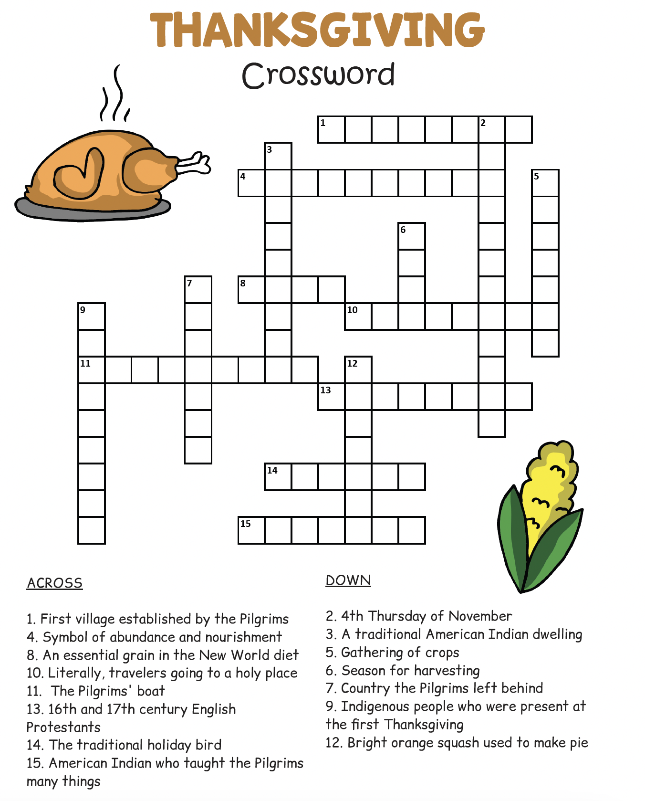

**Welcome to our new and returning clients!**

Click on the text box and Insert names

**A gigantic THANK YOU to all who referred us last month…**

Insert names

Get a

with my

**Referral Rewards Program**

As you probably know, advertising is very expensive. Instead of paying the newspaper or another place to advertise, we’d rather reward you. So we’ve assembled the Referral Rewards Program.

Every time you refer someone who becomes a client, we will send you a gift certificate for two passes to the **Movies-8 Cinema.**

And Hey! What’s a movie without popcorn? The gift certificate will also cover a big box of hot, buttered popcorn and sodas!

*Come by our store to   
claim your prize!*

1. Plymouth 2. Thanksgiving 3. Longhouse 4. Cornucopia 5. Harvest 6. Fall 7. England 8. Corn 9. Wamponoag 10. Pilgrims 11. Mayflower 12. Pumpkin 13. Puritans 14. Turkey 15. Squanto

Answers:

**Your Company Name**

123 Address, Someplace, ZZ 555555

555.555.5555 Phone ⚫ 555.555.5555 Fax

email@yourcompanyname.com

**YourCompanyWebsite.com**