

Reliable news for healthy living, saving money, and having fun!

****

Dear Friends,

Your personal message goes here.

The personal message is important because it allows you to connect in a very personal way with your clients. This personal connection is sorely lacking in most businesses. Topic ideas:

Your hobbies

Something interesting happening this month. Wish them “Merry Christmas” or “Happy Thanksgiving.”

A thought from your heart

Appreciation for your clients and their referrals. Remind them that you will bend over backwards to provide their referrals with World Class Service.

Mention that month’s “special offer” insert

Your Friend,

Your Signature

Your Name

**October 14** Columbus Day **October 16** Boss’ Day

**October 19** Sweetest Day **October 31** Halloween

**Jimbo’s Floors**

Suzie Smith!

You are this month’s   
Mystery Winner!

We have a   
**$10.00 Starbucks   
gift card**   
reserved just for you!

Come by our store to   
claim your prize!

Inside This Issue…

* Are you this month’s Mystery Winner?
* Month at a Glance
* A Black Cat’s Halloween Tale
* Did You Know
* Mega Trivia Contest
* DIY Artwork To Personalize Your Home
* Thank you for the Kind Words
* Client of the Month
* Halloween Wordsearch
* Thank You to our clients

*“You’ll love your new floors or I’ll replace them free!”*

~Jim Armstrong & Mick  
[www.JimbosFloors.com](http://www.JimbosFloors.com)

Scan to visit our website

October 2024

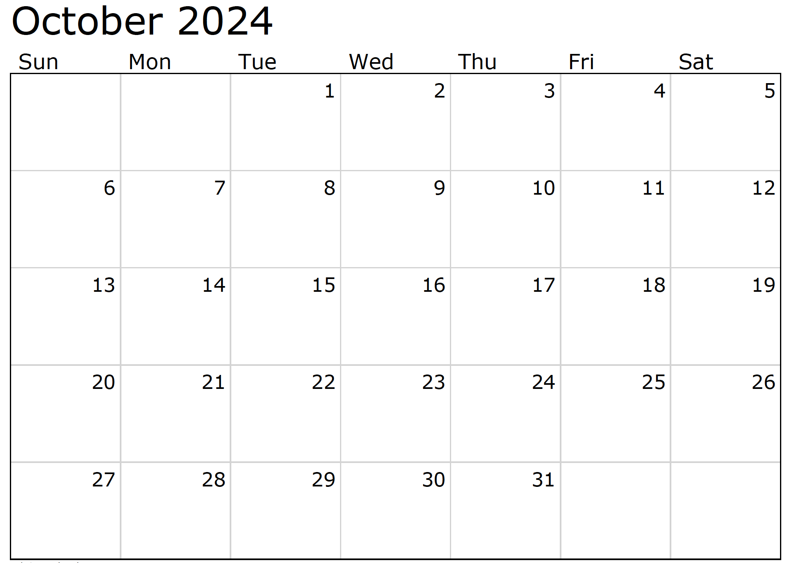

Month at a Glance!

**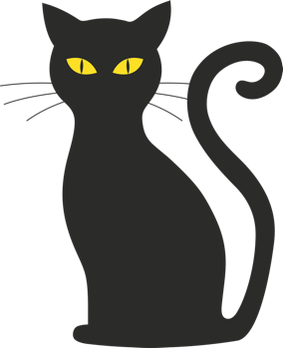*****

***Last month’s question: (Answer is in bold print)*** *National Grandparent’s Day became official in the US in 1978. What year did it become official in Canada?*

*A) 1968* ***B) 1995*** *C) 1943 D) 2007*

What does the acronym “URL” stand for when talking about the internet?:  
 A) Uniform Resource Locator C) Unique Resource Locator  
 B) User Request Link D) Universal Reference Library

To enter, email [Support@JimbosFloors.com](mailto:Support@JimbosFloors.com) and enter “Mega Trivia Contest” as the subject line. Take your best guess…your chances of winning are better than you think!

Hello, humans!

It's me, your friendly neighborhood black cat, here to share what it's like to be a black cat during the Halloween season. Spoiler alert: it's quite an adventure!

As soon as the leaves start turning and pumpkins appear on doorsteps, I notice a definite change in the air. Suddenly, I'm the star of the season. Decorations, costumes, and spooky tales all seem to feature black cats prominently. It’s like the world is celebrating me and my fellow feline friends!

But being a black cat during Halloween is a double-edged sword. On one hand, I love the attention. People often find me mysterious and intriguing, and I can't deny I enjoy the extra treats and affection from my human friends. There's something magical about the way my sleek, dark fur seems to shimmer in the moonlight on those crisp October nights.

On the other hand, the season can bring some challenges. You see, not everyone understands us black cats. There are still those silly superstitions about bad luck, and sometimes that means I have to be extra cautious. My human makes sure I'm safe and sound indoors during Halloween night to avoid any potential pranks or misunderstandings. It’s a little frustrating because I’d love to join in the fun and festivities outside!

Despite the occasional scare, I revel in the Halloween season. It’s a time when people appreciate the mystery and beauty of black cats like me. I get to bask in the eerie ambiance, enjoy the cozy warmth of a fireplace, and maybe even curl up with a good spooky story (well, I might nap through it, but you get the idea).

So, next time you see a black cat around Halloween, remember we’re not just symbols of the spooky season. We’re curious, affectionate, and quite fond of the magic that this time of year brings.

Have a purr-fectly wonderful Halloween!

With whiskers and winks,

Your Black Cat

### Who Else Wants to Win

### Dinner for Two at the City Café!

### Take our Trivia Challenge and *you could win too!*

This month’s Mega Trivia question:

Congratulations to last month’s winner: **Client Name**

Come by our store to claim your prize!

(NOTE: see the HA instructions for this month if you don’t have the Jim Armstrong Marketing Website to direct them to.)

**We’d be happy to send you our electronic newsletter!**

The same combination of useful tips and offbeat stories you read here, but with these differences:

* The e-Advisor will arrive in your email account once you give us permission
* We send it once a week
* The e-Advisor does not have the same content as the print Home Advisor – you’ll read all new stories, from helpful advice to items that give you a smile

Simply let us know which email account you’d like us to use for the e-Advisor.

A Black Cat's Halloween Tale



DIY Artwork To Personalize Your Home



Congratulations to our

**Susan Johnson!**

Susan is a 3rd time returning client, and she recently purchased new laminate for her kitchen and dining room. She always has a big smile on her face and is a lot of fun to work with. *Thanks, Susan!*

As always, our clients of the month receive **2 movie passes for Movies-8!**

*Watch for your name here in a coming month!*

Come by our store to   
claim your prize!

“My new laminate floors in my kitchen and dining room are beautiful. I was treated with respect and courtesy as a single woman raising a daughter. I genuinely felt that Jim Armstrong and his staff display concern for my flooring needs and were a guiding light for me. I recommend his service to anyone looking for a supportive, positive experience.”

~Marsha Avalos, School Teacher, Yuba City

“We Recently went to Jimbo’s Floors for new tile for our bathroom, and we’re thrilled with the results! This is our third time using Jimbo’s. Jim will never make you feel uncomfortable for asking questions and he’ll do anything in his power to accommodate your needs. When you do business with Jim and the staff at Jimbo’s Floors, you will be treated like royalty. Our experience was painless and very professional. Jim is not only our flooring expert, he’s a friend. That’s how he makes you feel.”

~Marvin and Sandy Moeller, owners of Sierra Landscaping, Yuba City

Thank You for the Kind Words!

Looking to add a personal touch to your home décor? Creating your own artwork is a fun and rewarding way to express your style and make your space truly unique. Here are some simple and inspiring DIY projects to get you started.

**Photo Collage**

Gather your favorite photos and arrange them in a creative collage. Use a large frame or canvas as the base and experiment with different layouts until you find a design you love. Enhance your collage with decorative elements like washi tape, stickers, or scrapbook paper to add texture and interest. This project is perfect for preserving memories and adding a personal touch to any room.

**Abstract Painting**

Unleash your inner artist with an abstract painting. Choose a color palette that complements your home’s décor. Using acrylic paints and brushes, create bold, sweeping strokes on a blank canvas. Don’t worry about perfection—abstract art is all about expressing emotion and creativity. The result will be a unique piece of art that reflects your personal style.

**Framed Quotes**

Find quotes that inspire you and print them out in stylish fonts. Frame each quote and arrange them in a gallery wall format. Mixing and matching frame styles and sizes can create an eclectic look that adds character to your space. This project is not only motivational but also visually appealing.

**Nature Prints**

Bring the outdoors inside by creating nature prints. Collect leaves, flowers, or other natural elements from your garden. Press them between heavy books for a few days to flatten them. Once pressed, arrange them on a canvas or in a frame to create a natural, organic piece of art. This project adds a touch of nature’s beauty to your home.

**Fabric Wall Hangings**

Use leftover fabric pieces to create a unique wall hanging. Sew or glue the fabric onto a canvas or frame it. This project is perfect for adding a pop of color and texture to any room. You can experiment with different patterns and fabrics to match your décor.

Creating DIY artwork is not only a great way to personalize your home but also a fun and creative activity. Whether you’re crafting a photo collage, painting an abstract masterpiece, or framing your favorite quotes, these projects will help you express your style and make your space uniquely yours.

Happy crafting!



**Be sure to stop by to pick out and schedule   
your new floor installation, and   
from our families to yours have a great month!**

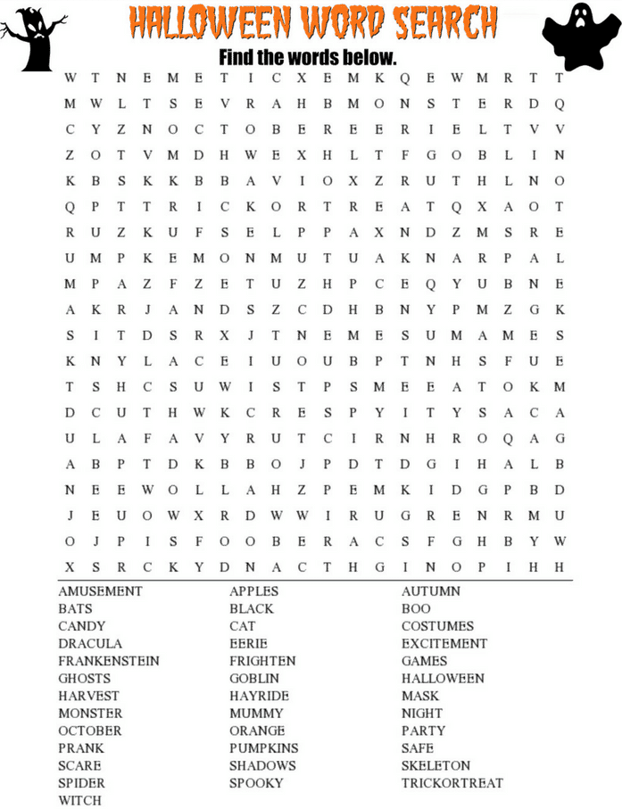

**Welcome to our new and returning clients!**

Click on the text box and Insert names

**A gigantic THANK YOU to all who referred us last month…**

Insert names

Get a

with my

**Referral Rewards Program**

As you probably know, advertising is very expensive. Instead of paying the newspaper or another place to advertise, we’d rather reward you. So we’ve assembled the Referral Rewards Program.

Every time you refer someone who becomes a client, we will send you a gift certificate for two passes to the **Movies-8 Cinema.**

And Hey! What’s a movie without popcorn? The gift certificate will also cover a big box of hot, buttered popcorn and sodas!

*Come by our store to   
claim your prize!*

**Your Company Name**

123 Address, Someplace, ZZ 555555

555.555.5555 Phone ⚫ 555.555.5555 Fax

email@yourcompanyname.com

**YourCompanyWebsite.com**