

Reliable news for healthy living, saving money, and having fun!

********

September 2024

**Jimbo’s Floors**

**Sept. 2** Labor Day **Sept. 8** Grandparent’s Day

**Sept. 11** Patriot Day

Suzie Smith!

You are this month’s   
Mystery Winner!

We have a   
**$10.00 Starbucks   
gift card**   
reserved just for you!

Come by our store to   
claim your prize!

Inside This Issue…

* Are you this month’s Mystery Winner?
* Month at a Glance
* Local Autumn Festivals
* Did You Know
* Mega Trivia Contest
* Kitchen Renovation Guide
* Thank you for the Kind Words
* Client of the Month
* Crossword Fill-In
* Thank You to our clients

*“You’ll love your new floors or I’ll replace them free!”*

~Jim Armstrong & Mick  
[www.JimbosFloors.com](http://www.JimbosFloors.com)

Scan to visit our website

Dear Friends,

Your personal message goes here.

The personal message is important because it allows you to connect in a very personal way with your clients. This personal connection is sorely lacking in most businesses. Topic ideas:

Your hobbies

Something interesting happening this month. Wish them “Merry Christmas” or “Happy Thanksgiving.”

A thought from your heart

Appreciation for your clients and their referrals. Remind them that you will bend over backwards to provide their referrals with World Class Service.

Mention that month’s “special offer” insert

Your Friend,

Your Signature

Your Name

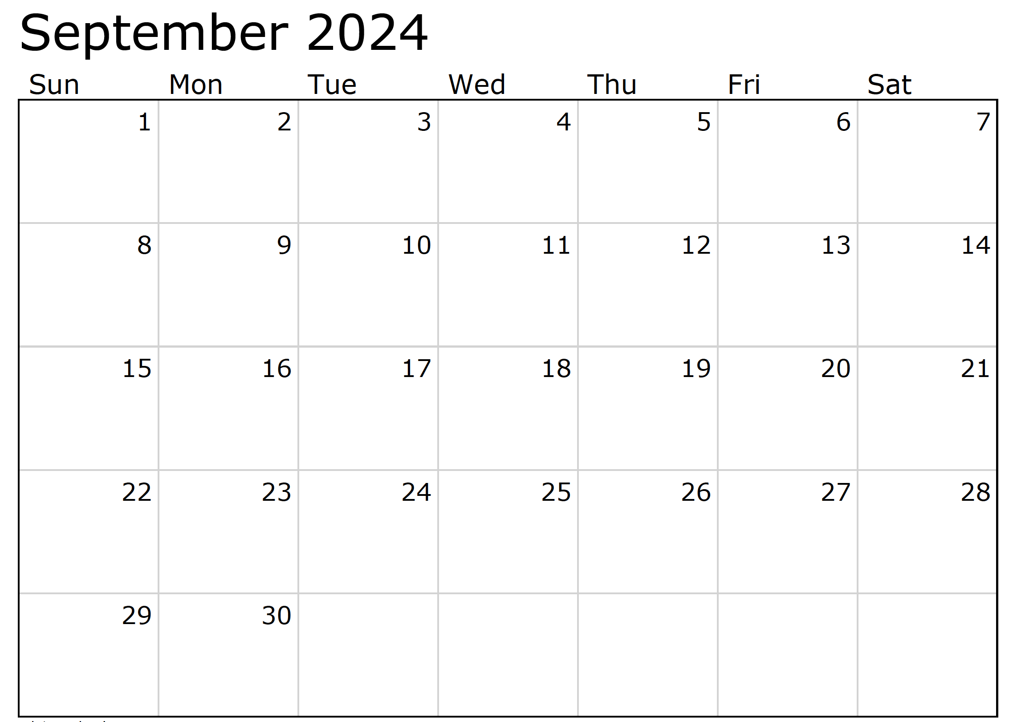

Month at a Glance!

*****

***Last month’s question: (Answer is in bold print)*** *What popular dining franchise is the founder of Atari responsible for  
A) Applebee’s B) Crumbl Cookies****C) Chuck E Cheese*** *D) McDonald’s*

National Grandparent’s Day became official in the US in 1978. What year did it become official in Canada?

A) 1968 B) 1995 C) 1943 D) 2007

To enter, email [Support@JimbosFloors.com](mailto:Support@JimbosFloors.com) and enter “Mega Trivia Contest” as the subject line. Take your best guess…your chances of winning are better than you think!

### Who Else Wants to Win

### Dinner for Two at the City Café!

### Take our Trivia Challenge and *you could win too!*

This month’s Mega Trivia question:

Congratulations to last month’s winner: **Client Name**

Come by our store to claim your prize!

(NOTE: see the HA instructions for this month if you don’t have the Jim Armstrong Marketing Website to direct them to.)

**We’d be happy to send you our electronic newsletter!**

The same combination of useful tips and offbeat stories you read here, but with these differences:

* The e-Advisor will arrive in your email account once you give us permission
* We send it once a week
* The e-Advisor does not have the same content as the print Home Advisor – you’ll read all new stories, from helpful advice to items that give you a smile

Simply let us know which email account you’d like us to use for the e-Advisor.

As the crisp September air sets in, it's the perfect time to explore the array of autumn festivals popping up in communities everywhere. These local events offer a wonderful opportunity for families and friends to celebrate the season, enjoy delicious food, and create lasting memories. Here are some fun and interesting reasons to check out your local autumn festivals this month.

**1. Seasonal Flavors and Food**

Autumn festivals are a haven for food lovers. From pumpkin spice everything to hot apple cider and hearty harvest meals, there’s something to satisfy every palate. Don’t miss the chance to indulge in homemade pies, freshly roasted corn, and other seasonal treats that highlight the best of fall’s bounty.

**2. Arts and Crafts**

Many festivals feature local artisans and crafters selling unique, handmade goods. It’s a great way to find one-of-a-kind items, from jewelry and pottery to seasonal decorations and artwork. Supporting local artists not only helps the community but also allows you to bring home a piece of the festival’s charm.

**3. Fun Activities for All Ages**

Autumn festivals often include a variety of activities that cater to all ages. Children can enjoy hayrides, corn mazes, and pumpkin carving contests, while adults might appreciate live music, wine tasting, or historical reenactments. These events are designed to provide entertainment and fun for everyone in the family.

**4. Community Spirit**

Attending local festivals is a fantastic way to connect with your community. It’s a chance to meet neighbors, support local businesses, and participate in community traditions. The festive atmosphere encourages a sense of belonging and togetherness, making it an enriching experience for all.

**5. Beautiful Scenery**

Take advantage of the picturesque fall landscape as you explore festival grounds. The vibrant colors of changing leaves provide a stunning backdrop for any outdoor activity. Whether it’s a rural fairground or a charming town square, the natural beauty of autumn enhances the overall experience.

So, this September, venture out to discover and enjoy the local autumn festivals in your area. They offer a delightful break from the daily routine and a wonderful way to embrace the seasonal spirit.

Happy festival-going!

Discovering Local Autumn Festivals- A Fun Way to Enjoy the Season

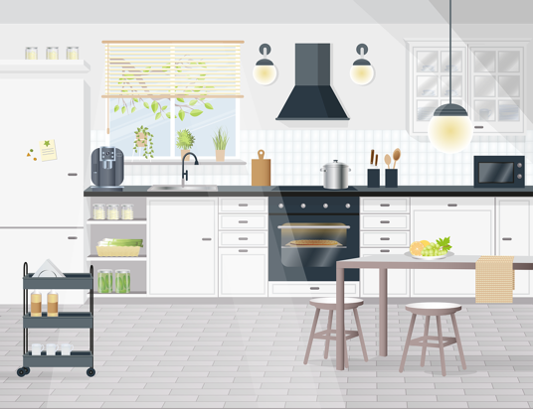

Kitchen Renovation Guide - From Layout to Appliances



Congratulations to our

**Susan Johnson!**

Susan is a 3rd time returning client, and she recently purchased new laminate for her kitchen and dining room. She always has a big smile on her face and is a lot of fun to work with. *Thanks, Susan!*

As always, our clients of the month receive **2 movie passes for Movies-8!**

*Watch for your name here in a coming month!*

Come by our store to   
claim your prize!

“My new laminate floors in my kitchen and dining room are beautiful. I was treated with respect and courtesy as a single woman raising a daughter. I genuinely felt that Jim Armstrong and his staff display concern for my flooring needs and were a guiding light for me. I recommend his service to anyone looking for a supportive, positive experience.”

~Marsha Avalos, School Teacher, Yuba City

“We Recently went to Jimbo’s Floors for new tile for our bathroom, and we’re thrilled with the results! This is our third time using Jimbo’s. Jim will never make you feel uncomfortable for asking questions and he’ll do anything in his power to accommodate your needs. When you do business with Jim and the staff at Jimbo’s Floors, you will be treated like royalty. Our experience was painless and very professional. Jim is not only our flooring expert, he’s a friend. That’s how he makes you feel.”

~Marvin and Sandy Moeller, owners of Sierra Landscaping, Yuba City

Thank You for the Kind Words!

Renovating your kitchen can be an exciting yet daunting task. It's the heart of your home, where meals are prepared, and memories are made. Here's a concise guide to help you navigate through the process, from layout design to selecting the right appliances.

**1. Planning Your Layout**

Start by envisioning the kitchen layout that best suits your needs. The classic work triangle—connecting the sink, stove, and refrigerator—remains popular for its efficiency. However, modern designs often favor more flexible layouts. Consider incorporating an island for additional workspace and storage. Open shelving can add an airy feel, while maximizing cabinet space is crucial for a clutter-free kitchen.

**2. Choosing Your Style**

Your kitchen's aesthetic sets the tone for your entire home. Decide on a style that resonates with you, whether it's sleek and modern, warm and rustic, or somewhere in between. Select cabinetry, countertops, and flooring that complement each other. Granite, quartz, and marble are popular choices for countertops due to their durability and timeless appeal.

**3. Lighting Matters**

Proper lighting is essential for both functionality and ambiance. Layered lighting, which includes ambient, task, and accent lighting, ensures your kitchen is well-lit for cooking and entertaining. Pendant lights over an island or dining area can make a stylish statement, while under-cabinet lighting enhances visibility and adds a modern touch.

**4. Picking the Right Appliances**

Investing in quality appliances can make a significant difference in your kitchen's performance. Stainless steel appliances are a favorite for their sleek look and durability. Consider energy-efficient models to save on utility bills and reduce your environmental footprint. Don't forget about the smaller details, like a quiet dishwasher or a powerful range hood, which can enhance your kitchen experience.

**5. Adding Personal Touches**

Finally, personalize your space with elements that reflect your personality and lifestyle. Add a splash of color with a bold backsplash, display your favorite cookware, or incorporate a cozy seating area. Plants, artwork, and decorative items can infuse warmth and character into your kitchen.

Renovating your kitchen is a substantial investment, but with careful planning and thoughtful choices, you can create a space that is both beautiful and functional for years to come. Happy renovating!



**Welcome to our new and returning clients!**

Click on the text box and Insert names

**A gigantic THANK YOU to all who referred us last month…**

Insert names

Get a

with my

**Referral Rewards Program**

As you probably know, advertising is very expensive. Instead of paying the newspaper or another place to advertise, we’d rather reward you. So we’ve assembled the Referral Rewards Program.

Every time you refer someone who becomes a client, we will send you a gift certificate for two passes to the **Movies-8 Cinema.**

And Hey! What’s a movie without popcorn? The gift certificate will also cover a big box of hot, buttered popcorn and sodas!

*Come by our store to   
claim your prize!*

Crossword Fill-in – Have fun!

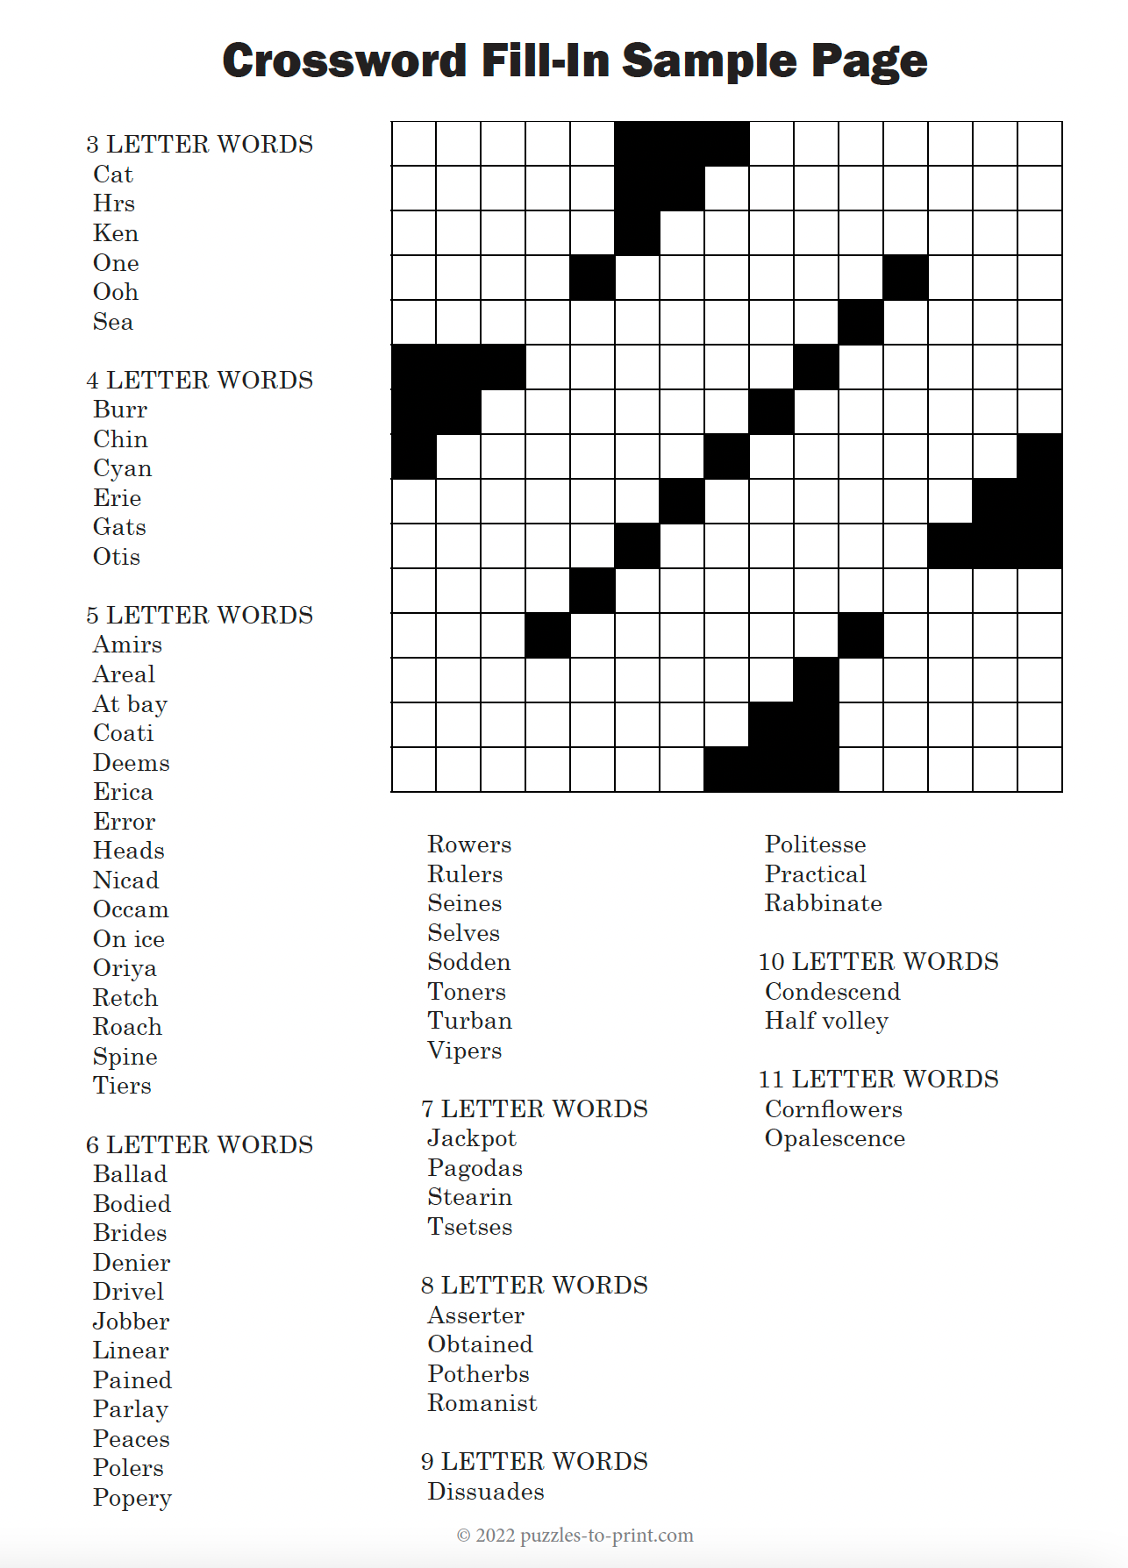

**Be sure to stop by to pick out and schedule   
your new floor installation, and   
from our families to yours have a great month!**

**Your Company Name**

123 Address, Someplace, ZZ 555555

555.555.5555 Phone ⚫ 555.555.5555 Fax

email@yourcompanyname.com

**YourCompanyWebsite.com**