

Reliable news for healthy living, saving money, and having fun!

********

**August 12** Middle Child’s Day **August 13** Left Hander’s Day

**August 19** World Photography Day

**Jimbo’s Floors**

Suzie Smith!

You are this month’s   
Mystery Winner!

We have a   
**$10.00 Starbucks   
gift card**   
reserved just for you!

Come by our store to   
claim your prize!

Inside This Issue…

* Are you this month’s Mystery Winner?
* Month at a Glance
* The Art of Backyard Camping
* Did You Know
* Mega Trivia Contest
* Cooling Down With Homemade Ice Cream
* Thank you for the Kind Words
* Client of the Month
* The Tale of Two Apples
* Thank You to our clients

*“You’ll love your new floors or I’ll replace them free!”*

~Jim Armstrong & Mick  
[www.JimbosFloors.com](http://www.JimbosFloors.com)

Scan to visit our website

Dear Friends,

Your personal message goes here.

The personal message is important because it allows you to connect in a very personal way with your clients. This personal connection is sorely lacking in most businesses. Topic ideas:

Your hobbies

Something interesting happening this month. Wish them “Merry Christmas” or “Happy Thanksgiving.”

A thought from your heart

Appreciation for your clients and their referrals. Remind them that you will bend over backwards to provide their referrals with World Class Service.

Mention that month’s “special offer” insert

Your Friend,

Your Signature

Your Name

August 2024

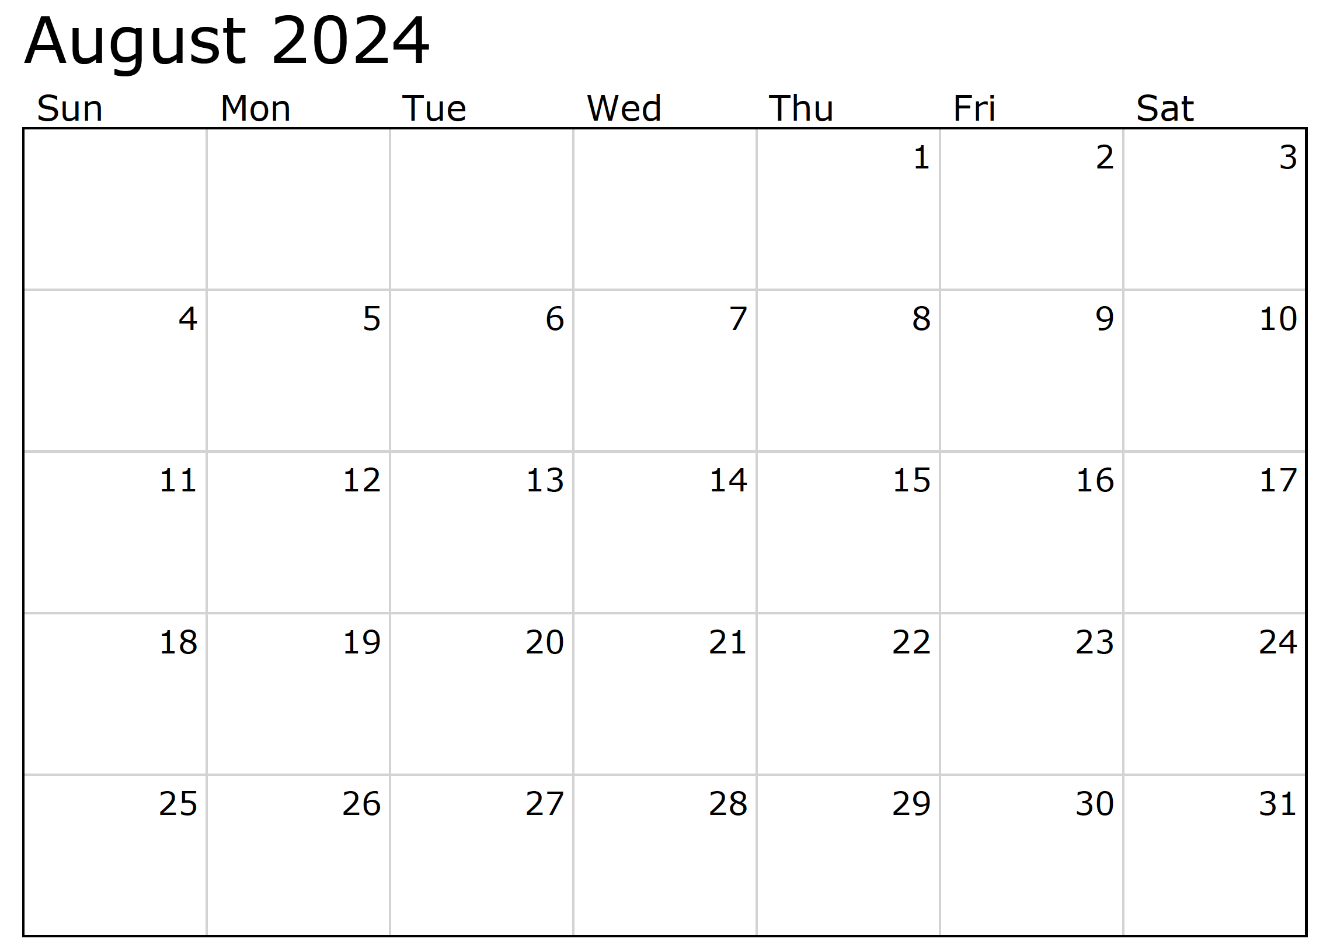

Month at a Glance!

**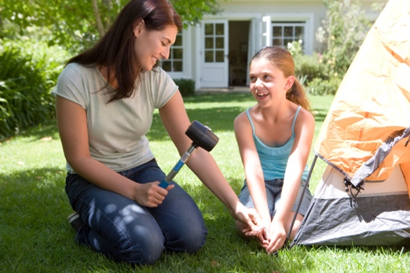*****

**We’d be happy to   
send you our   
eNewsletter!**

The same combination of useful tips and offbeat stories you read here, but with these differences:

The e-Advisor will arrive in your email account once you give us permission

We send it once a week

The e-Advisor does not have the same content as the print Home Advisor – you’ll read all new stories, from helpful advice to items that give you a smile

Simply let us know which email account you’d like us to use for the e-Advisor.

(NOTE: see the HA instructions for this month if you don’t have the Jim Armstrong Marketing Website to direct them to.)

### Who Else Wants to Win

### Dinner for Two at the City Café!

### Take our Trivia Challenge and *you could win too!*

This month’s Mega Trivia question:

***Last month’s question: (Answer is in bold print)*** *How many countries participate in the Olympic Games?*

*A) 300* ***B) 206*** *C) 75 D) 50*

Congratulations to last month’s winner: **Client Name**

Come by our store to claim your prize!

What popular dining franchise is the founder of Atari responsible for? A) Applebee’s B) Crumbl Cookies C) Chuck E Cheese D) McDonald’s

To enter, email [Support@JimbosFloors.com](mailto:Support@JimbosFloors.com) and enter “Mega Trivia Contest” as the subject line. Take your best guess…your chances of winning are better than you think!

Transform Your Outdoor Space into a Summer Retreat

Embrace the charm of the great outdoors without leaving the comfort of your home by transforming your backyard into a cozy camping retreat. Backyard camping offers a delightful way to unwind, bond with family, and enjoy nature. Here are some tips to create an unforgettable experience.

**Setting Up Camp:** Begin with a sturdy tent. If you don’t have one, consider using a canopy or even a makeshift shelter with blankets and poles. Lay down sleeping bags or air mattresses for a comfortable night's sleep. Fairy lights or lanterns can add a magical touch, making the space feel warm and inviting.

**Campfire Alternatives:** While a real campfire may not be feasible, you can mimic the experience with a fire pit or even a cluster of candles. Gather around the "fire" for storytelling, singing, and, of course, making s'mores. For a safer option, try an indoor s'mores maker.

**Fun Activities:** Plan engaging activities to keep everyone entertained. Stargazing is a must—download a stargazing app to identify constellations. Scavenger hunts, outdoor games like cornhole or frisbee, and nature crafts can also enhance the experience. Don’t forget to bring a few board games for when the sun goes down.

**Outdoor Dining:** Enjoying meals al fresco is a highlight of camping. Grill hotdogs and burgers or prepare a picnic with sandwiches, fruits, and snacks. For breakfast, try cooking pancakes or scrambled eggs on a portable griddle.

**Relaxation Time:** Finally, make time for relaxation. Bring out comfortable chairs, hammocks, or blankets. Enjoy the peace of your backyard by reading a book, meditating, or simply listening to the sounds of nature.

Backyard camping is a wonderful way to create lasting memories. With a bit of creativity, you can enjoy the adventure and relaxation of camping without the hassle of traveling.

The Art of Backyard Camping



Cooling Down with Homemade Ice Cream



Congratulations to our

**Susan Johnson!**

Susan is a 3rd time returning client, and she recently purchased new laminate for her kitchen and dining room. She always has a big smile on her face and is a lot of fun to work with. *Thanks, Susan!*

As always, our clients of the month receive **2 movie passes for Movies-8!**

*Watch for your name here in a coming month!*

Come by our store to   
claim your prize!

“My new laminate floors in my kitchen and dining room are beautiful. I was treated with respect and courtesy as a single woman raising a daughter. I genuinely felt that Jim Armstrong and his staff display concern for my flooring needs and were a guiding light for me. I recommend his service to anyone looking for a supportive, positive experience.”

~Marsha Avalos, School Teacher, Yuba City

“We Recently went to Jimbo’s Floors for new tile for our bathroom, and we’re thrilled with the results! This is our third time using Jimbo’s. Jim will never make you feel uncomfortable for asking questions and he’ll do anything in his power to accommodate your needs. When you do business with Jim and the staff at Jimbo’s Floors, you will be treated like royalty. Our experience was painless and very professional. Jim is not only our flooring expert, he’s a friend. That’s how he makes you feel.”

~Marvin and Sandy Moeller, owners of Sierra Landscaping, Yuba City

Thank You for the Kind Words!

Recipes and Tips for Delicious Summer Treats

As summer temperatures soar, there's no better way to cool down than with homemade ice cream. Making ice cream at home is not only fun but also allows you to experiment with flavors and ingredients. Here are some simple recipes and tips to help you create delicious summer treats without needing an ice cream maker.

**Basic Vanilla Ice Cream:** Start with a basic recipe. Whisk together 2 cups of heavy cream, 1 cup of whole milk, ¾ cup of sugar, and 2 teaspoons of vanilla extract. Pour the mixture into a shallow dish and freeze for about an hour. Once it starts to harden, stir it vigorously to break up ice crystals, then return it to the freezer. Repeat this process every 30 minutes until the ice cream is smooth and creamy.

**Flavor Variations:** Customize your ice cream by adding mix-ins or flavors. For chocolate ice cream, mix in ½ cup of cocoa powder with the sugar before combining it with the cream and milk. Swirl in fruit purees, such as strawberry or mango, during the stirring process for a fruity twist. Nuts, chocolate chips, or cookie pieces can also be added for extra texture and flavor.

**No-Churn Ice Cream:** For an even simpler method, try no-churn ice cream. Beat 2 cups of heavy whipping cream until stiff peaks form. In a separate bowl, mix a 14-ounce can of sweetened condensed milk with your desired flavorings (like vanilla, cocoa powder, or fruit puree). Gently fold the whipped cream into the condensed milk mixture until well combined. Pour into a loaf pan, cover with plastic wrap, and freeze for at least 6 hours.

**Tips for Success:** Ensure your ingredients are very cold before you start, as this helps the ice cream freeze more quickly. Use airtight containers to store your ice cream and prevent ice crystals from forming. And most importantly, have fun experimenting with different flavors and combinations!

Homemade ice cream is a delightful way to enjoy summer. Gather your family or friends, get creative in the kitchen, and savor the sweet rewards of your efforts.



APPLE, TREE, COUPLE, WHISPERED, QUICKLY, TREE, WELL, FELL, OVER, BUMPS, BASKET, ORCHARD, LITTLE, HUSBAND, GREW, ROAM

Answers:

**Be sure to stop by to pick out and schedule   
your new floor installation, and   
from our families to yours have a great month!**



**Welcome to our new and returning clients!**

Click on the text box and Insert names

**A gigantic THANK YOU to all who referred us last month…**

Insert names

Get a

with my

**Referral Rewards Program**

As you probably know, advertising is very expensive. Instead of paying the newspaper or another place to advertise, we’d rather reward you. So we’ve assembled the Referral Rewards Program.

Every time you refer someone who becomes a client, we will send you a gift certificate for two passes to the **Movies-8 Cinema.**

And Hey! What’s a movie without popcorn? The gift certificate will also cover a big box of hot, buttered popcorn and sodas!

*Come by our store to   
claim your prize!*

**Your Company Name**

123 Address, Someplace, ZZ 555555

555.555.5555 Phone ⚫ 555.555.5555 Fax

email@yourcompanyname.com

**YourCompanyWebsite.com**