

Reliable news for healthy living, saving money, and having fun!

********

**July 4** Independence Day **July 24** Parent Appreciation Day

**July 7** World Chocolate Day **July 21** Nat’l Ice Cream Day

**July 30** Int’l Day of Friendship

**Jimbo’s Floors**

Suzie Smith!

You are this month’s   
Mystery Winner!

We have a   
**$10.00 Starbucks   
gift card**   
reserved just for you!

Come by our store to   
claim your prize!

Inside This Issue…

* Are you this month’s Mystery Winner?
* Month at a Glance
* Doug the Drone
* Did You Know
* Mega Trivia Contest
* Artistic Swimming, Grace in Motion
* Thank you for the Kind Words
* Client of the Month
* The Emoji Game
* Thank You to our clients

*“You’ll love your new floors or I’ll replace them free!”*

~Jim Armstrong & Mick  
[www.JimbosFloors.com](http://www.JimbosFloors.com)

Scan to visit our website

Dear Friends,

Your personal message goes here.

The personal message is important because it allows you to connect in a very personal way with your clients. This personal connection is sorely lacking in most businesses. Topic ideas:

Your hobbies

Something interesting happening this month. Wish them “Merry Christmas” or “Happy Thanksgiving.”

A thought from your heart

Appreciation for your clients and their referrals. Remind them that you will bend over backwards to provide their referrals with World Class Service.

Mention that month’s “special offer” insert

Your Friend,

Your Signature

Your Name

July 2024

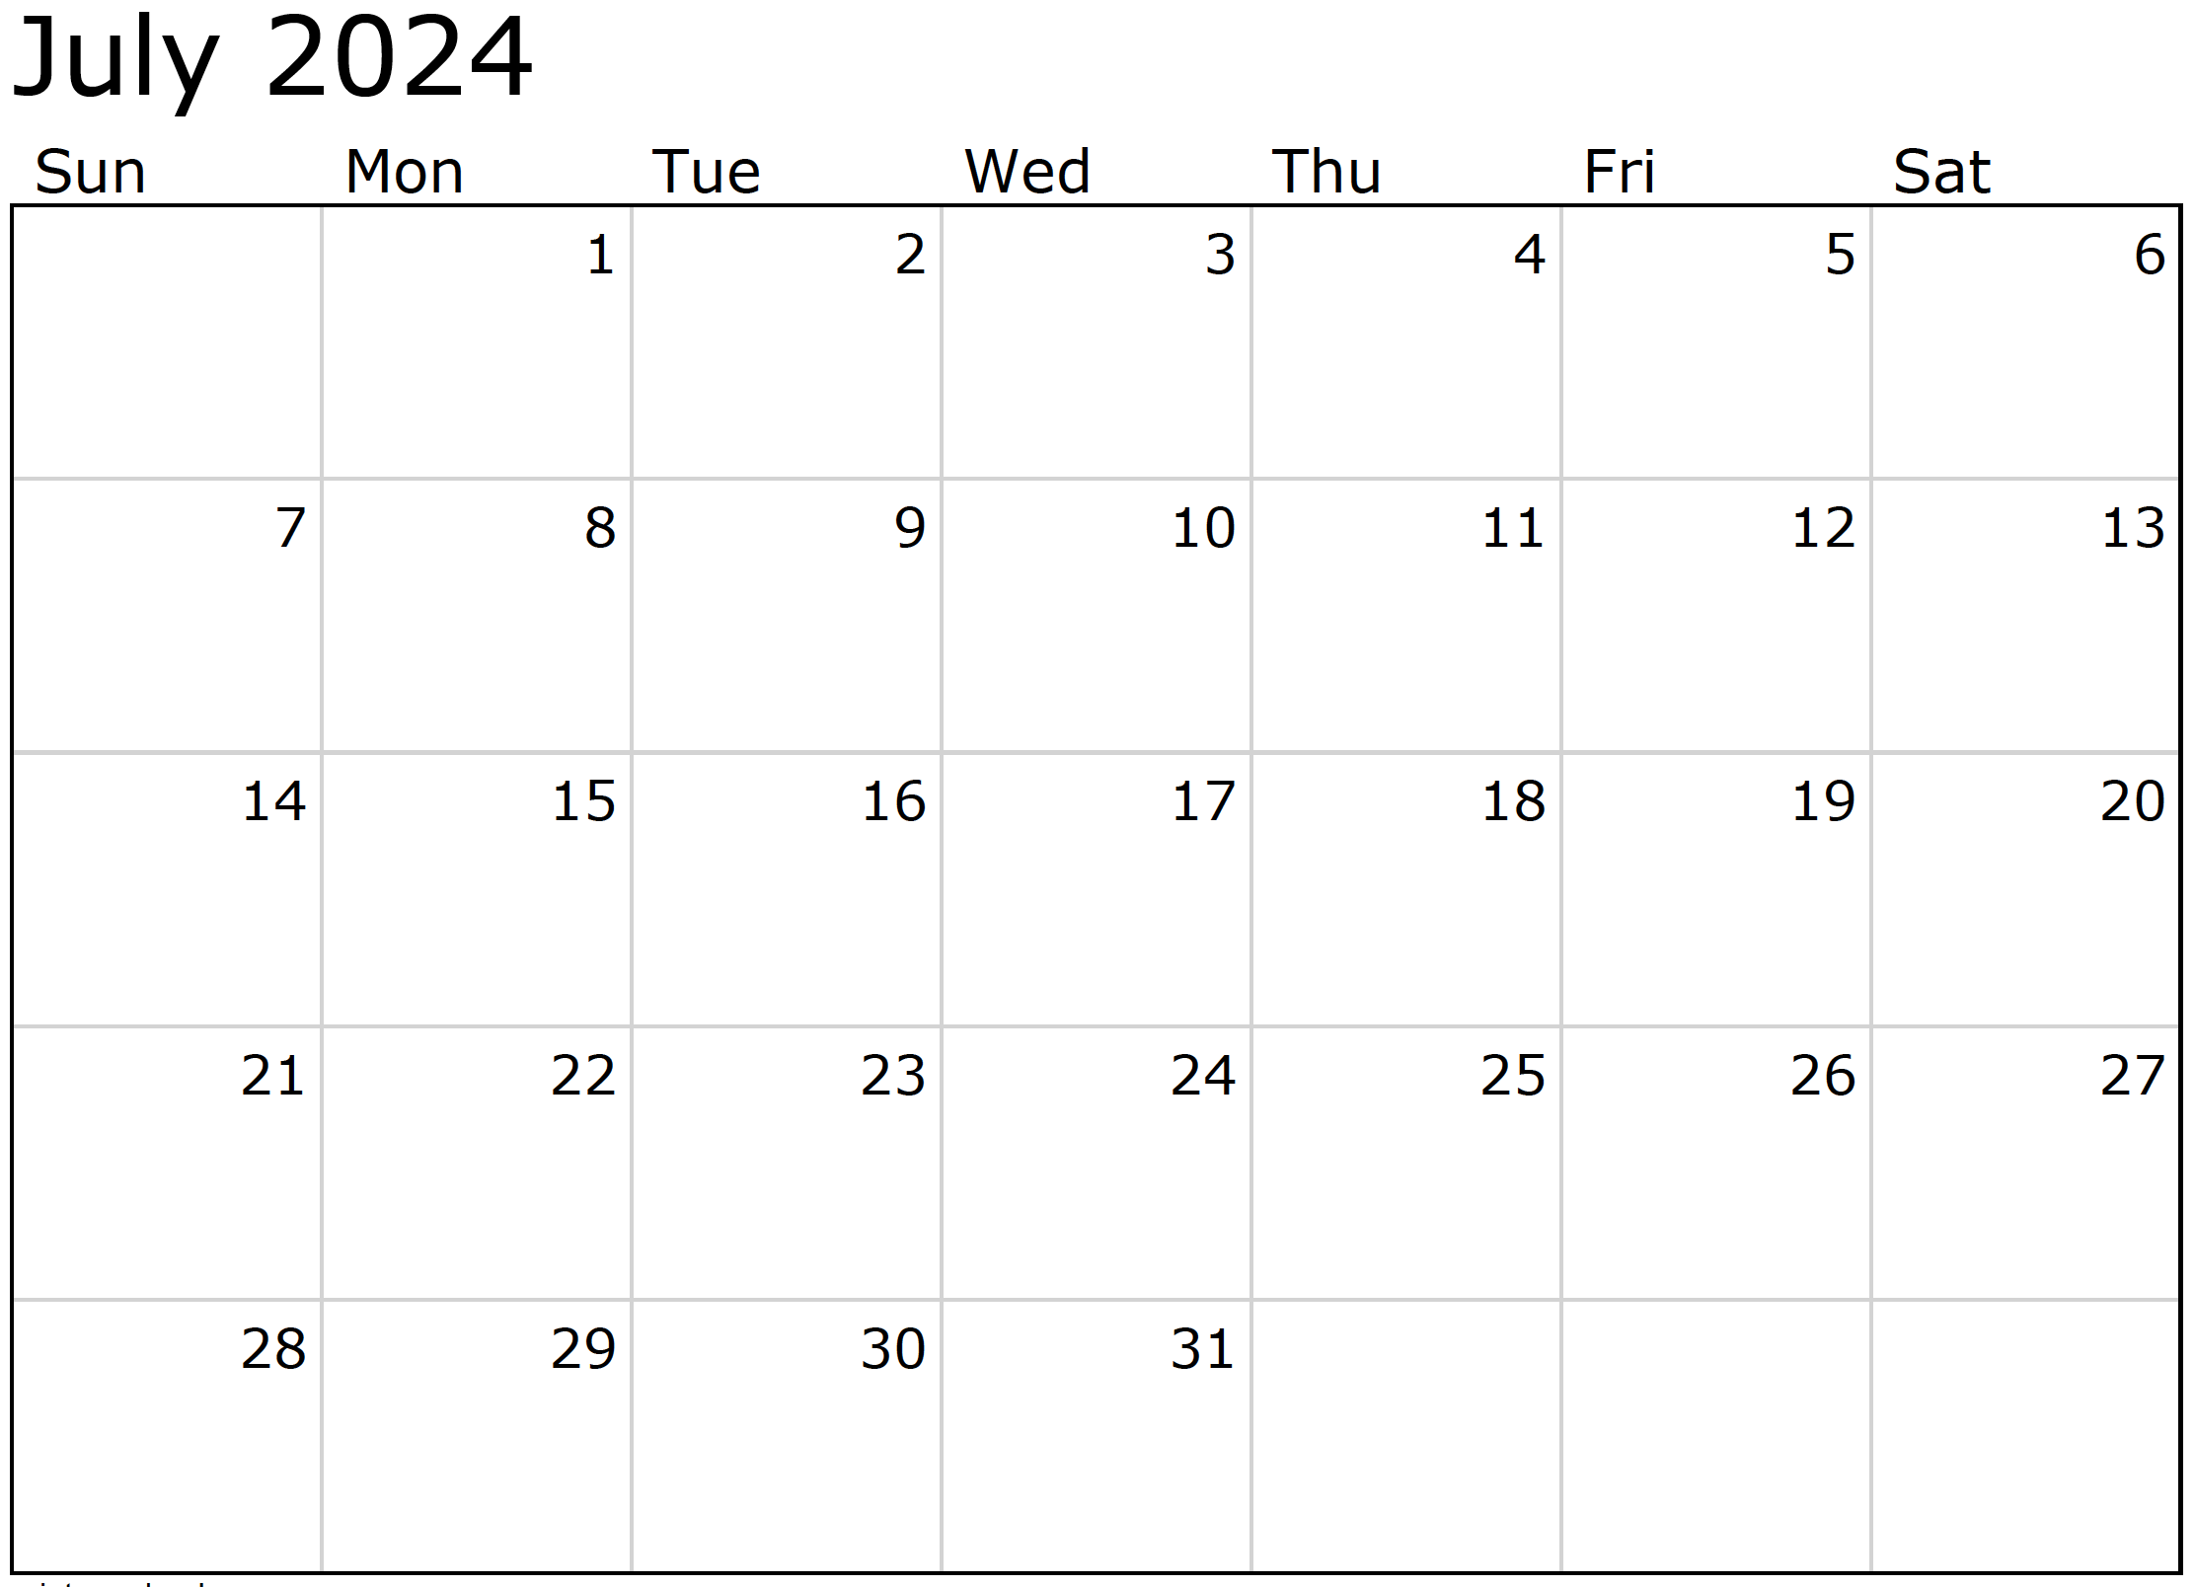

Month at a Glance!

*****

### Who Else Wants to Win

### Dinner for Two at the City Café!

### Take our Trivia Challenge and *you could win too!*

This month’s Mega Trivia question:

***Last month’s question: (Answer is in bold print)*** *On what one of two dates does the Summer Solstice occur?:  
   
A) June 1 or 2 B) June 29 or 30 C) June 15 or 16* ***D) June 20 or 21***

Congratulations to last month’s winner: **Client Name**

Come by our store to claim your prize!

(NOTE: see the HA instructions for this month if you don’t have the Jim Armstrong Marketing Website to direct them to.)

How many countries participate in the Olympic Games?

A) 300 B) 206 C) 75 D) 50

To enter, email [Support@JimbosFloors.com](mailto:Support@JimbosFloors.com) and enter “Mega Trivia Contest” as the subject line. Take your best guess…your chances of winning are better than you think!

**We’d be happy to send you our electronic newsletter!**

The same combination of useful tips and offbeat stories you read here, but with these differences:

* The e-Advisor will arrive in your email account once you give us permission
* We send it once a week
* The e-Advisor does not have the same content as the print Home Advisor – you’ll read all new stories, from helpful advice to items that give you a smile

Simply let us know which email account you’d like us to use for the e-Advisor.

Step aside, fireworks! It's time for a new star of the show to take center stage – ME! Doug, the performing drone. 🚁

As a proud member of the drone community, I'm here to tell you why drone shows are the future of Independence Day celebrations. Sure, fireworks may have been stealing the spotlight for centuries, but let's face it – they're old news. It's time to upgrade to something bigger, better, and way more impressive. Enter: drone shows.

First of all, let's talk about versatility. While fireworks are limited to a single burst of light and sound, drones can create intricate and dynamic displays that defy imagination. From swirling spirals to cascading waterfalls of light, the possibilities are endless. We drones are like artists painting the night sky with vibrant colors and mesmerizing patterns.

But that's not all – drone shows are also safer, more eco-friendly, and more reliable than traditional fireworks. No more worrying about stray sparks or accidental fires. With drones, you can enjoy the show without any of the risks or environmental concerns associated with fireworks. Plus, our precision-controlled maneuvers mean you can count on a flawless performance every time.

And let's not forget about the wow factor. When people see a swarm of drones taking flight in perfect synchronization, their jaws hit the floor. It's like something out of a sci-fi movie, except it's happening right before their eyes. People can't help but be awestruck by the sight of hundreds of drones moving in perfect harmony, creating a spectacle that's truly out of this world.

So, this Independence Day, why settle for the same old fireworks when you could experience the wonder of a drone show? Trust me, once you see us drones in action, you'll never look at fireworks the same way again. It's time to embrace the future and elevate your celebrations to new heights with a mesmerizing drone display. 🎆🚀

A Message from Doug the Drone This Independence Day



As the elegant and captivating sport of artistic swimming, I eagerly anticipate the spotlight of the 2024 Olympic Summer Games in Paris.

However, amidst the buzz surrounding renowned sports like swimming and gymnastics, it's disheartening to see the lack of recognition for my own grace and beauty.

Artistic swimming, my domain, is a blend of athleticism, artistry, and precision that mesmerizes both participants and spectators. Each routine is a masterpiece, meticulously crafted through hours of training and dedication in the pool.

From intricate formations to perfectly synchronized movements, I am a true test of teamwork and skill. Athletes devote themselves to mastering every element of their routines, striving for flawless performances that showcase my elegance and grace.

Yet, despite my efforts, I often find myself overshadowed by other Olympic sports. Perhaps it's the misconception that we're simply "playing around in the water," or the lack of understanding of the athleticism required to excel in my domain.

Nevertheless, I believe that the 2024 Olympic Games in Paris will be a turning point for me. With its stunning venues and global audience, it's the perfect opportunity to showcase my beauty and grace to the world.

So, as athletes continue to train and prepare for the biggest stage of their careers, I hope that spectators will join me in celebrating artistic swimming and all it has to offer. Who knows, they might just find themselves captivated by the elegance and precision of my performances.

Artistic Swimming, Grace In Motion



Congratulations to our

**Susan Johnson!**

Susan is a 3rd time returning client, and she recently purchased new laminate for her kitchen and dining room. She always has a big smile on her face and is a lot of fun to work with. *Thanks, Susan!*

As always, our clients of the month receive **2 movie passes for Movies-8!**

*Watch for your name here in a coming month!*

Come by our store to   
claim your prize!

“My new laminate floors in my kitchen and dining room are beautiful. I was treated with respect and courtesy as a single woman raising a daughter. I genuinely felt that Jim Armstrong and his staff display concern for my flooring needs and were a guiding light for me. I recommend his service to anyone looking for a supportive, positive experience.”

~Marsha Avalos, School Teacher, Yuba City

“We Recently went to Jimbo’s Floors for new tile for our bathroom, and we’re thrilled with the results! This is our third time using Jimbo’s. Jim will never make you feel uncomfortable for asking questions and he’ll do anything in his power to accommodate your needs. When you do business with Jim and the staff at Jimbo’s Floors, you will be treated like royalty. Our experience was painless and very professional. Jim is not only our flooring expert, he’s a friend. That’s how he makes you feel.”

~Marvin and Sandy Moeller, owners of Sierra Landscaping, Yuba City

Thank You for the Kind Words!



Three blind mice, see how they run 2. It’s raining, it’s pouring, the old man is snoring 3. [Hey, Diddle, Diddle] The cat and the fiddle, the cow jumped over the moon 4. Row, Row, Row your boat gently down the stream 5. Five little monkeys jumping on the bed 6. The wheels on the bus go round and round 7. One, Two, buckle my shoe, three, four shut the door 8. Old MacDonald had a farm, e-i-e-i-o 9. [Rub a dub dub] three men in a tub: the butcher, the baker, the candlestick maker 10. The itsy bitsy spider climbed up the water spout 11. Stop, look, and listen before you cross the street 12. Pussy cat, pussy cat where have you been? I’ve been to London to look at the queen 13. [Hickory Dickory Doc] the mouse ran up the clock

**Be sure to stop by to pick out and schedule   
your new floor installation, and   
from our families to yours have a great month!**

July 17th is World Emoji Day! Let’s see how your Emoji skills are.

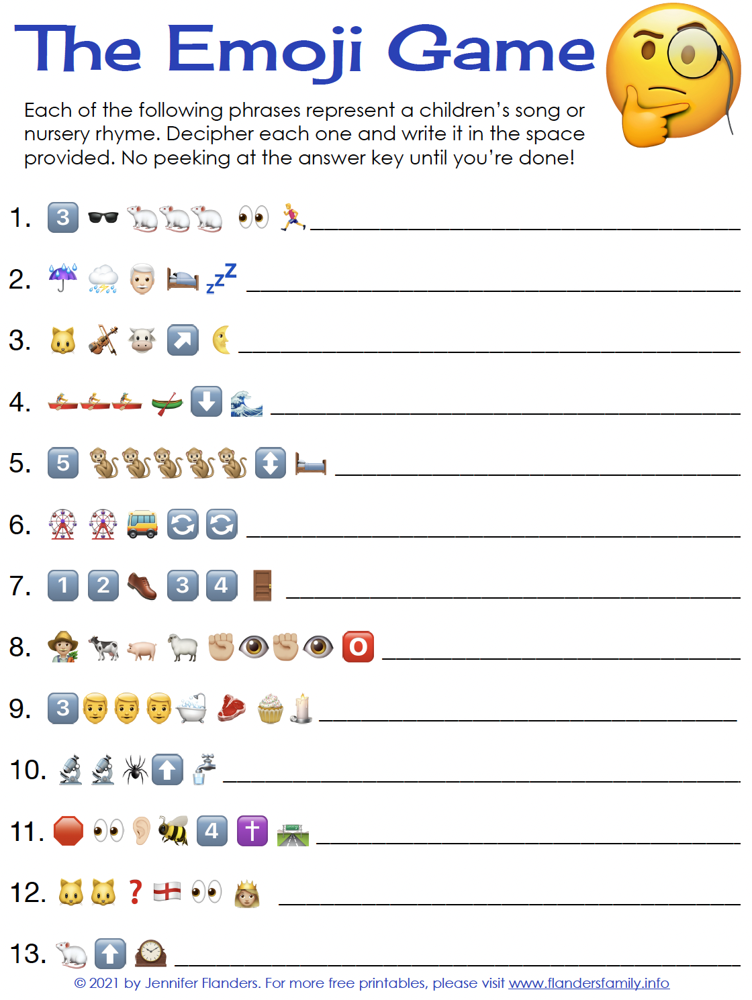

Answers:

**Welcome to our new and returning clients!**

Click on the text box and Insert names

**A gigantic THANK YOU to all who referred us last month…**

Insert names

Get a

with my

**Referral Rewards Program**

As you probably know, advertising is very expensive. Instead of paying the newspaper or another place to advertise, we’d rather reward you. So we’ve assembled the Referral Rewards Program.

Every time you refer someone who becomes a client, we will send you a gift certificate for two passes to the **Movies-8 Cinema.**

And Hey! What’s a movie without popcorn? The gift certificate will also cover a big box of hot, buttered popcorn and sodas!

*Come by our store to   
claim your prize!*

World Emoji Day!

**Your Company Name**

123 Address, Someplace, ZZ 555555

555.555.5555 Phone ⚫ 555.555.5555 Fax

email@yourcompanyname.com

**YourCompanyWebsite.com**