

Reliable news for healthy living, saving money, and having fun!



**June 14** Flag Day **June 16** Father’s Day

**Jimbo’s Floors**

Suzie Smith!

You are this month’s   
Mystery Winner!

We have a   
**$10.00 Starbucks   
gift card**   
reserved just for you!

Come by our store to   
claim your prize!

Inside This Issue…

* Are you this month’s Mystery Winner?
* Month at a Glance
* Transforming Your Outdoor Space
* Did You Know
* Mega Trivia Contest
* AI At Home
* Thank you for the Kind Words
* Client of the Month
* The Fun of Sudoku
* Thank You to our clients

*“You’ll love your new floors or I’ll replace them free!”*

~Jim Armstrong & Mick  
[www.JimbosFloors.com](http://www.JimbosFloors.com)

Scan to visit our website

Dear Friends,

Your personal message goes here.

The personal message is important because it allows you to connect in a very personal way with your clients. This personal connection is sorely lacking in most businesses. Topic ideas:

Your hobbies

Something interesting happening this month. Wish them “Merry Christmas” or “Happy Thanksgiving.”

A thought from your heart

Appreciation for your clients and their referrals. Remind them that you will bend over backwards to provide their referrals with World Class Service.

Mention that month’s “special offer” insert

Your Friend,

Your Signature

Your Name

June 2024

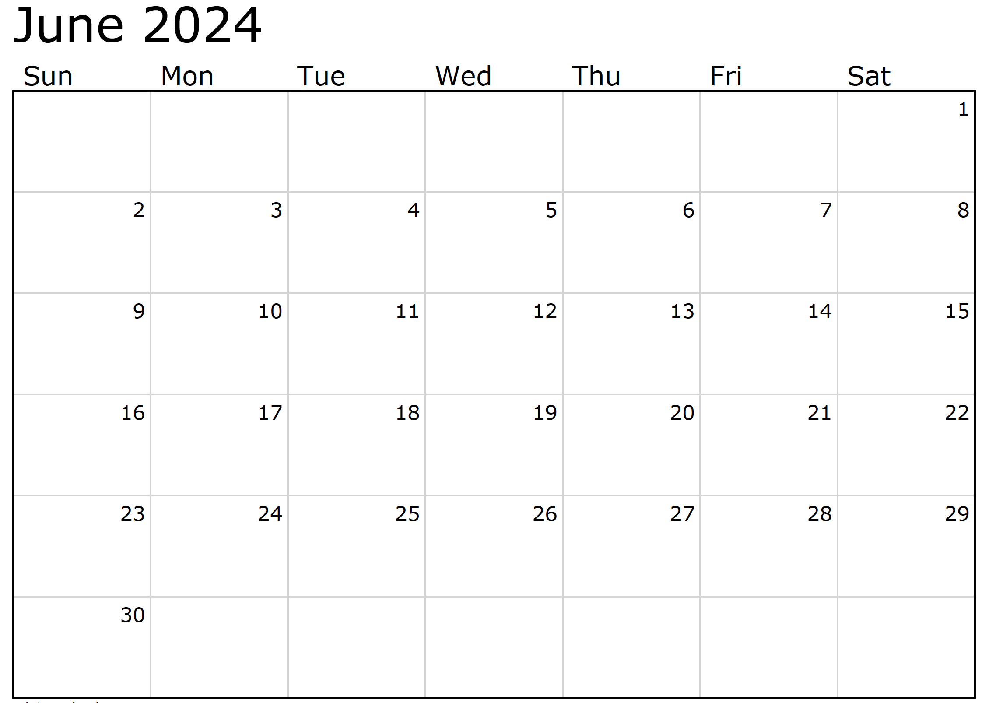

Month at a Glance!

*****

**We’d be happy to   
send you our   
electronic newsletter!**

The same combination of useful tips and offbeat stories you read here, but with these differences:

* The e-Advisor will arrive in your email account once you give us permission
* We send it once a week
* The e-Advisor does not have the same content as the print Home Advisor – you’ll read all new stories, from helpful advice to items that give you a smile

Simply let us know which email account you’d like us to use for the e-Advisor.

***Last month’s question: (Answer is in bold print)*** *What city is known as the birthplace of Memorial Day?*

*A) Las Vegas, NV* ***B) Waterloo, NY*** *C) Miami, FL D) Boston, MA*

(NOTE: see the HA instructions for this month if you don’t have the Jim Armstrong Marketing Website to direct them to.)

As the weather warms up, it's time to turn our attention to outdoor living spaces. Whether you have a sprawling backyard or a cozy balcony, there are endless possibilities for transforming your outdoor space into a personal oasis. Here are some creative ideas for patio and garden design that will inspire you to make the most of your outdoor area.

**Vertical Gardens**: Don't let limited space hold you back. Vertical gardens are a great way to add greenery to small outdoor areas. Use trellises, hanging planters, or wall-mounted containers to create a lush garden that climbs upwards, maximizing space while adding visual interest.

**Cozy Seating Nooks**: Create inviting seating areas where you can relax and unwind outdoors. Arrange comfortable chairs, benches, or even a cozy hammock surrounded by potted plants and soft lighting to create a tranquil retreat for reading, lounging, or enjoying a cup of coffee.

**Al Fresco Dining**: Take your dining experience outdoors with a stylish patio dining set. Whether you have a spacious patio or a compact balcony, there are plenty of options available to suit your space and style. Add ambiance with string lights, lanterns, or a fire pit for cozy evening gatherings.

**Fire Features**: Speaking of fire pits, adding a fire feature to your outdoor space can create a warm and inviting atmosphere. Choose from a traditional fire pit, a sleek fire table, or even a portable chiminea to add warmth and ambiance to your patio or garden.

**Water Features**: Incorporating water features into your outdoor design can add a sense of tranquility and serenity to your space. Consider adding a small fountain, pond, or bubbling water feature to create a soothing focal point that enhances your outdoor oasis.

**Creative Lighting**: Illuminate your outdoor space with creative lighting solutions that enhance its beauty and functionality. Use string lights, solar-powered lanterns, or LED pathway lighting to create a magical ambiance that extends into the evening hours.

With these creative ideas for patio and garden design, you can transform your outdoor space into a beautiful and inviting retreat that you'll love spending time in all season long. Whether you're looking to create a cozy nook for relaxation, an inviting dining area for entertaining, or a lush garden oasis, the possibilities are endless when it comes to outdoor design.

### Who Else Wants to Win

### Dinner for Two at the City Café!

### Take our Trivia Challenge and *you could win too!*

This month’s Mega Trivia question:

Congratulations to last month’s winner: **Client Name**

Come by our store to claim your prize!

On what one of two dates does the Summer Solstice occur?:

A) June 1 or 2 B) June 29 or 30 C) June 15 or 16 D) June 20 or 21

To enter, email [Support@JimbosFloors.com](mailto:Support@JimbosFloors.com) and enter “Mega Trivia Contest” as the subject line. Take your best guess…your chances of winning are better than you think!

Transforming Your Outdoor Space



AI at Home- From Smart Speakers to Robotic Helpers



In the realm of homeownership, AI (Artificial Intelligence) has swiftly transformed from science fiction to a practical tool, offering a plethora of advantages to homeowners.

From streamlining mundane tasks to enhancing home security, AI is revolutionizing the way we live and manage our homes, and homeowners are eagerly embracing the benefits.

One of the most beloved AI assistants in homes today is the smart speaker, affectionately known as "Alexa," "Siri," or "Google." With just a voice command, homeowners can summon their digital butlers to play music, set reminders, answer questions, and even control smart home devices like thermostats, lights, and locks. It's like having a personal assistant who never sleeps and never forgets the grocery list (unless, of course, the Wi-Fi goes out).

Speaking of smart home devices, AI-powered security systems are a homeowner's best friend when it comes to keeping their castle safe and sound. With features like facial recognition, motion detection, and real-time alerts, homeowners can sleep soundly knowing that their home is being guarded by a vigilant digital sentry. Plus, with smart doorbells equipped with cameras and two-way audio, homeowners can greet visitors (or scare off solicitors) without even leaving the comfort of their couch.

 But AI isn't just limited to practical applications; it's also adding a dash of whimsy and fun to homeowners' lives. AI-powered robots like robotic vacuum cleaners and lawn mowers are taking care of household chores with the efficiency of a well-trained butler (albeit a slightly clumsier one). And let's not forget about AI-powered pet toys and treat dispensers that keep our furry friends entertained while we're away, ensuring that they never have a ruff day.

With AI as their trusty sidekick, homeowners can sit back, relax, and enjoy the perks of modern living in the digital age. Who knew that the future of homeownership would be so smart, so efficient, and dare we say, so darn delightful?  And of course, totally safe and without any potential danger lurking. ;)

Congratulations to our

**Susan Johnson!**

Susan is a 3rd time returning client, and she recently purchased new laminate for her kitchen and dining room. She always has a big smile on her face and is a lot of fun to work with. *Thanks, Susan!*

As always, our clients of the month receive **2 movie passes for Movies-8!**

*Watch for your name here in a coming month!*

Come by our store to   
claim your prize!

“My new laminate floors in my kitchen and dining room are beautiful. I was treated with respect and courtesy as a single woman raising a daughter. I genuinely felt that Jim Armstrong and his staff display concern for my flooring needs and were a guiding light for me. I recommend his service to anyone looking for a supportive, positive experience.”

~Marsha Avalos, School Teacher, Yuba City

“We Recently went to Jimbo’s Floors for new tile for our bathroom, and we’re thrilled with the results! This is our third time using Jimbo’s. Jim will never make you feel uncomfortable for asking questions and he’ll do anything in his power to accommodate your needs. When you do business with Jim and the staff at Jimbo’s Floors, you will be treated like royalty. Our experience was painless and very professional. Jim is not only our flooring expert, he’s a friend. That’s how he makes you feel.”

~Marvin and Sandy Moeller, owners of Sierra Landscaping, Yuba City

Thank You for the Kind Words!



**Be sure to stop by to pick out and schedule   
your new floor installation, and   
from our families to yours have a great month!**

**Welcome to our new and returning clients!**

Click on the text box and Insert names

**A gigantic THANK YOU to all who referred us last month…**

Insert names

Get a

with my

**Referral Rewards Program**

As you probably know, advertising is very expensive. Instead of paying the newspaper or another place to advertise, we’d rather reward you. So we’ve assembled the Referral Rewards Program.

Every time you refer someone who becomes a client, we will send you a gift certificate for two passes to the **Movies-8 Cinema.**

And Hey! What’s a movie without popcorn? The gift certificate will also cover a big box of hot, buttered popcorn and sodas!

*Come by our store to   
claim your prize!*

The Fun of Sudoku!

Can you do it? Dive into the delightful world of Sudoku with this easy-peasy puzzle!

Simply fill in the grid so that every row, column, and 3x3 box contains the digits 1 through 9 – no repeating numbers in any row, column or box!

Ready, set, solve!



**Your Company Name**

123 Address, Someplace, ZZ 555555

555.555.5555 Phone ⚫ 555.555.5555 Fax

email@yourcompanyname.com

**YourCompanyWebsite.com**