

Reliable news for healthy living, saving money, and having fun!

********

**Jimbo’s Floors**

**April 1** April Fool’s Day **April 15** Tax Day

Suzie Smith!

You are this month’s   
Mystery Winner!

We have a   
**$10.00 Starbucks   
gift card**   
reserved just for you!

Come by our store to   
claim your prize!

Inside This Issue…

* Are you this month’s Mystery Winner?
* Month at a Glance
* The New Way We Communicate
* Did You Know
* Mega Trivia Contest
* Kitchen Remodel Survival Guide
* Thank you for the Kind Words
* Client of the Month
* Brain Teasers
* Thank You to our clients

*“You’ll love your new floors or I’ll replace them free!”*

~Jim Armstrong & Mick  
[www.JimbosFloors.com](http://www.JimbosFloors.com)

Scan to visit our website

Dear Friends,

Your personal message goes here.

The personal message is important because it allows you to connect in a very personal way with your clients. This personal connection is sorely lacking in most businesses. Topic ideas:

Your hobbies

Something interesting happening this month. Wish them “Merry Christmas” or “Happy Thanksgiving.”

A thought from your heart

Appreciation for your clients and their referrals. Remind them that you will bend over backwards to provide their referrals with World Class Service.

Mention that month’s “special offer” insert

Your Friend,

Your Signature

Your Name

April 2024

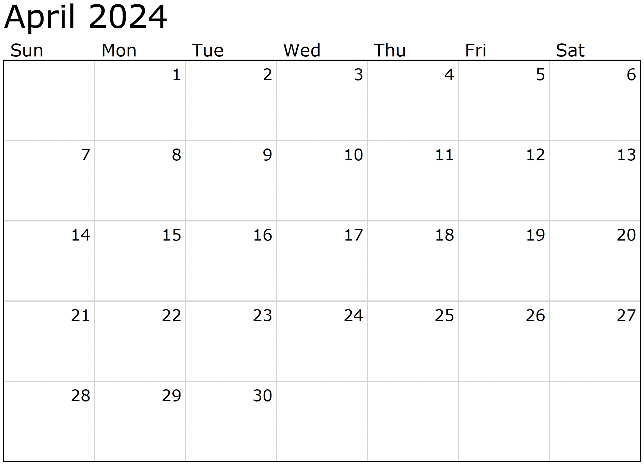

Month at a Glance!

*****

***Last month’s question: (Answer is in bold print)*** *Who is known for being the first African American prima ballerina:*

*A) Anne Benna Sims B) Aesha Ash* ***C) Janet Collins*** *D) Barbie Doll*

Congratulations to last month’s winner: **Client Name**

Come by our store to claim your prize!

### Who Else Wants to Win

### Dinner for Two at the City Café!

### Take our Trivia Challenge and *you could win too!*

This month’s Mega Trivia question:

(NOTE: see the HA instructions for this month if you don’t have the Jim Armstrong Marketing Website to direct them to.)

What year was the social media platform Myspace launched?

A) 2003 B) 1845 C) 2009 D) 1997

To enter, email [Support@JimbosFloors.com](mailto:Support@JimbosFloors.com) and enter “Mega Trivia Contest” as the subject line. Take your best guess…your chances of winning are better than you think!

**We’d be happy to send you our electronic newsletter!**

The same combination of useful tips and offbeat stories you read here, but with these differences:

* The e-Advisor will arrive in your email account once you give us permission
* We send it once a week
* The e-Advisor does not have the same content as the print Home Advisor – you’ll read all new stories, from helpful advice to items that give you a smile

Simply let us know which email account you’d like us to use for the e-Advisor.

In the ever-evolving landscape of modern communication, social media stands as a transformative force that has reshaped how we connect, share, and express ourselves. From the advent of platforms like Facebook, Twitter, and Instagram to the rise of newer entrants like TikTok, the influence of social media on our daily lives is undeniable.

One of the most prominent shifts brought about by social media is the immediacy of communication. Gone are the days of patiently waiting for letters or even emails. Now, a simple message or status update can instantly reach friends and family across the globe. This instant connectivity has made the world feel smaller, fostering a sense of interconnectedness that transcends geographical boundaries.

Moreover, social media has become the stage for self-expression. Individuals curate their online personas, sharing not just life updates but carefully crafted glimpses into their interests, opinions, and experiences. It's a space where creativity flourishes, with users showcasing their talents through photos, videos, and written posts.

The impact on interpersonal relationships is profound. Social media acts as both a bridge and a barrier, bringing people together while introducing new challenges. It allows us to maintain connections with friends from different phases of life, yet it can also create a paradox of isolation as we get absorbed in virtual interactions, often at the expense of face-to-face communication.

The rise of influencers and content creators has transformed social media into a hub of trends, influencing everything from fashion choices to lifestyle preferences. It has become a powerful tool for shaping public opinion and even mobilizing social movements, as seen in various global events.

While social media has undoubtedly enriched our communicative landscape, it's not without its concerns. Issues of privacy, the spread of misinformation, and the impact on mental health have become subjects of intense scrutiny. Balancing the advantages and pitfalls of this digital realm is an ongoing challenge.

In essence, social media has become an integral part of our daily lives, revolutionizing the way we communicate, share, and shape our identities. As we navigate this dynamic landscape, understanding its influence empowers us to make mindful choices in our digital interactions.

The new way we communicate: Social media’s role in our everyday lives

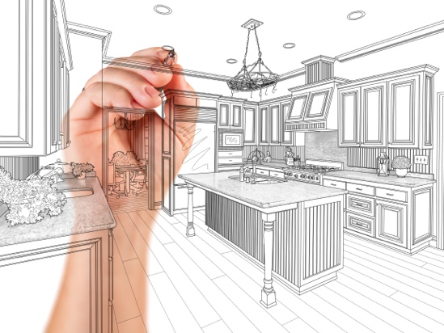

Kitchen Remodel Survival Guide



Congratulations to our

**Susan Johnson!**

Susan is a 3rd time returning client, and she recently purchased new laminate for her kitchen and dining room. She always has a big smile on her face and is a lot of fun to work with. *Thanks, Susan!*

As always, our clients of the month receive **2 movie passes for Movies-8!**

*Watch for your name here in a coming month!*

Come by our store to   
claim your prize!

“My new laminate floors in my kitchen and dining room are beautiful. I was treated with respect and courtesy as a single woman raising a daughter. I genuinely felt that Jim Armstrong and his staff display concern for my flooring needs and were a guiding light for me. I recommend his service to anyone looking for a supportive, positive experience.”

~Marsha Avalos, School Teacher, Yuba City

“We Recently went to Jimbo’s Floors for new tile for our bathroom, and we’re thrilled with the results! This is our third time using Jimbo’s. Jim will never make you feel uncomfortable for asking questions and he’ll do anything in his power to accommodate your needs. When you do business with Jim and the staff at Jimbo’s Floors, you will be treated like royalty. Our experience was painless and very professional. Jim is not only our flooring expert, he’s a friend. That’s how he makes you feel.”

~Marvin and Sandy Moeller, owners of Sierra Landscaping, Yuba City

Thank You for the Kind Words!

Embarking on a kitchen remodel can be both exciting and daunting. As you prepare for this transformative journey, here's a survival guide to help you navigate the process with ease.

**Plan Ahead:** Start by creating a detailed plan. Determine your budget, layout, and design preferences. This upfront work will help you make informed decisions throughout the remodel.

**Temporary Kitchen:** Set up a temporary kitchen in another part of your home. Stock it with essentials like a microwave, toaster oven, and a portable cooktop. This will be your culinary haven during the remodel.

**Storage Solutions:** Empty your kitchen cabinets and store their contents in labeled boxes. This will make it easier to find what you need when the remodel is complete. Don't forget to protect delicate items.

**Communication with Contractors:** Maintain open communication with your contractors. Regular updates and discussions will ensure everyone is on the same page, preventing misunderstandings and delays.

**Expect the Unexpected:** Unforeseen issues can arise during a remodel. Be prepared for surprises like hidden plumbing problems or structural issues. Having a contingency fund can provide peace of mind.

**Protect Your Floors:** Lay down protective coverings on your floors to prevent damage from heavy equipment and foot traffic. Your flooring will thank you later.

**Dust Containment:** Dust is inevitable during a remodel. Seal off the work area with plastic sheeting and use air purifiers to keep the rest of your home clean.

**Stay Flexible:** Be prepared for some inconvenience. You may have to wash dishes in the bathroom sink or dine on paper plates. It's all part of the process.

**Quality Over Speed:** While it's tempting to rush the process, prioritize quality workmanship. A well-executed remodel will bring long-lasting satisfaction.

**Celebrate Completion:** Once the remodel is finished, celebrate your new kitchen with a home-cooked meal. It's a satisfying way to break in your beautiful, functional space.

In the whirlwind of a kitchen remodel, remember that you're not just creating a new cooking space; you're crafting memories. Embrace the process, stay adaptable, and when it's all done, relish in the delightful moments and delicious meals your new kitchen will bring to life.





**Welcome to our new and returning clients!**

Click on the text box and Insert names

**A gigantic THANK YOU to all who referred us last month…**

Insert names

Get a

with my

**Referral Rewards Program**

As you probably know, advertising is very expensive. Instead of paying the newspaper or another place to advertise, we’d rather reward you. So we’ve assembled the Referral Rewards Program.

Every time you refer someone who becomes a client, we will send you a gift certificate for two passes to the **Movies-8 Cinema.**

And Hey! What’s a movie without popcorn? The gift certificate will also cover a big box of hot, buttered popcorn and sodas!

*Come by our store to   
claim your prize!*

Primp, Hunch, Zerox, Costic, Neon, Kayak, Ginseng, Bathtub, Wallow, Tourist, Amnesia, Lethal, Oregano, Erudite, Yesterday, Maximum, Superfluous, Fief, Dread, Reservoir

Answers:

**Be sure to stop by to pick out and schedule   
your new floor installation, and   
from our families to yours have a great month!**

**Your Company Name**

123 Address, Someplace, ZZ 555555

555.555.5555 Phone ⚫ 555.555.5555 Fax

email@yourcompanyname.com

**YourCompanyWebsite.com**