

Reliable news for healthy living, saving money, and having fun!

********

**March 8** International Women’s Day **March 10** Daylight Savings Time Starts

**March 17** St. Patrick’s Day **March 20** Spring Starts!

**March 24** Palm Sunday **March 29** Good Friday

**March 31** Easter Sunday

**Women’s History Month**

Suzie Smith!

You are this month’s   
Mystery Winner!

We have a   
**$10.00 Starbucks   
gift card**   
reserved just for you!

Come by our store to   
claim your prize!

Inside This Issue…

* Are you this month’s Mystery Winner?
* Month at a Glance
* Another Daylight-Saving Time Article
* Did You Know
* Mega Trivia Contest
* Best ways to care for different types of flooring
* Thank you for the Kind Words
* Client of the Month
* Easer Egg Hunt
* Thank You to our clients

*“You’ll love your new floors or I’ll replace them free!”*

~Jim Armstrong & Mick  
[www.JimbosFloors.com](http://www.JimbosFloors.com)

Scan to visit our website

Dear Friends,

Your personal message goes here.

The personal message is important because it allows you to connect in a very personal way with your clients. This personal connection is sorely lacking in most businesses. Topic ideas:

Your hobbies

Something interesting happening this month. Wish them “Merry Christmas” or “Happy Thanksgiving.”

A thought from your heart

Appreciation for your clients and their referrals. Remind them that you will bend over backwards to provide their referrals with World Class Service.

Mention that month’s “special offer” insert

Your Friend,

Your Signature

Your Name

**Jimbo’s Floors**

March 2024

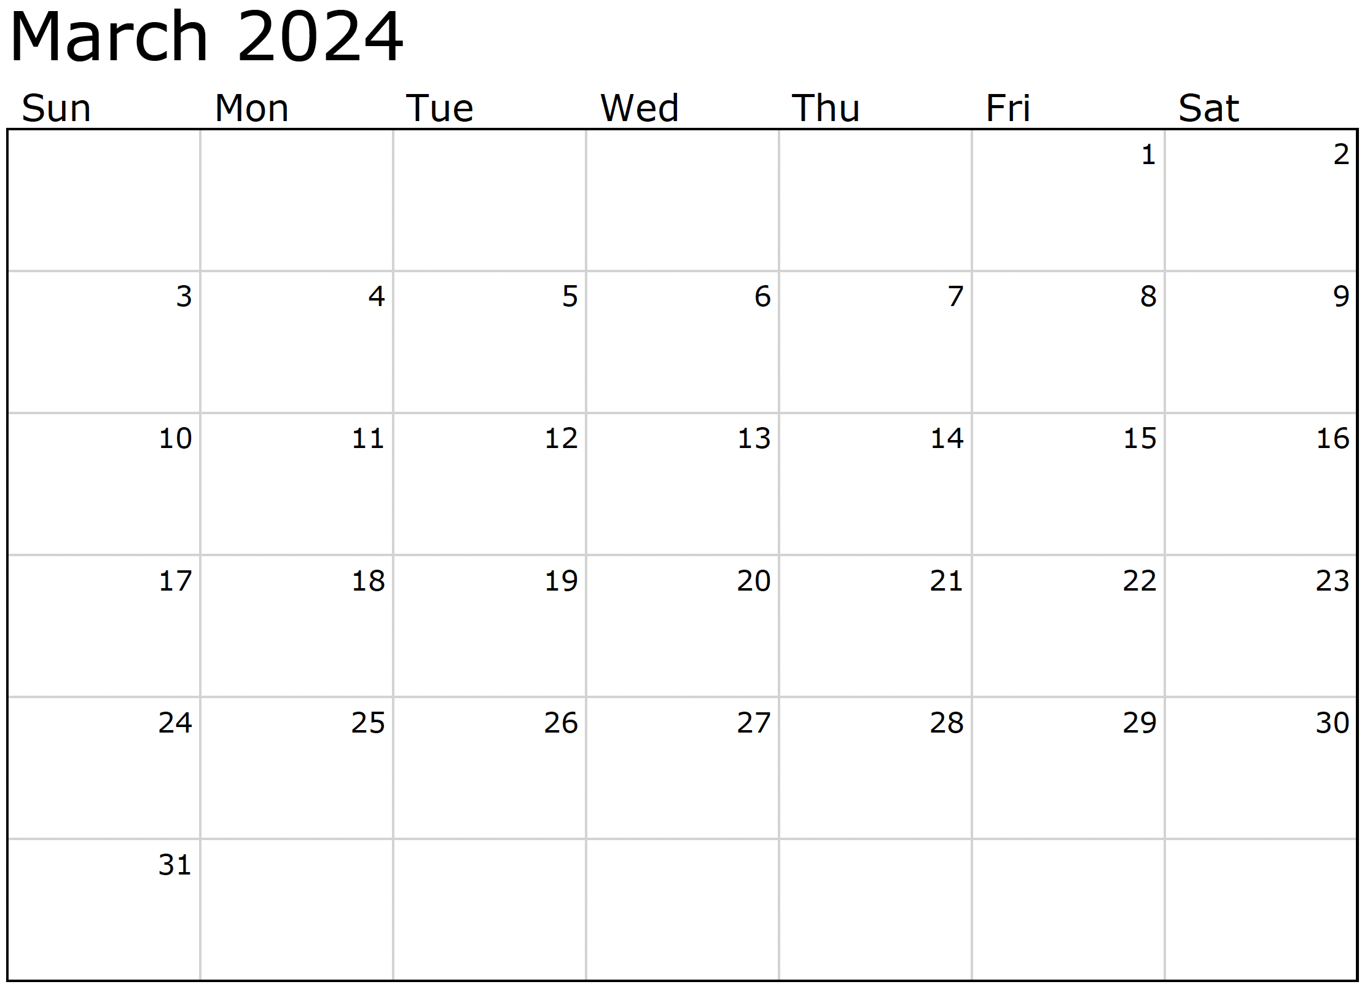

Month at a Glance!

**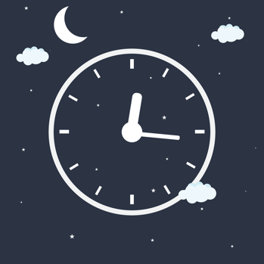*****

Who is known for being the first African American prima ballerina:

A) Anne Benna Sims B) Aesha Ash C) Janet Collins D) Barbie Doll

To enter, email [Support@JimbosFloors.com](mailto:Support@JimbosFloors.com) and enter “Mega Trivia Contest” as the subject line. Take your best guess…your chances of winning are better than you think!

***Last month’s question: (Answer is in bold print)*** *Which monarch officially made Valentine's Day a holiday in 1537?  
 A) Henry III B) Charles III C) Alfred The Great* ***D) Henry VIII***

(NOTE: see the HA instructions for this month if you don’t have the Jim Armstrong Marketing Website to direct them to.)

Ah, Daylight Saving Time—because who doesn't love a biannual ritual of sleep confusion and resetting all the clocks in the house?

It's that magical time when we collectively agree to mess with the fabric of space and time just to make better use of daylight. Here's another thrilling article about the wonders of Daylight Saving Time:

First off, let's marvel at the genius who thought, "You know what the world needs? An extra hour of daylight in the evening! But wait, let's take it away in the morning and watch chaos unfold." It's a stroke of clock-manipulating brilliance.

Now, picture this: You're all snug in bed, dreaming of a world without time zones, and bam! Suddenly, you're either late or annoyingly early for everything. Thanks, Daylight Saving Time, for turning us into time-traveling amateurs twice a year.

Let's not forget the joy of resetting every clock in the house, car, microwave, and maybe even the coffee maker if it has a clock, because consistency is overrated. Nothing says "productivity" like spending an hour hunting down all your time-telling devices. (A quick thank you to the dramatic increase in smart devices who are doing this for us lately.)

And for the cherry on top, the circadian rhythm chaos that ensues. Your body, that wonderfully adaptable vessel, now gets to figure out why it's dark when it was light yesterday. Good luck explaining that to your internal clock—it's just as confused as you are.

But fear not, because it's all for the noble cause of saving energy, right? Except it turns out the energy savings are about as real as a unicorn. So, we endure this chronometric rollercoaster for reasons even the experts can't fully agree on.

In conclusion, here's to Daylight Saving Time, the biannual spectacle that makes us question the very nature of time, disrupts our sleep, and gives us an excuse for being fashionably late. Because who needs a consistent sleep schedule or a timely arrival anyway? Cheers to time-warping traditions!

### Who Else Wants to Win

### Dinner for Two at the City Café!

### Take our Trivia Challenge and *you could win too!*

This month’s Mega Trivia question:

Congratulations to last month’s winner: **Client Name**

Come by our store to claim your prize!

**We’d be happy to send you our electronic newsletter!**

The same combination of useful tips and offbeat stories you read here, but with these differences:

* The e-Advisor will arrive in your email account once you give us permission
* We send it once a week
* The e-Advisor does not have the same content as the print Home Advisor – you’ll read all new stories, from helpful advice to items that give you a smile

Simply let us know which email account you’d like us to use for the e-Advisor.

Another Daylight-Saving Time Article



Best ways to care for different types of flooring



Luxury Vinyl Plank (LVP) has become one of the most popular types of flooring in the US for a lot of reasons.  Let’s focus first on best ways to care for this popular type of flooring.

The best way to clean luxury vinyl plank (LVP) flooring is to sweep or vacuum regularly to remove dirt and debris. Then you can use a damp mop or a cleaning solution specifically designed for vinyl flooring. Here are a few tips for cleaning LVP flooring:

* Use a microfiber mop or a soft-bristled broom to avoid scratching the surface of the flooring.
* Avoid using excess water and make sure to dry the floor thoroughly after cleaning to prevent water damage or mildew growth.
* Avoid using abrasive cleaners or steel wool, as they can scratch the surface of the flooring.
* Do not use wax or oil-based products on LVP flooring as it can damage the surface.
* If you have any tough stains, use a spot cleaner specifically made for LVP or a mild detergent mixed with water.

Here is a general guide for cleaning some of the most popular types of flooring:

**Hardwood:** Sweep or vacuum regularly to remove dirt and debris. Use a damp mop or a hardwood floor cleaning solution specifically designed for hardwood. Avoid excess water and never use abrasive cleaners.

**Laminate:** Sweep or vacuum regularly to remove dirt and debris. Use a damp mop or a laminate floor cleaning solution specifically designed for laminate. Avoid excess water and never use abrasive cleaners or any product that contains wax or oil.

**Tile:** Sweep or vacuum regularly to remove dirt and debris. Clean with a mop and a mild detergent or a tile floor cleaning solution. Avoid excess water and be sure to dry the floor thoroughly to prevent water damage or mildew growth.

**Carpet:** Vacuum regularly to remove dirt and debris. Use a carpet cleaning solution or hire a professional carpet cleaner to deep clean your carpets at least once a year.

It's always best to check the manufacturer's instructions and recommendations, or ask our professionals, for cleaning any type of flooring.

Congratulations to our

**Susan Johnson!**

Susan is a 3rd time returning client, and she recently purchased new laminate for her kitchen and dining room. She always has a big smile on her face and is a lot of fun to work with. *Thanks, Susan!*

As always, our clients of the month receive **2 movie passes for Movies-8!**

*Watch for your name here in a coming month!*

Come by our store to   
claim your prize!

“My new laminate floors in my kitchen and dining room are beautiful. I was treated with respect and courtesy as a single woman raising a daughter. I genuinely felt that Jim Armstrong and his staff display concern for my flooring needs and were a guiding light for me. I recommend his service to anyone looking for a supportive, positive experience.”

~Marsha Avalos, School Teacher, Yuba City

“We Recently went to Jimbo’s Floors for new tile for our bathroom, and we’re thrilled with the results! This is our third time using Jimbo’s. Jim will never make you feel uncomfortable for asking questions and he’ll do anything in his power to accommodate your needs. When you do business with Jim and the staff at Jimbo’s Floors, you will be treated like royalty. Our experience was painless and very professional. Jim is not only our flooring expert, he’s a friend. That’s how he makes you feel.”

~Marvin and Sandy Moeller, owners of Sierra Landscaping, Yuba City

Thank You for the Kind Words!

Answers:

**Your Company Name**

123 Address, Someplace, ZZ 555555

555.555.5555 Phone ⚫ 555.555.5555 Fax

email@yourcompanyname.com

**YourCompanyWebsite.com**

**Be sure to stop by to pick out and schedule   
your new floor installation, and   
from our families to yours have a great month!**

Mr. Hops- green- 4th, Jumper- yellow- 2nd, Long Ears- red- 1st,   
Mrs. Littlenose- blue- 3rd

**Welcome to our new and returning clients!**

Click on the text box and Insert names

**A gigantic THANK YOU to all who referred us last month…**

Insert names

Get a

with my

**Referral Rewards Program**

As you probably know, advertising is very expensive. Instead of paying the newspaper or another place to advertise, we’d rather reward you. So we’ve assembled the Referral Rewards Program.

Every time you refer someone who becomes a client, we will send you a gift certificate for two passes to the **Movies-8 Cinema.**

And Hey! What’s a movie without popcorn? The gift certificate will also cover a big box of hot, buttered popcorn and sodas!

*Come by our store to   
claim your prize!*

Easter Egg Hunt

It was Easter in Easter village and all the Easter bunnies are joyful. The annual Easter egg hunt was just finished. The Easter egg hunt is where four Easter bunnies search for any of the four colored eggs and then cross the finish line. Can you figure out which Easter bunny found which egg and what place they finished?  
  
Easter bunnies- Mr Hops, Jumper, Long Ears, and Mrs. Littlenose  
  
Easter Eggs- blue, red, green, and yellow  
  
Clues:  
  
1. Long Ears did not finish in 2nd place.  
  
2. Jumper did not finish in 1st  
  
3. Long Ears found the red Easter egg.  
  
4. The bunny that finished in 2nd did not find the green egg.  
  
5. Mr. Hops did not find the blue egg.  
  
6. Littlenose did not finish in 2nd.  
  
7. The bunny that found the blue egg did not finish in 1st or 2nd.  
  
8. Hops finished in 4th.