

Reliable news for healthy living, saving money, and having fun!

********

**February 2** Groundhog Day **February 13** Mardi Gras

**February 14** Valentine’s Day **February 14** Ash Wednesday

**February 19** Presidents Day

Suzie Smith!

You are this month’s   
Mystery Winner!

We have a   
**$10.00 Starbucks   
gift card**   
reserved just for you!

Come by our store to   
claim your prize!

Inside This Issue…

* Are you this month’s Mystery Winner?
* Month at a Glance
* Chocolate’s Valentine’s Day Celebration Suggestions
* Did You Know
* Mega Trivia Contest
* Leap Year Perspectives
* Thank you for the Kind Words
* Client of the Month
* Presidents Day Wordsearch
* Thank You to our clients

*“You’ll love your new floors or I’ll replace them free!”*

~Jim Armstrong & Mick  
[www.JimbosFloors.com](http://www.JimbosFloors.com)

Scan to visit our website

Dear Friends,

Your personal message goes here.

The personal message is important because it allows you to connect in a very personal way with your clients. This personal connection is sorely lacking in most businesses. Topic ideas:

Your hobbies

Something interesting happening this month. Wish them “Merry Christmas” or “Happy Thanksgiving.”

A thought from your heart

Appreciation for your clients and their referrals. Remind them that you will bend over backwards to provide their referrals with World Class Service.

Mention that month’s “special offer” insert

Your Friend,

Your Signature

Your Name

**Jimbo’s Floors**

February 2024

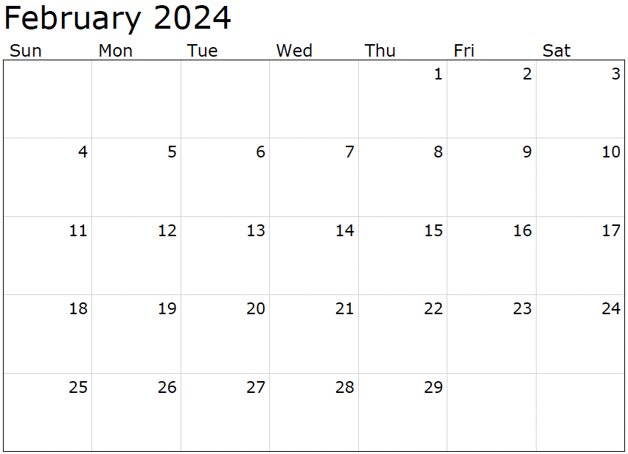

Month at a Glance!

*****

(NOTE: see the HA instructions for this month if you don’t have the Jim Armstrong Marketing Website to direct them to.)

### Who Else Wants to Win

### Dinner for Two at the City Café!

### Take our Trivia Challenge and *you could win too!*

This month’s Mega Trivia question:

***Last month’s question: (Answer is in bold print)***In the TV show “Friends”, what song was Phoebe most well-known for?  
 **A) Smelly Cat** B) Everybody Talks   
 C) What Now? D) Coffee Shop Song

Congratulations to last month’s winner: **Client Name**

Come by our store to claim your prize!

Which monarch officially made Valentine's Day a holiday in 1537? A) Henry III B) Charles III C) Alfred The Great D) Henry VIII

To enter, email [Support@JimbosFloors.com](mailto:Support@JimbosFloors.com) and enter “Mega Trivia Contest” as the subject line. Take your best guess…your chances of winning are better than you think!

**We’d be happy to send you our electronic newsletter!**

The same combination of useful tips and offbeat stories you read here, but with these differences:

* The e-Advisor will arrive in your email account once you give us permission
* We send it once a week
* The e-Advisor does not have the same content as the print Home Advisor – you’ll read all new stories, from helpful advice to items that give you a smile

Simply let us know which email account you’d like us to use for the e-Advisor.

As a chocolate, I am the ultimate symbol of love and indulgence, and there's no better occasion to enjoy me than on Valentine's Day. So, here are a few suggestions on how to celebrate Valentine's Day with me as the star of the show:

**Chocolate Fondue:** Ignite the romance with a pot of melted chocolate, perfect for dipping fruits, marshmallows, cookies, and pretzels. It's a warm and sweet experience.

**Chocolate-Covered Strawberries:** Indulge in the classic combination of sweet, ripe strawberries enveloped in rich chocolate. A timeless and irresistible treat.

**Chocolate Truffles:** Elevate your indulgence with luxurious bite-size truffles. Whether homemade or from artisanal chocolatiers, they're a decadent delight.

**Chocolate Cake or Pie:** Dive into the world of desserts with a luscious chocolate cake or a heavenly chocolate cream pie. Perfect for satisfying any chocolate lover's cravings.

**Chocolate Spa Treatments:** Immerse yourself in a day of relaxation with chocolate-infused spa treatments—massages, facials, and body wraps. A unique and indulgent way to unwind together.

**Chocolate and Wine Pairing:** Explore the exquisite combination of different chocolates with various wines. Discover the enchanting taste profiles that tickle your taste buds.

**Chocolate Gift Box:** Surprise your loved one with a thoughtfully curated gift box featuring dark, milk, and white chocolate, truffles, and chocolate-covered fruits. A delightful and personalized gesture.

In conclusion, Valentine's Day offers the perfect excuse to revel in the delicious world of chocolate. With numerous ways to enjoy it, from romantic dinners to spa days and sweet surprises, chocolate ensures your celebration is a sweet success.

Chocolate’s Valentine’s Day Celebration Suggestions

Hello there, I am February 29th and I am here to tell you about the life of a leap year day.

You may think that having an extra day in the year is a blessing, but let me tell you, it's not all it's cracked up to be.

First of all, I am only here once every four years. That means I get to see the world go by, but I am not really a part of it. I am like a ghost, always present but never really acknowledged. And when I do finally arrive, no one is ever really ready for me. They are all scrambling to get their affairs in order, trying to make up for lost time.

And let's not forget about the leaplings, those poor souls born on my day. They have it even worse than I do. They have to deal with all the administrative challenges of having a birthday that only comes around once every four years.

They can't even legally drive or vote until they are 18 or 21. It's like they are stuck in a time loop, always four years behind.

But perhaps the worst part of being a leap year day is the constant confusion and misunderstanding. People always think that I am here to fix things, to make up for lost time.

But the truth is, I am just an extra day, nothing more, nothing less.

So, the next time you see me, February 29th, remember that I am not a savior, I am not a miracle worker. I am just a day, trying to make the best of my limited time on this earth.

And maybe, just maybe, you can spare a thought for me and all the other leap year days out there, trying to make our way in a world that doesn't always make sense.

Leap Year Perspectives You Never Thought About



Congratulations to our

**Susan Johnson!**

Susan is a 3rd time returning client, and she recently purchased new laminate for her kitchen and dining room. She always has a big smile on her face and is a lot of fun to work with. *Thanks, Susan!*

As always, our clients of the month receive **2 movie passes for Movies-8!**

*Watch for your name here in a coming month!*

Come by our store to   
claim your prize!

“My new laminate floors in my kitchen and dining room are beautiful. I was treated with respect and courtesy as a single woman raising a daughter. I genuinely felt that Jim Armstrong and his staff display concern for my flooring needs and were a guiding light for me. I recommend his service to anyone looking for a supportive, positive experience.”

~Marsha Avalos, School Teacher, Yuba City

“We Recently went to Jimbo’s Floors for new tile for our bathroom, and we’re thrilled with the results! This is our third time using Jimbo’s. Jim will never make you feel uncomfortable for asking questions and he’ll do anything in his power to accommodate your needs. When you do business with Jim and the staff at Jimbo’s Floors, you will be treated like royalty. Our experience was painless and very professional. Jim is not only our flooring expert, he’s a friend. That’s how he makes you feel.”

~Marvin and Sandy Moeller, owners of Sierra Landscaping, Yuba City

Thank You for the Kind Words!



**Be sure to stop by to pick out and schedule   
your new floor installation, and   
from our families to yours have a great month!**

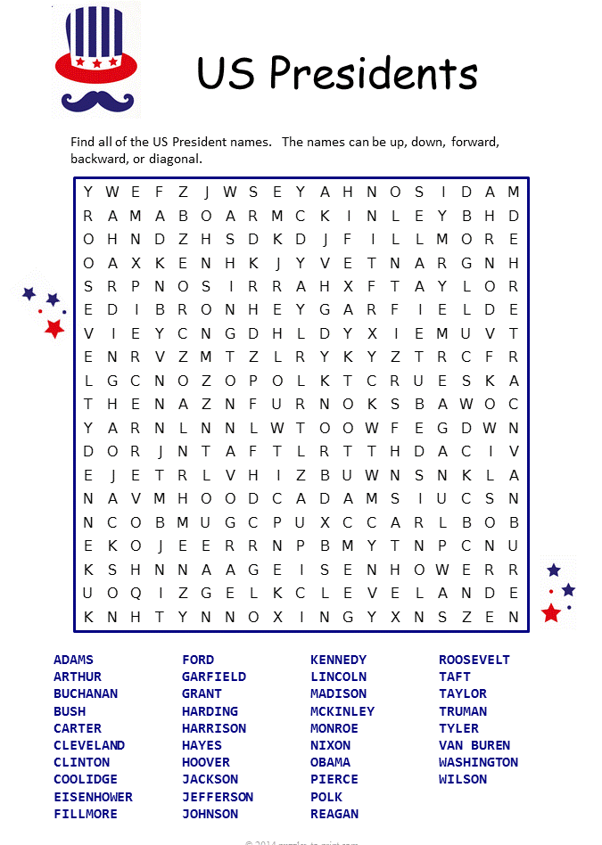

**Welcome to our new and returning clients!**

Click on the text box and Insert names

**A gigantic THANK YOU to all who referred us last month…**

Insert names

Get a

with my

**Referral Rewards Program**

As you probably know, advertising is very expensive. Instead of paying the newspaper or another place to advertise, we’d rather reward you. So we’ve assembled the Referral Rewards Program.

Every time you refer someone who becomes a client, we will send you a gift certificate for two passes to the **Movies-8 Cinema.**

And Hey! What’s a movie without popcorn? The gift certificate will also cover a big box of hot, buttered popcorn and sodas!

*Come by our store to   
claim your prize!*

Presidents Day Wordsearch

**Your Company Name**

123 Address, Someplace, ZZ 555555

555.555.5555 Phone ⚫ 555.555.5555 Fax

email@yourcompanyname.com

**YourCompanyWebsite.com**