

Reliable news for healthy living, saving money, and having fun!

********

Dear Friends,

Your personal message goes here.

The personal message is important because it allows you to connect in a very personal way with your clients. This personal connection is sorely lacking in most businesses. Topic ideas:

Your hobbies

Something interesting happening this month. Wish them “Merry Christmas” or “Happy Thanksgiving.”

A thought from your heart

Appreciation for your clients and their referrals. Remind them that you will bend over backwards to provide their referrals with World Class Service.

Mention that month’s “special offer” insert

Your Friend,

Your Signature

Your Name

**Jimbo’s Floors**

**January 1** New Year’s Day **January 15** Martin Luther King Day

(USA)

Suzie Smith!

You are this month’s   
Mystery Winner!

We have a   
**$10.00 Starbucks   
gift card**   
reserved just for you!

Come by our store to   
claim your prize!

Inside This Issue…

* Are you this month’s Mystery Winner?
* Month at a Glance
* New Puppy Survival Guide
* Did You Know
* Mega Trivia Contest
* Home Office Design Tips
* Thank you for the Kind Words
* Client of the Month
* School Life Wordsearch
* Thank You to our clients

*“You’ll love your new floors or I’ll replace them free!”*

~Jim Armstrong  
[www.JimbosFloors.com](http://www.JimbosFloors.com)

Scan to visit our website

January 2024

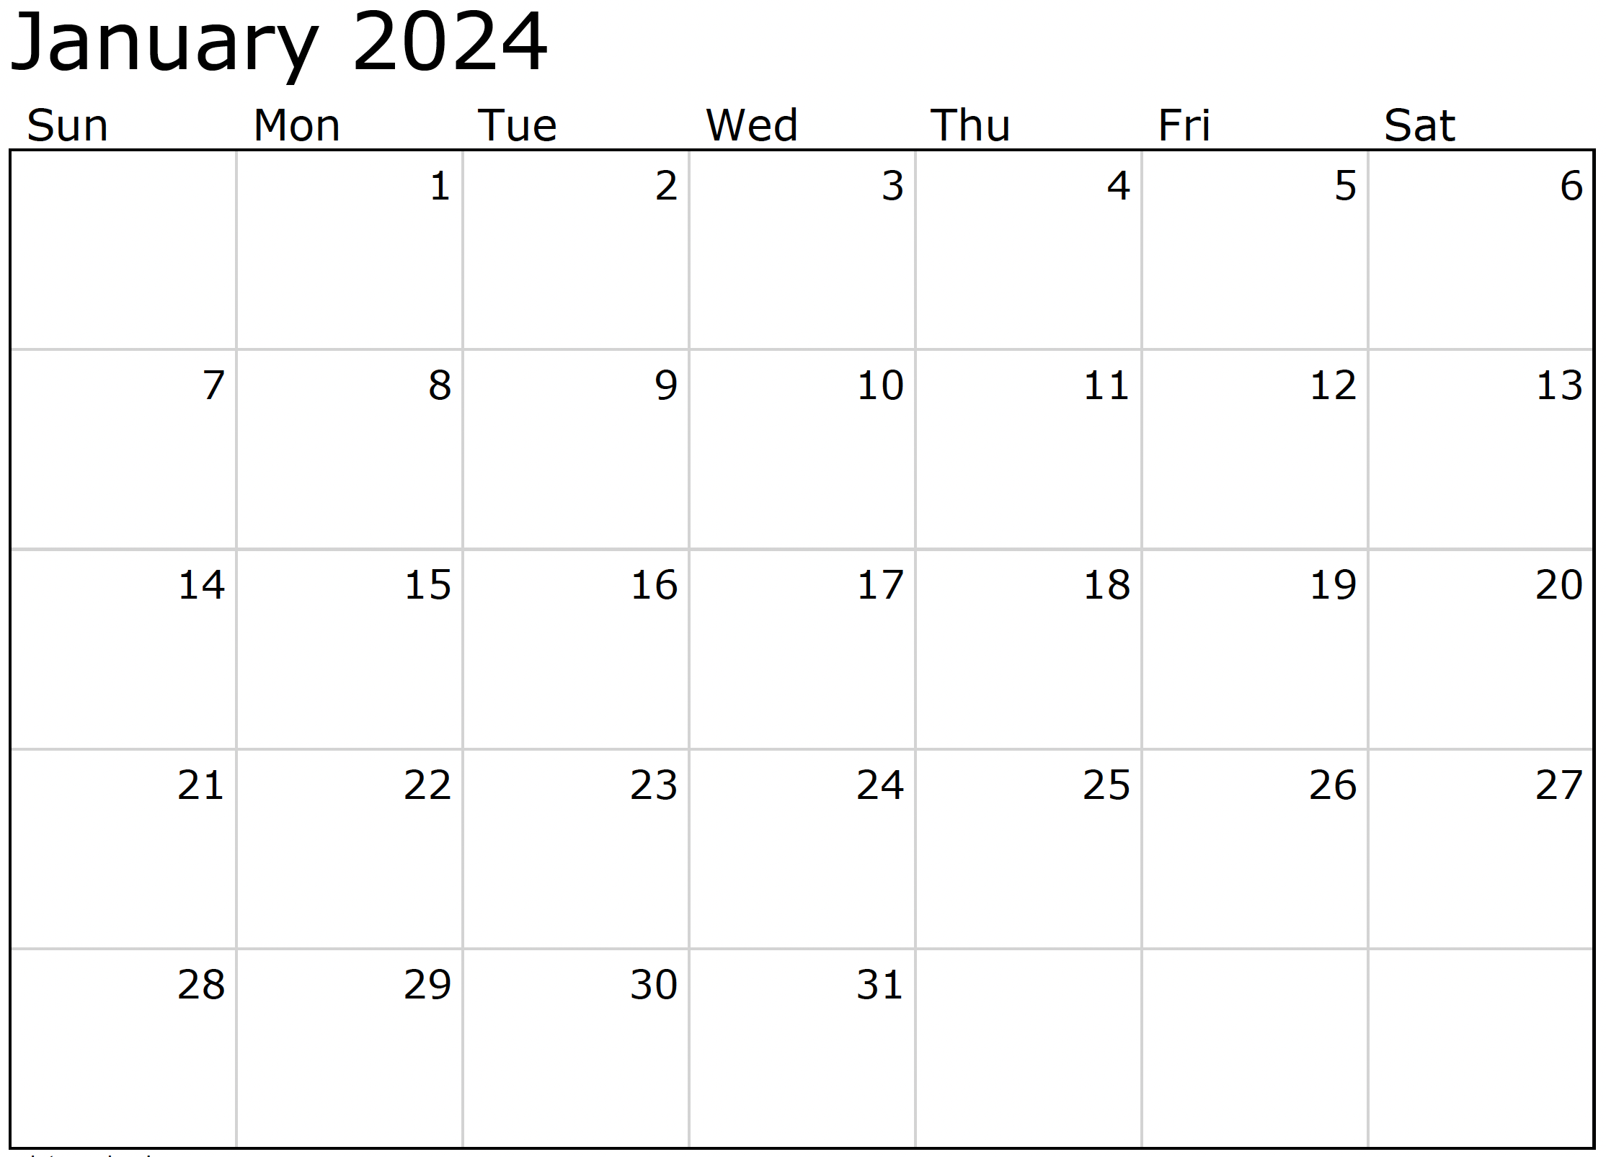

Month at a Glance!

*****

**We’d be happy to   
send you our   
electronic newsletter!**

The same combination of useful tips and offbeat stories you read here, but with these differences:

* The e-Advisor will arrive in your email account once you give us permission
* We send it once a week
* The e-Advisor does not have the same content as the print Home Advisor – you’ll read all new stories, from helpful advice to items that give you a smile

Simply let us know which email account you’d like us to use for the e-Advisor.

(NOTE: see the HA instructions for this month if you don’t have the Jim Armstrong Marketing Website to direct them to.)

***Last month’s question: (Answer is in bold print)***In what country did the tradition of putting up a Christmas Tree begin?

A) England B) France **C) Germany** D) Italy

### Who Else Wants to Win

### Dinner for Two at the City Café!

### Take our Trivia Challenge and *you could win too!*

This month’s Mega Trivia question:

Congratulations to last month’s winner: **Client Name**

Come by our store to claim your prize!

In the TV show “Friends”, what song was Phoebe most well-known for?  
 A) Smelly Cat B) Everybody Talks   
 C) What Now? D) Coffee Shop Song

To enter, email [Support@JimbosFloors.com](mailto:Support@JimbosFloors.com) and enter “Mega Trivia Contest” as the subject line. Take your best guess…your chances of winning are better than you think!

Are you one of the many lucky people who welcomed a new puppy into your home over the holiday season? If so, you aren’t alone. New pets are a fairly common holiday gift for kids. Welcoming a new puppy into your home is an exciting adventure, and not to be taken lightly. Here's a survival guide to help you navigate the joys and challenges of puppy parenthood:

**Puppy-Proof Your Home:** Remove potential hazards from your puppy's reach. This includes toxic plants, chemicals, and small objects that could be swallowed.

**Socialization:** Early socialization is crucial. Introduce your puppy to various people, animals, and environments to build confidence and prevent behavior issues.

**Training Basics:** Begin basic training early. Teach commands like "sit," "stay," and "come." Consistency and positive reinforcement are key.

**Housebreaking:** Be patient during housebreaking. Establish a routine, reward success, and clean accidents promptly with an enzymatic cleaner.

**Chew Toys:** Puppies love to chew. Provide plenty of appropriate chew toys to save your furniture and belongings from teething mischief.

**Healthy Diet:** Consult your vet for a suitable puppy diet. Proper nutrition is essential for growth and development.

**Regular Exercise:** Puppies have boundless energy. Ensure they get enough exercise to prevent boredom and destructive behavior.

**Grooming:** Depending on the breed, grooming needs vary. Brush your puppy regularly and introduce them to grooming tools and procedures.

**Healthcare:** Stay on top of vaccinations, deworming, and regular check-ups. Discuss flea, tick, and heartworm prevention with your vet.

**Unconditional Love:** Finally, shower your puppy with love and affection. Building a strong bond will create a happy and well-adjusted furry family member.

Through the trials and triumphs of puppyhood, remember that your new furry companion is an irreplaceable part of your family. With love, patience, and training, you're not just raising a puppy; you're nurturing a lifelong bond filled with wagging tails and endless joy.

New Puppy Survival Guide



Home Office Design Tips



Congratulations to our

**Susan Johnson!**

Susan is a 3rd time returning client, and she recently purchased new laminate for her kitchen and dining room. She always has a big smile on her face and is a lot of fun to work with. *Thanks, Susan!*

As always, our clients of the month receive **2 movie passes for Movies-8!**

*Watch for your name here in a coming month!*

Come by our store to   
claim your prize!

“My new laminate floors in my kitchen and dining room are beautiful. I was treated with respect and courtesy as a single woman raising a daughter. I genuinely felt that Jim Armstrong and his staff display concern for my flooring needs and were a guiding light for me. I recommend his service to anyone looking for a supportive, positive experience.”

~Marsha Avalos, School Teacher, Yuba City

“We Recently went to Jimbo’s Floors for new tile for our bathroom, and we’re thrilled with the results! This is our third time using Jimbo’s. Jim will never make you feel uncomfortable for asking questions and he’ll do anything in his power to accommodate your needs. When you do business with Jim and the staff at Jimbo’s Floors, you will be treated like royalty. Our experience was painless and very professional. Jim is not only our flooring expert, he’s a friend. That’s how he makes you feel.”

~Marvin and Sandy Moeller, owners of Sierra Landscaping, Yuba City

Thank You for the Kind Words!

It seems like the home offices we designed through the pandemic were *good enough*… But if working from home has become permanent, it’s time to really put some thought into that Covid-era office and decide if it might be time for an upgrade.

Creating an optimal home office blends functionality, aesthetics, and productivity. Here’s a concise guide to integrating the latest design tips into your workspace:

**Ergonomic Essentials:** Invest in a lumbar-supportive chair and a height-adjustable desk. Position your monitor at eye level to reduce strain.

**Efficient Layout:** Place your desk near a window for natural light, organize cables, and utilize smart storage solutions.

**Aesthetic Appeal:** Personalize your space with artwork and plants. Choose soothing colors and embrace minimalist design.

**Acoustics and Privacy:** Use rugs and curtains for soundproofing. Consider a privacy screen or room divider for boundaries.

**Effective Lighting:** Maximize natural light and incorporate task lighting with adjustable desk lamps.

**Technology Integration:** Ensure high-speed internet and use wireless charging stations. Keep tech cables organized.

**Biophilic Design:** Integrate indoor plants and natural materials like wood or stone for a calming atmosphere.

**Personal Space:** Designate a separate room or area for work. Use curtains or dividers in shared spaces.

**Flexibility:** Opt for modular furniture and plan your space for easy transitions from work to leisure.

**Smart Technology:** Utilize voice-controlled assistants and smart thermostats for convenience and energy efficiency.

By embracing these tips, you’ll craft a functional, visually appealing home office conducive to privacy and focus, enhancing your productivity and well-being in the remote work era.

Don’t forget, we can help you with every step of your project!



**Be sure to stop by to pick out and schedule   
your new floor installation.  
  
And from our families to yours –**

**welcome to 2024 & have a great month!**

Puzzle Time!

**Your Company Name**

123 Address, Someplace, ZZ 555555

555.555.5555 Phone ⚫ 555.555.5555 Fax

email@yourcompanyname.com

**YourCompanyWebsite.com**

**Welcome to our new and returning clients!**

Click on the text box and Insert names

**A gigantic THANK YOU to all who referred us last month…**

Insert names

Get a

with my

**Referral Rewards Program**

As you probably know, advertising is very expensive. Instead of paying the newspaper or another place to advertise, we’d rather reward you. So we’ve assembled the Referral Rewards Program.

Every time you refer someone who becomes a client, we will send you a gift certificate for two passes to the **Movies-8 Cinema.**

And Hey! What’s a movie without popcorn? The gift certificate will also cover a big box of hot, buttered popcorn and sodas!

*Come by our store to   
claim your prize!*

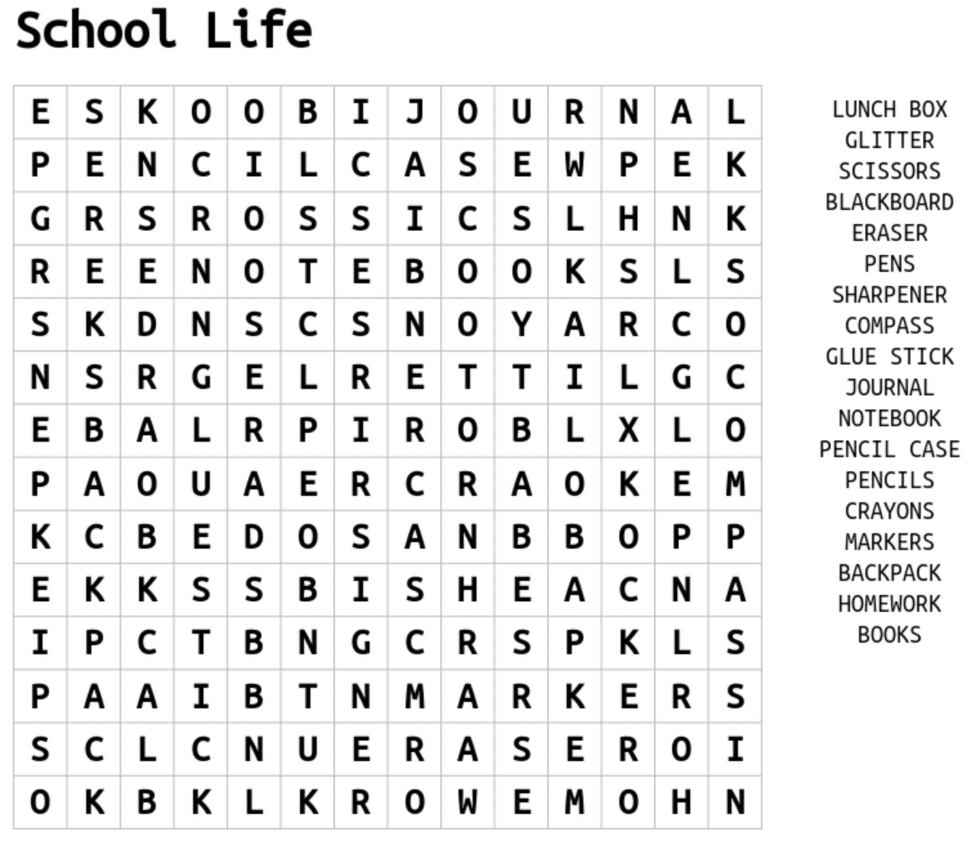

Love a good word search? We do too! What better way to get back into gear for Spring Semester than a good ‘School Life’ word search! But if you’re stuck finding one of the back-to-school words above, email us at [Support@JimbosFloors.com](mailto:Support@JimbosFloors.com) for the completed puzzle.