

Reliable news for healthy living, saving money, and having fun!

********

**Jimbo’s Floors**

**November 11 November 23 November 24 November 25**

Veterans Day Thanksgiving Family Day Small Biz Saturday

Suzie Smith!

You are this month’s   
Mystery Winner!

We have a   
**$10.00 Starbucks   
gift card**   
reserved just for you!

Come by our store to   
claim your prize!

Inside This Issue…

* Are you this month’s Mystery Winner?
* Month at a Glance
* A Message from Brussels Sprout
* Did You Know
* Mega Trivia Contest
* Teen Bedroom Trends
* Thank you for the Kind Words
* Client of the Month
* Brain Teasers
* Thank You to our clients

*“You’ll love your new floors or I’ll replace them free!”*

~Jim Armstrong & Mick  
[www.JimbosFloors.com](http://www.JimbosFloors.com)

Scan to visit our website

Dear Friends,

Your personal message goes here.

The personal message is important because it allows you to connect in a very personal way with your clients. This personal connection is sorely lacking in most businesses. Topic ideas:

Your hobbies

Something interesting happening this month. Wish them “Merry Christmas” or “Happy Thanksgiving.”

A thought from your heart

Appreciation for your clients and their referrals. Remind them that you will bend over backwards to provide their referrals with World Class Service.

Mention that month’s “special offer” insert

Your Friend,

Your Signature

Your Name

November 2023

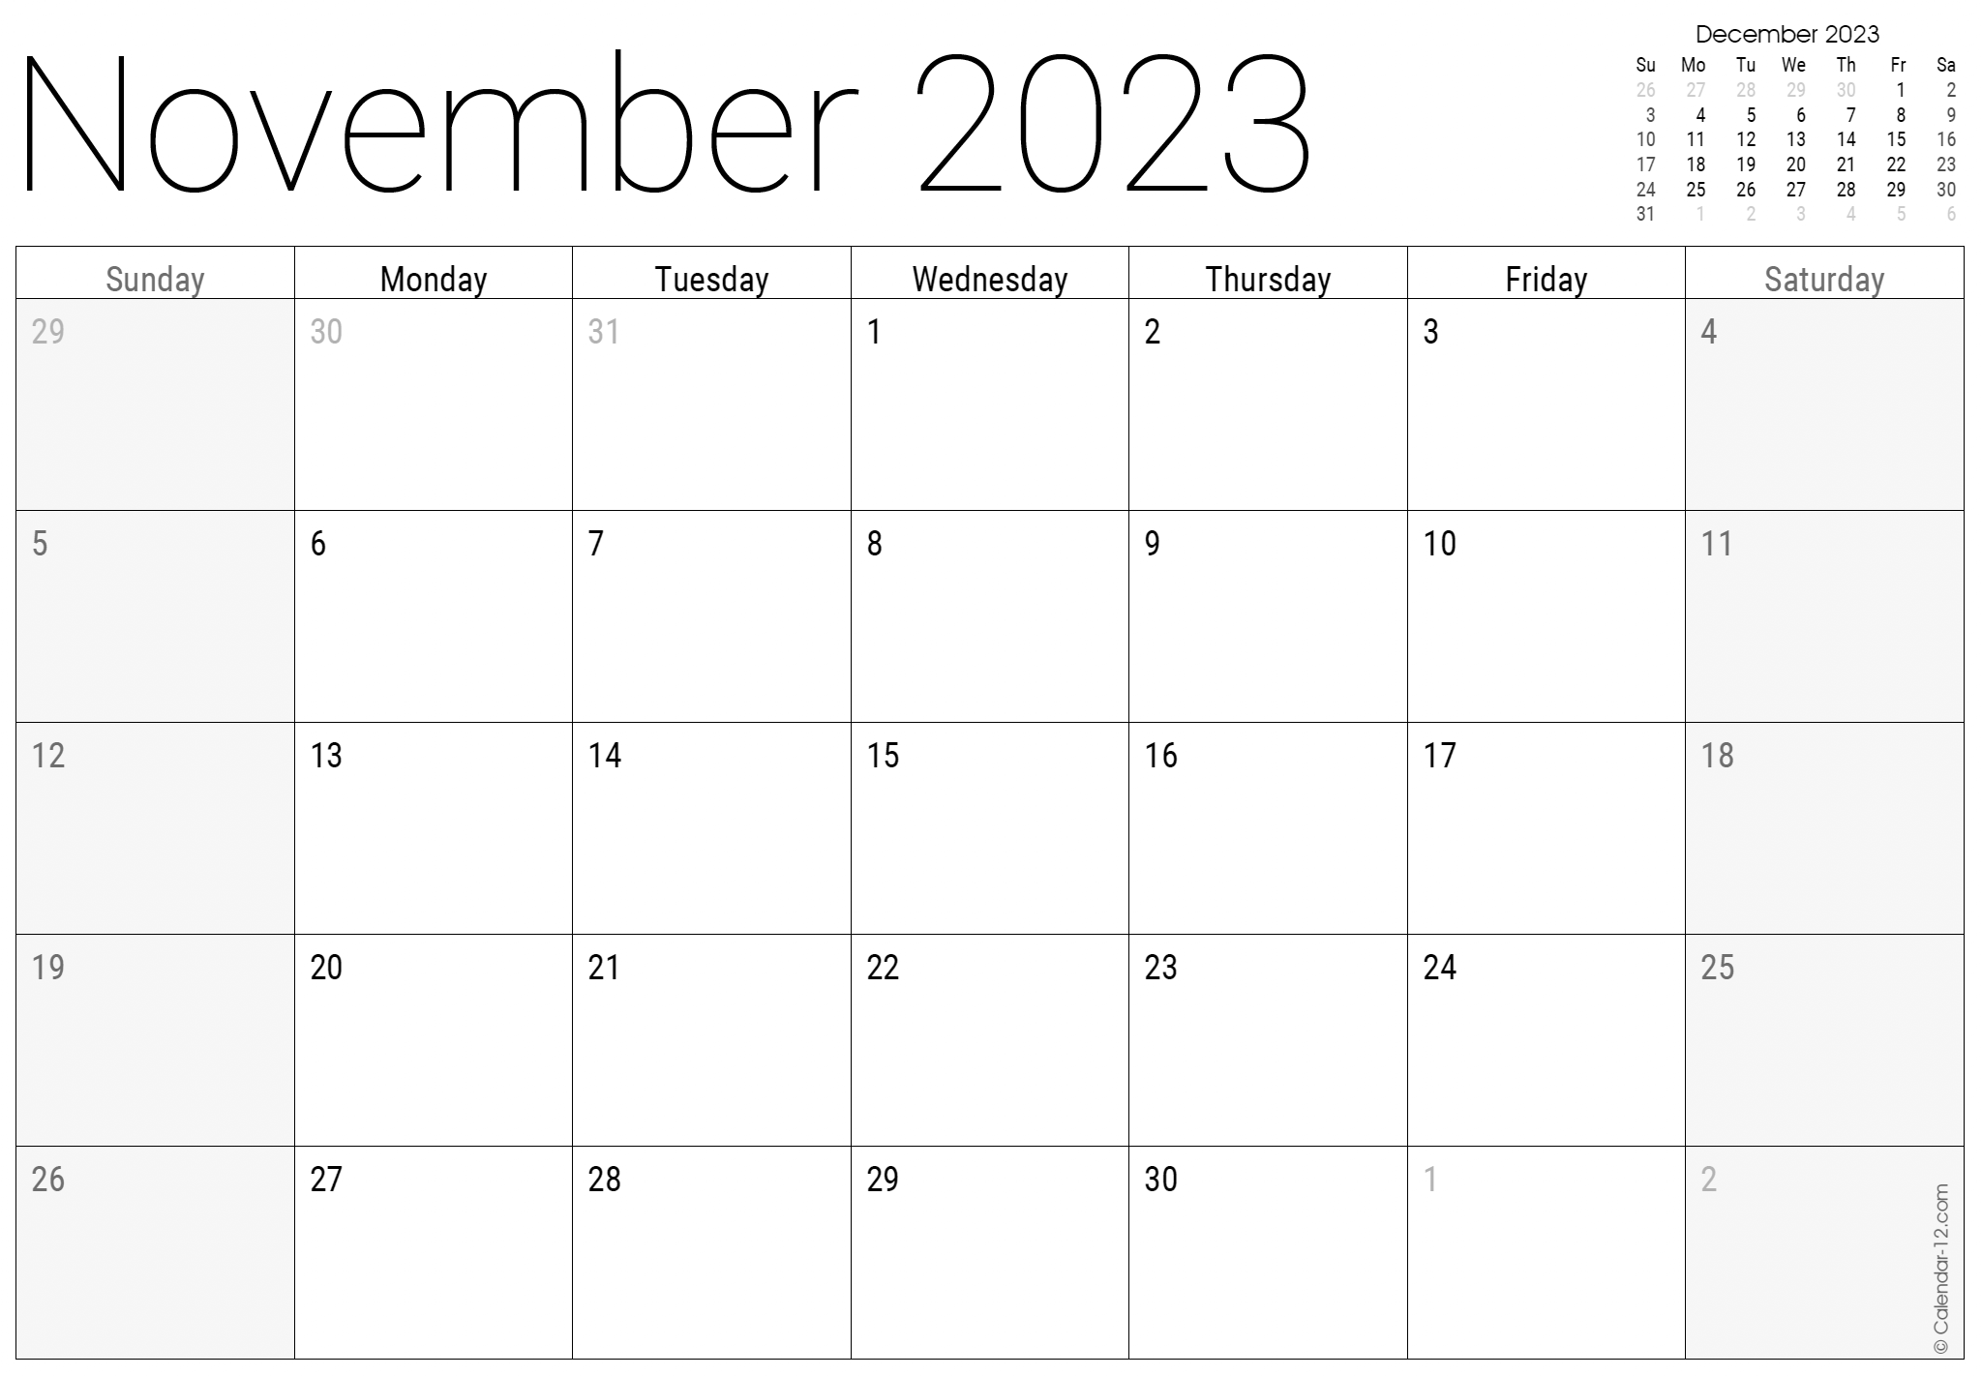

Month at a Glance!

*****

**When you buy**

**floors from us, you**

**are protected by our Installer Professionalism guarantee!** *It’s part of our Jimbo’s Floors 100% Iron-Clad Triple Guarantee.*

Our installers are neat, clean, well-groomed, well-spoken and professional. They are trained and certified. They are guests in your home, and they conduct themselves as such. They respect your home by using wall and corner guards, shoe covers and drop cloths.

You’ll receive the highest-quality installation in the business. And after they’re finished, they will leave your home as neat and clean as when they arrived!

(NOTE: see the HA instructions for this month if you don’t have the Jim Armstrong Marketing Website to direct them to.)

***Last month’s question: (answer in bold)*** *What was the first toy to be advertised on television?*

***A) Mr. Potato Head*** *B) Barbie C) Legos D) Diecast Cars*

What actor played Alex Keaton on the '80s TV show "Family Ties?"

A) Stefani Germanotta B) Michael J. Fox   
C) Elvis Presley D) Michael Flatley

To enter, email [Support@JimbosFloors.com](mailto:Support@JimbosFloors.com) and enter “Mega Trivia Contest” as the subject line. Take your best guess…your chances of winning are better than you think!

Hello, my dear friends,

I am A. Brussels Sprout, and I have come to you today with a heavy heart. You see, I cannot understand why so many people seem to dislike me. I am a delicious and nutritious vegetable, full of vitamins and minerals. Yet, so many people turn their noses up at me.

I understand that my small, compact size may not be as visually appealing as other vegetables, but I promise you, my flavor is anything but small. Roasted with a bit of olive oil, salt and pepper, I become a crispy, caramelized, and delicious treat. Plus, I can be enjoyed in so many ways, sautéed, steamed, or even raw in a salad.

But it's not just about taste, I am also incredibly good for you. I am high in fiber, vitamin K, vitamin C, and antioxidants. I can help support healthy digestion, and may even reduce the risk of certain cancers.

I know that I may not be the most popular vegetable, but please do not underestimate me. I may be small, but I am mighty in flavor and nutrition. I implore you to give me a chance; to give your taste buds a chance, to experience my deliciousness.

I can't bear the thought of being neglected and overlooked, it breaks my heart. I want to be loved and appreciated like my fellow vegetables. So, please, do not be afraid to give me a try, I promise, you won't be disappointed.

Sincerely,

A Brussels Sprout

*(Please keep in mind that the above message is written from a humorous and playful perspective, and it is not possible for plants to think or feel in such way, but it can be a fun way to engage with food and to make a point about how some foods are not as appreciated as they could be.*😉*)*

### Who Else Wants to Win

### Dinner for Two at the City Café!

### Take our Trivia Challenge and *you could win too!*

This month’s Mega Trivia question:

Congratulations to last month’s winner: **Client Name**

Come by our store to claim your prize!

A Message From Brussels Sprout

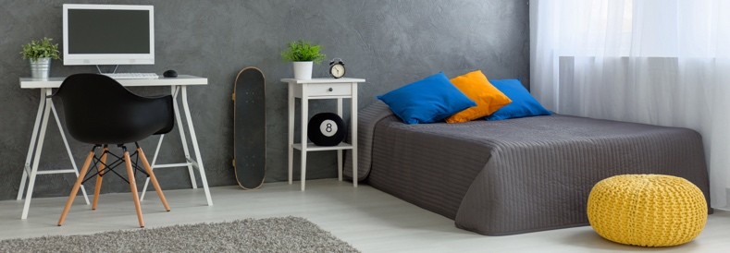

Teenagers often view their bedroom as a personal sanctuary—a space to express their unique personalities and escape from the outside world. In this article, we'll explore some of the current trends that will inspire teens to create stylish and personalized bedrooms.

**Bold Color Palettes:**

Today's teen bedrooms embrace bold and vibrant color schemes. Teens are opting for rich jewel tones, such as deep blues, emerald greens, and striking purples, to add a splash of drama and personality to their spaces. Colorful accent walls, bedding, and accessories provide a dynamic and energetic vibe.

**Multifunctional Furniture:**

Teens often have limited space, so maximizing functionality is key. Beds with built-in storage drawers, desk space, or pull-out seating options offer practical solutions for both sleeping and studying. Loft beds with integrated study areas or lounging spaces underneath have also been popular for a while now, utilizing vertical space effectively.

**Personalized Gallery Walls:**

Gallery walls allow teens to curate a collection of artwork, photographs, posters, and inspirational quotes that reflect their passions. Mixing different frame styles, sizes, and textures adds visual interest, while string lights or wall-mounted shelves can further enhance the display.

**Cozy and Relaxing Nooks:**

Bean bags, floor cushions, or hanging chairs provide comfortable and inviting spaces for reading, relaxing, or chatting with friends. Adding soft textures, such as plush rugs or oversized floor pillows, contributes to the cozy atmosphere.

**Tech-Friendly Spaces:**

Built-in charging stations, smart lighting systems, and innovative storage solutions for gadgets ensure a clutter-free and organized space. Creating designated areas for gaming setups, streaming, or

Teen Bedroom Trends



study stations showcases a modern and tech-savvy environment.

**Nature-Inspired Elements:**

Incorporating natural elements such as plants, botanical wallpaper, or nature-inspired artwork adds a refreshing touch to the bedroom. Earthy tones, organic textures, and sustainable materials create a harmonious and calming ambiance.

Teen bedroom trends are constantly evolving to meet the ever-changing needs and desires of today's youth. The key is to encourage self-expression and provide a comfortable, functional, and visually appealing space that allows teens to relax, study, and explore their individuality. Let the latest trends inspire you and embark on the journey of transforming your teen's bedroom into a reflection of their unique personality.

Congratulations to our

**Susan Johnson!**

Susan is a 3rd time returning client, and she recently purchased new laminate for her kitchen and dining room. She always has a big smile on her face and is a lot of fun to work with. *Thanks, Susan!*

As always, our clients of the month receive **2 movie passes for Movies-8!**

*Watch for your name here in a coming month!*

Come by our store to   
claim your prize!

“My new laminate floors in my kitchen and dining room are beautiful. I was treated with respect and courtesy as a single woman raising a daughter. I genuinely felt that Jim Armstrong and his staff display concern for my flooring needs and were a guiding light for me. I recommend his service to anyone looking for a supportive, positive experience.”

~Marsha Avalos, School Teacher, Yuba City

“We Recently went to Jimbo’s Floors for new tile for our bathroom, and we’re thrilled with the results! This is our third time using Jimbo’s. Jim will never make you feel uncomfortable for asking questions and he’ll do anything in his power to accommodate your needs. When you do business with Jim and the staff at Jimbo’s Floors, you will be treated like royalty. Our experience was painless and very professional. Jim is not only our flooring expert, he’s a friend. That’s how he makes you feel.”

~Marvin and Sandy Moeller, owners of Sierra Landscaping, Yuba City

Thank You for the Kind Words!



**Be sure to stop by to pick out and schedule   
your new floor installation, and   
from our families to yours have a great month!**

Answers:

1) The missing number is 17. In all the numbers the first digit is multiplied by the second digit then the third digit is added to the total (8 x 3 + 4 = 28), (6 x 7 + 5 = 47), (9 x 1 + 8 = 17) and (5 x 2 + 7 = 17). 2) The answer is hand number 2. It is the odd one out because it is a left hand. all the others are right hands. 3) The highest number you can make by moving 2 matches is 781. Take the middle and bottom horizontal matches off the three and make a 1 behind the eight. 4) The answer is paper or tissue paper. If can fall from great heights without a problem but water will destroy it. 5) The next letter is T. The puzzle uses a decreasing sequence in the order of the alphabet. The letters are 5,4,3,2 places after each other. K is 5 letters after F, O is 4 letters after K, R is 3 letters after 0, and T is 2 letters after R. 6) The woman’s mouth/lips are upside down.

**Welcome to our new and returning clients!**

Click on the text box and Insert names

**A gigantic THANK YOU to all who referred us last month…**

Insert names

Get a

with my

**Referral Rewards Program**

As you probably know, advertising is very expensive. Instead of paying the newspaper or another place to advertise, we’d rather reward you. So we’ve assembled the Referral Rewards Program.

Every time you refer someone who becomes a client, we will send you a gift certificate for two passes to the **Movies-8 Cinema.**

And Hey! What’s a movie without popcorn? The gift certificate will also cover a big box of hot, buttered popcorn and sodas!

*Come by our store to   
claim your prize!*

Happy Brain Teaser Month!

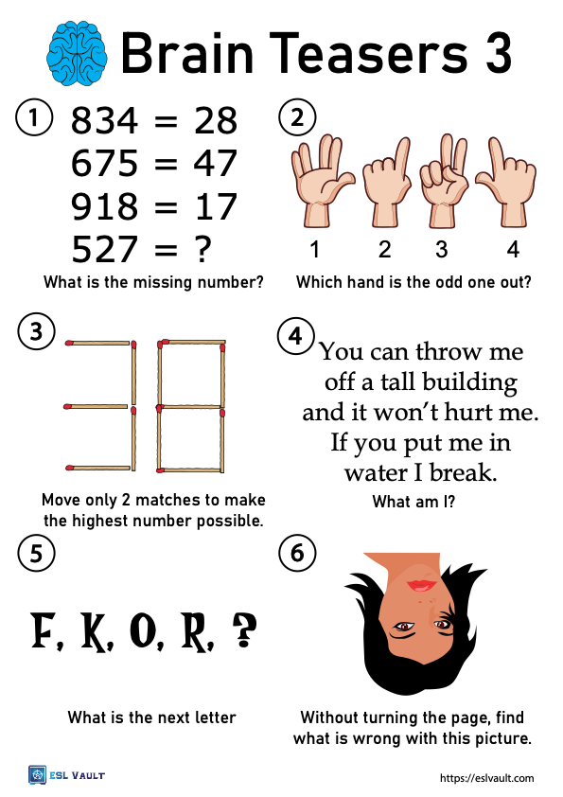

**Your Company Name**

123 Address, Someplace, ZZ 555555

555.555.5555 Phone ⚫ 555.555.5555 Fax

email@yourcompanyname.com

**YourCompanyWebsite.com**