

Reliable news for healthy living, saving money, and having fun!

********

**Jimbo’s Floors**

**October 9** Columbus Day **October 16** Boss’ Day

**October 21** Sweetest Day **October 31** Halloween

Suzie Smith!

You are this month’s   
Mystery Winner!

We have a   
**$10.00 Starbucks   
gift card**   
reserved just for you!

Come by our store to   
claim your prize!

Inside This Issue…

* Are you this month’s Mystery Winner?
* Month at a Glance
* Best Flooring for Fur Babies
* Did You Know
* Mega Trivia Contest
* Ups and Downs of Electric Vehicles
* Thank you for the Kind Words
* Client of the Month
* Maze Month
* Thank You to our clients

*“You’ll love your new floors or I’ll replace them free!”*

~Jim Armstrong & Mick  
[www.JimbosFloors.com](http://www.JimbosFloors.com)

Scan to visit our website

Dear Friends,

Your personal message goes here.

The personal message is important because it allows you to connect in a very personal way with your clients. This personal connection is sorely lacking in most businesses. Topic ideas:

Your hobbies

Something interesting happening this month. Wish them “Merry Christmas” or “Happy Thanksgiving.”

A thought from your heart

Appreciation for your clients and their referrals. Remind them that you will bend over backwards to provide their referrals with World Class Service.

Mention that month’s “special offer” insert

Your Friend,

Your Signature

Your Name

October 2023

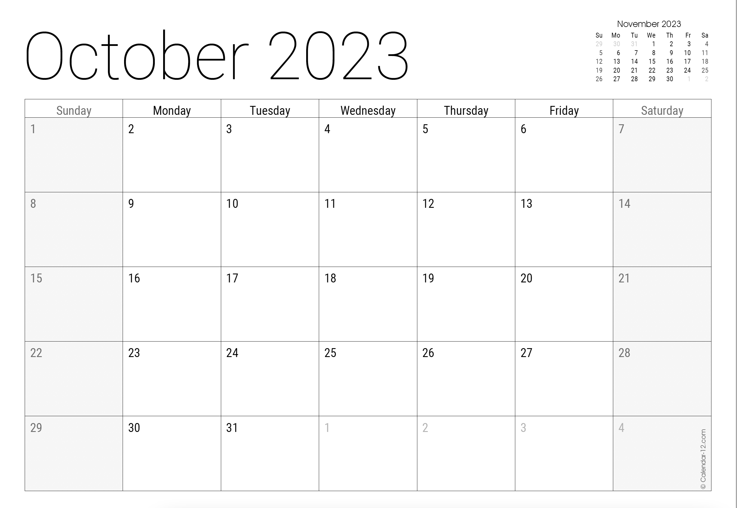

Month at a Glance!

*****

***Last month’s question: (answer in bold)*** *The unicorn is the national animal of which country?*

1. *America B) Peru C) Turkey* ***D) Scotland***

What was the first toy to be advertised on television?

A) Mr. Potato Head B) Barbie C) Legos D) Diecast Cars

To enter, email [Support@JimbosFloors.com](mailto:Support@JimbosFloors.com) and enter “Mega Trivia Contest” as the subject line. Take your best guess…your chances of winning are better than you think!

Pets can be tough on flooring, so it's important to choose a material that can stand up to wear and tear, is easy to clean, and won't be easily damaged by scratches and spills. Here are a few options for pet-friendly flooring:

**Vinyl flooring**, such as luxury vinyl plank (LVP) and luxury vinyl tile (LVT), is one of the best options for pet owners. It is extremely durable, water-resistant, and easy to clean. It also comes in a variety of styles and patterns that mimic the look of hardwood or tile.

**Laminate flooring** is also a good option for pet owners as it's durable, scratch-resistant and easy to clean.

**Hardwood flooring** can be a good option for pet owners with well-trained pets. Hardwood flooring is durable, but it can be easily scratched by pets. You can also consider engineered hardwood which is slightly more resistant to scratches.

**Tile:** Ceramic, porcelain, and stone tile are durable, easy to clean, and resistant to scratches and spills, making them a good option for pet owners. But these flooring materials may not be suitable for pets with joint issues.

**Our honorable mention is Carpet.** While not the best option for pet owners, there are some carpets made from pet-proof fibers such as polypropylene or nylon. Additionally, a low-pile and tightly-woven carpet is less likely to show stains or wear as easily as a shag or berber carpet.

Regardless of the flooring material you choose, it's important to keep it clean and maintained to ensure it lasts as long as possible.

Vacuuming and spot cleaning regularly is essential, as well as using protective floor mats or carpets in high-traffic areas. In addition, consider keeping your pets nails trimmed to minimize scratches and scuffs.

Ultimately, the best flooring choice will depend on the specific needs of your pets and the look and feel you want to achieve in your home.

### Who Else Wants to Win

### Dinner for Two at the City Café!

### Take our Trivia Challenge and *you could win too!*

This month’s Mega Trivia question:

Congratulations to last month’s winner: **Client Name**

Come by our store to claim your prize!

(NOTE: see the HA instructions for this month if you don’t have the Jim Armstrong Marketing Website to direct them to.)

**We’d be happy to send you our electronic newsletter!**

The same combination of useful tips and offbeat stories you read here, but with these differences:

* The e-Advisor will arrive in your email account once you give us permission
* We send it once a week
* The e-Advisor does not have the same content as the print Home Advisor – you’ll read all new stories, from helpful advice to items that give you a smile

Simply let us know which email account you’d like us to use for the e-Advisor.

Best flooring for fur babies

Ups and Downs of Electric Vehicles



Congratulations to our

**Susan Johnson!**

Susan is a 3rd time returning client, and she recently purchased new laminate for her kitchen and dining room. She always has a big smile on her face and is a lot of fun to work with. *Thanks, Susan!*

As always, our clients of the month receive **2 movie passes for Movies-8!**

*Watch for your name here in a coming month!*

Come by our store to   
claim your prize!

“My new laminate floors in my kitchen and dining room are beautiful. I was treated with respect and courtesy as a single woman raising a daughter. I genuinely felt that Jim Armstrong and his staff display concern for my flooring needs and were a guiding light for me. I recommend his service to anyone looking for a supportive, positive experience.”

~Marsha Avalos, School Teacher, Yuba City

“We Recently went to Jimbo’s Floors for new tile for our bathroom, and we’re thrilled with the results! This is our third time using Jimbo’s. Jim will never make you feel uncomfortable for asking questions and he’ll do anything in his power to accommodate your needs. When you do business with Jim and the staff at Jimbo’s Floors, you will be treated like royalty. Our experience was painless and very professional. Jim is not only our flooring expert, he’s a friend. That’s how he makes you feel.”

~Marvin and Sandy Moeller, owners of Sierra Landscaping, Yuba City

Thank You for the Kind Words!

Electric vehicles (EVs) have been gaining popularity in recent years as a sustainable alternative to traditional gas-powered cars. However, as with any new technology, there are both upsides and downsides to consider when thinking about purchasing an EV.

***Advantages of EVs include:***

**Zero emissions** at the tailpipe. They produce no tailpipe emissions, meaning they don’t contribute to poor air quality or climate change.

**Low operating costs**. Electricity is cheaper than gasoline and requires less maintenance.

**Quieter and smoother ride**. Electric motors are quieter and provide a smoother driving experience.

**Tax Incentives**. Some governments offer tax credits or incentives to help offset the higher purchase price of EVs.

***Disadvantages of EVs include:***

**Limited driving range**: Most EVs have a limited driving range, typically between 100 and 400 miles per charge, which can be a concern for some drivers.

**Charging time and infrastructure**: Charging an EV can take significantly longer than filling a gas tank. Public charging infrastructure can also be limited and this can make some EV owners feel limited in their travel options.

**Higher initial cost**: Although the long-term operating costs of EVs are lower, the initial purchase price can be higher than traditional gas-powered cars.

**Battery degradation**: The batteries in EVs will degrade over time, which can affect the vehicle's performance and range.

Ultimately, whether an EV is the right choice for you will depend on your individual needs and preferences. We hope this article has provided at least the high-points you need to consider in order to make the right choice for you.



**Be sure to stop by to pick out and schedule   
your new floor installation, and   
from our families to yours have a great month!**

**Your Company Name**

123 Address, Someplace, ZZ 555555

555.555.5555 Phone ⚫ 555.555.5555 Fax

email@yourcompanyname.com

**YourCompanyWebsite.com**

**Welcome to our new and returning clients!**

Click on the text box and Insert names

**A gigantic THANK YOU to all who referred us last month…**

Insert names

Get a

with my

**Referral Rewards Program**

As you probably know, advertising is very expensive. Instead of paying the newspaper or another place to advertise, we’d rather reward you. So we’ve assembled the Referral Rewards Program.

Every time you refer someone who becomes a client, we will send you a gift certificate for two passes to the **Movies-8 Cinema.**

And Hey! What’s a movie without popcorn? The gift certificate will also cover a big box of hot, buttered popcorn and sodas!

*Come by our store to   
claim your prize!*

Maze Month!

How fast can you solve this maze?

