

**There’s No Need To Cry Over**

**Worn, Dated, Embarrassing Floors!**

***With The Jimbo’s Floors Economic Stimulus Plan***

double_lines_2***You Can Afford New Floors Right Now!***

Dear Friend & Client,

 Hi, Jim Armtrong here. I love our great country, and I’m very patriotic! So I’ve decided that Jimbo’s Floors is going to do its part to help stimulate the economy AND help you get new floors right now!

**Don’t Cry….Get 17.3% More FREE!**

“My husband and I were referred to Jimbo’s by our Realtor after we experienced on going “nightmares” with the flooring store we originally had. We were told that if we wanted someone that was “phenomenal” and that would “hold our hand” and see us through until the very end and she knew the perfect person to do that for us. Roberto Gonzales of Jimbo’s Floors was that perfect person! He turned the nightmare we were having into an enjoyable process in purchasing flooring for our new home. He informed us of things we were completely unaware of and completely demonstrated the true meaning of customer service. He treated us like family and continues to do so even after our new hard wood floors were installed. They look AWESOME! We will be referring everyone we know to Roberto and Jimbo’s Floors!”

-Barry & Diana, Retired, Yuba City

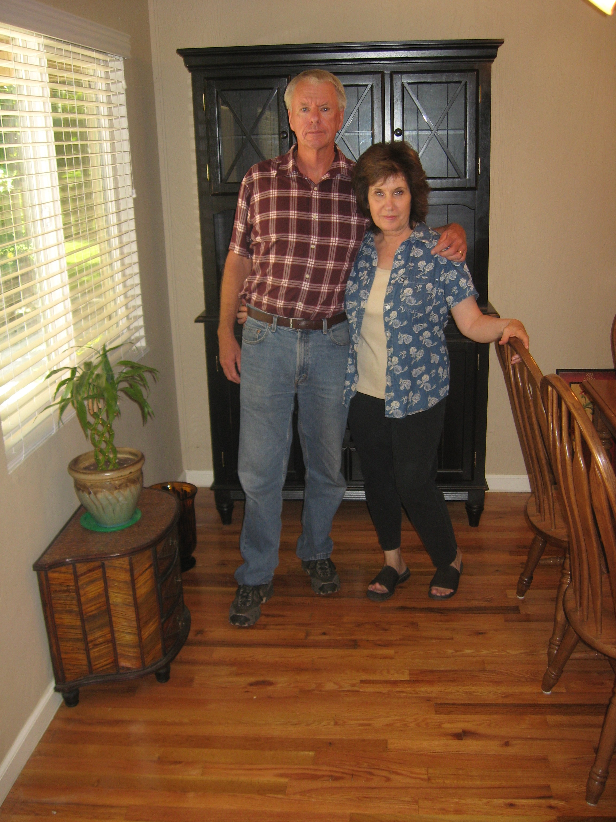 Bring this letter to Jimbo’s Floors by March 31st, and you’ll get 17.3% more flooring FREE on top of whatever you purchase! This applies to all types of floor, including wood, laminate, carpet, ceramic tile, vinyl, stone….everything offered at Jimbo’s!

**5 Reasons You’ll Love Jimbo’s Floors**

1

You are protected by my “Zero Regrets Guarantee.” You’ll love your new floors, or I’ll replace them FREE in the first 30 days!

I’ll give you a FREE lifetime installation warranty on any floor you buy!

I only hire courteous, clean-cut, professional installers who are thoroughly trained and certified.

I have a thick book of testimonials from past clients. Have a look through it when you visit. We keep it right on the front counter!

And we’ll put a smile back on your face!

**Barry & Diana on their beautiful new hardwood floors!**

**Any Friend Of Yours Is A Friend Of Mine!**

Who do you know that is looking to purchase new floors? Can I count on you to pass this letter along to them? You will be doing them a tremendous favor by referring them to a professional floor dealer they can trust. AND…don’t forget about my Referral Reward Program. If you refer someone who purchases floors during the month of March, I’ll send you and a guest out to dinner at the Rusty Duck!

Sincerely,



Jim Armstrong

**Take advantage of the Jimbo’s Floors Economic Stimulus Package! Get 17.3% more FREE! But this “stimulating” offer expires March 31st**

**What Others Are Saying About Jimbo’s Floors!**

“Jim—you already know we think you’re great—we refer you all the time and will keep doing so! Our new carpet looks awesome!”

**-Mike & Julie Nickel, Firefighter & Office Manager, Live Oak**

“I recently found the home of my dreams. I was feeling a little overwhelmed trying to decide which kind of floor would be best. Add that to the experience of buying my first home and I was feeling very stressed. I visted Jimbo’s Floors and met Roberto. He could tell I was stressed, so he took the time to do a Design Audit that really helped in picking the right floor. He also kept in touch during the whole installation process as well as Sheryl, the Project Coordinator. Then to top all of this, I received a nice surprise package from Roberto when he visited after I moved in my new house. Roberto and Sheryl are both topnotch professionals. They are detail oriented and handled every step of the buying and installation process as if it was their own. The carpets make the house look brand new…they’re great! I believe in having as stress-free an environment as possible and having Roberto and Sheryl at Jimbo’s Floors handle my flooring was a pleasure. If ever I need flooring, it’s Jimbo’s Floors. Thanks Roberto and Sheryl. Sincerely,”

**-Jeanne Stiller, Loan Dept. of Bank of America, Yuba City**

“My new laminate floors in my kitchen and dining room are beautiful. I was treated with respect and courtesy as a single woman raising a daughter. I genuinely felt that Jim Armstrong and his staff display concern for my flooring needs and were a guiding light for me. I recommend his service to anyone looking for a supportive, positive experience.”

**-Marsha Avalos, School Teacher, Yuba City**

“Dear Jim, I would like you to know that we were very impressed with the way that you do business. It is literally a throw back to a time when service and professionalism truly meant something, and unfortunately is all but forgotten in today’s business world. Specifically, I would like to thank you for your efforts throughout our entire floor-buying process. Your honesty, quick response, and communication were a welcome change from all of our previous flooring experiences. Please know that my wife and I have spoken of this to everyone we know if the subject arose, and we will continue to do so. You will indeed be our “flooring consultant for life.” Thank you again for reminding me that some people still do business the right way.”

**-Alex & Jennifer Johnson, General Contractor and Home Maker, Marysville**

“We Recently went to Jimbo’s Floors for new tile for our bathroom, and we’re thrilled with the results! This is our third time using Jimbo’s. Jim Armstrong makes you feel like you’ve known him forever, making you feel right at home from the start. Jim will never make you feel uncomfortable for asking questions and he’ll do anything in his power to accommodate your needs. When you do business with Jim and the staff at Jimbo’s Floors, you will be treated like royalty. Our experience was painless and very professional. Jim is not only our flooring expert, he’s a friend. That’s how he makes you feel. With our sincere Thanks!”

**-Marvin and Sandy Moeller, owners of Sierra Landscaping, Yuba City**

“From the very first time I met Jim and Sheryl, and the rest of the staff, I was made to feel very comfortable. I thoroughly enjoyed the friendliness and personability of the staff at Jimbo’s throughout the entire installation process. I get tons of compliments on my new hardwood floors! I’m super happy!”

**-Andy Koch, Architect, Yuba City**

**“**Jim and his sales staff have the ability to listen and then offer many solutions. We especially liked the Design Audit. It really helped us narrow down our options and find the right flooring for our needs. We have three kids and a dog, and Jim’s recommendation to put laminate in the hallways and carpet everywhere else was really helpful. It looks great! I can’t wait to host this year’s family Christmas get-together. Also, we were treated like royalty! From the moment we walked into Jimbo’s and were asked if we wanted coffee or soda, to meeting with Jim’s salesperson, Roberto in the design room, to the installation, and the surprise gift afterwards, the service was top-notch. Roberto’s personal touch is how he wants to educate his clients and keep them forever. He put us at ease and gave us confidence that we were serving our family wisely by choosing Jimbos! Thank You!”

**-Chuck and Sonya Laney, Plumber and Seceratary, Yuba City**

Last August in Carmel, CA. (I’m the dapper looking chap on the far right.)

There’s so much beauty and outdoor stuff to enjoy in our area. We’ve got the Sierra’s in our backyard, and the coast within 2 hours drive. We are so blessed!

If you don’t normally take time to visit the great outdoors, make time this Spring! You’ll be glad you did. If you’re looking for ideas on places that are drop-dead gorgeous but easy to get to, give me a call and I’ll be glad to share some of my favorite spots with you! 530-790-3338.

*-Jim A.*

Yours Truly and my son, Chase, and daughter, Kristen. This was taken a couple of years ago at Donner Lake.