

Reliable news for healthy living, saving money, and having fun!

******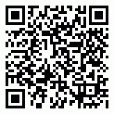**

Inside This Issue…

* Are you this month’s Mystery Winner?
* Month at a Glance
* How Many Passwords Do You Have?
* Did You Know
* Mega Trivia Contest
* Where The Wild Horses Still Roam
* Thank you for the Kind Words
* Client of the Month
* Brain Teasers
* Thank You to our clients

**September 4**

Labor Day

**September 10** Grandparent’s Day

**September 11** Patriot’s Day

**September 16** Stepfamily Day

September 2023

Suzie Smith!

You are this month’s   
Mystery Winner!

We have a   
**$10.00 Starbucks   
gift card**   
reserved just for you!

Come by our store to   
claim your prize!

*“You’ll love your new floors or I’ll replace them free!”*

~Jim Armstrong & Mick  
[www.JimbosFloors.com](http://www.JimbosFloors.com)

Scan to visit our website

Dear Friends,

Your personal message goes here.

The personal message is important because it allows you to connect in a very personal way with your clients. This personal connection is sorely lacking in most businesses. Topic ideas:

Your hobbies

Something interesting happening this month. Wish them “Merry Christmas” or “Happy Thanksgiving.”

A thought from your heart

Appreciation for your clients and their referrals. Remind them that you will bend over backwards to provide their referrals with World Class Service.

Mention that month’s “special offer” insert

Your Friend,

Your Signature

Your Name

**Jimbo’s Floors**

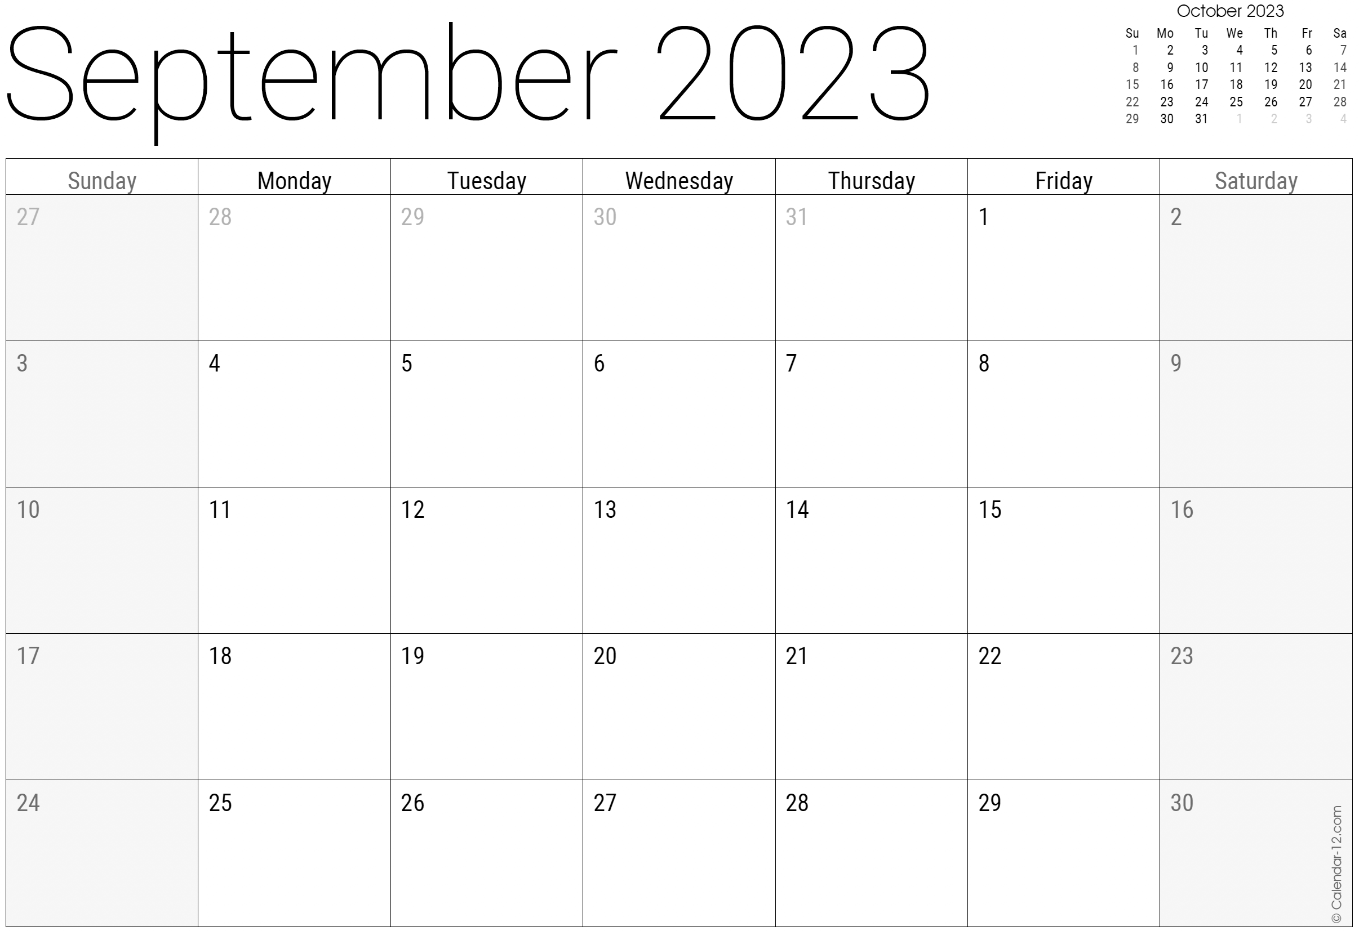

Month at a Glance!

*****

The unicorn is the national animal of which country?

1. America B) Peru C) Turkey D) Scotland

To enter, email [Support@JimbosFloors.com](mailto:Support@JimbosFloors.com) and enter “Mega Trivia Contest” as the subject line. Take your best guess…your chances of winning are better than you think!

Congratulations to last month’s winner: **Client Name**

Come by our store to claim your prize!

***Last month’s question****:* ***(answer is bold)***How many hearts does an octopus have?

**A) 3** B) 1 C) 4 D) 17

We’ve got a LOT of passwords to manage over here!  In fact, according to a survey conducted by *LastPass*, a password manager company, the average person in 2017 had around 200 digital accounts that required passwords.  And that was 6 years ago. Password management practices and the number of online accounts people have evolves over time, we know ours have!

In addition to *LastPass*, one of the most popular password managers, there are many password managers available on the market, and different people may have different preferences. However, some of the most highly rated password managers for consumers include:

**1Password:** This password manager is known for its user-friendly interface and strong security features, it also offers a free trial and multiple plans to choose from.

**Dashlane:** This password manager offers a free version with basic features, as well as a paid version with additional features such as two-factor authentication, password sharing and emergency contact.

**Keeper:** A password manager that offers a range of features such as password sharing, two-factor authentication, and Dark Web Monitoring.

**Bitwarden:** A open-source and free password manager that offers a range of features such as password sharing, two-factor authentication and end-to-end encryption.

These are just a few examples, and there are many other password managers available on the market. It's important to research and compare different options to find the one that best meets your needs and preferences.

This is a good time to look at two-factor authentication: This method provides an additional layer of security by requiring a second form of identification, such as a code sent to your phone, in addition to your password. This can help protect your accounts even if your password is compromised.

Of course you could always just…

Write them down: Some people prefer to write down their passwords on a piece of paper and store it in a secure location. This method can be useful if you don't want to use a digital password manager, but it's important to ensure that the paper is kept in a safe and secure place.

Finally, there’s a certain kind of person who believes that the best place to keep their passwords is on a sticky note, conveniently placed on their computer monitor for easy access. They may even have different colored sticky notes for different accounts, like a rainbow of security breaches waiting to happen. It's as if they're daring hackers to come and take their information. It's like leaving your keys under the doormat and expecting no one to come and take them. But hey, at least they'll never have to remember their passwords, just hope that the post-it note doesn't fall off or get stuck to someone else's computer.

### Who Else Wants to Win

### Dinner for Two at the City Café!

### Take our Trivia Challenge and *you could win too!*

This month’s Mega Trivia question:

(NOTE: see the HA instructions for this month if you don’t have the Jim Armstrong Marketing Website to direct them to.)

**We’d be happy to send you our electronic newsletter!**

The same combination of useful tips and offbeat stories you read here, but with these differences:

* The e-Advisor will arrive in your email account once you give us permission
* We send it once a week
* The e-Advisor does not have the same content as the print Home Advisor – you’ll read all new stories, from helpful advice to items that give you a smile

Simply let us know which email account you’d like us to use for the e-Advisor.

How Many Passwords Do You Have?



Where The Wild Horses Still Roam



Congratulations to our

**Susan Johnson!**

Susan is a 3rd time returning client, and she recently purchased new laminate for her kitchen and dining room. She always has a big smile on her face and is a lot of fun to work with. *Thanks, Susan!*

As always, our clients of the month receive **2 movie passes for Movies-8!**

*Watch for your name here in a coming month!*

Come by our store to   
claim your prize!

“My new laminate floors in my kitchen and dining room are beautiful. I was treated with respect and courtesy as a single woman raising a daughter. I genuinely felt that Jim Armstrong and his staff display concern for my flooring needs and were a guiding light for me. I recommend his service to anyone looking for a supportive, positive experience.”

~Marsha Avalos, School Teacher, Yuba City

“We Recently went to Jimbo’s Floors for new tile for our bathroom, and we’re thrilled with the results! This is our third time using Jimbo’s. Jim will never make you feel uncomfortable for asking questions and he’ll do anything in his power to accommodate your needs. When you do business with Jim and the staff at Jimbo’s Floors, you will be treated like royalty. Our experience was painless and very professional. Jim is not only our flooring expert, he’s a friend. That’s how he makes you feel.”

~Marvin and Sandy Moeller, owners of Sierra Landscaping, Yuba City

Thank You for the Kind Words!

Wild horses still roam in several regions of the United States, primarily in the western states.

The Bureau of Land Management (BLM) manages wild horse populations on public lands in 10 western states, including Arizona, California, Colorado, Idaho, Montana, Nevada, New Mexico, Oregon, Utah, and Wyoming.

The largest population of wild horses managed by the BLM is in the Great Basin area of Nevada.  According to the BLM, there are currently around 22,000 wild horses and burros in the Great Basin Herd Management Area, which covers parts of Nevada, Utah, and California.

The BLM works to maintain a balance between the wild horse population and the available forage and water resources in the area, and periodically conducts roundups to remove excess horses from the range. The BLM also engages in adoption programs to find homes for wild horses that have been removed from the range. The population is tightly managed and controlled by the government to prevent overgrazing and overpopulation.

Wild horses can also be found roaming in the following areas:

***The Pryor Mountains Wild Horse Range*** in Montana is home to a small population of wild horses, managed by the BLM.

***The Assateague Island National Seashore*** in Maryland and Virginia is home to a population of wild horses that are believed to have descended from horses brought to the island by settlers in the 17th century.

***The Chincoteague Island*** in Virginia is also home to a population of wild horses, many of whom are descended from those brought over by settlers and are managed by the Chincoteague Volunteer Fire Company.

It's worth noting that wild horses are protected by the Wild Free-Roaming Horses and Burros Act of 1971. It's illegal to trap or remove wild horses from public lands without authorization from the BLM. The BLM actively manages wild horse populations through a variety of methods, including fertility control and removal of excess animals through adoption or sale.



**Your Company Name**

123 Address, Someplace, ZZ 555555

555.555.5555 Phone ⚫ 555.555.5555 Fax

email@yourcompanyname.com

**YourCompanyWebsite.com**

**Be sure to stop by to pick out and schedule   
your new floor installation, and   
from our families to yours have a great month!**

**Welcome to our new and returning clients!**

Click on the text box and Insert names

**A gigantic THANK YOU to all who referred us last month…**

Insert names

Get a

with my

**Referral Rewards Program**

As you probably know, advertising is very expensive. Instead of paying the newspaper or another place to advertise, we’d rather reward you. So we’ve assembled the Referral Rewards Program.

Every time you refer someone who becomes a client, we will send you a gift certificate for two passes to the **Movies-8 Cinema.**

And Hey! What’s a movie without popcorn? The gift certificate will also cover a big box of hot, buttered popcorn and sodas!

*Come by our store to   
claim your prize!*

Number Search!

Here’s a fun twist on a word search puzzle, for the number lovers out there!

