

Reliable news for healthy living, saving money, and having fun!

********

**August 12** Middle Child’s Day **August 13** Left Hander’s Day

Suzie Smith!

You are this month’s   
Mystery Winner!

We have a   
**$10.00 Starbucks   
gift card**   
reserved just for you!

Come by our store to   
claim your prize!

Inside This Issue…

* Are you this month’s Mystery Winner?
* Month at a Glance
* Silliest Holidays Around The World
* Did You Know
* Mega Trivia Contest
* Best Dogs For Families
* Thank you for the Kind Words
* Client of the Month
* Brain Teasers
* Thank You to our clients

*“You’ll love your new floors or I’ll replace them free!”*

~Jim Armstrong & Mick  
[www.JimbosFloors.com](http://www.JimbosFloors.com)

Scan to visit our website

Dear Friends,

Your personal message goes here.

The personal message is important because it allows you to connect in a very personal way with your clients. This personal connection is sorely lacking in most businesses. Topic ideas:

Your hobbies

Something interesting happening this month. Wish them “Merry Christmas” or “Happy Thanksgiving.”

A thought from your heart

Appreciation for your clients and their referrals. Remind them that you will bend over backwards to provide their referrals with World Class Service.

Mention that month’s “special offer” insert

Your Friend,

Your Signature

Your Name

**Jimbo’s Floors**

August 2023



Month at a Glance!

*****

**We’d be happy to send you our electronic newsletter!**

The same combination of useful tips and offbeat stories you read here, but with these differences:

* The e-Advisor will arrive in your email account once you give us permission
* We send it once a week
* The e-Advisor does not have the same content as the print Home Advisor – you’ll read all new stories, from helpful advice to items that give you a smile

Simply let us know which email account you’d like us to use for the e-Advisor.

Last month’s question: (answer is bolded)   
How many moons does Neptune have?

A) 1 B) 5 **C) 14**  D) 0

August is often seen as a month that lacks major holidays compared to other months throughout the year. While it may not have as many traditional holidays or widely celebrated occasions, August offers its own unique charm. It provides an opportunity for individuals to embrace a slower pace, recharge, and enjoy the last days of summer.

All this down-time allows us to look at some of the silliest holidays throughout the year. Here are a few examples:

1. **"Up Helly Aa" Festival** in Scotland. This festival is celebrated on the last Tuesday in January and features men dressed in Viking costumes parading through the streets with torches, before culminating in the burning of a Viking longboat.
2. **“Bun Festival"** in Hong Kong. Taking place on the island of Cheung Chau in April or May, this traditional Chinese festival is known for its iconic Bun Tower. Participants engage in various lively activities, including a bun scrambling competition where contestants climb up a tower covered in buns to collect as many as possible. The festival also features colorful parades, lion dances, and cultural performances, showcasing the rich heritage of Hong Kong.
3. **"La Tomatina"** in Spain. This festival, held each August in the town of Buñol, features thousands of people throwing overripe tomatoes at each other in the streets.
4. **"Mud Festival"** in South Korea. This festival is held in July in Boryeong, and features people covering themselves in mud and participating in various mud-themed activities such as mud wrestling, mud sliding, and more.
5. **"Cheese Rolling Festival"** in England. This annual event takes place in May, in Cooper's Hill, Gloucestershire. Participants chase a wheel of cheese down a steep hill while competing to catch it, resulting in many participants tumbling down the hill.
6. **"The world's smallest St. Patrick's Day Parade"** in Hot Springs, Arkansas, United States. This parade is known for its humorous and offbeat floats and floats that include golf carts and bicycles.

These holidays often have a historical and cultural background. They offer a glimpse into the vibrant tapestry of celebrations around the world. Use your August down time to find some other interesting holidays   
from around the world.

### Who Else Wants to Win

### Dinner for Two at the City Café!

### Take our Trivia Challenge and *you could win too!*

This month’s Mega Trivia question:

Congratulations to last month’s winner: **Client Name**

Come by our store to claim your prize!

(NOTE: see the HA instructions for this month if you don’t have the Jim Armstrong Marketing Website to direct them to.)

How many hearts does an octopus have?

A) 3 B) 1 C) 4 D) 17

To enter, email [Support@JimbosFloors.com](mailto:Support@JimbosFloors.com) and enter “Mega Trivia Contest” as the subject line. Take your best guess…your chances of winning are better than you think!

Silliest Holidays Around The World



Best Dogs For Families



Many breeds of dogs make great companions for families, but some are particularly well-suited for family life. Here are a few breeds that are often considered to be some of the best dogs for families:

**Labrador Retriever:** Known for their friendly, outgoing personalities, Labradors are highly trainable and make great family pets. They are good with children and have a lot of energy, making them great companions for active families.

**Golden Retriever:** Similar to Labrador Retriever, Golden Retrievers are friendly, loyal, and patient with children. They are also highly trainable and excel in obedience and agility training.

**Bulldog:** Bulldogs have a reputation for being calm and easygoing, making them great pets for families with children. They are also relatively low-maintenance and do well in smaller living spaces.

**Beagle:** Beagles are known for their playful and friendly personalities. They are good with children and make great family pets. Beagles are also relatively small in size and can adapt to both city and country life.

**Poodle:** Poodles are highly trainable and make great family pets. They come in different sizes and can adapt to different living environments, they are also hypoallergenic which can be beneficial for families with allergies.

**Border Collie:** Border Collies are highly intelligent and highly trainable, making them great family pets. They are also very energetic and require plenty of exercise and mental stimulation.

**Australian Shepherd:** Australian Shepherds are known for their high energy levels and love for herding, which makes them great for active families. They are also highly trainable and good with children.

These are just a few examples of dog breeds that are known to make great family pets. Remember - each dog is unique, and finding the right fit for your family involves considering factors such as lifestyle, living arrangements, and individual temperaments.

So, take the time to assess your family's needs and preferences, and with careful consideration, you'll find a furry friend who will bring endless joy and companionship to your home.

Congratulations to our

**Susan Johnson!**

Susan is a 3rd time returning client, and she recently purchased new laminate for her kitchen and dining room. She always has a big smile on her face and is a lot of fun to work with. *Thanks, Susan!*

As always, our clients of the month receive **2 movie passes for Movies-8!**

*Watch for your name here in a coming month!*

Come by our store to   
claim your prize!

“My new laminate floors in my kitchen and dining room are beautiful. I was treated with respect and courtesy as a single woman raising a daughter. I genuinely felt that Jim Armstrong and his staff display concern for my flooring needs and were a guiding light for me. I recommend his service to anyone looking for a supportive, positive experience.”

~Marsha Avalos, School Teacher, Yuba City

“We Recently went to Jimbo’s Floors for new tile for our bathroom, and we’re thrilled with the results! This is our third time using Jimbo’s. Jim will never make you feel uncomfortable for asking questions and he’ll do anything in his power to accommodate your needs. When you do business with Jim and the staff at Jimbo’s Floors, you will be treated like royalty. Our experience was painless and very professional. Jim is not only our flooring expert, he’s a friend. That’s how he makes you feel.”

~Marvin and Sandy Moeller, owners of Sierra Landscaping, Yuba City

Thank You for the Kind Words!

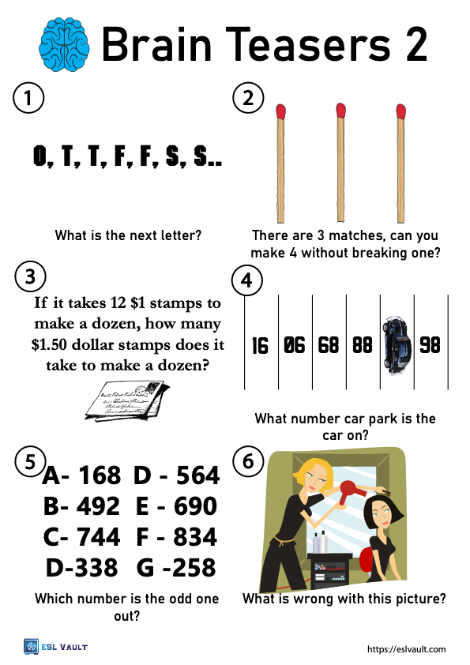

1) The next letter should be E. The letters represent the first letter of the numbers one, two, three, four, five, six, and seven. 2) Simply arrange the matchsticks into the numeral 4 which is 3 strokes or lines. 3) 12. 4) The car is in park number 87. The picture is upside down. Turn it over the other way to see it clearly. 5) The odd one out is D. All the other 3 digit numbers add up to 15. In D the numbers add up to 14 (3+3+8=14). 6) The cord/lead for the electric hairdryer is missing. The start of the lead can be seen behind the hairdresser but then it stops

Answers:

**Welcome to our new and returning clients!**

Click on the text box and Insert names

**A gigantic THANK YOU to all who referred us last month…**

Insert names

Get a

with my

**Referral Rewards Program**

As you probably know, advertising is very expensive. Instead of paying the newspaper or another place to advertise, we’d rather reward you. So we’ve assembled the Referral Rewards Program.

Every time you refer someone who becomes a client, we will send you a gift certificate for two passes to the **Movies-8 Cinema.**

And Hey! What’s a movie without popcorn? The gift certificate will also cover a big box of hot, buttered popcorn and sodas!

*Come by our store to   
claim your prize!*

**Be sure to stop by to pick out and schedule   
your new floor installation, and   
from our families to yours have a great month!**

**Your Company Name**

123 Address, Someplace, ZZ 555555

555.555.5555 Phone ⚫ 555.555.5555 Fax

email@yourcompanyname.com

**YourCompanyWebsite.com**