

Reliable news for healthy living, saving money, and having fun!



**June 2** National Donut Day **June 18** Father’s Day **June 19** Juneteenth

**Jimbo’s Floors**

Suzie Smith!

You are this month’s   
Mystery Winner!

We have a   
**$10.00 Starbucks   
gift card**   
reserved just for you!

Come by our store to   
claim your prize!

Inside This Issue…

* Are you this month’s Mystery Winner?
* Month at a Glance
* Did you Know
* Mega Trivia Contest
* June 2023 Interior Design Trends
* Thank you for the Kind Words
* Client of the Month
* Best states for hiking trails
* A new year, your home’s fresh start

*“You’ll love your new floors or I’ll replace them free!”*

~Jim Armstrong & Mick  
[www.JimbosFloors.com](http://www.JimbosFloors.com)

Scan to see our website

Dear Friends,

Your personal message goes here.

The personal message is important because it allows you to connect in a very personal way with your clients. This personal connection is sorely lacking in most businesses. Topic ideas:

Your hobbies

Something interesting happening this month. Wish them “Merry Christmas” or “Happy Thanksgiving.”

A thought from your heart

Appreciation for your clients and their referrals. Remind them that you will bend over backwards to provide their referrals with World Class Service.

Mention that month’s “special offer” insert

Your Friend,

Your Signature

Your Name

June 2023

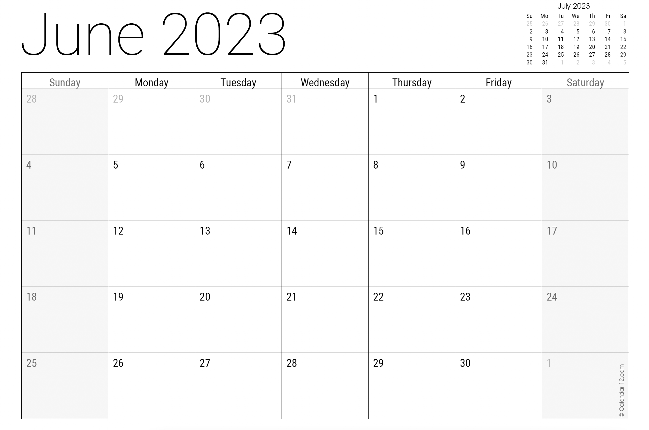

Month at a Glance!

(NOTE: see the HA instructions for this month if you don’t have the Jim Armstrong Marketing Website to direct them to.)

**We’d be happy to   
send you our electronic newsletter!**

The same combination of useful tips and offbeat stories you read here, but with these differences:

* The e-Neighborhood Advisor will arrive in your email account once you give us permission
* We send it once a week
* The e-Neighborhood Advisor does not have the same content as the print Neighborhood Advisor – you’ll read all new stories, from helpful advice to items that give you a smile

Simply let us know which email account you’d like us to use for the e-Neighborhood Advisor.

Congratulations to last month’s winner: **Client Name**

Come by our store to claim your prize!

***Last month’s question****:   
What flavor ice cream did Baskin-Robbins release in 1969 to commemorate America’s landing on the moon?*

***A) Lunar Cheesecake*** *B) Butterscotch Blonde C) Moon Lemon D) Moon Pie*

What is illegal to eat with a fork in Georgia?

A) Soup B) Fried Chicken C) Spaghetti D) Steak

To enter, email [Support@JimbosFloors.com](mailto:Support@JimbosFloors.com) and enter “Mega Trivia Contest” as the subject line. Take your best guess…your chances of winning are better than you think!

### Who Else Wants to Win

### Dinner for Two at the City Café!

### Take our Trivia Challenge and *you could win too!*

This month’s Mega Trivia question:

Welcome to the month of June, a time of transition and new beginnings. As we embark on this month, we can anticipate exciting changes in the world of interior design. From sustainable materials to natural elements, multifunctional spaces to warm metallics, there are intriguing trends that are set to shape the interior design landscape. Let's explore some of the top trends to watch for in June 2023, as we prepare to elevate our spaces with style and functionality.

**Sustainable materials:** Environmentally conscious interior design is gaining momentum, with sustainable materials like bamboo, cork, and recycled materials taking center stage. Not only do these materials add a unique touch to any space, but they also contribute to a greener and more sustainable lifestyle.

**Embracing nature:** The beauty of natural elements like wood, stone, and plants is finding its way into interior design. These elements bring warmth, comfort, and a sense of connection with nature to any space, creating a more inviting and rejuvenating atmosphere.

**Biophilic design:** The concept of biophilic design, which seeks to incorporate nature into the built environment, is also on the rise. Living walls, ample natural light, and views of nature are being incorporated to foster a deeper connection with the natural world and enhance well-being.

**Minimalist approach:** The enduring trend of minimalist design continues to captivate interior design enthusiasts. With its emphasis on simplicity, functionality, and clean lines, this trend creates a sense of calm and tranquility in a space, allowing for a more focused and mindful living experience.

**Multifunctional spaces:** With the continued rise of remote work, the demand for multifunctional spaces is on the rise. Home offices that double as guest rooms or recreation areas, for example, are becoming more popular, offering flexibility and maximizing limited space.

**Warm metallics:** Warm metallic finishes like brass and copper are making a comeback in interior design. These materials add a touch of glamour, sophistication, and visual interest to a space, providing an elegant and eye-catching focal point.

These trends are set to create comfortable, inviting spaces that are not only stylish but also environmentally conscious and practical. So get ready to embrace the latest interior design trends and elevate your space to new heights!

June 2023 Interior Design Trends



The United States is home to some of the most beautiful and diverse hiking trails in the world. It's difficult to pick just one state that has the best hiking trails, as different states have different strengths. However, here are a few states that are known for their excellent hiking trails:

**California:** California offers a wide variety of hiking trails, from the rugged Sierra Nevada Mountains to the scenic Pacific Coast. Some of the best hiking trails in California include the John Muir Trail, the Pacific Crest Trail, and the Mist Trail to Vernal and Nevada Falls in Yosemite National Park.

**Colorado:** Colorado is known for its rugged mountains and stunning alpine scenery. Some of the best hiking trails in Colorado include the Maroon Bells in Aspen, the Four Pass Loop in Maroon Bells-Snowmass Wilderness, and the Mount Elbert Trail, the highest peak in the Rocky Mountains.

**Oregon:** Oregon is home to some of the most diverse and beautiful hiking trails in the United States. Some of the best hiking trails in Oregon include the Eagle Creek Trail in the Columbia River Gorge, the Pacific Crest Trail, and the Timberline Trail around Mount Hood.

**Utah:** Utah offers some of the most spectacular hiking trails in the American Southwest. With its red-rock canyons, towering sandstone cliffs, and colorful slot canyons, it's a hikers paradise. Some of the best hiking trails in Utah include Angels Landing in Zion National Park, The Narrows in Zion National Park, and the Delicate Arch Trail in Arches National Park.

**North Carolina:** The North Carolina's Blue Ridge Mountains is home to the famous Appalachian Trail, which stretches more than 2,000 miles through 14 states from Maine to Georgia. It's one of the most iconic hiking trails in the country. The state also offers many other excellent hiking trails such as the Linville Gorge and the Chimney Rock at Chimney Rock State Park.

These are just a few examples of the many great hiking trails that can be found throughout the United States. Each state offers its own unique hiking experiences, so it's worth checking out the trails in your area or planning a trip to explore the trails in another state.

Always be prepared before hitting the trails, check the weather and trail condition, bring enough food and water and tell someone where you are going and when you expect to be back. Let us know what your favorite trail is!

Best states for hiking trails



Congratulations to our

**Susan Johnson!**

Susan is a 3rd time returning client, and she recently purchased new laminate for her kitchen and dining room. She always has a big smile on her face and is a lot of fun to work with. *Thanks, Susan!*

As always, our clients of the month receive **2 movie passes for Movies-8!**

*Watch for your name here in a coming month!*

Come by our store to   
claim your prize!

“My new laminate floors in my kitchen and dining room are beautiful. I was treated with respect and courtesy as a single woman raising a daughter. I genuinely felt that Jim Armstrong and his staff display concern for my flooring needs and were a guiding light for me. I recommend his service to anyone looking for a supportive, positive experience.”

~Marsha Avalos, School Teacher, Yuba City

“We Recently went to Jimbo’s Floors for new tile for our bathroom, and we’re thrilled with the results! This is our third time using Jimbo’s. Jim will never make you feel uncomfortable for asking questions and he’ll do anything in his power to accommodate your needs. When you do business with Jim and the staff at Jimbo’s Floors, you will be treated like royalty. Our experience was painless and very professional. Jim is not only our flooring expert, he’s a friend. That’s how he makes you feel.”

~Marvin and Sandy Moeller, owners of Sierra Landscaping, Yuba City

Thank You for the Kind Words!



**Be sure to stop by to pick out and schedule   
your new floor installation, and   
from our families to yours have a great month!**

**Welcome to our new and returning clients!**

Click on the text box and Insert names

**A gigantic THANK YOU to all who referred us last month…**

Insert names

Get a

with my

**Referral Rewards Program**

As you probably know, advertising is very expensive. Instead of paying the newspaper or another place to advertise, we’d rather reward you. So we’ve assembled the Referral Rewards Program.

Every time you refer someone who becomes a client, we will send you a gift certificate for two passes to the **Movies-8 Cinema.**

And Hey! What’s a movie without popcorn? The gift certificate will also cover a big box of hot, buttered popcorn and sodas!

*Come by our store to   
claim your prize!*

Happy Brain Teaser Month!

1. A bundle of nerves 2. Small potatoes 3. Pinching pennies 4. Back on one’s feet 5. The birds and the bees 6. Finger in the pie 7. One in a million 8. Grey matter 9. Too funny for words 10. Not worth a red cent.

Answers:

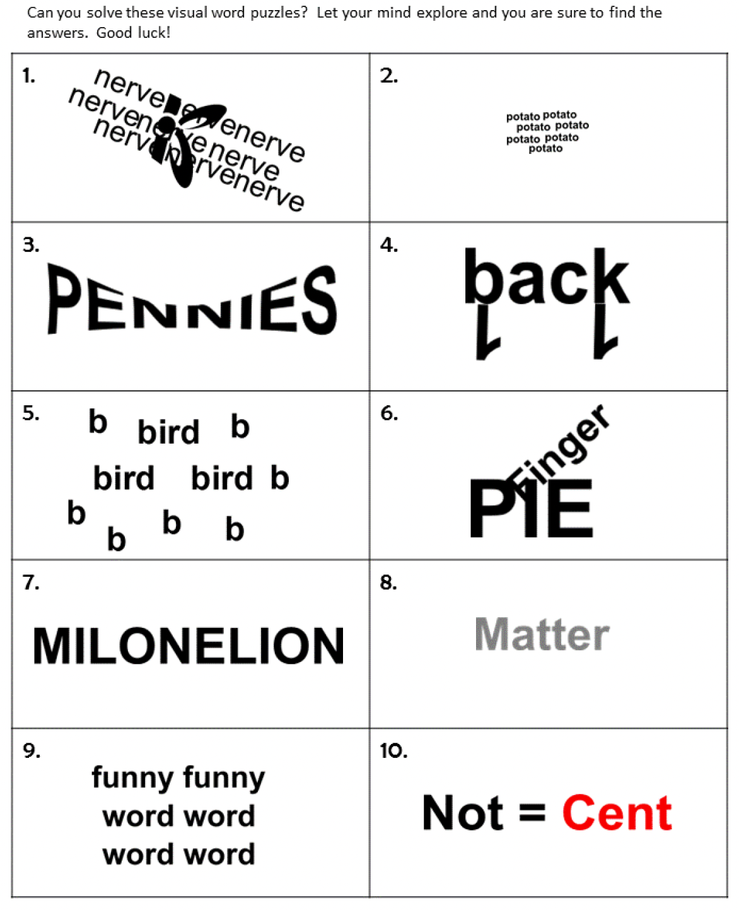

**Your Company Name**

123 Address, Someplace, ZZ 555555

555.555.5555 Phone ⚫ 555.555.5555 Fax

email@yourcompanyname.com

**YourCompanyWebsite.com**