

Reliable news for healthy living, saving money, and having fun!

********

Dear Friends,

Your personal message goes here.

The personal message is important because it allows you to connect in a very personal way with your clients. This personal connection is sorely lacking in most businesses. Topic ideas:

Your hobbies

Something interesting happening this month. Wish them “Merry Christmas” or “Happy Thanksgiving.”

A thought from your heart

Appreciation for your clients and their referrals. Remind them that you will bend over backwards to provide their referrals with World Class Service.

Mention that month’s “special offer” insert

Your Friend,

Your Signature

Your Name

**April 6 Passover begins**

**April 9 Easter Sunday**

Inside This Issue…

* Are you this month’s Mystery Winner?
* Month at a Glance
* Did you Know
* Mega Trivia Contest
* Really Short Workouts That Make a Difference
* Things You Didn’t Know About the Sinking of the Titanic
* Thank you for the Kind Words
* Client of the Month
* Find the Easter Treats!

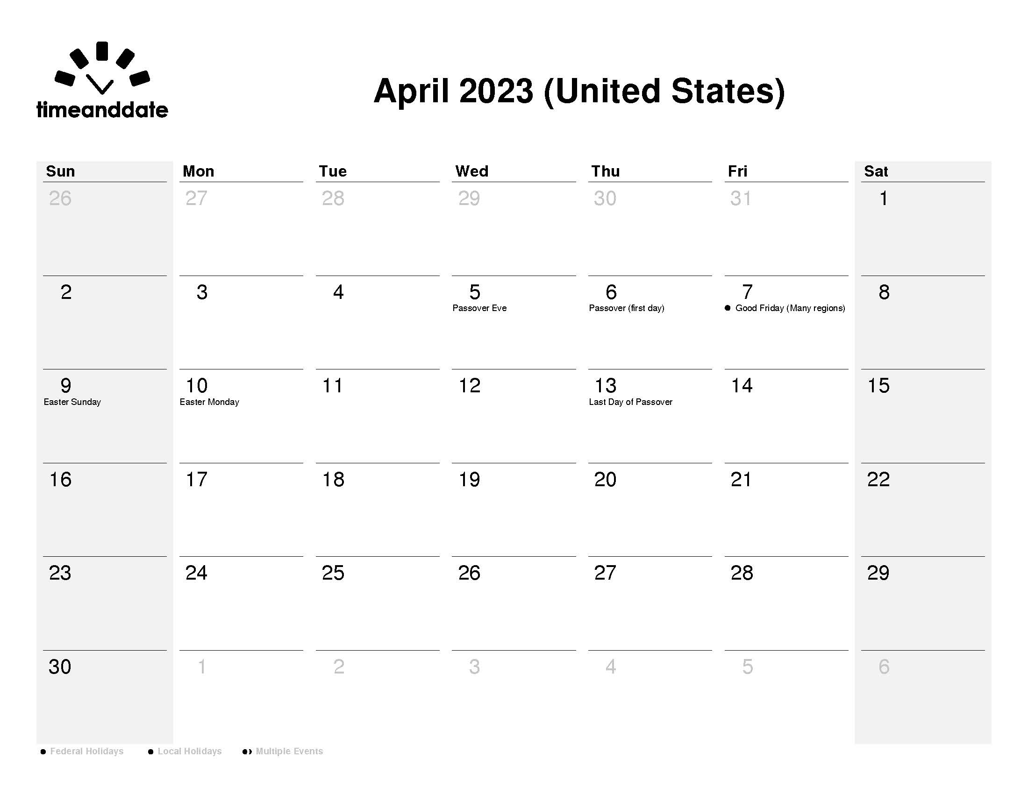

April 2023

Suzie Smith!

You are this month’s   
Mystery Winner!

We have a   
**$10.00 Starbucks   
gift card**   
reserved just for you!

Come by our store to   
claim your prize!

Scan to visit our website

*“You’ll love your new floors or I’ll replace them free!”*

~Jim Armstrong & Mick  
[www.JimbosFloors.com](http://www.JimbosFloors.com)

**Jimbo’s Floors**

Month at a Glance!

The science has spoken: you do not need to exercise for hours on end in order to improve all aspects of your health, nor to boost your life expectancy. In fact, the secret to feeling fit, healthy and mentally buoyant actually lies in how consistently you move, according to *British Vogue*. Even the most die-hard fitness experts agree that getting your heart pumping, however you choose to do it, is the ticket to improving your health – and you don’t need to be committing to hour-long studio classes to do that.

So, how short is short? And how can those of us who are time-poor (or exercise-averse) reap the benefits? Here is some of the science that illustrates how ‘exercise snacks’ of 10 minutes or less can make all the difference. Turns out even a four second burst of intense exercise could make us fitter. A small 2021 study saw a group of young, healthy individuals in their twenties cycle at maximum effort for four seconds, then rest for around 15 to 30 seconds, 30 times, thrice weekly – amounting to two minutes of intense exercise three times a week, or six minutes total per week. Findings showed improved cardio and anaerobic power (meaning they could generate more power with less oxygen), and while it’s important to note the participants were already young and fit, the research nonetheless suggests that even as little as two minutes of really intense HIIT exercise can pay dividends.

A study published in December 2022 by *Nature Medicine* (which surveyed the fitness tracking records of over 25,000 people with an average age of 60, who didn’t regularly exercise), found that small bursts of movement throughout the day – be that two minutes of fast walking or quickly climbing the stairs – showed a 50 percent decrease in death from cardiovascular problems and a further 40 percent decrease in the risk of dying from cancer, compared to those who had no spurts of movement at all. Put simply, even the smallest amounts of exercise can increase our life expectancy – so next time you’re faced with the choice of “stairs or elevator?” always choose the stairs.

Have you heard of Tabata? A favorite in fitness circles, it’s a type of workout that takes just four minutes. The idea – the brainchild of Dr Tabata in 1996 – is to do 20 seconds of work at maximum effort, followed by 10 seconds of rest. Exercises might include squat jumps, push-ups, high knees or mountain climbers (or a mix, alternated). Hard work but over before you know it, even four-minute bursts can help lower the risk of premature death.

While you don’t have to toil over the dumbbells to make a difference to your health, research points to the fact that consistency is key. Move a little each day and make a promise to yourself to prioritize it – there is always time for a quick walk.

**You Get A FREE Lifetime Installation Warranty With Every Floor From Jimbo’s!**

Buying flooring is not like buying any other piece of interior décor, such as a sofa or a lamp. Why? Because unlike other products, flooring is installed or “manufactured” in your home. This makes the installation critical. I offer a lifetime installation warranty at Jimbo’s Floors. You NEVER have to worry about something going wrong with the installation. If it does, I’ll fix it FREE! And I’ll do it quickly.

(NOTE: see the HA instructions for this month if you don’t have the Jim Armstrong Marketing Website to direct them to.)

***Last month’s question****:   
What celebrity was married nine times?   
A) Larry King* ***B) Zsa Zsa Gabor*** *C) Richard Pryor D) Elizabeth Taylor*

After google.com, what is the most visited website in the U.S.?

A) Facebook B) You Tube C) Wikipedia D) Amazon

To enter, email [Support@JimbosFloors.com](mailto:Support@JimbosFloors.com) and enter “Mega Trivia Contest” as the subject line. Take your best guess…your chances of winning are better than you think!

Congratulations to last month’s winner: **Client Name**

Come by our store to claim your prize!

### Who Else Wants to Win

### Dinner for Two at the City Café!

### Take our Trivia Challenge and *you could win too!*

This month’s Mega Trivia question:

Really Short Workouts That Make a Difference

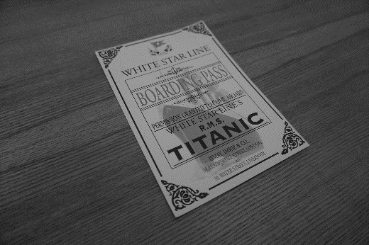

Things You Didn’t Know About the Sinking of the Titanic



Congratulations to our

**Susan Johnson!**

Susan is a 3rd time returning client, and she recently purchased new laminate for her kitchen and dining room. She always has a big smile on her face and is a lot of fun to work with. *Thanks, Susan!*

As always, our clients of the month receive **2 movie passes for Movies-8!**

*Watch for your name here in a coming month!*

Come by our store to   
claim your prize!

April 15, 1912 is the day the British ocean liner Titanic sank after hitting an iceberg during its maiden voyage from Southampton to New York City. Here are surprising facts you may not know about the sinking of the Titanic from *Trivia Today*.

**The Sinking of the Titanic Was Predicted in More Than One Book**

The first was the 1886 novel The Sinking of a Modern Liner, a British story about a ship that leaves Liverpool for New York, hits something, sinks, and loses most of her passengers because she lacked the correct number of lifeboats. What's even stranger is that the author of this book, W.T. Stead, died on the Titanic. Another book is 1898's Futility, or the Wreck of the Titan, in which a liner named Titan, supposedly unsinkable, hits an ice shelf and sinks. Additional creepy details include sinking off Newfoundland, like the Titanic; not having enough lifeboats; and traveling at similar speeds. A third book was 1908's The Ship's Run. However, there were so many similarities between the Titanic and the ship in the book that there is speculation that the author saw construction plans for the Titanic before writing the story. The fourth book was 1912's The White Ghost of Disaster. This book saw a ship crash at a specific speed—the same one that the Titanic traveled at when it hit the iceberg.

**The Last Titanic Survivor Died in 2009**

The last survivor of the Titanic died at age 97 in 2009. Millvina Dean, was also the youngest passenger on the ship, which she boarded with her parents and brother at just two months old. Although third-class passengers, she, her mother, and her brother escaped in a lifeboat, but her father went down with the ship.

**One of The Ship's Musicians Wasn't Officially Declared Dead Until 2000**

One of the ship's musicians, a 21-year-old cellist, was not actually declared dead until 2000. Roger Bricoux was the Titanic's cello player when he perished during the ship's sinking. But Bricoux wasn't officially declared dead until 2000 although he went down with the ship.

**One Little Key Might Have Prevented the Collision**

A number of factors contributed to the sinking of the ship, of course, but being able to spot icebergs ahead of time would have really helped. The ship did carry binoculars that lookouts could have used. However, the binoculars were all locked away -- and the one key that could have given the crew access was carried by the ship's second officer who was replaced from the ship's crew at the last minute. The ship's lookouts, Frederick Fleet and Reginald Lee, instead had to rely on their eyesight alone. The key resurfaced at auction in 2010, where it was sold for over $130,000.

“My new laminate floors in my kitchen and dining room are beautiful. I was treated with respect and courtesy as a single woman raising a daughter. I genuinely felt that Jim Armstrong and his staff display concern for my flooring needs and were a guiding light for me. I recommend his service to anyone looking for a supportive, positive experience.”

~Marsha Avalos, School Teacher, Yuba City

“We Recently went to Jimbo’s Floors for new tile for our bathroom, and we’re thrilled with the results! This is our third time using Jimbo’s. Jim will never make you feel uncomfortable for asking questions and he’ll do anything in his power to accommodate your needs. When you do business with Jim and the staff at Jimbo’s Floors, you will be treated like royalty. Our experience was painless and very professional. Jim is not only our flooring expert, he’s a friend. That’s how he makes you feel.”

~Marvin and Sandy Moeller, owners of Sierra Landscaping, Yuba City

Thank You for the Kind Words!



**Welcome to our new and returning clients!**

Click on the text box and Insert names

**A gigantic THANK YOU to all who referred us last month…**

Insert names

Get a

with my

**Referral Rewards Program**

As you probably know, advertising is very expensive. Instead of paying the newspaper or another place to advertise, we’d rather reward you. So we’ve assembled the Referral Rewards Program.

Every time you refer someone who becomes a client, we will send you a gift certificate for two passes to the **Movies-8 Cinema.**

And Hey! What’s a movie without popcorn? The gift certificate will also cover a big box of hot, buttered popcorn and sodas!

*Come by our store to   
claim your prize!*

Find the Easter Treats!

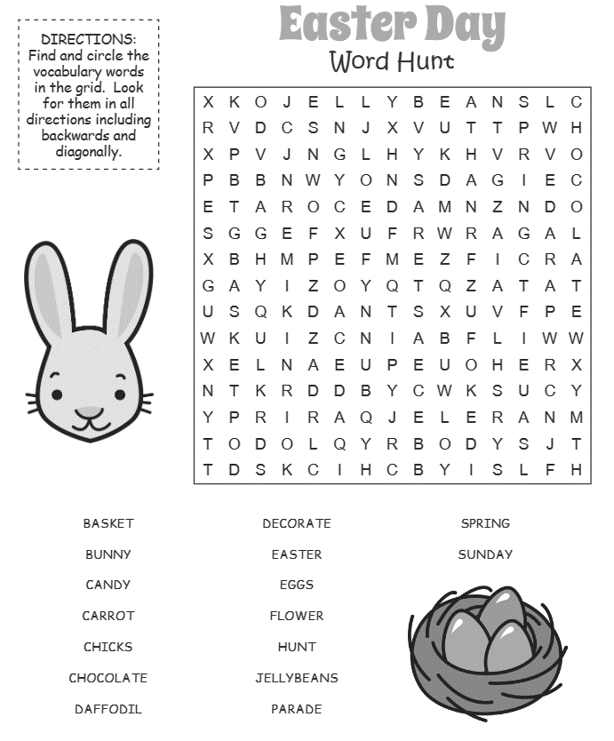

**Be sure to stop by to pick out and schedule   
your new floor installation, and   
from our families to yours have a great month!**

**Your Company Name**

123 Address, Someplace, ZZ 555555

555.555.5555 Phone ⚫ 555.555.5555 Fax

email@yourcompanyname.com

**YourCompanyWebsite.com**