

Reliable news for healthy living, saving money, and having fun!

********

Suzie Smith!

You are this month’s   
Mystery Winner!

We have a   
**$10.00 Starbucks   
gift card**   
reserved just for you!

Come by our store to   
claim your prize!

**February 9** National Pizza Day **February 12** Superbowl Sunday **February 14** Valentine’s Day **February 20** President’s Day

Inside This Issue…

* Are you this month’s Mystery Winner?
* Month at a Glance
* Did you Know
* Mega Trivia Contest
* Valentine’s Traditions from Around the World
* Things You Didn’t Know About Thomas Jefferson
* Thank you for the Kind Words
* Client of the Month
* Solve the Football Word Scramble!

*“You’ll love your new floors or I’ll replace them free!”*

~Jim Armstrong & Mick  
[www.JimbosFloors.com](http://www.JimbosFloors.com)



February 2023

Scan to visit our website

Dear Friends,

Your personal message goes here.

The personal message is important because it allows you to connect in a very personal way with your clients. This personal connection is sorely lacking in most businesses. Topic ideas:

Your hobbies

Something interesting happening this month. Wish them “Merry Christmas” or “Happy Thanksgiving.”

A thought from your heart

Appreciation for your clients and their referrals. Remind them that you will bend over backwards to provide their referrals with World Class Service.

Mention that month’s “special offer” insert

Your Friend,

Your Signature

Your Name

**Jimbo’s Floors**

Month at a Glance!

**When you buy floors from us, you are protected by our Installer Professionalism guarantee! It’s part of our Jimbo’s Floors 100% Iron-Clad Triple Guarantee.**

Our installers are neat, clean, well-groomed, well-spoken and professional. They are trained and certified. They are guests in your home, and they conduct themselves as such. They respect your home by using wall and corner guards, shoe covers and drop cloths.

You’ll receive the highest-quality installation in the business. And after they’re finished, they will leave your home as neat and clean as when they arrived!

.

***Last month’s question****:   
What month is named after the first Roman emperor?  
A) January B) March   
C) April* ***D) August***

Check out the interesting **Valentine’s day traditions around the world** from *Travel Triangle*. This day isn’t all about flowers and chocolates around the world. Different countries celebrate it in their own way.

**Argentina**

Argentinians don’t celebrate Valentine’s Day in Feb, but “the week of sweetness” in July. It’s the week when lovers exchange kisses and receive chocolates and other sweets.

**France**

It is believed that the first-ever Valentine’s Day card was originated in France, when Charles, the Duke of Orleans, sent love letters to his wife from the prison in 1415. And the French village called “Valentine” turns into the epicenter of romance between February 12-14. One can see the beautiful yards, trees, and homes decorated with cards, roses, and proposals for marriage. It probably is the most beautiful Valentine’s Day traditions in the world.

**South Korea**

Romantic couples in South Korea celebrate the day of love on the 14th of each month. “The day of roses” is celebrated in May, “the day of kisses” is celebrated in June, “the day of hugs in December” and single people celebrate “the black day” in April by eating black noodles.

**Philippines**

In the Philippines, Valentine’s Day is the time when many young couples marry in an event sponsored by the government as a form of public service. Among the most amazing Valentine’s Day celebrations around the world, this one is a gala event in the country and a special day for young people.

**Ghana**

In Ghana, Feb 14 is celebrated as “National Chocolate Day.” It is a step that the Ghana government took in 2007 to increase tourism in the country. Ghana is among the largest cocoa-producing countries in the world.

**Bulgaria**

On February 14, San Trifon Zartan is celebrated in Bulgaria, which means “day of winemakers”. Young and old couples celebrate their love with a glass of wonderful local wine.

**Japan**

Japan does it quite differently. It is celebrated on February 14 and women buy gifts and chocolates for their male companions or lovers. Men can’t return gifts until March 14, which is called the “white day.”

Which famous jeweler makes the Super Bowl trophy?

A) Cartier B) Harry Winston C) Tiffany & Co D) Zales

To enter, email [Support@JimbosFloors.com](mailto:Support@JimbosFloors.com) and enter “Mega Trivia Contest” as the subject line. Take your best guess…your chances of winning are better than you think!

Congratulations to last month’s winner: **Client Name**

Come by our store to claim your prize!

(NOTE: see the HA instructions for this month if you don’t have the Jim Armstrong Marketing Website to direct them to.)

### Who Else Wants to Win

### Dinner for Two at the City Café!

### Take our Trivia Challenge and *you could win too!*

This month’s Mega Trivia question:

Valentine’s Traditions from Around the World

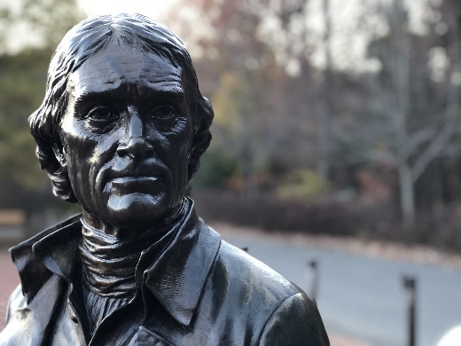

Things You Didn’t Know About Thomas Jefferson



Congratulations to our

**Susan Johnson!**

Susan is a 3rd time returning client, and she recently purchased new laminate for her kitchen and dining room. She always has a big smile on her face and is a lot of fun to work with. *Thanks, Susan!*

As always, our clients of the month receive **2 movie passes for Movies-8!**

*Watch for your name here in a coming month!*

Come by our store to   
claim your prize!

With President’s Day occurring this month, here are some lesser-known facts from *Trivia Today* about the author of the Declaration of Independence and the third president of the United States.

**He Bribed A Reporter**

James Callender condemned some politicians in his news articles for their indiscretions. His attention turned to Jefferson in 1801 because he had heard that he was romantically involved with Sally Hemings, his slave. Callender tried to blackmail Jefferson, asking for $200 and a postmaster’s job in exchange for keeping quiet. Although Jefferson angrily paid him $50, the reporter broke the news anyway. Callender later drowned in the James River in 1803.

**He Invented A Few Things**

Jefferson used his talent as an inventor to improve upon his farm at Monticello. Anxious to till soil more efficiently, he and his son-in-law Thomas Mann Randolph conceived of a plow that could navigate hills. Jefferson also made improvements to a dumbwaiter, a small elevator used to transport food and other items up and down different house levels without using the stairs.

**Jefferson Helped To Restock the Library of Congress**

British forces burned the Library of Congress during the War of 1812, reducing its 3000-volume library of books to ashes. To repopulate the repository of knowledge, Jefferson sold Congress his entire personal library of 6,707 books for $23,950. The books from Jefferson’s library were transported by wagon to Washington, D.C., from his home in Virginia.

**Jefferson Was One of The Founders of The University of Virginia**

Jefferson was a strong advocate of education and worked to establish a higher education institution in Virginia. Jefferson arranged funding, contributed design ideas, and helped shepherd the University of Virginia toward its opening in 1825.

**He Died On The Same Day As John Adams**

On July 4, 1826, Thomas Jefferson and John Adams, who were once fellow Patriots and then adversaries, died on the same day. Both men were the last surviving members of the original American revolutionaries who had stood up to the British empire and forged a new political system in the former colonies. On July 4, 1826, at the age of 90, Adams lay on his deathbed while the country celebrated Independence Day. His last words were, "Thomas Jefferson still survives." He was mistaken: Jefferson had died five hours earlier at Monticello at the age of 83.

“My new laminate floors in my kitchen and dining room are beautiful. I was treated with respect and courtesy as a single woman raising a daughter. I genuinely felt that Jim Armstrong and his staff display concern for my flooring needs and were a guiding light for me. I recommend his service to anyone looking for a supportive, positive experience.”

~Marsha Avalos, School Teacher, Yuba City

“We Recently went to Jimbo’s Floors for new tile for our bathroom, and we’re thrilled with the results! This is our third time using Jimbo’s. Jim will never make you feel uncomfortable for asking questions and he’ll do anything in his power to accommodate your needs. When you do business with Jim and the staff at Jimbo’s Floors, you will be treated like royalty. Our experience was painless and very professional. Jim is not only our flooring expert, he’s a friend. That’s how he makes you feel.”

~Marvin and Sandy Moeller, owners of Sierra Landscaping, Yuba City

Thank You for the Kind Words!



**Be sure to stop by to pick out and schedule   
your new floor installation, and   
from our families to yours have a great month!**

Solution: 1. Guard 2. Huddle 3. Center 4. Halftime 5. Punt 6. Linebacker 7. Quarterback 8. Down. 9. Score 10. Drive 11. Handoff 12. Tackle 13. Fumble 14. Sack 15. Endzone 16. Interception 17. Fieldgoal 18. Kickoff 19. Tightend 20. Pass

**Welcome to our new and returning clients!**

Click on the text box and Insert names

**A gigantic THANK YOU to all who referred us last month…**

Insert names

Get a

with my

**Referral Rewards Program**

As you probably know, advertising is very expensive. Instead of paying the newspaper or another place to advertise, we’d rather reward you. So we’ve assembled the Referral Rewards Program.

Every time you refer someone who becomes a client, we will send you a gift certificate for two passes to the **Movies-8 Cinema.**

And Hey! What’s a movie without popcorn? The gift certificate will also cover a big box of hot, buttered popcorn and sodas!

*Come by our store to   
claim your prize!*

Solve the Cryptogram!

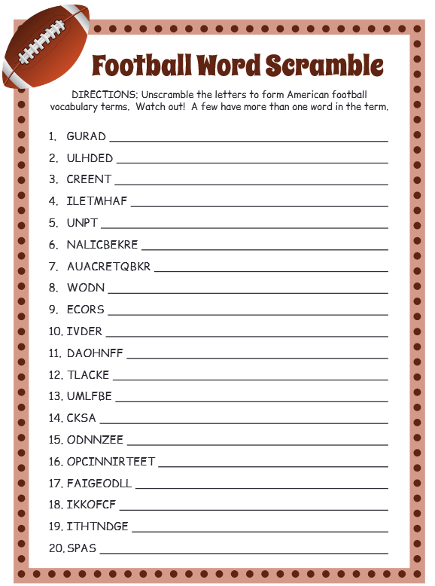

**Your Company Name**

123 Address, Someplace, ZZ 555555

555.555.5555 Phone ⚫ 555.555.5555 Fax

email@yourcompanyname.com

**YourCompanyWebsite.com**