

Reliable news for healthy living, saving money, and having fun!



Suzie Smith!

You are this month’s   
Mystery Winner!

We have a   
**$10.00 Starbucks   
gift card**   
reserved just for you!

Come by our store to   
claim your prize!

Inside This Issue…

* Are you this month’s Mystery Winner?
* Month at a Glance
* America’s First Grocery Store
* Mega Trivia Contest
* Did You Know
* Rules for Making Tough Decisions
* Thank you for the Kind Words
* Client of the Month
* Challenge Your Brain!

*“You’ll love your new floors, or I’ll replace them free!”*

~Jim Armstrong   
[www.JimbosFloors.com](http://www.JimbosFloors.com)

**September 3**

World Beard Day

**September 5**

Labor Day

**September 11**

Grandparents Day

**September 26**

Rosh Hashana



**Month at a Glance!**

September 2022

**Jimbo’s Floors**

Dear Friends,

Your personal message goes here.

The personal message is important because it allows you to connect in a very personal way with your clients. This personal connection is sorely lacking in most businesses. Topic ideas:

Your hobbies

Something interesting happening this month. Wish them “Merry Christmas” or “Happy Thanksgiving.”

A thought from your heart

Appreciation for your clients and their referrals. Remind them that you will bend over backwards to provide their referrals with World Class Service.

Mention that month’s “special offer” insert

Your Friend,

Your Signature

Your Name

Scan to see our website

**Answer to last month’s question: D) Anthony Bourdain**

Congratulations to last month’s winner: **Client Name**Come by our store to claim your prize!

Here at Jimbo’s Floors we use a special diagnostic tool called the Design Audit™.

Our free Design Audit™ is carefully crafted to take the headache out of shopping for new floors. A simple series of questions let my expert floor consultants narrow down the thousands of options to the two or three that exactly match your unique situation.

They’ll provide you with a written, customized “maintenance” plan with their professional recommendations for getting the longest life and beauty out of your floor.

### Who Else Wants to Win

### Dinner for Two

### at the City Café!

### Take our Trivia Challenge and *you could win too!*

This month’s Mega Trivia question:

Which sauce derives its name from an Italian word meaning “to pound?”

A) Alfredo B) Marinara

C) Pesto D) Carbonara

To enter, go to [www.JimbosFloors.com](http://www.JimbosFloors.com) and click on “Mega Trivia Contest.” Take your best guess… your chances of winning are better than you think!

On September 6, 1916, the first self-service grocery store, Piggly Wiggly, was opened in Memphis, Tennessee, by Clarence Saunders.

Before the first Piggly Wiggly opened, grocery customers were waited on by a salesperson who stood behind a counter, and most of the items for sale were out of their reach. Piggly Wiggly changed that by allowing customers to browse aisles and choose what they wanted themselves and then pay for them. It wasn’t a popular idea at first but quickly caught on.

**They Pioneered a Number of Firsts For Grocery Shoppers** Along with being the first self-serve grocery store, Piggly Wiggly pioneered a number of things we take for granted today. They were the first grocery store to have refrigerated cases, shopping carts, and checkout stands. In addition, their employees were the first to wear uniforms. They were also the first to develop a nationally recognized and advertised brand of food.

**The Grocery Chain Is Still Going Strong** Today, there are more than 600 store locations nationwide operating in 17 states, primarily in smaller cities and towns. Surprisingly enough, the headquarters is in Keene, New Hampshire, where they operate no grocery stores. Most of the company’s stores are located throughout the South and Midwest.

**Piggly Wiggly Was the First Company to Franchise** Clarence Saunders not only changed the way that shoppers bought food, his company was the first to offer franchises. This allowed purchasers to own and operate their own grocery stores under the Piggly Wiggly name.

**The Name “Piggly Wiggly” Is a Mystery** One story says that while riding a train, founder Clarence Saunders looked out his window and saw several little pigs struggling to get under a fence, which prompted him to think of the rhyme. Someone once asked him why he had chosen such an unusual name for his organization, to which he replied, “So people will ask that very question.” Up until his death in 1953, he never explained the reason. (Facts courtesy of *Trivia Today*.)



**America’s First Grocery Store**



**Rules for Making Tough Decisions**



“My new laminate floors in my kitchen and dining room are beautiful. I was treated with respect and courtesy as a single woman raising a daughter. I genuinely felt that Jim Armstrong and his staff display concern for my flooring needs and were a guiding light for me. I recommend his service to anyone looking for a supportive, positive experience.”

~Marsha Avalos, School Teacher, Yuba City

“We Recently went to Jimbo’s Floors for new tile for our bathroom, and we’re thrilled with the results! This is our third time using Jimbo’s. Jim will never make you feel uncomfortable for asking questions and he’ll do anything in his power to accommodate your needs. When you do business with Jim and the staff at Jimbo’s Floors, you will be treated like royalty. Our experience was painless and very professional. Jim is not only our flooring expert, he’s a friend. That’s how he makes you feel.”

~Marvin and Sandy Moeller, owners of Sierra Landscaping, Yuba City

Congratulations to our

**Susan Johnson!**

Susan is a 3rd time returning client, and she recently purchased new laminate for her kitchen and dining room. She always has a big smile on her face and is a lot of fun to work with. *Thanks, Susan!*

As always, our clients of the month receive **2 movie passes for Movies-8!**

*Watch for your name here in a coming month!*

Come by our store to   
claim your prize!

We spend an inordinate amount of time, and a tremendous amount of energy, making choices between equally attractive options in everyday situations. The problem is, that while they may be equally attractive, they are also differently attractive, with tradeoffs that require compromise.

Peter Bregman suggests several ways to make tough choices in the *Harvard Business Review*.

**The first method is to use habits as a way to reduce routine decision fatigue**. The idea is that if you build a habit — for example: always eat salad for lunch — then you avoid the decision entirely and you can save your decision-making energy for other things. That works for predictable and routine decisions. But what about unpredictable ones?

**The second method is to use if/then thinking to routinize unpredictable choices.** Let’s say someone constantly interrupts me and I’m not sure how to respond. My if/then rule might be: *if* the person interrupts me two times in a conversation, *then* I will say something.

These two techniques — habits and if/then — can help streamline many typical, routine choices we face in our lives.

**The third decision-making method: use a timer**. If the issues on the table have been reasonably vetted, the choices are equally attractive, and there is still no clear answer, then admit that there is no clearly identifiable right way to go and just decide.

The time you save by not deliberating pointlessly will pay massive dividends in productivity.

Hold on, you may protest. If I do spend more time on it, an answer will emerge. Sure, maybe. But, 1) you’ve wasted precious time waiting for that clarity and, 2) the clarity of that one decision seduces you to linger, counter-productively and in fruitless hope for clarity, on too many other decisions. Just make a decision and move forward.

Try it now. Pick a decision you have been postponing, give yourself three minutes, and just make it.

**Thank You for the Kind Words!**

**Harvest Festival Word Search!**

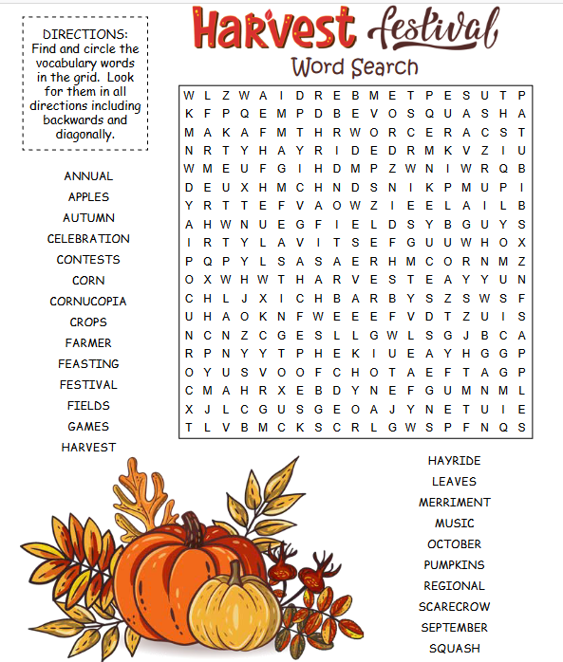 

**Your Company Name**

123 Address, Someplace, ZZ 555555

555.555.5555 Phone ⚫ 555.555.5555 Fax

email@yourcompanyname.com

**YourCompanyWebsite.com**

**Be sure to stop by to pick out and schedule   
your new floor installation, and   
from our families to yours have a great month!**

Get a

with my

**Referral Rewards Program**

As you probably know, advertising is very expensive. Instead of paying the newspaper or another place to advertise, we’d rather reward you. So we’ve assembled the Referral Rewards Program.

Every time you refer someone who becomes a client, we will send you a gift certificate for two passes to the **Movies-8 Cinema.**

And Hey! What’s a movie without popcorn? The gift certificate will also cover a big box of hot, buttered popcorn and sodas!

*Come by our store to   
claim your prize!*

**Welcome to our new and returning clients!**

Click on the text box and Insert names

**A gigantic THANK YOU to all who referred us last month…**

Insert names