

Reliable news for healthy living, saving money, and having fun!

********

**August 15**

Relaxation Day

**August 26**

National Dog Day

**Back to school!**

Inside This Issue…

* Are you this month’s Mystery Winner?
* Month at a Glance
* How to Keep Produce Fresh
* Mega Trivia Contest
* Did You Know
* Lesser-Known Facts About Lucille Ball
* Thank you for the Kind Words
* Client of the Month
* Challenge Your Brain!

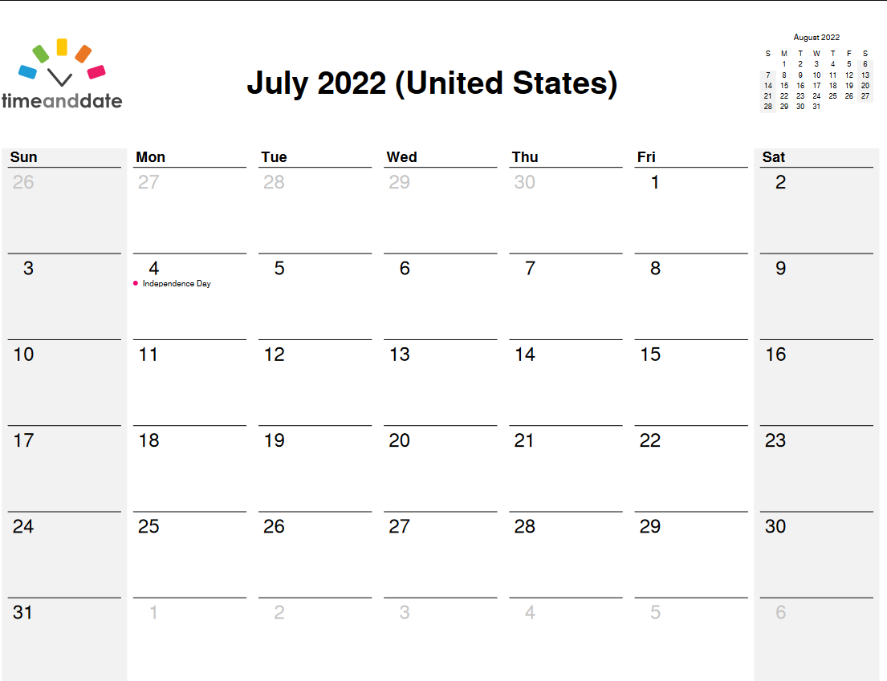

**Month at a Glance!**

August 2022

**Jimbo’s Floors**

Suzie Smith!

You are this month’s   
Mystery Winner!

We have a   
**$10.00 Starbucks   
gift card**   
reserved just for you!

Come by our store to   
claim your prize!

Dear Friends,

Your personal message goes here.

The personal message is important because it allows you to connect in a very personal way with your clients. This personal connection is sorely lacking in most businesses. Topic ideas:

Your hobbies

Something interesting happening this month. Wish them “Merry Christmas” or “Happy Thanksgiving.”

A thought from your heart

Appreciation for your clients and their referrals. Remind them that you will bend over backwards to provide their referrals with World Class Service.

Mention that month’s “special offer” insert

Your Friend,

Your Signature

Your Name

Scan to see our website

*“You’ll love your new floors, or I’ll replace them free!”*

~Jim Armstrong   
[www.JimbosFloors.com](http://www.JimbosFloors.com)

Which celebrity chef wrote mystery novels before becoming famous?

A) Julia Child B) Gordon Ramsay

C) Wolfgang Puck D) Anthony Bourdain

To enter, go to [www.JimbosFloors.com](http://www.JimbosFloors.com) and click on “Mega Trivia Contest.” Take your best guess… your chances of winning are better than you think!

**Answer to last month’s question: A) Will Ferrell**

Congratulations to last month’s winner: **Client Name**

Come by our store to claim your prize!

**When you buy floors from us, you are protected by our Installer Professionalism guarantee! It’s part of our Jimbo’s Floors 100% Iron-Clad Triple Guarantee.**

Our installers are neat, clean, well-groomed, well-spoken and professional. They are trained and certified. They are guests in your home, and they conduct themselves as such. They respect your home by using wall and corner guards, shoe covers and drop cloths.

You’ll receive the highest-quality installation in the business. And after they’re finished, they will leave your home as neat and clean as when they arrived!

### Who Else Wants to Win

### Dinner for Two

### at the City Café!

### Take our Trivia Challenge and *you could win too!*

This month’s Mega Trivia question:

If you’re tired of your produce going bad after a few days, *Popular Science* suggests a few tips to keep it fresh.

Keeping produce fresh starts with buying fresh produce in the first place. The fresher it is when you grab it off the shelf, the longer it’ll last once you take it home.

You might think local produce is your best bet, but don’t rush to the farmers market just yet. Produce at farmers markets is closer to the farm in terms of distance and time from harvest, but farmers market produce is sometimes not handled with proper temperature management, so it can be less fresh than chain grocery store produce.

So before you grab the first head of cabbage you see, ask the vendor how the products were stored and handled. Once you find a vendor you trust, stick with them. Finally, planning your meals ahead of time—and shopping accordingly—can ensure you eat food when it’s at its peak.

Refrigeration is a magical thing, which is probably why humans have relied on it, in one form or another, for centuries. But if you come home from the grocery store and toss your food on any shelf without a second thought, you might be unintentionally shortening its usable lifespan.

The USDA says your refrigerator needs to be set below 40 degrees Fahrenheit to avoid foodborne illness, but food experts recommend going a little lower for optimal freshness. Set the temperature in your refrigerator to about 36 degrees Fahrenheit—basically as low as you can without freezing the lettuce (which freezes at just below 32 degrees Fahrenheit).

If your fridge doesn’t have a built-in thermometer, consider buying an appliance thermometer to make sure the fridge is adhering to your desired temperature.

If you have multiple drawers, they may be intended for different types of food or have humidity sliders you can set. In general, you want one drawer set to high humidity and one set to low, with wilt-prone vegetables in the high-humidity drawer, and rot-prone produce such as apples and zucchini in low humidity.

Finally, some produce shouldn’t be stored in the fridge at all. Tomatoes, bananas, basil, mango, papaya, and other tropical fruits will lose quality when stored below room temperature, so leave those out on the counter for optimal freshness. Once you peel and slice them, though, they should go in the fridge for safety reasons.

When it comes to your freezer, zero degrees Fahrenheit will keep your food safe to eat almost indefinitely. Not all produce freezes well, though, so check out [this good-but-not-exhaustive list](https://nchfp.uga.edu/how/freeze/dont_freeze_foods.html/) of foods that will lose quality at freezing temperatures.

## Storage Is Key

“I think more produce in home refrigerators reaches the limit of its acceptable quality due to water loss than anything else,” Brecht says.

So if your lettuce won’t stop wilting, your goal should be to keep its moisture level high. Leave your produce in the plastic bags they provide at the grocery store before placing it in the drawer, so moisture doesn’t escape. You can also place a moistened paper towel in the produce drawer to increase its relative humidity, Brecht says.

In addition, you’ll want to store certain produce closer (or farther away) from other fruits and vegetables to avoid over-ripening.

“As some fruits ripen, they produce ethylene, a gas that promotes both the ripening of those fruits plus aging of other fruits and vegetables,” Brecht says.

That includes apples, pears, avocados, bananas, kiwifruit, peaches, plums, and other ethylene-sensitive fruits, so you’ll want to keep those away from other produce to avoid damage. You can, however, use this to your advantage.

“You can use the ethylene produced by ripening fruits like apples, avocados or bananas to speed up the ripening of other ethylene-producing fruits by putting them together in a loosely closed bag or in a fruit ripening bowl,” Brecht says.

It can feel a bit like a logic puzzle getting all your fruits and vegetables in their optimal storage spots, but you’ll get the hang of it. At the end of the day, planning your meals and shopping with a purpose is the best thing you can do. The more work you can do up front, the less often you’ll be disappointed by another head of wilted lettuce.



**How to Keep Produce Fresh**



**Lesser-Known Facts About Lucille Ball**



Congratulations to our

**Susan Johnson!**

Susan is a 3rd time returning client, and she recently purchased new laminate for her kitchen and dining room. She always has a big smile on her face and is a lot of fun to work with. *Thanks, Susan!*

As always, our clients of the month receive **2 movie passes for Movies-8!**

*Watch for your name here in a coming month!*

Come by our store to   
claim your prize!

On August 6, 1911, Lucille Desiree Ball, one of America’s most famous redheads and beloved comic actresses, was born near Jamestown, New York. Here are some lesser-known facts from *Trivia Today* about Lucille Ball...

**“Star Trek” Wouldn’t Have Existed Without Her** “If it were not for Lucy, there would be no Star Trek today,” former studio executive Ed Holly told Desilu historian Coyne Steven Sanders. CBS wasn’t interested in “Star Trek,” but Ball, who was talented at spotting a new show that would appeal to large numbers of viewers, overruled the decision and had the pilot produced. The initial pilot bombed, so a second pilot was made and funded by Ball that starred William Shatner as Captain James T. Kirk. Star Trek ended up making the 1966 fall TV schedule.

**Ball’s Pregnancy Was the First on Television** She also made headlines by becoming the first pregnant woman to play a pregnant woman on TV. Season 2 of “I Love Lucy” was a first on television because Lucille Ball was pregnant with Desi Arnaz Jr and it was written into the script. If network execs hadn’t agreed to it, the show might have been canceled or suspended until she had her baby. The birth of her own baby coincided with Lucy Ricardo’s, and about 44 million viewers tuned in to watch.

**She and Her Husband Were Television’s First Interracial Couple** Kathleen Brady, who wrote a popular book about Lucille Ball, said the network executives and Philip Morris, the sponsor, wanted her to star in her own show but had no interest in her husband, Desi. Brady said. “They said that the American public would not accept Desi as the husband of a red-blooded American girl.” However, Ball defended Arnaz, and according to Brady, she told CBS that they’d have to either cast them both or neither of them.

**She Was the First Woman to Run a Major Production Company** Following Ball’s divorce from Desi Arnaz in 1960, she bought out Arnaz’s shares of Desilu for $2.5 million, making her the first female CEO of a major production company. Per the outlet, she later sold her Desilu shares to Paramount Studios for $17 million.

“My new laminate floors in my kitchen and dining room are beautiful. I was treated with respect and courtesy as a single woman raising a daughter. I genuinely felt that Jim Armstrong and his staff display concern for my flooring needs and were a guiding light for me. I recommend his service to anyone looking for a supportive, positive experience.”

~Marsha Avalos, School Teacher, Yuba City

“We Recently went to Jimbo’s Floors for new tile for our bathroom, and we’re thrilled with the results! This is our third time using Jimbo’s. Jim will never make you feel uncomfortable for asking questions and he’ll do anything in his power to accommodate your needs. When you do business with Jim and the staff at Jimbo’s Floors, you will be treated like royalty. Our experience was painless and very professional. Jim is not only our flooring expert, he’s a friend. That’s how he makes you feel.”

~Marvin and Sandy Moeller, owners of Sierra Landscaping, Yuba City

**Thank You for the Kind Words!**

**Challenge your Brain!**

 

Get a

with my

**Referral Rewards Program**

As you probably know, advertising is very expensive. Instead of paying the newspaper or another place to advertise, we’d rather reward you. So, we’ve assembled the Referral Rewards Program.

Every time you refer someone who becomes a client, we will send you a gift certificate for two passes to the **Movies-8 Cinema.**

And Hey! What’s a movie without popcorn? The gift certificate will also cover a big box of hot, buttered popcorn and sodas!

*Come by our store to   
claim your prize!*

ANSWERS 1) Primp 2) Hunch 3) Xerox 4) Caustic 5) Neon 6) Kayak 7) Ginseng 8) Bathtub 9) Wallow 10) Tourist 11) Amnesia 12) Lethal 13) Oregano 14) Erudite 15) Yesterday 16) Maximum 17) Superfluous 18) Fief 19) Dread 20) Reservoir

**Welcome to our new and returning clients!**

Click on the text box and Insert names

**A gigantic THANK YOU to all who referred us last month…**

Insert names

**Be sure to stop by to pick out and schedule   
your new floor installation, and   
from our families to yours have a great month!**

**Your Company Name**

123 Address, Someplace, ZZ 555555

555.555.5555 Phone ⚫ 555.555.5555 Fax

email@yourcompanyname.com

**YourCompanyWebsite.com**