

Reliable news for healthy living, saving money, and having fun!



Suzie Smith!

You are this month’s   
Mystery Winner!

We have a   
**$10.00 Starbucks   
gift card**   
reserved just for you!

Come by our store to   
claim your prize!

Inside This Issue…

* Are you this month’s Mystery Winner?
* Month at a Glance
* Fascinating Facts About Independence Day
* Mega Trivia Contest
* Did You Know
* The Most Useless Car Tech Features
* Thank you for the Kind Words
* Client of the Month
* Unscramble the Ice Cream Flavors!

*“You’ll love your new floors, or I’ll replace them free!”*

~Jim Armstrong   
[www.JimbosFloors.com](http://www.JimbosFloors.com)

**July 1**

Canada Day

**July 4**

U.S. Independence Day

**July 7**

World Chocolate Day

**July 17**

World Emoji Day

**July 24**

Parent Appreciation Day

**July 30**

International Day of Friendship

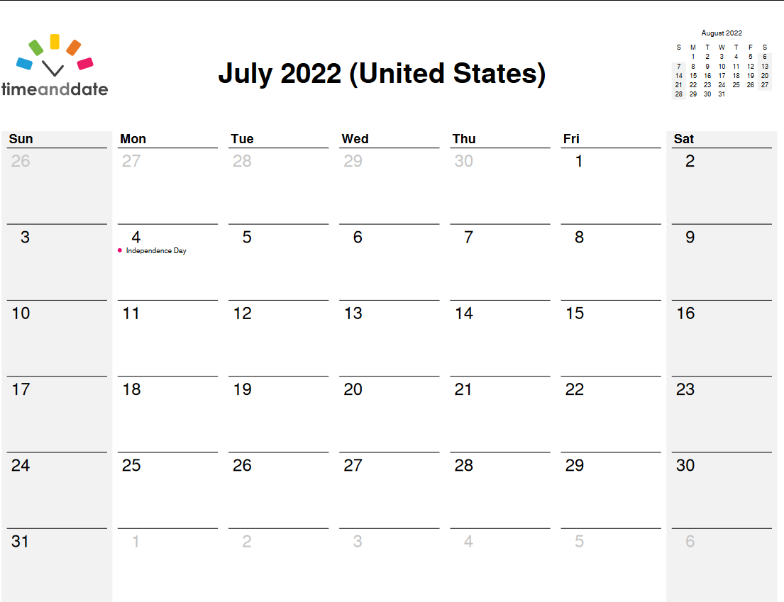

**Month at a Glance!**

July 2022

**Jimbo’s Floors**

Dear Friends,

Your personal message goes here.

The personal message is important because it allows you to connect in a very personal way with your clients. This personal connection is sorely lacking in most businesses. Topic ideas:

Your hobbies

Something interesting happening this month. Wish them “Merry Christmas” or “Happy Thanksgiving.”

A thought from your heart

Appreciation for your clients and their referrals. Remind them that you will bend over backwards to provide their referrals with World Class Service.

Mention that month’s “special offer” insert

Your Friend,

Your Signature

Your Name

Scan to see our website

Which former SNL cast member's father played keyboards and saxophone for The Righteous Brothers?

A) Will Ferrell B) Chris Rock

C) Chris Farley D) Eddie Murphy

To enter, go to [www.JimbosFloors.com](http://www.JimbosFloors.com) and click on “Mega Trivia Contest.” Take your best guess… your chances of winning are better than you think!

**Here at Jimbo’s Floors we pride ourselves on our Lifetime Installation Warranty!**

Buying flooring is not like buying any other piece of interior décor, such as a sofa or a lamp. Why?

Because unlike other products, flooring is installed or “manufactured” in your home. This makes the installation critical. I offer a lifetime installation warranty at Jimbo’s Floors as part of our 100% Iron-Clad Triple Guarantee!

You NEVER have to worry about something going wrong with the installation. If it does, I’ll fix it FREE! And I’ll do it quickly.

**Answer to last month’s question: D) Fig Newtons**

Congratulations to last month’s winner: **Client Name**

### Who Else Wants to Win

### Dinner for Two

### at the City Café!

### Take our Trivia Challenge and *you could win too!*

This month’s Mega Trivia question:

On July 4, 1776, the American colonies were declared free of British rule by the Second Continental Congress with the passage of the Declaration of Independence. Here are things you didn't know about Independence Day...

**Congress Didn't Actually Vote For Independence On July 4** It is widely believed that America’s first Continental Congress declared its independence from the British monarchy on July 4th, 1776. However, the official vote actually took place on July 2nd. In a letter that John Adams wrote on July 3, 1777, to his wife he predicted that “The Second Day of July 1776, will be the most memorable Epocha, in the History of America.”

**Most Delegates Didn’t Sign The Declaration of Independence** **Until August** It is often believed that everyone signed the Declaration on July 4, but it took an entire month to get all 56 delegates together to put their “John Hancock” on the document. The only person believed to sign the document on July 4th was also its first signer: John Hancock.

**“The Pursuit of Property”?** Arguably the most famous line in the Declaration of Independence is the second sentence of the preamble, which begins, “We hold these truths to be self-evident, that all men are created equal, that they are endowed, by their Creator, with certain unalienable Rights, that among these are Life, Liberty and the pursuit of Happiness.” But as originally drafted by Thomas Jefferson, the pursuit was not of happiness, but of “Property.”

**Americans Eat More Hot Dogs on July 4 Than Any Other Day** Hot dogs are a popular item on the 4th of July menu, and Americans eat around 150 million of them to celebrate America’s independence. That’s enough hot dogs to lay end to end from Los Angeles to Washington, D.C. around five times.

**July 4 Is The Biggest Day Of The Year For Fatal Car Accidents** According to the Insurance Institute for Highway Safety, each Independence Day has seen an average of 118.4 persons killed in traffic accidents over the last five years, making it the most deadly day of the year.



**Fascinating Facts About Independence Day**

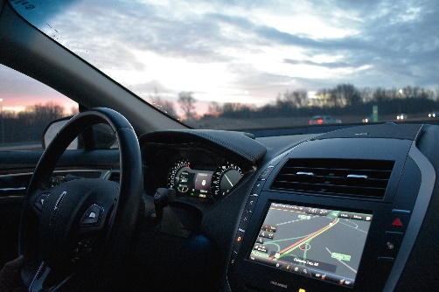

**The Most Useless Car Tech Features**



According to ***Popular Science*** magazine, more than one in three advanced technologies go unused during the average vehicle’s first 90 days of ownership. The biggest reason? Most people say that they simply don’t need fancy features like an infotainment system that can pay for their coffee, driver-to-passenger communication devices, and gesture controls.

For example, General Motors’ aptly-named Marketplace app and others like it are infotainment-based tools where drivers can pay for food and fuel, make reservations at a nearby hotel, or check-in to a store for curbside pickup. These seem like things that people would do from their phones instead of their car, and most new vehicle owners who have a marketplace-equipped vehicle seem to agree. A total of 61 percent of those owners say they have never used their in-car marketplace, and 51 percent of those also say that they have no need for it at all.

Driver-to-passenger communication devices seem to be another gimmick, at least according to owners. These features typically are reserved for larger vehicles and allow the driver and passengers a way to better hear one another without raising their voices—the Honda Odyssey has CabinTalk, the Toyota Sienna calls it Driver Easy Speak, and Cadillac’s premium Escalade SUV refers to this as its “Conversation Enhancement System.” Still, at least 52 percent of owners have never tried this at all in their feature-equipped vehicle, and 40 percent of those say they don’t need it, period.

Then there are the features like BMW’s gesture controls, which some people find intuitive. Instead of reaching forward to tap on the infotainment screen, drivers can use their hands to navigate menus, change the volume, and more. This tech also gives buyers the most trouble, with 41 problems reported per 100 vehicles

Two of the most-loved technologies revolve around vision. Owners say that a camera-based rear-view mirror and ground-view camera are the most well-executed tech feature in their vehicle. The systems are also highly desirable for owners, with 62 percent of U.S. buyers saying that they would want the ground-view camera to be equipped in their next vehicle.

“My new laminate floors in my kitchen and dining room are beautiful. I was treated with respect and courtesy as a single woman raising a daughter. I genuinely felt that Jim Armstrong and his staff display concern for my flooring needs and were a guiding light for me. I recommend his service to anyone looking for a supportive, positive experience.”

~Marsha Avalos, School Teacher, Yuba City

“We Recently went to Jimbo’s Floors for new tile for our bathroom, and we’re thrilled with the results! This is our third time using Jimbo’s. Jim will never make you feel uncomfortable for asking questions and he’ll do anything in his power to accommodate your needs. When you do business with Jim and the staff at Jimbo’s Floors, you will be treated like royalty. Our experience was painless and very professional. Jim is not only our flooring expert, he’s a friend. That’s how he makes you feel.”

~Marvin and Sandy Moeller, owners of Sierra Landscaping, Yuba City

Congratulations to our client of the month,

**Susan Johnson!**

Susan is a 3rd time returning client, and she recently purchased new laminate for her kitchen and dining room. She always has a big smile on her face and is a lot of fun to work with. *Thanks, Susan!*

As always, our clients of the month receive **2 movie passes for Movies-8!**

*Watch for your name here in a coming month!*

**Thank You for the Kind Words!**

**We all Scream for Ice Cream!**

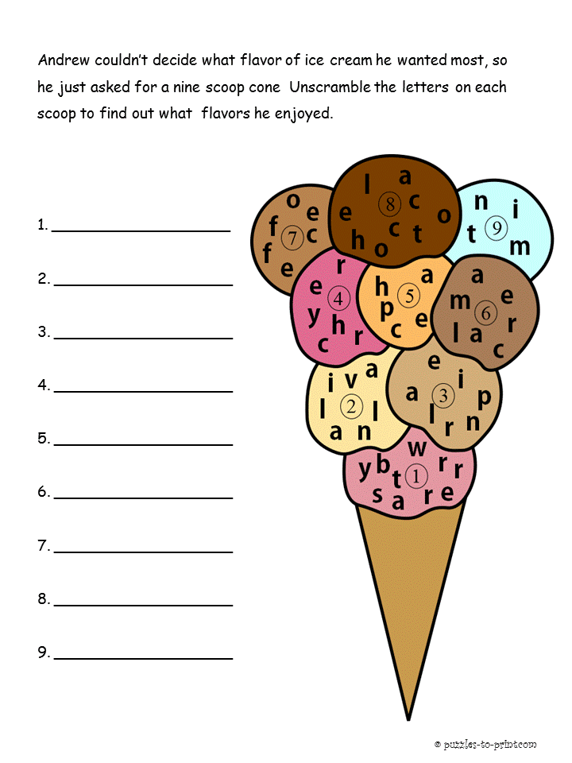 

ANSWERS 1) Strawberry 2) Vanilla 3) Praline 4) Cherry 5) Peach 6) Caramel 7) Coffee 8) Chocolate 9) Mint

Get a Night Out at the Movies for 2 with my

**Referral Rewards Program**

As you probably know, advertising is very expensive. Instead of paying the newspaper or another place to advertise, we’d rather reward you. So, we’ve assembled the Referral Rewards Program.

Every time you refer someone who becomes a client, we will send you a gift certificate for two passes to the **Movies-8 Cinema.**

And Hey! What’s a movie without popcorn? The gift certificate will also cover a big box of hot, buttered popcorn and sodas!

**Welcome to our new and returning clients!**

Click on the text box and Insert names

**A gigantic THANK YOU to all who referred us last month…**

Insert names

**Be sure to stop by to pick out and schedule   
your new floor installation, and   
from our families to yours have a great month!**

**Your Company Name**

123 Address, Someplace, ZZ 555555

555.555.5555 Phone ⚫ 555.555.5555 Fax

email@yourcompanyname.com

**YourCompanyWebsite.com**