

Reliable news for healthy living, saving money, and having fun!

********

**June 3**

World Bicycle Day

**June 14**

Flag Day

**June 18**

International Picnic Day

**June 19**

Father’s Day!

**June 19**

Juneteenth

Suzie Smith!

You are this month’s   
Mystery Winner!

We have a   
**$10.00 Starbucks   
gift card**   
reserved just for you!

Come by our store to   
claim your prize!

Inside This Issue…

* Are you this month’s Mystery Winner?
* Month at a Glance
* Why Do We Eat Birthday Cake?
* Mega Trivia Contest
* Did You Know
* Facts You Didn’t Know About the U.S. Constitution
* Thank you for the Kind Words
* Client of the Month
* Find the Camping Related Words!

*“You’ll love your new floors, or I’ll replace them free!”*

~Jim Armstrong   
[www.JimbosFloors.com](http://www.JimbosFloors.com)



**Month at a Glance!**

June 2022

**Jimbo’s Floors**

Dear Friends,

Your personal message goes here.

The personal message is important because it allows you to connect in a very personal way with your clients. This personal connection is sorely lacking in most businesses. Topic ideas:

Your hobbies

Something interesting happening this month. Wish them “Merry Christmas” or “Happy Thanksgiving.”

A thought from your heart

Appreciation for your clients and their referrals. Remind them that you will bend over backwards to provide their referrals with World Class Service.

Mention that month’s “special offer” insert

Your Friend,

Your Signature

Your Name

Scan to see our website

### Cake is essential to any birthday celebration, but has it always been? Turns out, this tradition has its roots in Ancient Greece, but it's made quite an evolution since then. *Allrecipes* dug into the history of birthday cakes and answered the question: Why do we eat cake on our birthday?

### The Greeks Start the Candle Tradition Long before celebrating birthdays became a common tradition, the Ancient Greeks were decorating cakes with candles as an act of worship to Artemis, the goddess of the moon and the hunt. The candles were meant to make the cakes glow like the moon, and it was believed that the smoke from the candles would carry their wishes up to the gods.

### The Romans Begin Celebrating Birthdays The Romans were the first to begin celebrating the birthdays of ordinary people. Prior to this, birthdays were reserved for religious figures.

Any Roman man turning 50 years old would receive a special cake baked with wheat flour, nuts, yeast, and honey. Women's birthdays were not celebrated anywhere until about the 12th century.

### Germany Invents the Modern Birthday Celebration The Germans are largely credited as the originators of the contemporary birthday celebration. In the 18th century, children's birthdays were celebrated in a tradition known as “Kinderfest.” There were no gifts, but there were well wishers, and a cake was decorated with a candle for each year of life as well as an extra to represent the year to come. These candles were lit in the morning and replaced as they burned throughout the day. At the end of the day, the child would blow them out and make a wish, much like the modern tradition.

### The Industrial Revolution Popularizes Birthday Cakes Prior to the Industrial Revolution, cakes were considered a luxury good. But mass production made it possible for everyone, not just the wealthy, to partake in cake on their birthday. Ingredients became more widely available, which allowed bakeries to offer pre-made cakes at lower prices.

**You are protected by Jimbo’s Floors “Zero Regrets Guarantee!” You’ll love your new floors or I’ll replace them FREE!**

If at any time during the first 30 days after installation you decide you don’t like your new flooring for whatever reason, just let me know. I’ll replace the materials free of charge. (With an outrageously good guarantee like this, I can’t include the cost of installation, so you’ll have to cover that.)

It’s just part of Jimbo’s 100% Iron-Clad Triple Guarantee!

Which famous cookie is named after a suburb of Boston?

A) Oreo B) Nutter Butter

C) Nilla Wafers D) Fig Newtons

To enter, go to [www.JimbosFloors.com](http://www.JimbosFloors.com) and click on “Mega Trivia Contest.” Take your best guess… your chances of winning are better than you think!

**Answer to last month’s question: B) KFC**

Congratulations to last month’s winner: **Client Name**



**Why Do We Eat Birthday Cake?**

### Who Else Wants to Win

### Dinner for Two

### at the City Café!

### Take our Trivia Challenge and *you could win too!*

This month’s Mega Trivia question:

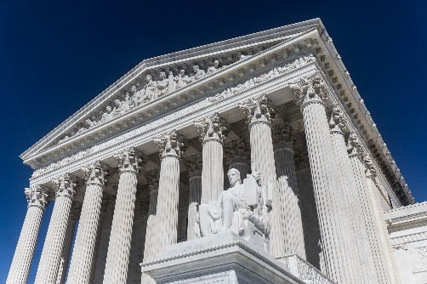

**Facts You Didn’t Know About the U.S. Constitution**



“My new laminate floors in my kitchen and dining room are beautiful. I was treated with respect and courtesy as a single woman raising a daughter. I genuinely felt that Jim Armstrong and his staff display concern for my flooring needs and were a guiding light for me. I recommend his service to anyone looking for a supportive, positive experience.”

~Marsha Avalos, School Teacher, Yuba City

“We Recently went to Jimbo’s Floors for new tile for our bathroom, and we’re thrilled with the results! This is our third time using Jimbo’s. Jim will never make you feel uncomfortable for asking questions and he’ll do anything in his power to accommodate your needs. When you do business with Jim and the staff at Jimbo’s Floors, you will be treated like royalty. Our experience was painless and very professional. Jim is not only our flooring expert, he’s a friend. That’s how he makes you feel.”

~Marvin and Sandy Moeller, owners of Sierra Landscaping, Yuba City

Congratulations to our

**Susan Johnson!**

Susan is a 3rd time returning client, and she recently purchased new laminate for her kitchen and dining room. She always has a big smile on her face and is a lot of fun to work with. *Thanks, Susan!*

As always, our clients of the month receive **2 movie passes for Movies-8!**

*Watch for your name here in a coming month!*

On June 21, 1788, New Hampshire became the ninth and last necessary state to ratify the United States Constitution, thereby making the document the law of the land. From *Trivia Today*, here are things you probably didn’t know.

**The Electoral College Was Just As Controversial Then As It Is Now** The Electoral College is a topic that has long been shrouded in contention and debate. And the debate dates back to the time when the Constitution was first drafted. Those who argued in favor of the Electoral College believed it was a solid middle ground between those who wanted the president to be chosen based on the popular vote and those who wanted a Congressional vote. Since then, there have been over 500 proposals to reform or abolish the Electoral College.

**It Cost $30 To Write the Constitution** Many of the founding fathers were present when the Constitution was written and ratified, including George Washington and Benjamin Franklin. But the actual wording and writing of the document were conducted by other individuals who were paid for their services. Gouverneur Morris, a Founding Father of the United States, wrote the Preamble to the Constitution and handled the majority of the document's wording. Jacob Shallus, an assistant clerk, was the one who actually held the pen and wrote the now-infamous words. Shallus was paid a handsome $30 for his penmanship, which equates to approximately $900 today.

**Not Every Delegate Signed It** Not all founding fathers signed the Constitution. Some were unable to attend during its signing, including Thomas Jefferson, who was serving as the Minister to France in Paris at the time, and John Adams, who was serving as Minister to Great Britain. Three of the delegates refused to sign it because there was no bill of rights that added protections for ordinary citizens. Others such as Samuel Adams, Patrick Henry, and John Hancock—whose signature was such a standout on the Declaration of Independence—did not attend. When Henry was asked why he declined to attend the convention, he supposedly said, "I smelt a rat."

**Thank You for the Kind Words!**

**Find the Camping Related Words!**

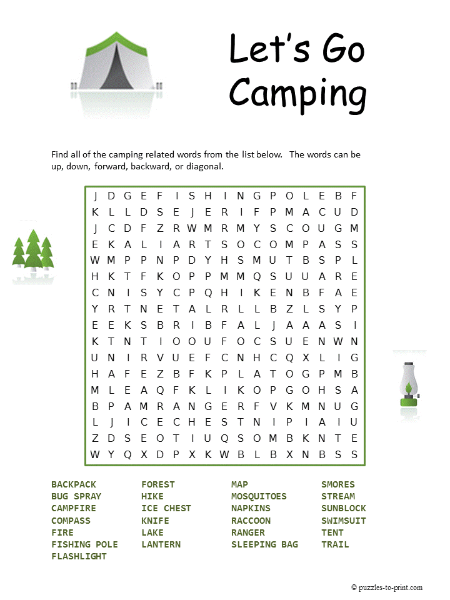 

**Your Company Name**

123 Address, Someplace, ZZ 555555

555.555.5555 Phone ⚫ 555.555.5555 Fax

email@yourcompanyname.com

**YourCompanyWebsite.com**

**Be sure to stop by to pick out and schedule   
your new floor installation, and   
from our families to yours have a great month!**

Get a

with my

**Referral Rewards Program**

As you probably know, advertising is very expensive. Instead of paying the newspaper or another place to advertise, we’d rather reward you. So, we’ve assembled the Referral Rewards Program.

Every time you refer someone who becomes a client, we will send you a gift certificate for two passes to the **Movies-8 Cinema.**

And Hey! What’s a movie without popcorn? The gift certificate will also cover a big box of hot, buttered popcorn and sodas!

**Welcome to our new and returning clients!**

Click on the text box and Insert names

**A gigantic THANK YOU to all who referred us last month…**

Insert names