

Reliable news for healthy living, saving money, and having fun!

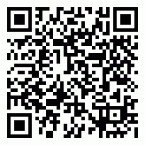

Suzie Smith!

You are this month’s   
Mystery Winner!

We have a   
**$10.00 Starbucks   
gift card**   
reserved just for you!

Come by our store to   
claim your prize!

Inside This Issue…

* Are you this month’s Mystery Winner?
* Month at a Glance
* Natural Remedies for Everyday Ailments
* Mega Trivia Contest
* Did You Know
* Things You Didn’t Know about Memorial Day
* Thank you for the Kind Words
* Client of the Month
* Unscramble These Signs of Spring!

*“You’ll love your new floors, or I’ll replace them free!”*

~Jim Armstrong   
[www.JimbosFloors.com](http://www.JimbosFloors.com)

**May 3**

National Teacher Day

**May 5**

Cinco De Mayo

**May 8**

Mother’s Day

**May 20**

Bike To Work Day

**May 30**

Memorial Day

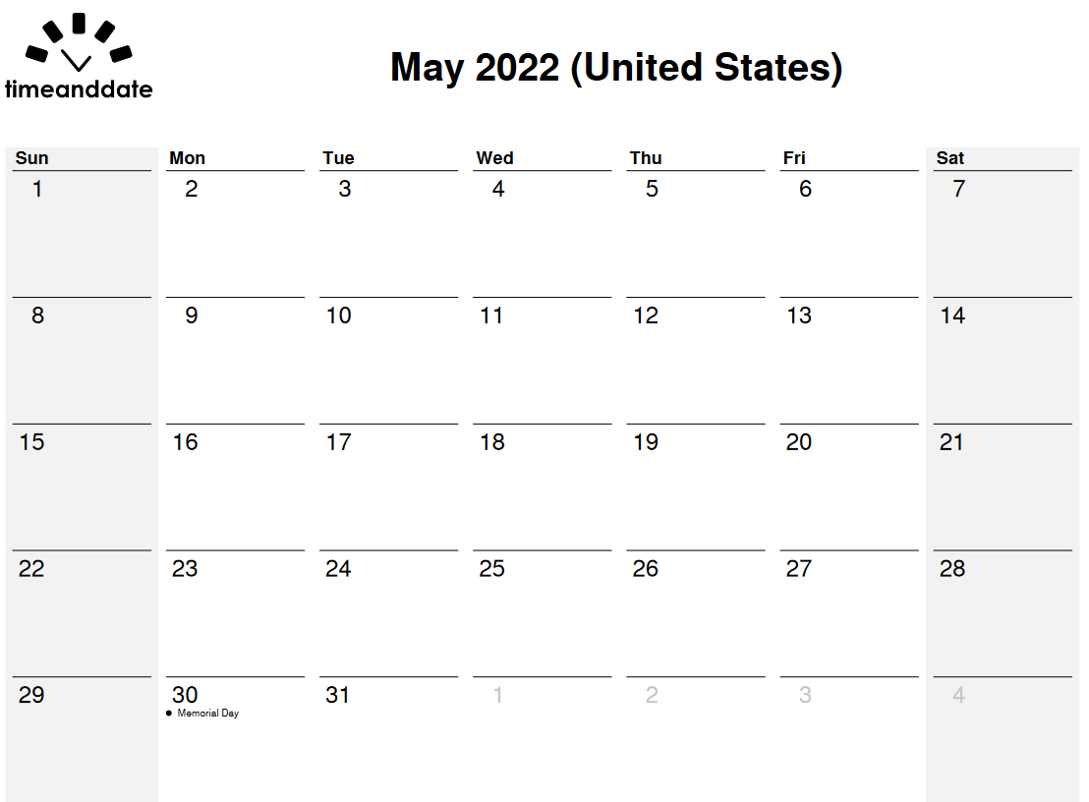

**Month at a Glance!**

May 2022

**Jimbo’s Floors**

Dear Friends,

Your personal message goes here.

The personal message is important because it allows you to connect in a very personal way with your clients. This personal connection is sorely lacking in most businesses. Topic ideas:

Your hobbies

Something interesting happening this month. Wish them “Merry Christmas” or “Happy Thanksgiving.”

A thought from your heart

Appreciation for your clients and their referrals. Remind them that you will bend over backwards to provide their referrals with World Class Service.

Mention that month’s “special offer” insert

Your Friend,

Your Signature

Your Name

Scan to see our website

**Answer to last month’s question: B) Pepsi**

Congratulations to last month’s winner: **Client Name**Come by our store to claim your prize!

The latest surveys show that about a third of Americans now use natural or complementary medicine, and the number is growing. Fish oil is the most common natural product used for health—nearly 8% of adults take it preventively for heart health. Next in popularity are glucosamine/ chondroitin, probiotics, and melatonin.

*Prevention Magazine* asked doctors about the natural remedies they swear by. Here are some you may have never heard of but could come to trust.

**Acne: Coconut oil**

**Doctor Says:** “People with acne tend to overdry their skin, which triggers more oil production. I recommend applying a very thin coat of coconut oil to bumps after first cleansing with a salicylic wash. Coconut oil has antimicrobial and anti-inflammatory properties and contains lauric and capric acids and vitamin E. It repairs the skin barrier, is easy to use, prevents overdrying of skin and helps the marks heal faster.”

**Hay fever and other seasonal allergies: Pycnogenol**, a natural plant extract derived from French maritime pine bark

**Doctor Says:** “Most people suffering from seasonal allergies reach for OTC antihistamines, but these can often cause side effects like drowsiness and dizziness. Pycnogenol works by reducing the inflammation that can lead to the typical symptoms of sneezing, itchy eyes, and irritated throat. It can be found in vitamins, supplements, lotions, and serums and can also be taken by itself in tablets or capsules. I recommend 100 mg a day in the weeks leading up to allergy season.”

**Anxiety:** **Green tea and dark chocolate**

**Doctor Says:** “Green tea and dark chocolate can each help take the edge off worries and tension; use them along with—not instead of—prescribed anti-anxiety medications. Green tea contains L-theanine, an amino acid that's been shown to help induce quiet and calm. Dark chocolate is one of my favorite food-as-medicine prescriptions, as it's rich in compounds that gently lift mood. Have a piece of dark chocolate with your cup of tea to get the benefits of both.”

What is the most popular meal for Christmas in Japan?

A) Applebee’s B) KFC

C) TGI Fridays D) Arby’s

To enter, go to [www.JimbosFloors.com](http://www.JimbosFloors.com) and click on “Mega Trivia Contest.” Take your best guess… your chances of winning are better than you think!

***We’d be happy to send you our electronic newsletter!***

The same combination of useful tips and offbeat stories you read here, but with these differences:

* The e-Neighborhood Advisor will arrive in your email account once you give us permission
* We send it once a week
* The e-Neighborhood Advisor does not have the same content as the print Neighborhood Advisor – you’ll read all new stories, from helpful advice to items that give you a smile

Simply let us know which email account you’d like us to use for the e-Neighborhood Advisor.



**Doctor-Recommended Natural Remedies for Everyday Ailments**

### Who Else Wants to Win

### Dinner for Two

### at the City Café!

### Take our Trivia Challenge and *you could win too!*

This month’s Mega Trivia question:



**Things You Didn’t Know about Memorial Day**



Congratulations to our

**Susan Johnson!**

Susan is a 3rd time returning client, and she recently purchased new laminate for her kitchen and dining room. She always has a big smile on her face and is a lot of fun to work with. *Thanks, Susan!*

As always, our clients of the month receive **2 movie passes for Movies-8!**

*Watch for your name here in a coming month!*

Memorial Day is the day we remember those who died in war defending the United States. While we realize that means you'll likely be spending your time barbecuing and relaxing, here are several fun facts about Memorial Day from *Trivia Today*.

Memorial Day had its beginnings at the end of the Civil War when the North and South went about commemorating the dead who fell in what remains the bloodiest war in American history. The loss of life and its effect on communities led to several spontaneous commemorations of laying flowers on headstones in the months after the war ended.

A retired Union Army major general, John A. Logan, the commander-in-chief of a veterans' group, which was called the Grand Army of the Republic, set the date of the holiday for May 30. He chose that specific date because it was not the anniversary of any particular battle. The date was also selected to ensure that flowers across the country would be in full bloom by that time.

Memorial Day was not officially recognized nationwide until Congress declared it a national holiday in 1971. Due to the Uniform Monday Holiday Act, which took effect in 1971, Memorial Day was moved to the last Monday of May to ensure long weekends. Some groups, like the veterans’ organization American Legion, have been working to restore the original date to set Memorial Day apart and pay proper tribute to the servicemen and women who sacrificed their lives.

Congress also established an exact minute of remembrance. The National Moment of Remembrance Act, which was signed into law by President Bill Clinton in 2000, asks every citizen to pause each Memorial Day at 3:00 p.m. local time to remember the brave men and women who died serving this country. In addition to any federal observances. Major League Baseball games come to a stop during the Moment of Remembrance, and for the past several years, Amtrak engineers have taken up the practice of sounding their horns in unison at precisely 3:00 p.m.

“My new laminate floors in my kitchen and dining room are beautiful. I was treated with respect and courtesy as a single woman raising a daughter. I genuinely felt that Jim Armstrong and his staff display concern for my flooring needs and were a guiding light for me. I recommend his service to anyone looking for a supportive, positive experience.”

~Marsha Avalos, School Teacher, Yuba City

“We Recently went to Jimbo’s Floors for new tile for our bathroom, and we’re thrilled with the results! This is our third time using Jimbo’s. Jim will never make you feel uncomfortable for asking questions and he’ll do anything in his power to accommodate your needs. When you do business with Jim and the staff at Jimbo’s Floors, you will be treated like royalty. Our experience was painless and very professional. Jim is not only our flooring expert, he’s a friend. That’s how he makes you feel.”

~Marvin and Sandy Moeller, owners of Sierra Landscaping, Yuba City

**Thank You for the Kind Words!**

**Unscramble these Signs of Spring!**

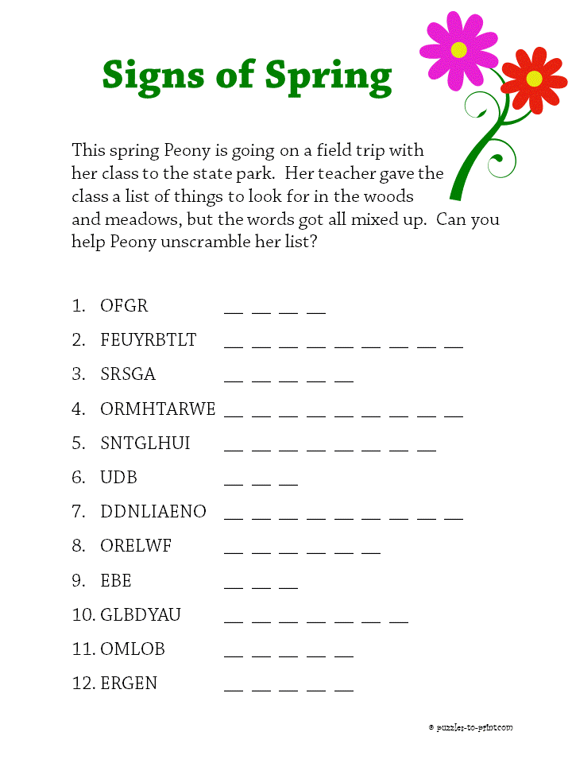 

Get a

with my

**Referral Rewards Program**

As you probably know, advertising is very expensive. Instead of paying the newspaper or another place to advertise, we’d rather reward you. So, we’ve assembled the Referral Rewards Program.

Every time you refer someone who becomes a client, we will send you a gift certificate for two passes to the **Movies-8 Cinema.**

And Hey! What’s a movie without popcorn? The gift certificate will also cover a big box of hot, buttered popcorn and sodas!

**Your Company Name**

123 Address, Someplace, ZZ 555555

555.555.5555 Phone ⚫ 555.555.5555 Fax

email@yourcompanyname.com

**YourCompanyWebsite.com**

**Be sure to stop by to pick out and schedule   
your new floor installation, and   
from our families to yours have a great month!**

Frog, Butterfly, Grass, Earthworm, Sunlight, Bud, Dandelion, Flower, Bee, Ladybug, Bloom, Green

**Welcome to our new and returning clients!**

Click on the text box and Insert names

**A gigantic THANK YOU to all who referred us last month…**

Insert names