

Reliable news for healthy living, saving money, and having fun!

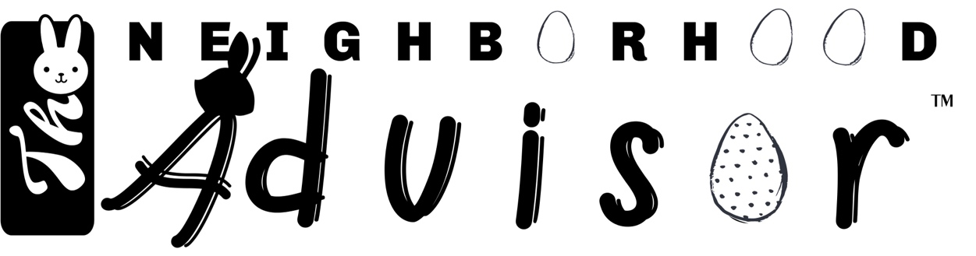

Suzie Smith!

You are this month’s   
Mystery Winner!

We have a   
**$10.00 Starbucks   
gift card**   
reserved just for you!

Come by our store to   
claim your prize!

**April 17**

Easter Sunday

Inside This Issue…

* Are you this month’s Mystery Winner?
* Month at a Glance
* Where to Start When Cleaning the Living Room
* Mega Trivia Contest
* Did You Know
* Easter Facts
* Thank you for the Kind Words
* Client of the Month
* Find the Easter Words!



**Month at a Glance!**

April 2022

**Jimbo’s Floors**

Dear Friends,

Your personal message goes here.

The personal message is important because it allows you to connect in a very personal way with your clients. This personal connection is sorely lacking in most businesses. Topic ideas:

Your hobbies

Something interesting happening this month. Wish them “Merry Christmas” or “Happy Thanksgiving.”

A thought from your heart

Appreciation for your clients and their referrals. Remind them that you will bend over backwards to provide their referrals with World Class Service.

Mention that month’s “special offer” insert

Your Friend,

Your Signature

Your Name

Scan to see our website

*“You’ll love your new floors, or I’ll replace them free!”*

~Jim Armstrong   
[www.JimbosFloors.com](http://www.JimbosFloors.com)

Which brand was created in a New Bern pharmacy and marketed under the slogan “Born in the Carolinas”?

A) Yoo-Hoo B) Pepsi

C) Heinz Ketchup D) A.1. Sauce

To enter, go to [www.JimbosFloors.com](http://www.JimbosFloors.com) and click on “Mega Trivia Contest.” Take your best guess… your chances of winning are better than you think!

### Who Else Wants to Win

### Dinner for Two

### at the City Café!

### Take our Trivia Challenge and *you could win too!*

This month’s Mega Trivia question:

**Answer to last month’s question: A) Family Ties**

Congratulations to last month’s winner: **Client Name**

Come by our store to claim your prize!

***Here at Jimbo’s Floors, we want to treat your friends like royalty!***

Not just your friends, but your neighbors, co-workers and relatives too.

For every person you refer who becomes a client, I will send you and a friend to the Movies-8 Cinema AND I’ll spring for the popcorn and soda!

We worked hard to earn your trust, and we take that trust seriously. We’ll provide anyone you send to us with outstanding service and treat them like royalty. And I promise that if you refer someone to Jimbo’s, we will do everything in our power to make sure you look like a hero for referring us!

Many of us have spring cleaning on our minds at this time of year. ***Apartment Therapy’s*** Shifrah Combiths tell us there is no wrong way to clean. But where you start matters more than you might think.

Some people clean to prepare for company. Others clean for the self-satisfaction of relaxing in a picked-up living room. And some folks clean when they just can’t ignore the popcorn crumbs in the cushions and dust on the mantel any longer. There are people who attack mess in a cleaning frenzy, and others who clean like a slow-dripping faucet, where one thing leads to another and before you know it, you’ve put away the clutter and dusted, vacuumed, and fluffed the pillows.

When it comes to cleaning the living room, as tempting as it is to begin by tidying up around a central point, you shouldn’t start with the coffee table. Instead, **start with the overhead light fixture.**

Your living room light fixture is a landing spot for dust and dirt. The last thing you want to do is knock that mess onto your already meticulously polished and arranged coffee table and have to clean it up again. Starting your living room cleaning session by dusting your light fixture ensures that the mess that floats down to the surfaces beneath it will get dusted, wiped, or vacuumed up when you’re performing those tasks later anyway.

The top-to-bottom strategy is great if you’re cleaning for speed and want to make your efforts more efficient. But it’s an advanced effort, and here’s a lesson from *Housekeeping 101*: Do your own thing. If what gets you motivated to clean the rest of the living room is seeing your reflection in the gleaming wood of your freshly polished coffee table, start there. If the thought of vacuum lines in your carpet makes you get up off the couch to reach for your cleaning kit, cleaning from top to bottom can take a seat.

Cleaning “rules” might be ways to get the job done according to someone’s definition of efficiency or thoroughness, but it’s all going to get dirty again no matter what’s cleaned first or last, and the actual best cleaning routine is the one that works for you!



**Where to Start When Cleaning the Living Room**



**Easter Facts**

Congratulations to our

**Susan Johnson!**

Susan is a 3rd time returning client, and she recently purchased new laminate for her kitchen and dining room. She always has a big smile on her face and is a lot of fun to work with. *Thanks, Susan!*

As always, our clients of the month receive **2 movie passes for Movies-8!**

*Watch for your name here in a coming month!*

Come by our store to claim your prize!

“My new laminate floors in my kitchen and dining room are beautiful. I was treated with respect and courtesy as a single woman raising a daughter. I genuinely felt that Jim Armstrong and his staff display concern for my flooring needs and were a guiding light for me. I recommend his service to anyone looking for a supportive, positive experience.”

~Marsha Avalos, School Teacher, Yuba City

“We Recently went to Jimbo’s Floors for new tile for our bathroom, and we’re thrilled with the results! This is our third time using Jimbo’s. Jim will never make you feel uncomfortable for asking questions and he’ll do anything in his power to accommodate your needs. When you do business with Jim and the staff at Jimbo’s Floors, you will be treated like royalty. Our experience was painless and very professional. Jim is not only our flooring expert, he’s a friend. That’s how he makes you feel.”

~Marvin and Sandy Moeller, owners of Sierra Landscaping, Yuba City

Easter Sunday is the most important day of the year for Christians, as it is the celebration of Jesus being resurrected from the dead. ***Trivia Today*** shares these interesting facts about the Easter holiday.

The Easter egg appears in many ancient traditions as a symbol for life, or life's beginnings. In medieval Europe, eggs were often one of the first foods — blessed by a priest of course — eaten after the Lenten fast. The practice of dyeing eggs can be traced back to early Greek and Syrian Christians, who exchanged crimson eggs to represent the blood of Christ. German and Austrian immigrants later brought the practice to America.

Have you ever wondered where the Easter Bunny story originated? The idea of the Easter bunny giving candies and eggs is said to have originated in Germany during the Middle Ages, with the first written mention of this tradition dating back to the 16th century. Dutch settlers in Pennsylvania brought the bunny to the United States in the 1700s.

Americans eat about 1.5 million Peeps during Easter. Peeps date back to the 1920s and at the time were very difficult to make by hand, requiring approximately 30 hours to complete just one. Now they are made in about 6 minutes. Over 70 million of the tasty chicks are sold at Easter every year. That makes these colorful marshmallows the most popular non-chocolate Easter candy. The Bethlehem, Pennsylvania, factory makes an impressive 5.5 million a day.

An online survey of more than 28,000 Americans reveals that 59 percent of us eat the ears first. About 4 percent start at the other end with the feet or tail, while 33 percent of people indicate no preference at all when going in for the all-important first bite.

**Thank You for the Kind Words!**

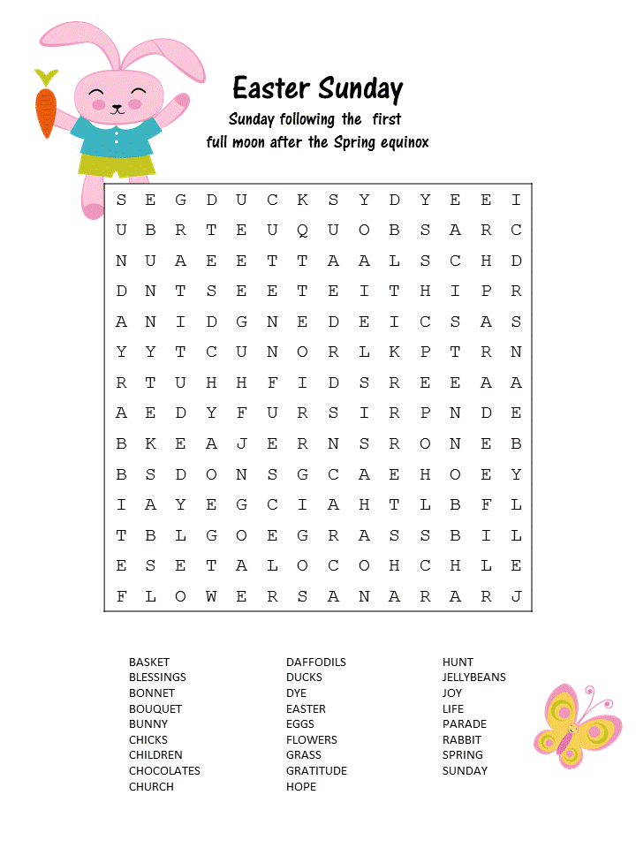

Get a

with my

**Referral Rewards Program**

As you probably know, advertising is very expensive. Instead of paying the newspaper or another place to advertise, we’d rather reward you. So, we’ve assembled the Referral Rewards Program.

Every time you refer someone who becomes a client, we will send you a gift certificate for two passes to the **Movies-8 Cinema.**

And Hey! What’s a movie without popcorn? The gift certificate will also cover a big box of hot, buttered popcorn and sodas!

Come by our store to   
claim your prize!

**Your Company Name**

123 Address, Someplace, ZZ 555555

555.555.5555 Phone ⚫ 555.555.5555 Fax

email@yourcompanyname.com

**YourCompanyWebsite.com**

**Be sure to stop by to pick out and schedule   
your new floor installation, and   
from our families to yours have a great month!**

**Welcome to our new and returning clients!**

Click on the text box and Insert names

**A gigantic THANK YOU to all who referred us last month…**

Insert names

**Here’s *Hopping* the Bunny Fills Your Basket!**