

Reliable news for healthy living, saving money, and having fun!

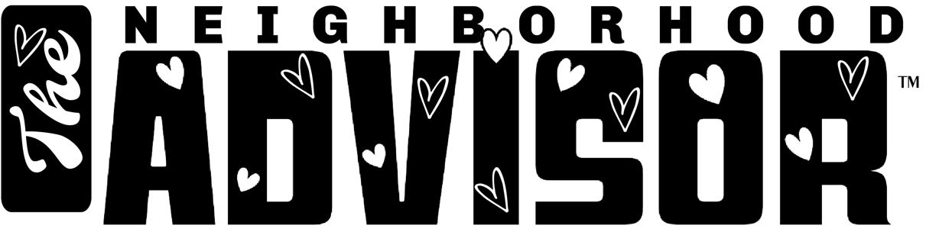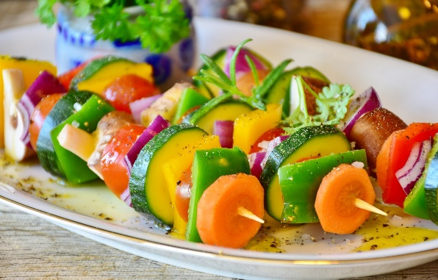

Suzie Smith!

You are this month’s   
Mystery Winner!

We have a   
**$10.00 Starbucks   
gift card**   
reserved just for you!

Come by our store to   
claim your prize!

Inside This Issue…

* Are you this month’s Mystery Winner?
* Month at a Glance
* How Your Diet Affects Your Mental Health
* Mega Trivia Contest
* Did You Know
* Things You Didn’t Know About Valentine’s Day
* Thank you for the Kind Words
* Client of the Month
* Solve the Word Search!

*“You’ll love your new floors, or I’ll replace them free!”*

~Jim Armstrong   
[www.JimbosFloors.com](http://www.JimbosFloors.com)

**February 14**

Valentine’s Day

**February 21**

President’s Day



**Month at a Glance!**

February 2022

**Jimbo’s Floors**

Dear Friends,

Your personal message goes here.

The personal message is important because it allows you to connect in a very personal way with your clients. This personal connection is sorely lacking in most businesses. Topic ideas:

Your hobbies

Something interesting happening this month. Wish them “Merry Christmas” or “Happy Thanksgiving.”

A thought from your heart

Appreciation for your clients and their referrals. Remind them that you will bend over backwards to provide their referrals with World Class Service.

Mention that month’s “special offer” insert

Your Friend,

Your Signature

Your Name

Scan to see our website

Zsa Zsa Gabor was once married

to the founder of which hotel chain?

A) Hyatt B) Marriott

C) Hilton D) Sheraton

To enter, go to [www.JimbosFloors.com](http://www.JimbosFloors.com) and click on “Mega Trivia Contest.” Take your best guess… your chances of winning are better than you think!

Many people tend to overthink what food is doing for their body—Is keto good for endurance? What’s the perfect post-training meal? Butter or no butter in my coffee?— but underthink what it’s doing for their mind. Yet you’ve probably noticed that what you eat impacts what’s going on upstairs. We’ve all devoured a cheat meal and afterward felt off, not just physically but also mentally and emotionally. Per *Outside* magazine, research suggests that the connection between diet and mental well-being is more nuanced than scientists once thought.

Earlier studies suggest what you might expect: eating junk isn’t great for your brain. People who consume plenty of fruit, vegetables, and fish seem to be less at risk of depression compared to those who favor fatty meats, processed carbs, and sweets.

But emerging research shows that even among healthy diets, some might be better for mental health than others. In a recent review published in Molecular Psychology, researchers analyzed 41 studies that sought to quantify the impact of various diets on clinical depression. The analysis accounted for a variety of eating plans including the Mediterranean diet, the DASH diet, and the Healthy Eating Index.

The winner? The Mediterranean diet, which according to the American Journal of Clinical Nutrition features abundant fruits and vegetables, olive oil, dairy products like yogurt and cheese, cereals, beans, fish and poultry, and moderate amounts of red meat and wine. (Sometimes it seems to be the best diet for just about everything: it may help you live longer, and it recently won the top spot in an exhaustive, expert-led analysis of 40 diets based on metrics like being heart-healthy, plant heavy, and easy to adhere to.)

The Mediterranean diet may have a positive effect on mental health because it helps fight inflammation. The full list of foods with purported mental-health benefits is expansive, but vegetables, organ meats (like liver), fruits, and seafood took the top four categories.

No single food has magical powers, however. It doesn’t really matter which leafy green you eat—what matters is that leafy greens are a regular part of your food intake.

**You Get A FREE Lifetime Installation Warranty with Every Floor from Jimbo’s!**



Buying flooring is not like buying any other piece of interior décor, such as a sofa or a lamp. Why? Because unlike other products, flooring is installed or “manufactured” in your home. This makes the installation critical. I offer a lifetime installation warranty at Jimbo’s Floors. You NEVER have to worry about something going wrong with the installation. If it does, I’ll fix it FREE! And I’ll do it quickly.

**Answer to last month’s question: B) Yogi Bear**

Congratulations to last month’s winner: **Client Name**



**How Your Diet Affects Your Mental Health**

### Who Else Wants to Win

### Dinner for Two

### at the City Café!

### Take our Trivia Challenge and *you could win too!*

This month’s Mega Trivia question:



**Things You Didn’t Know About Valentine’s Day**

+



Lovers from around the world exchange chocolates, flowers and gifts to celebrate the most romantic day of the year. Here are interesting facts from *Trivia Today* about Valentine's Day.

**Valentine's Day Became an Official Holiday in the 1300s** February 14 was officially declared "St. Valentine's Day" by Roman Pope Gelasius at the end of the 5th century. But it wasn't until the 1300s that the holiday became known as the day of love and romance. This was based on the notion that February 14 marked the beginning of the mating season for birds. However, it wasn't until the 15th century that the first valentine was officially sent. According to *History.com*, the oldest recorded valentine sent was in 1415 by a French medieval duke who sent his wife a romantic poem that he wrote while imprisoned in the Tower of London.

**Americans Send 145 Million Valentine's Day** **Cards** **Each Year** According to Hallmark, a whopping 145 million Valentine's Day cards are exchanged every February 14. This makes Valentine's Day the second biggest holiday for exchanging greeting cards, after Christmas. Teachers receive the most Valentine's Day cards annually, followed by children, mothers and wives. Needless to say, we've come a long way from 1913, which was when Hallmark Cards produced their first Valentine's card.

**Cupid Has Its Roots in Greek and Roman Mythology** Several tokens and figures symbolize Valentine's Day, including the adorable cherub with his bow and arrow that adorns Valentine's Day cards. But where exactly did the idea of the love matchmaker come from and why was it linked to this holiday? According to *Time*, the idea dates back to 700 BC and is depicted in Eros, the handsome, young, Greek god of love who had the power to make people fall in love. The Romans eventually made Eros into the image of a cherub, who they had named "Cupid" by the 4th century BC, depicting him as a cute boy with a bow and arrow. By the turn of the 19th century, Cupid had become linked to Valentine's Day due to his love-matching powers.

“My new laminate floors in my kitchen and dining room are beautiful. I was treated with respect and courtesy as a single woman raising a daughter. I genuinely felt that Jim Armstrong and his staff display concern for my flooring needs and were a guiding light for me. I recommend his service to anyone looking for a supportive, positive experience.”

~Marsha Avalos, School Teacher, Yuba City

“We Recently went to Jimbo’s Floors for new tile for our bathroom, and we’re thrilled with the results! This is our third time using Jimbo’s. Jim will never make you feel uncomfortable for asking questions and he’ll do anything in his power to accommodate your needs. When you do business with Jim and the staff at Jimbo’s Floors, you will be treated like royalty. Our experience was painless and very professional. Jim is not only our flooring expert, he’s a friend. That’s how he makes you feel.”

~Marvin and Sandy Moeller, owners of Sierra Landscaping, Yuba City

Congratulations to our client of the month,

**Susan Johnson!**

Susan is a 3rd time returning client, and she recently purchased new laminate for her kitchen and dining room. She always has a big smile on her face and is a lot of fun to work with. *Thanks, Susan!*

As always, our clients of the month receive **2 movie passes for Movies-8!**

*Watch for your name here in a coming month!*

**Thank You for the Kind Words!**

**Your Company Name**

123 Address, Someplace, ZZ 555555

555.555.5555 Phone ⚫ 555.555.5555 Fax

email@yourcompanyname.com

**YourCompanyWebsite.com**

**Be sure to stop by to pick out and schedule   
your new floor installation, and   
from our families to yours have a great month!**

Get a Night Out at the Movies for 2 with my

**Referral Rewards Program**

As you probably know, advertising is very expensive. Instead of paying the newspaper or another place to advertise, we’d rather reward you. So, we’ve assembled the Referral Rewards Program.

Every time you refer someone who becomes a client, we will send you a gift certificate for two passes to the **Movies-8 Cinema.**

And Hey! What’s a movie without popcorn? The gift certificate will also cover a big box of hot, buttered popcorn and sodas!

**Welcome to our new and returning clients!**

Click on the text box and Insert names

**A gigantic THANK YOU to all who referred us last month…**

Insert names

**Valentine’s Day = Engagements!**