

Reliable news for healthy living, saving money, and having fun!

********

Inside This Issue…

* Are you this month’s Mystery Winner?
* Month at a Glance
* Fascinating Facts about January Babies
* Mega Trivia Contest
* Did You Know
* How to Wake up More Easily When It’s Dark Outside
* Thank you for the Kind Words
* Client of the Month
* Find the New Year’s Words!

**January 1**

New Year’s Day

**January 17**

Martin Luther King Jr Day



**Month at a Glance!**

January 2021

**Jimbo’s Floors**

Suzie Smith!

You are this month’s   
Mystery Winner!

We have a   
**$10.00 Starbucks   
gift card**   
reserved just for you!

Come by our store to   
claim your prize!

Dear Friends,

Your personal message goes here.

The personal message is important because it allows you to connect in a very personal way with your clients. This personal connection is sorely lacking in most businesses. Topic ideas:

Your hobbies

Something interesting happening this month. Wish them “Merry Christmas” or “Happy Thanksgiving.”

A thought from your heart

Appreciation for your clients and their referrals. Remind them that you will bend over backwards to provide their referrals with World Class Service.

Mention that month’s “special offer” insert

Your Friend,

Your Signature

Your Name

Scan to see our website

*“You’ll love your new floors, or I’ll replace them free!”*

~Jim Armstrong   
[www.JimbosFloors.com](http://www.JimbosFloors.com)

January is the month when everyone makes resolutions and starts fresh. But for babies born in January, it's all brand-new!

Per *Good Housekeeping*, the tradition of celebrating "Baby New Year," or the first baby born on January 1, has its origins in ancient Greece, and was popularized in America by a series of illustrations in the Saturday Evening Post. The magazine, which ran illustrations of Baby New Year on its cover from 1906 to 1943, saw the infant as emblematic of American resilience.

The snuggled-and-cozy fact of a winter birthday comes with advantages: Studies show that people born in the winter months are less irritable and less prone to mood swings than people born in other seasons.

Researchers at the Columbia University Department of Medicine found that January babies are at no major disadvantage when it comes to contracting diseases. Phew! However, another Columbia University study found that there is a relationship between low levels of sunlight in the late stages of pregnancy and an increased risk of type 2 diabetes, so January-borns need to keep an eye on that.

Kids with birthdays in January often end up being a little bit older than the rest of their classmates, which gives them an advantage in school athletics. Studies show that the oldest kids in the class are also the more likely to play varsity sports.

A 2015 study revealed that people born in January and February tended to show higher levels of creativity and imaginative problem-solving, according to Time, so ask a January-born next time you're stuck on a project.

A study out of the University of Vienna shows that men — not women — born in November, December and January are more likely to be left-handed.

The two most common career paths for people born in January are general practitioners or accountants. Alternately, very few people born in January become real estate agents. No matter the profession, January-borns are driven and headed for success.

**We Celebrate Your Referrals!**

Advertising in the newspaper, yellow pages, radio, etc., is expensive, so rather than pay for that, I’d rather reward you!

For every person you refer who becomes a client, I will send you and a friend to the Movies-8 Cinema AND I’ll spring for the popcorn and soda!

Of course, rewards are nice, but the real reason you refer a friend or loved one to Jimbo’s is because you trust us. When you send your aunt or grandmother or co-worker to Jimbo’s, you are trusting us to provide them with outstanding service, and to… well… to treat them like royalty!

My team and I take that trust very seriously. And I promise that if you refer someone to Jimbo’s, we will do everything in our power to make sure you look like a hero for referring us!

Which cartoon character is often shown wearing a collar and necktie but no shirt?

A) Elmer Fudd B) Yogi Bear

C) Wile E Coyote D) Yosemite Sam

To enter, go to [www.JimbosFloors.com](http://www.JimbosFloors.com) and click on “Mega Trivia Contest.” Take your best guess… your chances of winning are better than you think!

**Answer to last month’s question: D) Adobe**

Congratulations to last month’s winner: **Client Name**



**Fascinating Facts about January Babies**

### Who Else Wants to Win

### Dinner for Two

### at the City Café!

### Take our Trivia Challenge and *you could win too!*

This month’s Mega Trivia question:



# **How to Wake up More Easily When It’s Dark Outside**

+



## Waking up in winter can be tough. Opening your eyes to a room that’s still dark, poking a foot out of the duvet to be met with winter’s chill and nudging the curtain back only to see a grey sky is all enough to have you curling back up under the covers. ***Stylist*** offers these suggestions.

## **Keep Your Body Clock on a Regular Rhythm** Dr. Kat Lederle, head of sleep health at Somnia, stresses that it’s important to establish a regular light-dark exposure pattern throughout winter to keep your body clock on a regular rhythm.

According to Lederle there are two easy ways of pulling this off. “First, you need to establish regular going to bed and waking up times and stick to them seven days a week. You can make these slightly more indulgent than in summer, though, as we often need a little more sleep during the winter so allow yourself that time.”

## **Get a SAD Lamp** Hope Bastine, psychologist and resident expert at sleep tech firm SIMBA says that getting your fill of sunshine in the day is an important part of switching off at night.

She recommends changing your schedule to try and get some exposure to daylight, whether that means taking a walk outside or supplementing with a SAD lamp to give you a boost.

## **Be Mindful of When You Eat and What You Eat** Lederle advises taking better notice of your eating habits if you’re finding it hard to open your eyes in the morning. This is because having a regular eating rhythm helps to keep your body healthy and support good sleep.

## **Eat Apples for Breakfast** Stephanie Taylor, Managing Director of online health and wellbeing retailer StressNoMore says that one particular snack could help your mornings become easier.

She says: “An apple a day doesn’t just keep the doctor away. They also contain around 13g of natural sugar and according to studies, this has a similar effect on the body as coffee.

“My new laminate floors in my kitchen and dining room are beautiful. I was treated with respect and courtesy as a single woman raising a daughter. I genuinely felt that Jim Armstrong and his staff display concern for my flooring needs and were a guiding light for me. I recommend his service to anyone looking for a supportive, positive experience.”

~Marsha Avalos, School Teacher, Yuba City

“We Recently went to Jimbo’s Floors for new tile for our bathroom, and we’re thrilled with the results! This is our third time using Jimbo’s. Jim will never make you feel uncomfortable for asking questions and he’ll do anything in his power to accommodate your needs. When you do business with Jim and the staff at Jimbo’s Floors, you will be treated like royalty. Our experience was painless and very professional. Jim is not only our flooring expert, he’s a friend. That’s how he makes you feel.”

~Marvin and Sandy Moeller, owners of Sierra Landscaping, Yuba City

Congratulations to our client of the month,

**Susan Johnson!**

Susan is a 3rd time returning client, and she recently purchased new laminate for her kitchen and dining room. She always has a big smile on her face and is a lot of fun to work with. *Thanks, Susan!*

As always, our clients of the month receive **2 movie passes for Movies-8!**

*Watch for your name here in a coming month!*

**Thank You for the Kind Words!**

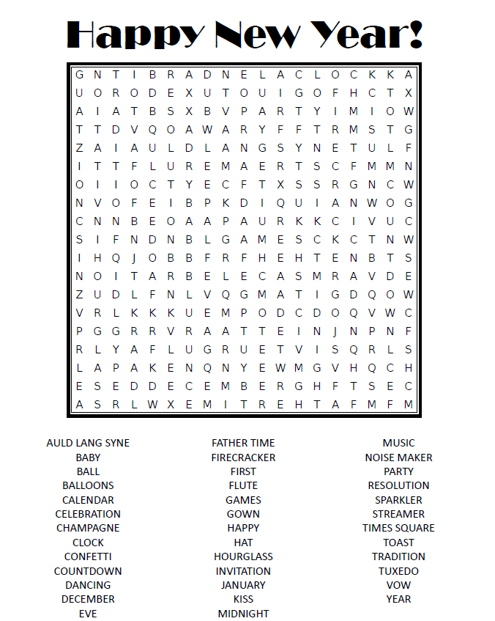

**Your Company Name**

123 Address, Someplace, ZZ 555555

555.555.5555 Phone ⚫ 555.555.5555 Fax

email@yourcompanyname.com

**YourCompanyWebsite.com**

**Be sure to stop by to pick out and schedule   
your new floor installation, and   
from our families to yours have a great month!**

Get a Night Out at the Movies for 2 with my

**Referral Rewards Program**

As you probably know, advertising is very expensive. Instead of paying the newspaper or another place to advertise, we’d rather reward you. So, we’ve assembled the Referral Rewards Program.

Every time you refer someone who becomes a client, we will send you a gift certificate for two passes to the **Movies-8 Cinema.**

And Hey! What’s a movie without popcorn? The gift certificate will also cover a big box of hot, buttered popcorn and sodas!

**Welcome to our new and returning clients!**

Click on the text box and Insert names

**A gigantic THANK YOU to all who referred us last month…**

Insert names

**Find the New Year’s Words!**