

Reliable news for healthy living, saving money, and having fun!

********

Inside This Issue…

* Are you this month’s Mystery Winner?
* Month at a Glance
* Five Fitness Pillars for Staying in Shape
* Mega Trivia Contest
* Did You Know
* Things you Didn’t Know about the Sound of Music
* Thank you for the Kind Words
* Client of the Month
* Solve the Secret Message!

**Nov. 11**

Veteran’s Day

**Nov. 25**

Thanksgiving Day



Month at a Glance!

November 2021

**Jimbo’s Floors**

Suzie Smith!

You are this month’s   
Mystery Winner!

We have a   
**$10.00 Starbucks   
gift card**   
reserved just for you!

Come by our store to   
claim your prize!

Dear Friends,

Your personal message goes here.

The personal message is important because it allows you to connect in a very personal way with your clients. This personal connection is sorely lacking in most businesses. Topic ideas:

Your hobbies

Something interesting happening this month. Wish them “Merry Christmas” or “Happy Thanksgiving.”

A thought from your heart

Appreciation for your clients and their referrals. Remind them that you will bend over backwards to provide their referrals with World Class Service.

Mention that month’s “special offer” insert

Your Friend,

Your Signature

Your Name

Scan to see our website

*“You’ll love your new floors, or I’ll replace them free!”*

~Jim Armstrong   
[www.JimbosFloors.com](http://www.JimbosFloors.com)

What common girl’s name was invented by William Shakespeare?

A) Julia B) Gertrude

C) Olivia D) Jessica

To enter, go to [www.JimbosFloors.com](http://www.JimbosFloors.com) and click on “Mega Trivia Contest.” Take your best guess… your chances of winning are better than you think!

## Want stellar health and a killer physique without the forced-march workouts? Get some skin back in the game with these 5 pillars of lifelong fitness from Men’s Health.

### Quit Obsessing Your Looks - Extreme leanness and muscularity—the kind you see in supplement ads—is not only an unrealistic goal for most busy guys but also unnecessary for athleticism.

Stop staring in the mirror and focus on performance instead. Work on nailing your first pullup, then your first five. Try cracking 21 minutes in a 5K, then 19. Conquer a 5.2 rock face, then a 5.3.

**Do Anything But Nothing -** Science suggests that you can get healthier, stronger, and fitter by following any plan regularly. The CDC recommends 150 minutes a week of moderate-intensity aerobic activity, along with twice-weekly muscle strengthening sessions. It’s not a high bar, but 76 percent of men don’t reach it. The best exercise is the exercise people actually do.

### Train, Don't Exercise - To a strength coach, exercise and training are as different as chalk and cheese. Exercise is something you do today because of how it makes you feel today. Training is a planned process to achieve a result somewhere down the road.

### Change It Up - Here's the curveball: To make that progress, you need to take strategic recovery breaks. Sure, sports belong in your training program, but focusing on a single sport or activity—year-round, with no time to heal and rebalance—might hurt you. For most of us, the ideal strategy is a three-weeks-on, one-week-off plan.

### Listen to Your Body - How do you find the sweet spot? Make sure your workout feels like work. Lifting to “volitional fatigue,” the point at which you can’t do any more reps while maintaining good form, is a more significant factor in determining muscle growth than weight lifted or reps performed, a new study reveals. If you don’t have a smile on your face when you’re working out, you’re doing something wrong.

Here at Jimbo’s Floors we use a special diagnostic tool called the Design Audit™.

Our free Design Audit™ is carefully crafted to take the headache out of shopping for new floors. A simple series of questions let my expert floor consultants narrow down the thousands of options to the two or three that exactly match your unique situation.

They’ll provide you with a written, customized “maintenance” plan with their professional recommendations for getting the longest life and beauty out of your floor.

Call or visit us today for your FREE Design Audit!™



Five Fitness Pillars for Staying in Shape

### Who Else Wants to Win

### Dinner for Two

### at the City Café!

### Take our Trivia Challenge and *you could win too!*

This month’s Mega Trivia question:

**Answer to last month’s question: C) Silent Cal**

Congratulations to last month’s winner: **Client Name**



Things You Didn’t Know about the Sound of Music

+



On November 16, 1959, “The Sound of Music” opened on Broadway.

**Critics in New York Hated It -** The musical opened at the Lunt-Fontanne Theater on Broadway, and New York critics hated it, thinking it was too saccharine. However, ticket sales made in advance were already up to $2 million, and the public had a different opinion, which ended up making “The Sound of Music” one of the most popular musicals in American history.

**Mary Martin Missed Only One Show** - During her two years appearing in the Broadway show as Maria, Mary Martin, the mother of actor Larry Hagman, only missed one show. She wasn’t considered for the movie role—that role went to Julie Andrews.

**Julie Andrews Nearly Turned Down The Role As Maria -** Julie Andrews had just finished filming Mary Poppins in 1964 when she was first approached to star in The Sound of Music. The actress nearly turned down the role of Maria for fear that the character was too similar to that of Mary Poppins.

**The Movie Is Historically Inaccurate** - Fans of the movie undoubtedly remember when the family crossed the mountains to reach the safety of Switzerland to escape the Nazis. However, the real Von Trapps made an easier journey to safety by taking a train to Italy. George von Trapp was reportedly a kind person, not as harsh as depicted in the movie. He had 10 children, not the seven portrayed in the film.

**Christopher Plummer Hated the Movie -** Although The Sound of Music is considered one of the best musicals ever made, Plummer hated the film so much that he called it "The Sound of Mucus.” He was quoted as saying “it was so awful and sentimental and gooey.”

**The Release of The Movie Rescued 20th Century Fox** – The movie Cleopatra had been a financial disaster for 20th Century Fox, costing more than $31 million, and the company was nearly bankrupt. Because The Sound of Music was such a huge hit, surpassing even Gone With the Wind, 20th Century Fox found itself rolling in money.

“My new laminate floors in my kitchen and dining room are beautiful. I was treated with respect and courtesy as a single woman raising a daughter. I genuinely felt that Jim Armstrong and his staff display concern for my flooring needs and were a guiding light for me. I recommend his service to anyone looking for a supportive, positive experience.”

~Marsha Avalos, School Teacher, Yuba City

“We Recently went to Jimbo’s Floors for new tile for our bathroom, and we’re thrilled with the results! This is our third time using Jimbo’s. Jim will never make you feel uncomfortable for asking questions and he’ll do anything in his power to accommodate your needs. When you do business with Jim and the staff at Jimbo’s Floors, you will be treated like royalty. Our experience was painless and very professional. Jim is not only our flooring expert, he’s a friend. That’s how he makes you feel.”

~Marvin and Sandy Moeller, owners of Sierra Landscaping, Yuba City

Congratulations to our client of the month,

**Susan Johnson!**

Susan is a 3rd time returning client, and she recently purchased new laminate for her kitchen and dining room. She always has a big smile on her face and is a lot of fun to work with. *Thanks, Susan!*

As always, our clients of the month receive **2 movie passes for Movies-8!**

*Watch for your name here in a coming month!*

Thank You for the Kind Words!

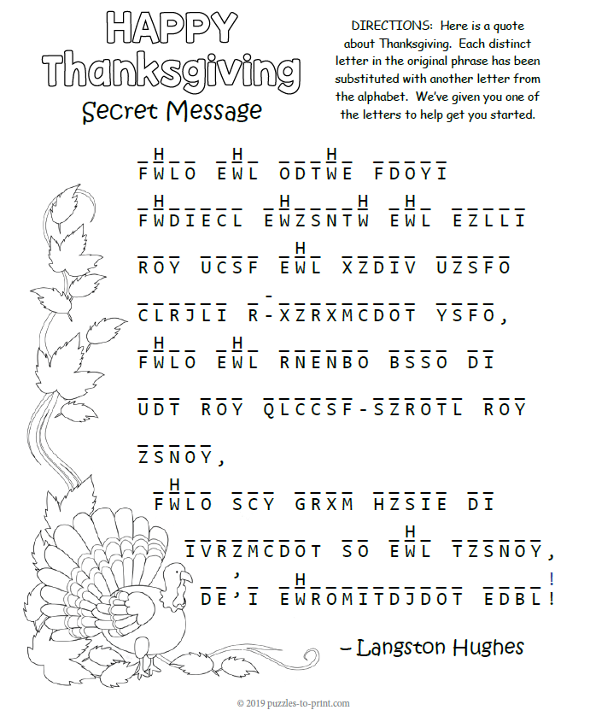

**Your Company Name**

123 Address, Someplace, ZZ 555555

555.555.5555 Phone ⚫ 555.555.5555 Fax

email@yourcompanyname.com

**YourCompanyWebsite.com**

**Be sure to stop by to pick out and schedule   
your new floor installation, and   
from our families to yours have a great month!**

When the night winds whistle through the trees

And blow the crisp brown leaves a-crackling down,

When the autumn moon is big and yellow-orange and round,

When old Jack Frost is sparkling on the ground,

It’s Thanksgiving time!

Get a Night Out at the Movies for 2 with my

**Referral Rewards Program**

As you probably know, advertising is very expensive. Instead of paying the newspaper or another place to advertise, we’d rather reward you. So, we’ve assembled the Referral Rewards Program.

Every time you refer someone who becomes a client, we will send you a gift certificate for two passes to the **Movies-8 Cinema.**

And Hey! What’s a movie without popcorn? The gift certificate will also cover a big box of hot, buttered popcorn and sodas!

**Welcome to our new and returning clients!**

Click on the text box and Insert names

**A gigantic THANK YOU to all who referred us last month…**

Insert names

Solve the Secret Message!