

Reliable news for healthy living, saving money, and having fun!

******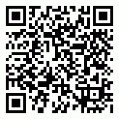**

**Oct. 31**

Halloween



Month at a Glance!

October 2021

**Jimbo’s Floors**

Suzie Smith!

You are this month’s   
Mystery Winner!

We have a   
**$10.00 Starbucks   
gift card**   
reserved just for you!

Come by our store to   
claim your prize!

Inside This Issue…

* Are you this month’s Mystery Winner?
* Month at a Glance
* Words You Should Never Use to Describe Yourself
* Mega Trivia Contest
* Did You Know
* Phone Call Anxiety & How to Get Over It
* Thank you for the Kind Words
* Client of the Month
* Do the Spooky Crossword!

Dear Friends,

Your personal message goes here.

The personal message is important because it allows you to connect in a very personal way with your clients. This personal connection is sorely lacking in most businesses. Topic ideas:

Your hobbies

Something interesting happening this month. Wish them “Merry Christmas” or “Happy Thanksgiving.”

A thought from your heart

Appreciation for your clients and their referrals. Remind them that you will bend over backwards to provide their referrals with World Class Service.

Mention that month’s “special offer” insert

Your Friend,

Your Signature

Your Name

Scan to see our website

*“You’ll love your new floors, or I’ll replace them free!”*

~Jim Armstrong   
[www.JimbosFloors.com](http://www.JimbosFloors.com)

Do you use cheesy clichés, overblown superlatives, or breathless adjectives to describe yourself in your social media profiles and marketing materials? Do you write things about yourself you would never actually have the nerve to *say*?

***Inc*** says that these words are great when other people use them to describe you—but you should never use to describe yourself (including the most overused words and phrases from LinkedIn profiles).

**Innovative** Most companies claim to be innovative. Most people claim to be innovative. Most are, however, not innovative. I'm definitely not. And that's OK, because innovation isn't a requirement for success. (You don't have to be new—you just have to be better.)

**World-class** What is a world-class professional or company? Who defines "world-class"? In your case: probably just you.

**Driven** Maybe you're data driven. (Wow, you try to objectively think through decisions?) Or maybe you're customer driven. (Wow, you try to please the people that pay you?)

Or maybe you're just plain old *driven*. No matter what the form, driven is like "motivated." Or "inspired." It's filler. Stop using it.

**Extensive experience** Say you have "extensive experience in web design." Fine, but how long you've been in business indicates nothing: You could still be the worst programmer in the world.

What matters more is what you've *done*: how many sites you've created, how many back-end systems you've installed, how many customer-specific applications you've developed (and what kind) ...

**Results-oriented** Really? You focus on doing what you get paid to do?

**Responsible** "Responsible" cuts two ways. You can be responsible (but, one hopes, isn't everyone?) or you can be responsible *for* (which is just a boring way of saying that you did something). Tell us what you've done. Achievements are always more impressive.

Don't tell us what you're responsible for. Tell us what you've *done*. Achievements are always more impressive.

What is the nickname of the only U.S. president born on the Fourth of July?

A) The Gipper B) Uncle Jumbo

C) Silent Cal D) Old Hickory

To enter, go to [www.JimbosFloors.com](http://www.JimbosFloors.com) and click on “Mega Trivia Contest.” Take your best guess… your chances of winning are better than you think!

When you buy floors from us, you are protected by our Installer Professionalism guarantee! It’s part of our Jimbo’s Floors 100% Iron-Clad Triple Guarantee.

Our installers are neat, clean, well-groomed, well-spoken and professional. They are trained and certified. They are guests in your home, and they conduct themselves as such. They respect your home by using wall and corner guards, shoe covers and drop cloths.

You’ll receive the highest-quality installation in the business. And after they’re finished, they will leave your home as neat and clean as when they arrived!



Words You Should Never Use to Describe Yourself

### Who Else Wants to Win

### Dinner for Two

### at the City Café!

### Take our Trivia Challenge and *you could win too!*

This month’s Mega Trivia question:

**Answer to last month’s question: B) Howard Cunningham**

Congratulations to last month’s winner: **Client Name**



Phone Call Anxiety & How to Get Over It

+



For some people, making or receiving calls is a stressful experience. Phone anxiety – or telephobia – is the fear and avoidance of phone conversations and it’s common among those with social anxiety disorder, according to Ilham Sebah in ***The Conversation.***

Some emotional symptoms of phone anxiety include delaying or avoiding making calls because of heightened anxiety, feeling extremely nervous or anxious before, during and after the call and obsessing or worrying about what you’ll say. Physical symptoms include nausea, increase in heart rate, shortness of breath, dizziness and muscular tension. If you suffer from these symptoms, there are some things you can do to make it easier.

## **Avoiding Phone Calls** Talking on the phone can be daunting because we’re limited to just the sounds of our voices. In the absence of all other social cues – including gestures, body language and eye contact – we can often feel self-conscious of the sound of our own voices and our choice of words.

Research also suggests phone anxiety is related to a preoccupation with what the other person thinks of them. By eliminating the immediate reaction of others in spoken conversations, text messaging may offer those with phone anxiety a way of making social contact without the fear of rejection or disapproval.

## **Pick Up the Phone** One of the most effective ways to overcome phone anxiety is to expose yourself to more phone calls. The more you do it, the less overwhelming it becomes. It’s also likely that your phone anxiety is linked to a lack of experience. The more practice you have, the less anxious and more confident you’ll feel.

You can start this process by making a list of the people you need to speak to on the phone, such as friends or colleagues, and go through each one by reflecting on what it is about the call that makes you anxious. When the call is over, acknowledging your success will help you stay motivated.

“My new laminate floors in my kitchen and dining room are beautiful. I was treated with respect and courtesy as a single woman raising a daughter. I genuinely felt that Jim Armstrong and his staff display concern for my flooring needs and were a guiding light for me. I recommend his service to anyone looking for a supportive, positive experience.”

~Marsha Avalos, School Teacher, Yuba City

“We Recently went to Jimbo’s Floors for new tile for our bathroom, and we’re thrilled with the results! This is our third time using Jimbo’s. Jim will never make you feel uncomfortable for asking questions and he’ll do anything in his power to accommodate your needs. When you do business with Jim and the staff at Jimbo’s Floors, you will be treated like royalty. Our experience was painless and very professional. Jim is not only our flooring expert, he’s a friend. That’s how he makes you feel.”

~Marvin and Sandy Moeller, owners of Sierra Landscaping, Yuba City

Congratulations to our client of the month,

**Susan Johnson!**

Susan is a 3rd time returning client, and she recently purchased new laminate for her kitchen and dining room. She always has a big smile on her face and is a lot of fun to work with. *Thanks, Susan!*

As always, our clients of the month receive **2 movie passes for Movies-8!**

*Watch for your name here in a coming month!*

Thank You for the Kind Words!

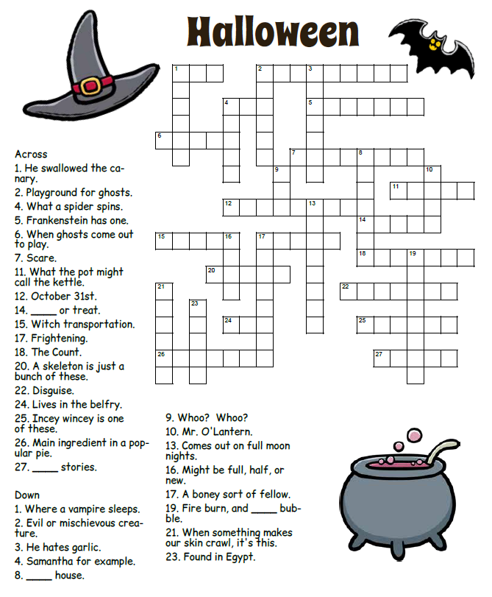

**Your Company Name**

123 Address, Someplace, ZZ 555555

555.555.5555 Phone ⚫ 555.555.5555 Fax

email@yourcompanyname.com

**YourCompanyWebsite.com**

Across 1 Cat 2 Graveyard 4 Web 5 Monster 6 Night 7 Frighten 11 Black 12 Halloween 14 Trick 15 Broom 17 Scary 18 Dracula 20 Bones 22 Costume 24 Bat 25 Spider 26 Pumpkin 27 Ghost

Down 1 Coffin 2 Goblin 3 Vampire 4 Witch 8 Haunted 9 Owl 10 Jack 13 Werewolf 16 Moon 17 Skeleton 19 Cauldron 21 Creepy 23 Mummy

**Be sure to stop by to pick out and schedule   
your new floor installation, and   
from our families to yours have a great month!**

Get a Night Out at the Movies for 2 with my

**Referral Rewards Program**

As you probably know, advertising is very expensive. Instead of paying the newspaper or another place to advertise, we’d rather reward you. So, we’ve assembled the Referral Rewards Program.

Every time you refer someone who becomes a client, we will send you a gift certificate for two passes to the **Movies-8 Cinema.**

And Hey! What’s a movie without popcorn? The gift certificate will also cover a big box of hot, buttered popcorn and sodas!

**Welcome to our new and returning clients!**

Click on the text box and Insert names

**A gigantic THANK YOU to all who referred us last month…**

Insert names

Do the Spooky Crossword! (*If you dare . . .)*