

Reliable news for healthy living, saving money, and having fun!

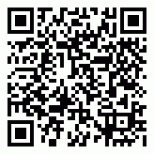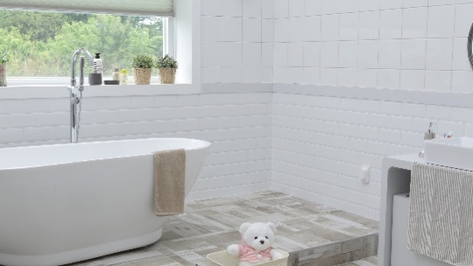

Suzie Smith!

You are this month’s   
Mystery Winner!

We have a   
**$10.00 Starbucks   
gift card**   
reserved just for you!

Come by our store to   
claim your prize!

**Sept. 6**

Labor Day

Month at a Glance!

September 2021

**Jimbo’s Floors**

Inside This Issue…

* Are you this month’s Mystery Winner?
* Month at a Glance
* Pet Peeves Home Stagers Have About Your Bathroom
* Mega Trivia Contest
* Did You Know
* Sweet Facts about Hershey’s Chocolate
* Thank you for the Kind Words
* Client of the Month
* Find the Baseball Parks!

Dear Friends,

Your personal message goes here.

The personal message is important because it allows you to connect in a very personal way with your clients. This personal connection is sorely lacking in most businesses. Topic ideas:

Your hobbies

Something interesting happening this month. Wish them “Merry Christmas” or “Happy Thanksgiving.”

A thought from your heart

Appreciation for your clients and their referrals. Remind them that you will bend over backwards to provide their referrals with World Class Service.

Mention that month’s “special offer” insert

Your Friend,

Your Signature

Your Name

Scan to see our website

*“You’ll love your new floors, or I’ll replace them free!”*

~Jim Armstrong   
[www.JimbosFloors.com](http://www.JimbosFloors.com)

Pet peeves home stagers have about your bathroom

Here at Jimbo’s Floors

we use a special diagnostic tool called the Design Audit™.

Our free Design Audit™ is carefully crafted to take the headache out of shopping for new floors. A simple series of questions let my expert floor consultants narrow down the thousands of options to the two or three that exactly match your unique situation.

They’ll provide you with a written, customized “maintenance” plan with their professional recommendations for getting the longest life and beauty out of your floor.

Call or visit us today for your FREE Design Audit!™

Which TV dad was the owner of a hardware store?

A) Mike Brady B) Howard Cunningham

C) Ward Cleaver D) Archie Bunker

To enter, go to [www.JimbosFloors.com](http://www.JimbosFloors.com) and click on “Mega Trivia Contest.” Take your best guess… your chances of winning are better than you think!

If you’re planning to sell your house soon, or are even just trying to increase the value for the time being, *Apartment Therapy* says don’t fall into these typical outdated bathroom traps.

## **Themes** Themes are out. Eclectic looks are much more appealing for the current market—so stay away from coordinating your flip-flop-shaped soap pump to a starfish shower curtain to hand towels with a beach picture on them.

## 

## **Putting unnecessary items on display** If you’re not going to actually use something, don’t put it on display in your bathroom. That means decorative towels, those seashell-shaped soaps everyone leaves on the countertop, and fake plants. Instead, put out some nice trays and top them with jars full of things you get use out of, like cotton balls and bath salts. If you’re selling your house, put away the less attractive things you use all the time, like cleaning products, tools, and personal items.

## **Window treatments** If you don’t need privacy in the bathroom from an unfortunately placed window, you don’t need window treatments, according to the pros. And if you do need that privacy, opt for something less obtrusive than a curtain and valance, like blinds or a frosted window film. Letting light in is key

## during a showing.

## **Rugs** Rugs and rug-like items (like fuzzy toilet seat covers) should only serve a practical purpose. If you’re worried about slipping when you get out of the tub, then get a bathmat—but only one. The more you break up that floor space, the smaller the room appears.

## **Medicine cabinets** Even if you’re not redoing your bathroom and you’re just trying to increase the look and value of your home to sell, replace that old fashioned medicine cabinet with a nice, updated mirror.

## **Towel bars** Towels hung on a bar almost always look messy, say the experts. Instead, install some hooks, which are a little more practical. Towels you don’t hang can be displayed folded into thirds and stacked in a little pyramid.



### Who Else Wants to Win

### Dinner for Two

### at the City Café!

### Take our Trivia Challenge and *you could win too!*

This month’s Mega Trivia question:

**Answer to last month’s question: A) Risk**

Congratulations to last month’s winner: **Client Name**



Sweet facts about Hershey’s chocolate

+



On September 13, 1857, Milton Hershey was born -- to the future delight of chocolate lovers. Here are sweet facts from *Trivia Today* you probably didn't know …

**Milton Hershey Got His Start Making Caramels, Not Chocolate** After launching two unsuccessful confectionery businesses in Philadelphia and New York, Hershey returned to Lancaster, Pennsylvania, and launched the Lancaster Caramel Company in 1886 using a recipe he acquired on his travels. The company was a massive success. He sold it for $1 million in 1900 (the equivalent of more than $28 million today) and focused his attentions on chocolate.

**The Name Mr. Goodbar Was A Misunderstanding**. While considering what to call their new candy bar with peanuts, an executive said that the new product was a “good bar.”  Milton Hershey was hard of hearing and thought that the exec had said “Mr. Good Bar.” He liked the name, so it stuck.

**Heat Resistant Hershey Chocolate Has Been To The Moon** During World War II, Hershey developed ration bars for the military that could withstand battlefield conditions. In 1971, these bars accompanied the Apollo 15 astronauts to the moon.

**Milton Hershey Was Supposed To Be On The Titanic** Milton and Kitty Hershey had paid a $300 deposit for a first-class cabin on the ill-fated maiden voyage of the RMS Titanic. Fortunately, either business or illness interfered with their plans, and they ended up taking a German liner called the Amerika, arriving back home before the Titanic met its gruesome end.

**The Company Once Made Gum** A rumor that Beech Nut Gum was going to make chocolate influenced Hershey to produce his own chewing gum in competition. The gum, named “Easy Chew,” came out in 1915, but it was a problem getting sugar and chicle because of import restrictions placed on non-essential products. The chewing gum was discontinued in 1924.

“My new laminate floors in my kitchen and dining room are beautiful. I was treated with respect and courtesy as a single woman raising a daughter. I genuinely felt that Jim Armstrong and his staff display concern for my flooring needs and were a guiding light for me. I recommend his service to anyone looking for a supportive, positive experience.”

~Marsha Avalos, School Teacher, Yuba City

“We Recently went to Jimbo’s Floors for new tile for our bathroom, and we’re thrilled with the results! This is our third time using Jimbo’s. Jim will never make you feel uncomfortable for asking questions and he’ll do anything in his power to accommodate your needs. When you do business with Jim and the staff at Jimbo’s Floors, you will be treated like royalty. Our experience was painless and very professional. Jim is not only our flooring expert, he’s a friend. That’s how he makes you feel.”

~Marvin and Sandy Moeller, owners of Sierra Landscaping, Yuba City

Congratulations to our client of the month,

**Susan Johnson!**

Susan is a 3rd time returning client, and she recently purchased new laminate for her kitchen and dining room. She always has a big smile on her face and is a lot of fun to work with. *Thanks, Susan!*

As always, our clients of the month receive **2 movie passes for Movies-8!**

*Watch for your name here in a coming month!*

Thank You for the Kind Words!

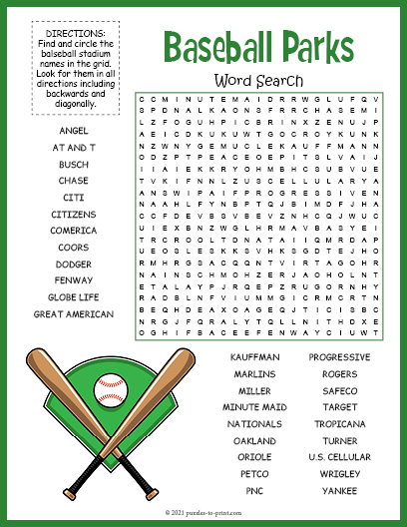

**Be sure to stop by to pick out and schedule   
your new floor installation, and   
from our families to yours have a great month!**

Get a Night Out at the Movies for 2 with my

**Referral Rewards Program**

As you probably know, advertising is very expensive. Instead of paying the newspaper or another place to advertise, we’d rather reward you. So, we’ve assembled the Referral Rewards Program.

Every time you refer someone who becomes a client, we will send you a gift certificate for two passes to the **Movies-8 Cinema.**

And Hey! What’s a movie without popcorn? The gift certificate will also cover a big box of hot, buttered popcorn and sodas!

**Welcome to our new and returning clients!**

Click on the text box and Insert names

**A gigantic THANK YOU to all who referred us last month…**

Insert names

Find the Baseball Parks!

**Your Company Name**

123 Address, Someplace, ZZ 555555

555.555.5555 Phone ⚫ 555.555.5555 Fax

email@yourcompanyname.com

**YourCompanyWebsite.com**