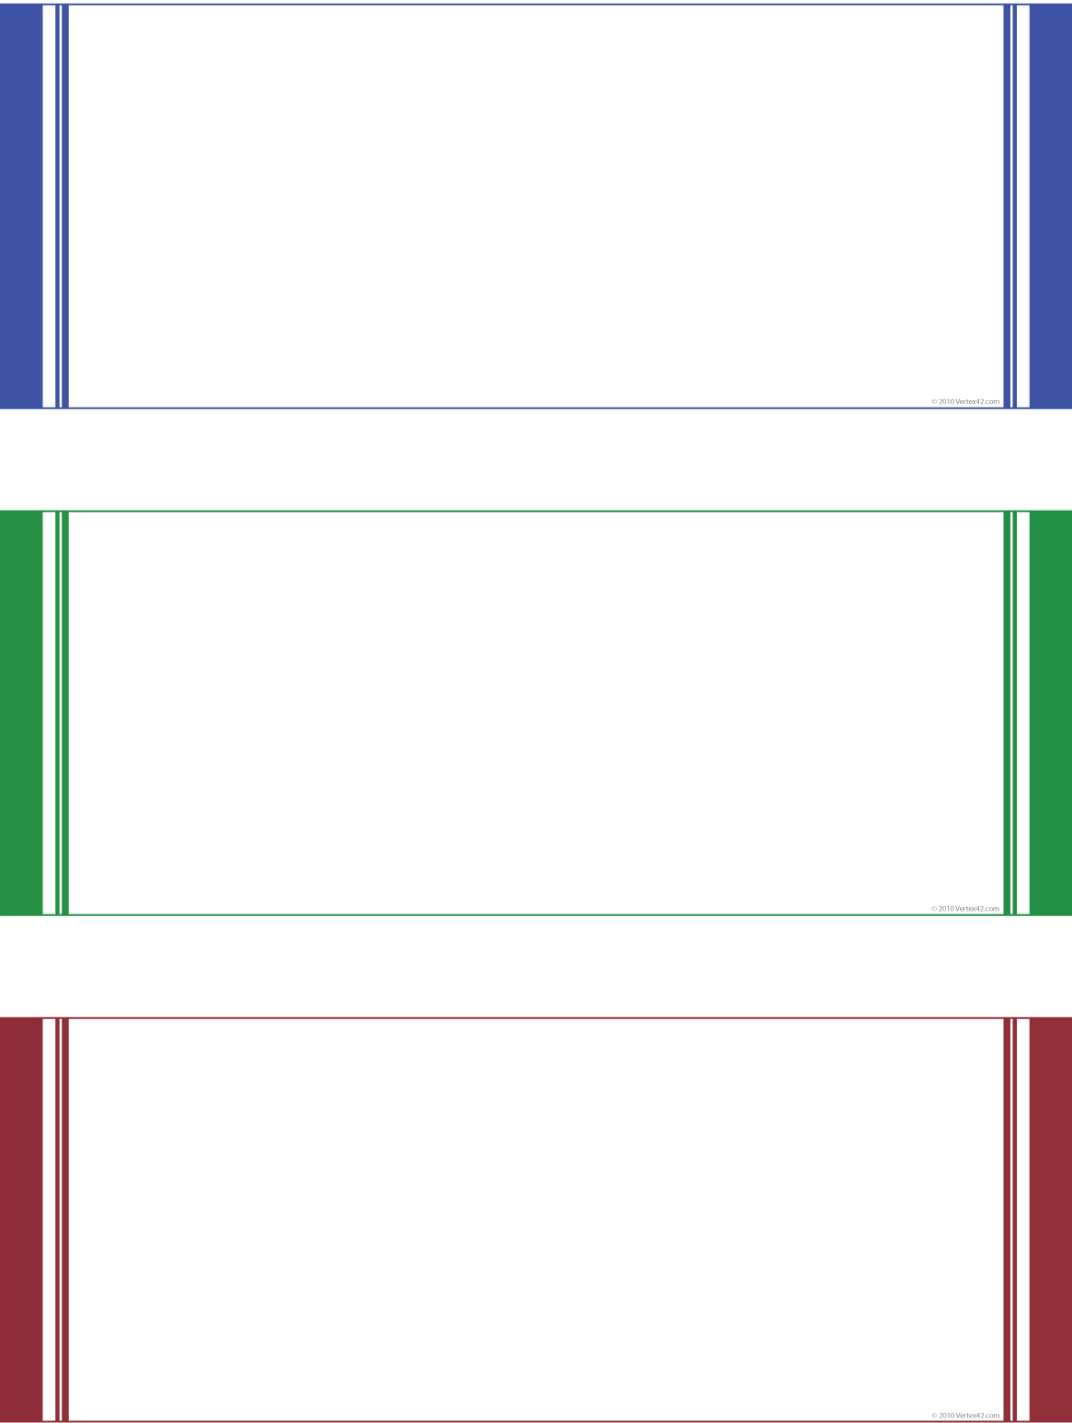

|  |  |  |
| --- | --- | --- |
| **$250**  Gift Certificate | Insert Logo Here  ADDRESS | CITY, ST | ZIP  PHONE | WEBSITE | |
| **Exclusively for the preferred clients of**  **Park Avenue Decorators** | |
| This gift certificate good for $250 towards any purchase at Jimbo’s Floors of $2,500 or more. For purchases between $1,000 and $2,499 you’ll receive dinner for two at the City Café and a free spotting kit. For purchases between $500-$999 you’ll receive two passes for the Movie’s-8 Cinema. | | |