

Reliable news for healthy living, saving money, and having fun!

********



Month at a Glance!

August 2021

**Jimbo’s Floors**

Suzie Smith!

You are this month’s   
Mystery Winner!

We have a   
**$10.00 Starbucks   
gift card**   
reserved just for you!

Come by our store to   
claim your prize!

Inside This Issue…

* Are you this month’s Mystery Winner?
* Month at a Glance
* Things you Didn’t Know about the TV Show, *Friends*
* Mega Trivia Contest
* Did You Know
* The Age When We Start to Feel Old
* Thank you for the Kind Words
* Client of the Month
* Solve the Summer Crossword!

Dear Friends,

Your personal message goes here.

The personal message is important because it allows you to connect in a very personal way with your clients. This personal connection is sorely lacking in most businesses. Topic ideas:

Your hobbies

Something interesting happening this month. Wish them “Merry Christmas” or “Happy Thanksgiving.”

A thought from your heart

Appreciation for your clients and their referrals. Remind them that you will bend over backwards to provide their referrals with World Class Service.

Mention that month’s “special offer” insert

Your Friend,

Your Signature

Your Name

Scan to see our website

*“You’ll love your new floors, or I’ll replace them free!”*

~Jim Armstrong   
[www.JimbosFloors.com](http://www.JimbosFloors.com)

With the *Friends* reunion in the news recently, *Trivia Today* shares these surprising things you probably didn’t know about NBC’s long-running comedy series...

**“Insomnia Café” Was the Original Name Of The Sitcom.** It would be tough to imagine Friends being named anything else. But before this simple name was chosen, other names were considered for the show. The show's creators originally created a pitch for a sitcom called Insomnia Café. Not only was the name of the show different, but so was the plot, with Joey and Monica being love interests instead of Ross and Rachel. When the pilot was bought by NBC, they changed the name to Friends Like Us and considered naming it Across the Hall. It changed again to Six of One, but finally ended up as Friends by the time it premiered.

**Phoebe's Twin Sister Ursula Was Also a Character on Mad About You.** Phoebe's twin sister, Ursula, wasn't just featured on Friends. She was also a character in another popular sitcom, Mad About You. In fact, Lisa Kudrow, who plays both Phoebe and Ursula, was already playing the character of Ursula on Mad About You before being cast on Friends. Friends producers decided to say the characters were twin sisters to address the potential confusion among viewers who may have been watching both shows with the same actor.

**The Show Could Have Had a Different Cast.** With a cast of six main characters, it's not surprising to know that many different actors were considered to play the different roles in Friends. For example, Kathy Griffin and Jane Lynch actually became friends after meeting while both were auditioning for the part of Phoebe.

Jon Cryer and Jon Favreau were considered for the role of Chandler before it went to Mathew Perry. Meanwhile, Perry almost didn't get the gig either. During the 1994 pilot season of Friends, Perry was also filming a pilot for the show LAX 2194. The show was about baggage handlers at LAX who sorted aliens’ luggage. Thankfully, that show was never picked up, leaving Perry committed to the role of Chandler Bing.

The inventor of which board game was also an Academy Award winner?

A) Risk B) Sorry

C) Candy Land D) Monopoly

To enter, go to [www.JimbosFloors.com](http://www.JimbosFloors.com) and click on “Mega Trivia Contest.” Take your best guess… your chances of winning are better than you think!

When you buy floors from us, you are protected by our Installer Professionalism guarantee! It’s part of our Jimbo’s Floors 100% Iron-Clad Triple Guarantee.

Our installers are neat, clean, well-groomed, well-spoken and professional. They are trained and certified. They are guests in your home, and they conduct themselves as such. They respect your home by using wall and corner guards, shoe covers and drop cloths.

You’ll receive the highest-quality installation in the business. And after they’re finished, they will leave your home as neat and clean as when they arrived!



Things you didn’t know about the TV show, *Friends*

### Who Else Wants to Win

### Dinner for Two

### at the City Café!

### Take our Trivia Challenge and *you could win too!*

This month’s Mega Trivia question:

**Answer to last month’s question: B) Good & Plenty**

Congratulations to last month’s winner: **Client Name**



The age when we start to feel old

+



Young at heart take note: Biological age, which refers to the age that someone feels as opposed to the number of years they have been alive (chronological age), is gaining more credibility as a useful health measure among medical professionals, as published in Ladders.

Although various factors influence whether or not someone feels especially young or old, the majority of people start feeling old around the age of (drum roll, please) 47. This was the most cited age — by 2,000 participants involved in a massive new poll commissioned by Foster Grant and conducted by OnePoll.

All of the participants involved in the report were over the age of 40 at the start of the analysis, and nearly four in five (77 percent) said that they feel younger than their chronological age. More than half (55 percent) even see their “younger selves” when they look in the mirror.

For the respondents, aging was defined by three principal markers: the inability to perform certain functions with ease, a lack of understanding of topical pop-culture references, and cosmetic decay (wrinkles, graying hair, etc.).

Sixty-one percent of respondents said that having to ask someone to read small print/squinting to be able to see small print are unmistakable signs of getting older*—*even if only 29 percent of the same group perceived being prescribed reading glasses as a definitive sign of aging.

Hearing a familiar song on the “oldies” station (43 percent), involuntarily grunting while getting out of a seat (37 percent), seeing a celebrity they’ve never heard of (33 percent), having trouble seeing in a dimly lit room (26 percent), and not being on TikTok (24 percent) were other factors that made participants feel older than their chronological age.

Still. 47 percent of the participants are uncomfortable with identifying as an older person and more than a third say they get offended if someone else calls them old. Previously conducted research has shown that reduced stress and diet — and increased amounts of sleep — can help people feel younger.

“My new laminate floors in my kitchen and dining room are beautiful. I was treated with respect and courtesy as a single woman raising a daughter. I genuinely felt that Jim Armstrong and his staff display concern for my flooring needs and were a guiding light for me. I recommend his service to anyone looking for a supportive, positive experience.”

~Marsha Avalos, School Teacher, Yuba City

“We Recently went to Jimbo’s Floors for new tile for our bathroom, and we’re thrilled with the results! This is our third time using Jimbo’s. Jim will never make you feel uncomfortable for asking questions and he’ll do anything in his power to accommodate your needs. When you do business with Jim and the staff at Jimbo’s Floors, you will be treated like royalty. Our experience was painless and very professional. Jim is not only our flooring expert, he’s a friend. That’s how he makes you feel.”

~Marvin and Sandy Moeller, owners of Sierra Landscaping, Yuba City

Congratulations to our client of the month,

**Susan Johnson!**

Susan is a 3rd time returning client, and she recently purchased new laminate for her kitchen and dining room. She always has a big smile on her face and is a lot of fun to work with. *Thanks, Susan!*

As always, our clients of the month receive **2 movie passes for Movies-8!**

*Watch for your name here in a coming month!*

Thank You for the Kind Words!

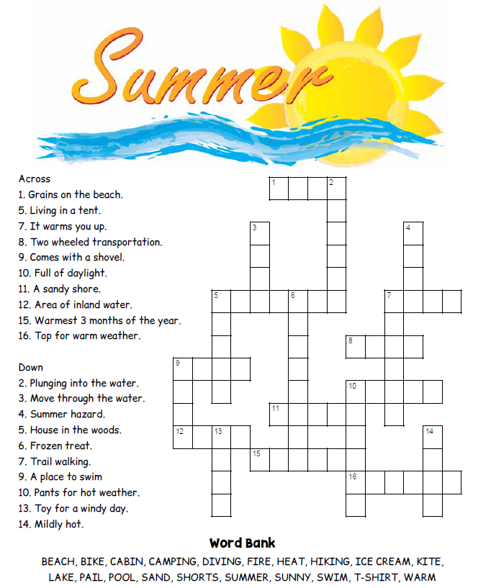 

**Your Company Name**

123 Address, Someplace, ZZ 555555

555.555.5555 Phone ⚫ 555.555.5555 Fax

email@yourcompanyname.com

**YourCompanyWebsite.com**

**Be sure to stop by to pick out and schedule   
your new floor installation, and   
from our families to yours have a great month!**

Get a Night Out at the Movies for 2 with my

**Referral Rewards Program**

As you probably know, advertising is very expensive. Instead of paying the newspaper or another place to advertise, we’d rather reward you. So, we’ve assembled the Referral Rewards Program.

Every time you refer someone who becomes a client, we will send you a gift certificate for two passes to the **Movies-8 Cinema.**

And Hey! What’s a movie without popcorn? The gift certificate will also cover a big box of hot, buttered popcorn and sodas!

**Welcome to our new and returning clients!**

Click on the text box and Insert names

**A gigantic THANK YOU to all who referred us last month…**

Insert names

Solve the Summer Crossword!