

Reliable news for healthy living, saving money, and having fun!

**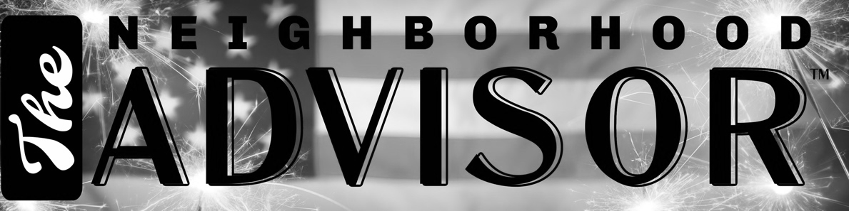****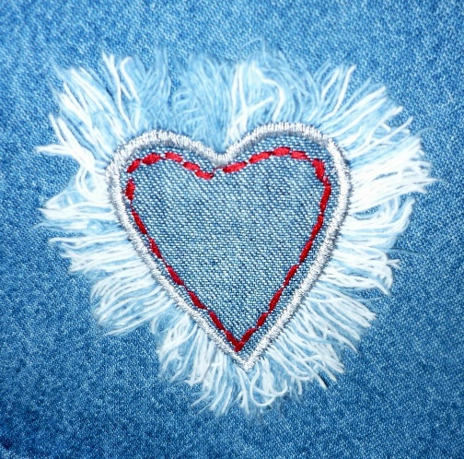**

**July 1**

Canada Day (CA)

**July 4**

Independence Day (US)



Month at a Glance!

July 2021

**Jimbo’s Floors**

Suzie Smith!

You are this month’s   
Mystery Winner!

We have a   
**$10.00 Starbucks   
gift card**   
reserved just for you!

Come by our store to   
claim your prize!

Inside This Issue…

* Are you this month’s Mystery Winner?
* Month at a Glance
* Baseball, hot dogs, apple pie and . . . blue jeans
* Mega Trivia Contest
* Did You Know
* Why Do We Eat Popcorn at Movies?
* Thank you for the Kind Words
* Client of the Month
* Solve the Fourth of July Scramble!

Dear Friends,

Your personal message goes here.

The personal message is important because it allows you to connect in a very personal way with your clients. This personal connection is sorely lacking in most businesses. Topic ideas:

Your hobbies

Something interesting happening this month. Wish them “Merry Christmas” or “Happy Thanksgiving.”

A thought from your heart

Appreciation for your clients and their referrals. Remind them that you will bend over backwards to provide their referrals with World Class Service.

Mention that month’s “special offer” insert

Your Friend,

Your Signature

Your Name

Scan to see our website

*“You’ll love your new floors, or I’ll replace them free!”*

~Jim Armstrong   
[www.JimbosFloors.com](http://www.JimbosFloors.com)

Although Levis are an iconic symbol of America, two immigrants were involved in their original design, says *Trivia Today*. Jacob Davis, an immigrant from Latvia, who was living in Reno, Nevada, came up with the idea of placing copper rivets at particular points in work pants to make them stronger. He contacted Levi Strauss, a German-born wholesale dry goods merchant, who supplied his fabric. Strauss financed the application for the patent and became the name of the popular denim jeans.

Copper rivets placed on the pockets made the seams more durable and prevented tearing, which was important to the miners who originally wore them. In the 1930s, pockets were sewn to the pants to cover the rivets because of complaints that they scratched furniture. But they were returned to view in 1947. A small fifth pocket was added as a handy carrying case for a pocket watch.

One of the world’s oldest pairs of Levi’s jeans - made in the 1880s and sold for around a dollar - was reacquired by Levi Strauss & Co. for $46,532. The jeans were found in an old gold mine in the Mojave Desert in California in 1999 and were reported to be 100 years old.  In what is believed to be the highest price ever paid for denim, Levi’s bought the jeans during an online eBay auction. Levi’s historian Lynn Downey said the company would use the jeans as a template for part of a vintage collection. Historians for Levi Strauss examined the fabric and patented copper rivets and concluded the jeans were produced between 1880 and 1885.

What people know today as jeans were originally called waist overalls. People continued to call them waist overalls or just plain overalls until the 1960s. Jean (or jeane) was the name for the cotton corduroy fabric made in Genoa, Italy, that was used to fashion the pants.

Jeans were associated with the working class, but Hollywood films changed that. It started first with Marlon Brando wearing jeans as a tough biker in “The Wild One” in 1953, and then with heartthrob James Dean in “Rebel Without a Cause” in 1955. By the time Marilyn Monroe appeared in “The Misfits” in 1961, everyone wanted to own at least a few pairs of jeans, including women.

Here at Jimbo’s Floors we pride ourselves on our Lifetime Installation Warranty!

Buying flooring is not like buying any other piece of interior décor, such as a sofa or a lamp.

Why? Because unlike other products, flooring is installed or “manufactured” in your home. This makes the installation critical. I offer a lifetime installation warranty at Jimbo’s Floors as part of our 100% Iron-Clad Triple Guarantee!

You NEVER have to worry about something going wrong with the installation. If it does, I’ll fix it FREE! And I’ll do it quickly.

What is the oldest brand of American candy still in production?

A) Tootsie Rolls B) Good & Plenty

C) Life Savers D) Twizzlers

To enter, go to [www.JimbosFloors.com](http://www.JimbosFloors.com) and click on “Mega Trivia Contest.” Take your best guess…your chances of winning are better than you think!



Baseball, hot dogs, apple pie and . . . blue jeans

### Who Else Wants to Win

### Dinner for Two

### at the City Café!

### Take our Trivia Challenge and *you could win too!*

This month’s Mega Trivia question:

**Answer to last month’s question: D) Switzerland**

Congratulations to last month’s winner: **Client Name**

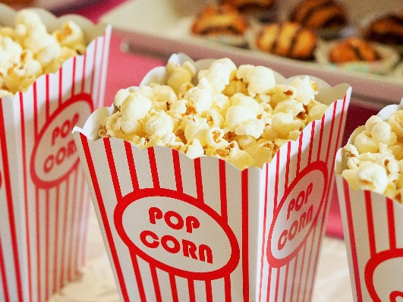

Why Do We Eat Popcorn at Movies?

+



Movie theater popcorn is a concession stand staple whose scent has spawned marketing ploys and copycat recipes, but movie theaters haven't always been saturated with the tempting smell of salt and butter, according to *Smithsonian Magazine*.

By 1848, popcorn had literally exploded onto the scene and was available everywhere—especially at entertainment sites like circuses and fairs. In fact, there was really only one entertainment site where the snack was absent: the theaters.

One reason for popcorn's increasing popularity was its mobility: in 1885, the first steam-powered popcorn maker hit the streets, invented by Charles Cretor of Chicago. The mobile nature of the machine made it the perfect production machine for serving patrons attending outdoor sporting events, or circuses and fairs. Not only was popcorn mobile, but it could be mass-produced without a kitchen. Another reason for its dominance over other snacks was its appealing aroma when popped, something that street vendors used to their advantage when selling popcorn.

Movie theaters wanted nothing to do with popcorn because they were trying to duplicate what was done in real theaters. Movie theaters were trying to appeal to a highbrow clientele and didn't want to deal with the distracting trash of concessions—or the distracting noise that snacking during a film would create.

The Great Depression presented an excellent opportunity for both movies and popcorn. Looking for a cheap diversion, audiences flocked to the movies. And at 5 to 10 cents a bag, popcorn was a luxury that most people were able to afford. Enterprising street vendors didn't miss a beat: they bought their own popping machines and sold popcorn outside the theaters to moviegoers before they entered the theater.

Eventually, movie theater owners realized that if they cut out the middleman, their profits would skyrocket. For many theaters, the transition to selling snacks helped save them from the crippling Depression. Concessions became their ticket to sustainability, and ultimately higher profits.

“My new laminate floors in my kitchen and dining room are beautiful. I was treated with respect and courtesy as a single woman raising a daughter. I genuinely felt that Jim Armstrong and his staff display concern for my flooring needs and were a guiding light for me. I recommend his service to anyone looking for a supportive, positive experience.”

~Marsha Avalos, School Teacher, Yuba City

“We Recently went to Jimbo’s Floors for new tile for our bathroom, and we’re thrilled with the results! This is our third time using Jimbo’s. Jim will never make you feel uncomfortable for asking questions and he’ll do anything in his power to accommodate your needs. When you do business with Jim and the staff at Jimbo’s Floors, you will be treated like royalty. Our experience was painless and very professional. Jim is not only our flooring expert, he’s a friend. That’s how he makes you feel.”

~Marvin and Sandy Moeller, owners of Sierra Landscaping, Yuba City

Congratulations to our client of the month,

**Susan Johnson!**

Susan is a 3rd time returning client, and she recently purchased new laminate for her kitchen and dining room. She always has a big smile on her face and is a lot of fun to work with. *Thanks, Susan!*

As always, our clients of the month receive **2 movie passes for Movies-8!**

*Watch for your name here in a coming month!*

Thank You for the Kind Words!

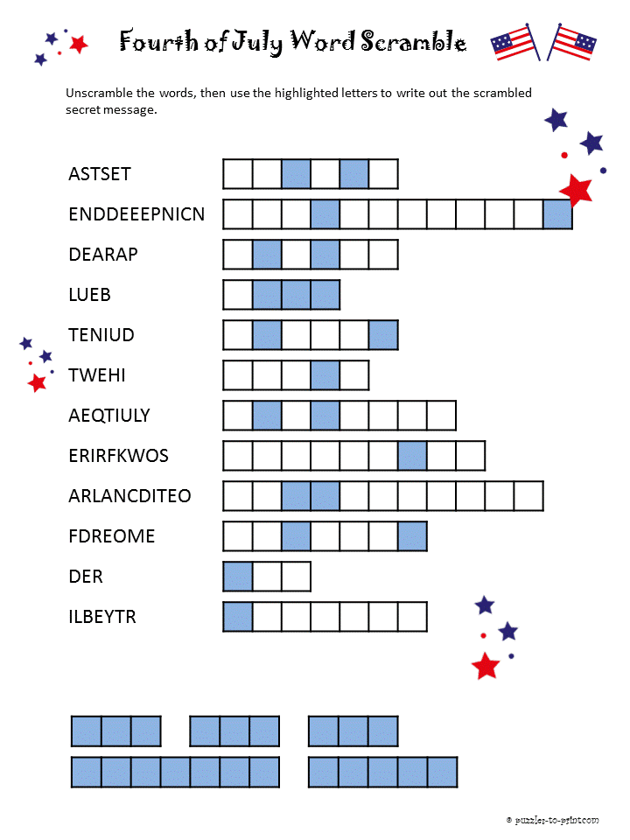 

**Be sure to stop by to pick out and schedule   
your new floor installation, and   
from our families to yours have a great month!**

Answers: States, Independence, Parade, Blue, United, White, Equality, Fireworks, Declaration, Freedom, Red, Liberty

All men are created equal

Get a Night Out at the Movies for 2 with my

**Referral Rewards Program**

As you probably know, advertising is very expensive. Instead of paying the newspaper or another place to advertise, we’d rather reward you. So, we’ve assembled the Referral Rewards Program.

Every time you refer someone who becomes a client, we will send you a gift certificate for two passes to the **Movies-8 Cinema.**

And Hey! What’s a movie without popcorn? The gift certificate will also cover a big box of hot, buttered popcorn and sodas!

**Welcome to our new and returning clients!**

Click on the text box and Insert names

**A gigantic THANK YOU to all who referred us last month…**

Insert names

Solve the Scramble!

**Your Company Name**

123 Address, Someplace, ZZ 555555

555.555.5555 Phone ⚫ 555.555.5555 Fax

email@yourcompanyname.com

**YourCompanyWebsite.com**