

Reliable news for healthy living, saving money, and having fun!

********

**June 19**

Juneteenth

(U.S.)

**June 20**

Father’s Day

(U.S. & Canada)

**June 21**

National Indigenous People’s Day (Canada)



Month at a Glance!

June 2021

**Jimbo’s Floors**

Suzie Smith!

You are this month’s   
Mystery Winner!

We have a   
**$10.00 Starbucks   
gift card**   
reserved just for you!

Come by our store to   
claim your prize!

Inside This Issue…

* Are you this month’s Mystery Winner?
* Month at a Glance
* The Best Ways to Travel Across the Country
* Mega Trivia Contest
* Did You Know
* Things You Didn’t Know about the Murder of John Lennon
* Thank you for the Kind Words
* Client of the Month
* Bottoms Up! Find the Coffee Words!

Dear Friends,

Your personal message goes here.

The personal message is important because it allows you to connect in a very personal way with your clients. This personal connection is sorely lacking in most businesses. Topic ideas:

Your hobbies

Something interesting happening this month. Wish them “Merry Christmas” or “Happy Thanksgiving.”

A thought from your heart

Appreciation for your clients and their referrals. Remind them that you will bend over backwards to provide their referrals with World Class Service.

Mention that month’s “special offer” insert

Your Friend,

Your Signature

Your Name

Scan to see our website

*“You’ll love your new floors, or I’ll replace them free!”*

~Jim Armstrong   
[www.JimbosFloors.com](http://www.JimbosFloors.com)

The dream of roaming pedal-to-the-metal across the continent is a transfixing one. The *Wall Street Journal* says it’s still possible to conduct an epic cross-country road trip during the pandemic, but do plenty of research before heading out the door. They asked the American Automobile Association (AAA) to outline a couple of memorable trips:

###### **New York to Seattle**

###### ***Shore to Shore***

###### Crossing the continent via Interstates 80 and 90 would take 42 hours straight through, but the AAA cautions travelers not to rush the 2,852-mile-long route. Bisecting 11 states, the journey offers plenty to see and do. The route includes urban layovers in Cleveland, with a visit to the Rock & Roll Hall of Fame, and Chicago for its deep-dish pizza (locals like delivery from Lou Malnati’s) as well as a stop by Lake Michigan. In South Dakota, visit the town of Mitchell and its Corn Palace. From Montana, a short southern detour to Wyoming will deliver you to Yellowstone and Grand Teton national parks, before finally ending by Puget Sound in Seattle and a visit to the Space Needle. (Amazon’s twin Spheres, however, are closed.)

###### **Chicago to Los Angeles**

#### **Time Travel to the Old West**

#### Any list of cross-country trips should include Route 66, the country’s “Mother Road” between the Midwest and California before the Interstate Highway System. The 2,448-mile-long drive is about going back in time. AAA’s recommended stops include iconic monuments like the St. Louis Gateway Arch and quirky roadside attractions like Illinois’s 1924 Ariston Café, or the Cadillac Ranch art installation in Amarillo, Tex.

#### In Arizona slight detours will take you to Grand Canyon and Petrified Forest national parks and if you need a respite, sleep over in Holbrook’s Wigwam Motel. In California you’ll pass near the desert wilds of Joshua Tree and Death Valley national parks before concluding the trip in Los Angeles at the Santa Monica Pier on the Pacific Ocean. Order a celebratory takeout meal at nearby local favorite Chez Jay.

You are protected by Jimbo’s Floors “Zero Regrets Guarantee!” You’ll love your new floors or I’ll replace them FREE!

If at any time during the first 30 days after installation you decide you don’t like your new flooring for whatever reason, just let me know.

I’ll replace the materials free of charge. (With an outrageously good guarantee like this, I can’t include the cost of installation, so you’ll have to cover that.)

It’s just part of Jimbo’s 100% Iron-Clad Triple Guarantee!

Which country made it illegal to own just one guinea pig?

A) Brazil B) Iran

C) Ethiopia D) Switzerland

To enter, go to [www.JimbosFloors.com](http://www.JimbosFloors.com) and click on “Mega Trivia Contest.” Take your best guess…your chances of winning are better than you think!



The Best Ways to Travel Across the Country

### Who Else Wants to Win

### Dinner for Two

### at the City Café!

### Take our Trivia Challenge and *you could win too!*

This month’s Mega Trivia question:

**Answer to last month’s question: C) Farfalle**

Congratulations to last month’s winner: **Client Name**



Things You Didn’t Know about the Murder of John Lennon

+



On June 22, 1981, over the objections of his lawyer, Mark David Chapman pleaded guilty to the murder of John Lennon on what he said were instructions from God. *Trivia Today* shares these things you didn't know about the murder of John Lennon.

Chapman's act wasn't spontaneous, even though it did involve some last-minute decisions. According to Chapman's wife, he almost tried to kill Lennon a couple of months earlier but stopped because of his wife. Unfortunately, his urge to kill Lennon won, much to the dismay of his wife. She knew he had gone on a trip to New York in December but didn't realize that he was planning to go through with his original intentions.

The day before Chapman shot Lennon, he encountered folk legend James Taylor. The singer later said of his encounter with the gunman, “His assassin had buttonholed me in the tube station... He pinned me to the wall, glistening with maniacal sweat, and tried to talk in some freak speech about what he was gonna do... how John was interested and how he was gonna get in touch with John Lennon. It was surreal to actually have contact with the guy 24 hours before he shot John.” At the time, Taylor was living in a building near the Dakota and recalled hearing the incident place just down the street.

In a now-famous moment, Howard Cosell announced Lennon's death on that evening's *Monday Night Football* during a game between the Miami Dolphins and the New England Patriots. The announcers, Howard Cosell and Frank Gifford, had briefly debated about cutting away from the game to announce the news. “Fellas, I just don't know. I'd like your opinion, I can't see this game situation allowing for this news flash,” he said to his team just before announcing the murder. “If we know it, we've got to do it,” his broadcast partner, Frank Gifford, replied. “It's a tragic moment, this is going to shake up the whole world.”

Chapman was given 20 years to life and has been up for parole several times since his sentencing. He has been denied each time. His latest hearing was in 2018, when he was denied and kept in prison for the safety of society.

“My new laminate floors in my kitchen and dining room are beautiful. I was treated with respect and courtesy as a single woman raising a daughter. I genuinely felt that Jim Armstrong and his staff display concern for my flooring needs and were a guiding light for me. I recommend his service to anyone looking for a supportive, positive experience.”

~Marsha Avalos, School Teacher, Yuba City

“We Recently went to Jimbo’s Floors for new tile for our bathroom, and we’re thrilled with the results! This is our third time using Jimbo’s. Jim will never make you feel uncomfortable for asking questions and he’ll do anything in his power to accommodate your needs. When you do business with Jim and the staff at Jimbo’s Floors, you will be treated like royalty. Our experience was painless and very professional. Jim is not only our flooring expert, he’s a friend. That’s how he makes you feel.”

~Marvin and Sandy Moeller, owners of Sierra Landscaping, Yuba City

Congratulations to our client of the month,

**Susan Johnson!**

Susan is a 3rd time returning client, and she recently purchased new laminate for her kitchen and dining room. She always has a big smile on her face and is a lot of fun to work with. *Thanks, Susan!*

As always, our clients of the month receive **2 movie passes for Movies-8!**

*Watch for your name here in a coming month!*

Thank You for the Kind Words!

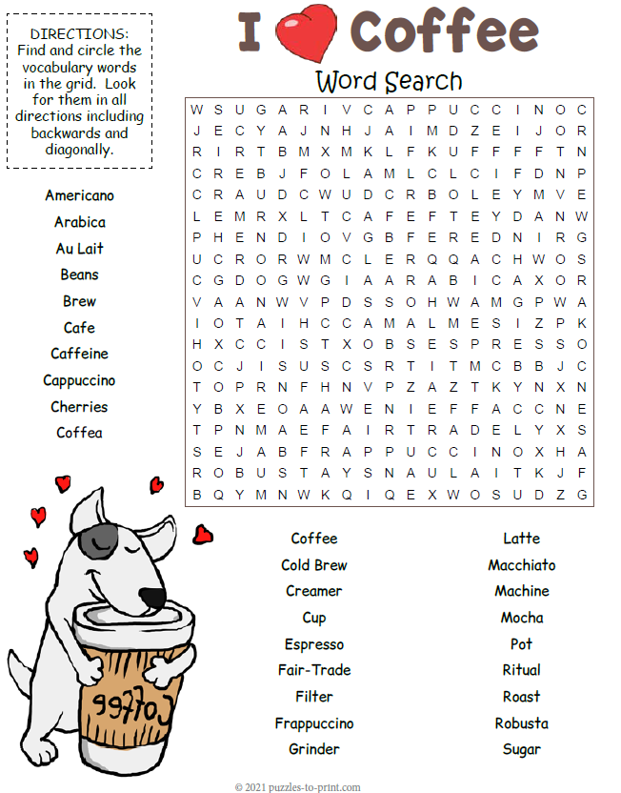 

Get a Night Out at the Movies for 2 with my

**Referral Rewards Program**

As you probably know, advertising is very expensive. Instead of paying the newspaper or another place to advertise, we’d rather reward you. So, we’ve assembled the Referral Rewards Program.

Every time you refer someone who becomes a client, we will send you a gift certificate for two passes to the **Movies-8 Cinema.**

And Hey! What’s a movie without popcorn? The gift certificate will also cover a big box of hot, buttered popcorn and sodas!

**Welcome to our new and returning clients!**

Click on the text box and Insert names

**A gigantic THANK YOU to all who referred us last month…**

Insert names

Bottoms Up!

**Be sure to stop by to pick out and schedule   
your new floor installation, and   
from our families to yours have a great month!**

**Your Company Name**

123 Address, Someplace, ZZ 555555

555.555.5555 Phone ⚫ 555.555.5555 Fax

email@yourcompanyname.com

**YourCompanyWebsite.com**