

Reliable news for healthy living, saving money, and having fun!

******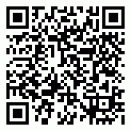**

**May 5**

Cinco de Mayo

**May 9**

Mother’s Day

(U.S. & Canada)

**May 24**

Victoria Day (Canada)

**May 31**

Memorial Day (U.S.)



Month at a Glance!

May 2021

**Jimbo’s Floors**

Suzie Smith!

You are this month’s   
Mystery Winner!

We have a   
**$10.00 Starbucks   
gift card**   
reserved just for you!

Come by our store to   
claim your prize!

Inside This Issue…

* Are you this month’s Mystery Winner?
* Month at a Glance
* Visiting the Largest Art Museum in the World
* Mega Trivia Contest
* Did You Know
* What Happens if You Drink Too Much Diet Soda
* Thank you for the Kind Words
* Client of the Month
* Find the Tasty Pastry!

Dear Friends,

Your personal message goes here.

The personal message is important because it allows you to connect in a very personal way with your clients. This personal connection is sorely lacking in most businesses. Topic ideas:

Your hobbies

Something interesting happening this month. Wish them “Merry Christmas” or “Happy Thanksgiving.”

A thought from your heart

Appreciation for your clients and their referrals. Remind them that you will bend over backwards to provide their referrals with World Class Service.

Mention that month’s “special offer” insert

Your Friend,

Your Signature

Your Name

Scan to see our website

*“You’ll love your new floors, or I’ll replace them free!”*

~Jim Armstrong   
[www.JimbosFloors.com](http://www.JimbosFloors.com)

The Louvre Museum in Paris was opened by the French Revolutionary Government in 1793.

*Trivia Today* says that there were only 721 works of art at first (537 paintings, 184 objects). Today, it houses over 38,000 pieces of art from all over Europe. Covering 60,000 square meters, it is estimated that a visitor would need around 100 days to completely tour the museum and see it all. Trying to tour the Louvre in one day is impossible.

The original Louvre was a moated fortress constructed in 1190 by King Philip II. The fortress became a palace in the 16th century, and when the Palace of Versailles became the home of the French monarchy, a section of it was used to house the Louvre and its art academies and was expanded over the years. It houses many famous works of art such as the “Mona Lisa” and paintings by Johannes Vermeer.

Interestingly, Napoléon Bonaparte actually (and temporarily) renamed the Louvre after himself. He called it the Musée Napoléon. In addition, during his rule Napoleon had the Mona Lisa hung in his private bedroom! After the emperor's reign ended in exile in 1815, the museum was given its current name, the Musée du Louvre.

Those lucky people who’ve seen the “Mona Lisa” are surprised at how small it is, measuring only 21 x 30 inches. The painting has bodyguards who shield it from harm and is surrounded by bulletproof glass. The 1911 theft of the Mona Lisa and its subsequent return was reported worldwide, leading to a massive increase in public recognition of the painting. About 6 million people view the painting at the Louvre each year.

The Louvre goes back to 1190, so it is reported to have an eclectic collection of ghosts that haunt it. Some of those said to be ghostly wanderers in the Louvre include a mummy named Belphegor, a WWII German soldier, Roman soldier, painter, and a young muse. The most famous ghost is that of Jean l’Ecorcheur, nicknamed “Jack the Skinner,” who was a henchman of Catherine de Medici and probably someone you wouldn’t want to meet in the dark.

We’d be happy to send you our electronic newsletter!

The same combination of useful tips and offbeat stories you read here, but with these differences:

* The e-Neighborhood Advisor will arrive in your email account once you give us permission
* We send it once a week
* The e-Neighborhood Advisor does not have the same content as the print Neighborhood Advisor – you’ll read all new stories, from helpful advice to items that give you a smile

Simply let us know which email account you’d like us to use for the e-Neighborhood Advisor.

What type of pasta is shaped like a bowtie?

A) Capellini B) Rigatoni

C) Farfalle D) Pappardelle

To enter, go to [www.JimbosFloors.com](http://www.JimbosFloors.com) and click on “Mega Trivia Contest.” Take your best guess…your chances of winning are better than you think!



Visiting the Largest Art Museum in the World

### Who Else Wants to Win

### Dinner for Two

### at the City Café!

### Take our Trivia Challenge and *you could win too!*

This month’s Mega Trivia question:

**Answer to last month’s question: A) International Space Station**

Congratulations to last month’s winner: **Client Name**

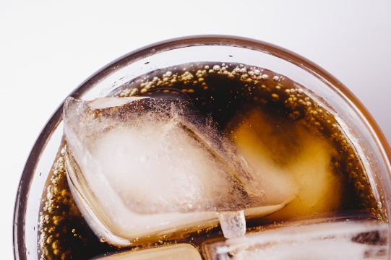

What Happens if You Drink Too Much Diet Soda

+



In the early 1960s, a new kind of beverage took the stage. It wasn't a new shape, or color, or flavor. No, this was diet soda. And It. Was. Awesome.

With fewer calories and less sugar, diet soda promised to be a healthier alternative to regular soda, per *Business Insider*. But like most promises in life that sound too good to be true, it probably is.

Until recently, everything we ate contained some amount of calories. When we ate something sweet, for example, the brain sent signals to our pancreas which started producing insulin, that stored the sugar molecules in our cells for energy. So, when we drink diet soda, the sweetness tricks our body into thinking it's real sugar. But when those energy-packed calories don't arrive, the insulin has nothing to store.

Scientists think that repeatedly tricking our body this way could explain why study after study keeps finding the same thing: that drinking diet soda is associated with metabolic syndrome. Metabolic syndrome is a mix of conditions that includes increased blood pressure, high blood sugar, and weight gain, which can increase the risk of diabetes, heart disease and stroke.

One study found that diet soda drinkers had a higher risk of stroke and dementia than regular soda drinkers. And for another 8-year-long study between 1979-1988, participants who started out at a normal weight and drank an average of 21 diet beverages a week faced DOUBLE the risk of becoming overweight or obese by the end of the study, compared to people who avoided diet beverages completely.

Drinking diet soda with a meal may sound like a tasty, calorie-free alternative to plain water, but research is starting to find that this may be the WORST time to drink it. The fake calories in the diet soda could ultimately disrupt how many of the real calories we metabolize, potentially leaving excess calories behind that we then store as fat.

So if the reason you're drinking diet soda is to drop a few pounds, maybe stick to water.

“My new laminate floors in my kitchen and dining room are beautiful. I was treated with respect and courtesy as a single woman raising a daughter. I genuinely felt that Jim Armstrong and his staff display concern for my flooring needs and were a guiding light for me. I recommend his service to anyone looking for a supportive, positive experience.”

~Marsha Avalos, School Teacher, Yuba City

“We Recently went to Jimbo’s Floors for new tile for our bathroom, and we’re thrilled with the results! This is our third time using Jimbo’s. Jim will never make you feel uncomfortable for asking questions and he’ll do anything in his power to accommodate your needs. When you do business with Jim and the staff at Jimbo’s Floors, you will be treated like royalty. Our experience was painless and very professional. Jim is not only our flooring expert, he’s a friend. That’s how he makes you feel.”

~Marvin and Sandy Moeller, owners of Sierra Landscaping, Yuba City

Congratulations to our client of the month,

**Susan Johnson!**

Susan is a 3rd time returning client, and she recently purchased new laminate for her kitchen and dining room. She always has a big smile on her face and is a lot of fun to work with. *Thanks, Susan!*

As always, our clients of the month receive **2 movie passes for Movies-8!**

*Watch for your name here in a coming month!*

Thank You for the Kind Words!

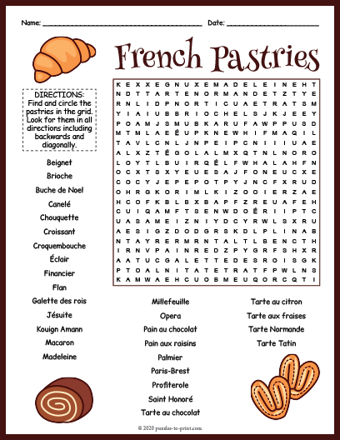 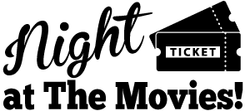

Get a Night Out at the Movies for 2 with my

**Referral Rewards Program**

As you probably know, advertising is very expensive. Instead of paying the newspaper or another place to advertise, we’d rather reward you. So, we’ve assembled the Referral Rewards Program.

Every time you refer someone who becomes a client, we will send you a gift certificate for two passes to the **Movies-8 Cinema.**

And Hey! What’s a movie without popcorn? The gift certificate will also cover a big box of hot, buttered popcorn and sodas!

**Welcome to our new and returning clients!**

Click on the text box and Insert names

**A gigantic THANK YOU to all who referred us last month…**

Insert names

Find the Tasty Pastry!

**Be sure to stop by to pick out and schedule   
your new floor installation, and   
from our families to yours have a great month!**

**Your Company Name**

123 Address, Someplace, ZZ 555555

555.555.5555 Phone ⚫ 555.555.5555 Fax

email@yourcompanyname.com

**YourCompanyWebsite.com**