

Reliable news for healthy living, saving money, and having fun!

********

**April 1**

April Fool’s Day

**April 2**

Good Friday

**April 4**

Easter Sunday

**April 15**

Tax Day

Month at a Glance!

April 2021

**Jimbo’s Floors**

Suzie Smith!

You are this month’s   
Mystery Winner!

We have a   
**$10.00 Starbucks   
gift card**   
reserved just for you!

Come by our store to   
claim your prize!

Inside This Issue…

* Are you this month’s Mystery Winner?
* Month at a Glance
* Spring Cleaning: Start with the Kitchen
* Mega Trivia Contest
* Did You Know
* 5 Things You Didn’t Know about the Corvette
* Thank you for the Kind Words
* Client of the Month
* Solve the Crossword!

Dear Friends,

Your personal message goes here.

The personal message is important because it allows you to connect in a very personal way with your clients. This personal connection is sorely lacking in most businesses. Topic ideas:

Your hobbies

Something interesting happening this month. Wish them “Merry Christmas” or “Happy Thanksgiving.”

A thought from your heart

Appreciation for your clients and their referrals. Remind them that you will bend over backwards to provide their referrals with World Class Service.

Mention that month’s “special offer” insert

Your Friend,

Your Signature

Your Name

Scan to see our website

*“You’ll love your new floors, or I’ll replace them free!”*

~Jim Armstrong   
[www.JimbosFloors.com](http://www.JimbosFloors.com)

Here at Jimbo’s Floors we use a special diagnostic tool called the Design Audit™.

Our free Design Audit™ is carefully crafted to take the headache out of shopping for new floors. A simple series of questions let my expert floor consultants narrow down the thousands of options to the two or three that exactly match your unique situation.

They’ll provide you with a written, customized “maintenance” plan with their professional recommendations for getting the longest life and beauty out of your floor.

Call or visit us today for your FREE Design Audit!™

With spring comes spring cleaning. Professional organizer Faith Roberson shared several of her favorite tips in *Bon Appetit* to help you get your space together.

**1. Go Multipurpose**

Embrace multipurpose tools to free up your shelves and your budget. Use a salad spinner insert as a colander, or mason jars for drinking, canning, *and* storing dried goods. You can use a pitcher for iced tea, of course, but you can also use it to hold cooking utensils next to your stove, or flowers on your table (just not all at once).

**2. Use That Wall Space**

Put up hooks on a free kitchen wall to hang pots and pans. Your most-used kitchenware will be at the ready, and you’ll free up precious cabinet space for bulkier, less attractive equipment like that clunky blender.

**3. Just Add Turntables**

Turntables can maximize space in cabinets, under the sink, and—game changing!—inside your refrigerator. Just be sure to measure your shelves before heading to the store to ensure your turntable will fit, then never lose a jar of mustard in the back of your fridge again.

**4. Relocate the Junk Drawer**

Of course, you should make sure your junk drawer is not...full of junk (yes to a flashlight, spare keys, matches, and Wi-Fi info; no to stretched-out rubber bands and the goody bag your kid took home from the dentist). But you should also consider moving your junk drawer out of the kitchen entirely. There’s no reason all the aforementioned stuff can’t live in the entryway or even the garage, freeing up precious storage space where you need it most.

**5. Clear Out The Fridge**

Be honest: When was the last time you wiped down your fridge? Before you grocery shop, try taking everything out and giving the inside a good clean. Doing this keeps surfaces glistening, of course, but you also see what has expired (that flavored mustard you were never going to eat anyway), what needs to be consumed ASAP (that lingering slice of leftover pizza), and what you actually need to stock up on.

What is the most expensive item ever built?

A) International Space Station B) Burj Khalifa

C) Hinkley Nuclear Power Station D) Hong Kong International Airport

To enter, go to [www.JimbosFloors.com](http://www.JimbosFloors.com) and click on “Mega Trivia Contest.” Take your best guess…your chances of winning are better than you think!



Spring Cleaning: Start with the Kitchen

### Who Else Wants to Win

### Dinner for Two

### at the City Café!

### Take our Trivia Challenge and *you could win too!*

This month’s Mega Trivia question:

**Answer to last month’s question: B) Miller High Life**

Congratulations to last month’s winner: **Client Name**



5 Things You Didn’t Know About the Corvette

+



Warmer weather makes us want to get out on the open road! In 1953, a prototype Chevrolet Corvette made its debut at the Motorama auto show in New York City. Here are five things you probably didn’t know about this iconic American muscle car according to *Trivia Today*:

**The Name Corvette Came from a Warship** The Corvette was a naval vessel that was small and fast and used throughout the 1800s and 1900s. In America, these smaller vessels were known as sloops and were employed during the War of 1812 at the Great Lakes and the Atlantic Ocean against more powerful British vessels.

**The Company Had to Change the Original Logo** The Chevy Corvette's logo is an iconic part of the car. The Corvette’s first logo featured a checkered flag crossed with the American flag. While it looked good, there was a major problem. The company learned that using the American flag commercially on a product is actually illegal and had to be changed. Only four days before the car debuted, Chevrolet replaced the design with the checkered flag, which is still used today.

**There Is Only One 1983 Model** Chevrolet ran into problems with their 1983 Corvette, and as a result, no Corvettes were released that year. Although 43 Corvettes were manufactured in 1983, all but one of them ended up being destroyed, with that final car now displayed in Bowling Green, Kentucky, at the National Corvette Museum.

**It Is the Official Car Of Kentucky** In 2010, the Chevrolet Corvette was named as Kentucky’s official sports car. This may not be much of a surprise, as the last Corvette factory in the country happens to be located in Bowling Green, Kentucky.

**The Fastest Corvette Isn't the Newest** Corvette is not only a sharp-looking sports car, but it's often sought out by those who want speed in a vehicle. Although many people probably believe the newer models are faster because of advancements in technology, it isn’t true. To date, the fastest Corvette Stingray ever made was back in 1968 with the LT-2 with a top speed of 200 mph.

“My new laminate floors in my kitchen and dining room are beautiful. I was treated with respect and courtesy as a single woman raising a daughter. I genuinely felt that Jim Armstrong and his staff display concern for my flooring needs and were a guiding light for me. I recommend his service to anyone looking for a supportive, positive experience.”

~Marsha Avalos, School Teacher, Yuba City

“We Recently went to Jimbo’s Floors for new tile for our bathroom, and we’re thrilled with the results! This is our third time using Jimbo’s. Jim will never make you feel uncomfortable for asking questions and he’ll do anything in his power to accommodate your needs. When you do business with Jim and the staff at Jimbo’s Floors, you will be treated like royalty. Our experience was painless and very professional. Jim is not only our flooring expert, he’s a friend. That’s how he makes you feel.”

~Marvin and Sandy Moeller, owners of Sierra Landscaping, Yuba City

Congratulations to our client of the month,

**Susan Johnson!**

Susan is a 3rd time returning client, and she recently purchased new laminate for her kitchen and dining room. She always has a big smile on her face and is a lot of fun to work with. *Thanks, Susan!*

As always, our clients of the month receive **2 movie passes for Movies-8!**

*Watch for your name here in a coming month!*

Thank You for the Kind Words!

 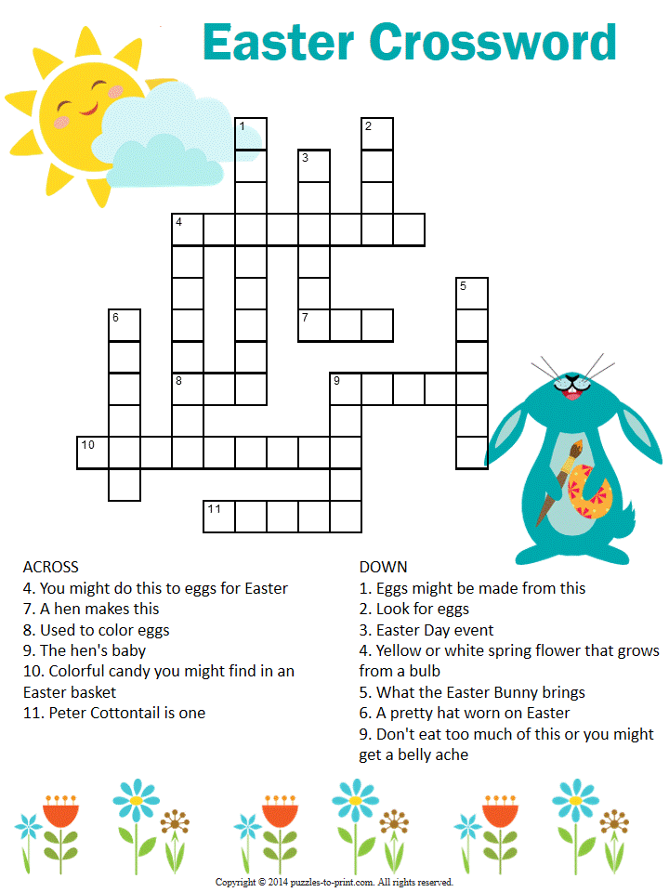

**Your Company Name**

123 Address, Someplace, ZZ 555555

555.555.5555 Phone ⚫ 555.555.5555 Fax

email@yourcompanyname.com

**YourCompanyWebsite.com**

**Be sure to stop by to pick out and schedule   
your new floor installation, and   
from our families to yours have a great month!**

ANSWERS: Across 4. Decorate. 7. Egg 8. Dye 9. Chick 10. Jellybean 11. Bunny

Down 1. Chocolate 2. Hunt 3. Parade 4. Daffodil 5. Basket 6. Bonnet 9. Candy

Get a Night Out at the Movies for 2 with my

**Referral Rewards Program**

As you probably know, advertising is very expensive. Instead of paying the newspaper or another place to advertise, we’d rather reward you. So, we’ve assembled the Referral Rewards Program.

Every time you refer someone who becomes a client, we will send you a gift certificate for two passes to the **Movies-8 Cinema.**

And Hey! What’s a movie without popcorn? The gift certificate will also cover a big box of hot, buttered popcorn and sodas!

**Welcome to our new and returning clients!**

Click on the text box and Insert names

**A gigantic THANK YOU to all who referred us last month…**

Insert names

Solve the Crossword!