

Reliable news for healthy living, saving money, and having fun!

********

**Dec. 11 Dec. 24 Dec. 25 Dec. 31**

Hannukah Begins Christmas Eve Christmas Day New Year’s Eve

**December 2020**

December 2020

**Jimbo’s Floors**

Suzie Smith!

You are this month’s   
Mystery Winner!

We have a   
**$10.00 Starbucks   
gift card**   
reserved just for you!

Come by our store to   
claim your prize!

Inside This Issue…

* Are you this month’s Mystery Winner?
* Month at a Glance
* Holiday Coping Tips
* Mega Trivia Contest
* Did You Know
* Best Christmas Movies Ever!
* Thank you for the Kind Words
* Client of the Month
* Find the Yummy Christmas Treats!

Dear Friends,

Your personal message goes here.

The personal message is important because it allows you to connect in a very personal way with your clients. This personal connection is sorely lacking in most businesses. Topic ideas:

Your hobbies

Something interesting happening this month. Wish them “Merry Christmas” or “Happy Thanksgiving.”

A thought from your heart

Appreciation for your clients and their referrals. Remind them that you will bend over backwards to provide their referrals with World Class Service.

Mention that month’s “special offer” insert

Your Friend,

Your Signature

Your Name

Month at a Glance!

Scan to see our website

*“You’ll love your new floors, or I’ll replace them free!”*

~Jim Armstrong   
[www.JimbosFloors.com](http://www.JimbosFloors.com)

Which of these was not a gift given by the Wise Men to Baby Jesus?

A) Gold B) Silver

C) Frankincense D) Myrrh

To enter, go to [www.JimbosFloors.com](http://www.JimbosFloors.com) and click on “Mega Trivia Contest.” Take your best guess…your chances of winning are better than you think!

We’d be happy to send

you our electronic newsletter!

The same combination of useful tips and offbeat stories you read here, but with these differences:

* The e-Neighborhood Advisor will arrive in your email account once you give us permission
* We send it once a week
* The e-Neighborhood Advisor does not have the same content as the print Neighborhood Advisor – you’ll read all new stories, from helpful advice to items that give you a smile

Simply let us know which email account you’d like us to use for the e-Neighborhood Advisor.



Holiday Coping Tips

Holiday **depression** is common and perhaps up to 10 percent of the population suffers from it to some degree or another. Psych Central reports that it’s because the holiday season brings back memories of a happier time in our lives. We may remember spending past holidays with a loved one who is no longer with us. Or we may get depressed by seeing so many others who have someone special in their lives — whether it be their family, close friends, or a significant other — to share the season with.

**Overeating** is another common holiday-related problem. With an abundance of food and drink available for many family gatherings, it is often the case where we overeat. Many people also use overeating as a way of coping with the increased stress or feelings of depression during this time of the year.

Whatever the reason for suffering from these problems, there are things you can do to try to ward them off, or at least minimize their impact in your life.

### Take Time for Yourself

Consider turning to those activities and hobbies which have often helped you in the past. This may mean volunteering more time at a local hospital or nursing home. Or devoting more time to writing, sewing, fixing up things around the house, reading, or any of a number of other activities.

### Spend Time with Friends You Enjoy

Hanging out with friends or family members who don’t have sad or negative emotions attached to them may be helpful. You may also consider spending more time online in a support group or chat area which is to your liking.

### Avoid Overeating

Overeating during the holidays is almost encouraged and an acceptable part of the holiday tradition. Thanks to COVID, this year in particular, we have isolated ourselves. Accepting that gain rather trying to fight it or feel guilty about it will help relieve some of the pressure and stress often associated with the holidays. There will always be time in the future to lose the weight.

### Who Else Wants to Win

### Dinner for Two

### at the City Café!

### Take our Trivia Challenge and *you could win too!*

This month’s Mega Trivia question:

**Answer to last month’s question: D) Benjamin Harrison**

Congratulations to last month’s winner: **Client Name**



Best Christmas Movies Ever!

+



For all of you nice boys and girls out there, Rotten Tomatoes has compiled their list of the Best Christmas Movies ever!

Wondering how they put this Christmas movie list together? Every movie on the list is Fresh and plays around with the spirit of Christmas and the holidays as a central theme. Then they sorted them all by Adjusted Tomatometer, which factors in release year and a movie’s number of reviews, to make the ultimate list of holiday films that melted even the most cynical critics’ hearts.

Make some hot chocolate, pile onto the sofa, and watch their top five!

**#5 Holiday Inn (1942)**

With the combined might of Bing Crosby, Fred Astaire, and Irving Berlin working in its favor, Holiday Inn is a seasonal classic -- not least because it introduced "White Christmas" to the world.

## **#4 The Shop Around the Corner (1940)**

Deftly directed by Ernst Lubitsch from a smart, funny script by Samson Raphaelson, The Shop Around the Corner is a romantic comedy in the finest sense of the term.

## **#3 Miracle on 34th Street (1947)**

Irrefutable proof that gentle sentimentalism can be the chief ingredient in a wonderful film, Miracle on 34th Street delivers a warm holiday message without resorting to treacle.

## **#2 Meet Me in St. Louis (1944)**

A disarmingly sweet musical led by outstanding performances from Judy Garland and Margaret O'Brien, Meet Me in St. Louis offers a holiday treat for all ages.

## **#1 It's a Wonderful Life (1946)**

The holiday classic to define all holiday classics, It's a Wonderful Life is one of a handful of films worth an annual viewing.

Wonder where some of your other favorites landed on the list? **Home Alone** is #52, **The Santa Clause** is #40, and **Die Hard** is #11.

“My new laminate floors in my kitchen and dining room are beautiful. I was treated with respect and courtesy as a single woman raising a daughter. I genuinely felt that Jim Armstrong and his staff display concern for my flooring needs and were a guiding light for me. I recommend his service to anyone looking for a supportive, positive experience.”

~Marsha Avalos, School Teacher, Yuba City

“We Recently went to Jimbo’s Floors for new tile for our bathroom, and we’re thrilled with the results! This is our third time using Jimbo’s. Jim will never make you feel uncomfortable for asking questions and he’ll do anything in his power to accommodate your needs. When you do business with Jim and the staff at Jimbo’s Floors, you will be treated like royalty. Our experience was painless and very professional. Jim is not only our flooring expert, he’s a friend. That’s how he makes you feel.”

~Marvin and Sandy Moeller, owners of Sierra Landscaping, Yuba City

Congratulations to our client of the month,

**Susan Johnson!**

Susan is a 3rd time returning client, and she recently purchased new laminate for her kitchen and dining room. She always has a big smile on her face and is a lot of fun to work with. *Thanks, Susan!*

As always, our clients of the month receive **2 movie passes for Movies-8!**

*Watch for your name here in a coming month!*

Thank You for the Kind Words!



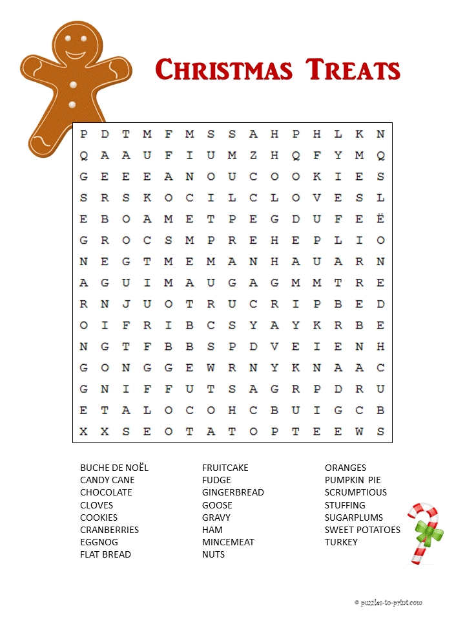

**Be sure to stop by to pick out and schedule   
your new floor installation, and   
from our families to yours have a great month!**

Get a Night Out at the Movies for 2 with my

**Referral Rewards Program**

As you probably know, advertising is very expensive. Instead of paying the newspaper or another place to advertise, we’d rather reward you. So, we’ve assembled the Referral Rewards Program.

Every time you refer someone who becomes a client, we will send you a gift certificate for two passes to the **Movies-8 Cinema.**

And Hey! What’s a movie without popcorn? The gift certificate will also cover a big box of hot, buttered popcorn and sodas!

**Welcome to our new and returning clients!**

Click on the text box and Insert names

**A gigantic THANK YOU to all who referred us last month…**

Insert names

Find the Yummy Christmas Treats!

**Your Company Name**

123 Address, Someplace, ZZ 555555

555.555.5555 Phone ⚫ 555.555.5555 Fax

email@yourcompanyname.com

**YourCompanyWebsite.com**