

Reliable news for healthy living, saving money, and having fun!

********

**Nov. 1**

Daylight Savings Time Ends

**Nov. 3**

Election Day

**Nov. 11**

Veteran’s Day

**Nov. 26**

Thanksgiving  
(US)



November 2020

**Jimbo’s Floors**

Suzie Smith!

You are this month’s   
Mystery Winner!

We have a   
**$10.00 Starbucks   
gift card**   
reserved just for you!

Come by our store to   
claim your prize!

Inside This Issue…

* Are you this month’s Mystery Winner?
* Month at a Glance
* Presidential Firsts
* Mega Trivia Contest
* Did You Know
* The White House: Presidential Home and Museum of American History
* Thank you for the Kind Words
* Client of the Month
* Find the First 44 Presidents!

Dear Friends,

Your personal message goes here.

The personal message is important because it allows you to connect in a very personal way with your clients. This personal connection is sorely lacking in most businesses. Topic ideas:

Your hobbies

Something interesting happening this month. Wish them “Merry Christmas” or “Happy Thanksgiving.”

A thought from your heart

Appreciation for your clients and their referrals. Remind them that you will bend over backwards to provide their referrals with World Class Service.

Mention that month’s “special offer” insert

Your Friend,

Your Signature

Your Name

Month at a Glance!

Scan to see our website

*“You’ll love your new floors, or I’ll replace them free!”*

~Jim Armstrong   
[www.JimbosFloors.com](http://www.JimbosFloors.com)

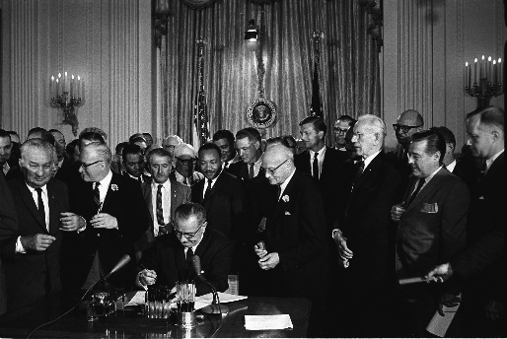



Presidential Firsts

In honor of the presidential election occurring this month, here are some firsts accomplished by presidents while in office, as featured in Trivia Today.

**William Henry Harrison: First President to Be Photographed While in Office** William Henry Harrison became the first president to have his photo taken during his term. It was after his inaugural address when he took office in March 1841. Unfortunately, the photo has been lost, and only a copy remains in the Metropolitan Museum of Art. The oldest surviving photo of a sitting president is of the 11th president, James K. Polk. John Quincy Adams, the sixth president, was also photographed, but it was taken when he was in his mid-70s and been out of office for decades.

**Martin Van Buren: First President Born a U.S. Citizen** Martin Van Buren, the eighth president, who was born in 1782, was the first man born a U.S. citizen to hold the office. Every president before that was born before 1776, and therefore as a colonial subject of Great Britain.

**Lyndon B. Johnson: First President Sworn in by a Woman** When Lyndon B. Johnson was sworn in as president after John F. Kennedy died, no one was really thinking about presidential firsts. Nevertheless, that swearing-in was the scene of a very important first: Johnson became the first president to be sworn in by a woman. Barefoot Sanders, a Texas attorney, called Sarah Hughes to tell her that then-Vice President Lyndon B. Johnson had requested that she administer the Oath of Office, and she headed to Dallas to board Air Force One. The swearing-in ceremony administered by Judge Hughes in an Air Force One conference room represented the first time that a woman administered the presidential oath of office as well as the only time it was conducted on an airplane.

**Richard M. Nixon: First President to Visit All 50 States** Resigning wasn’t the only thing Richard M. Nixon did first. The 37th president would be the first one to visit all 50 states before leaving office. Nixon visited his 50th state, Delaware, in 1971 for a meeting with Republican fundraisers. Presidents George H. W. Bush, Bill Clinton, and Barack Obama also would visit every state.

**Herbert Hoover: First President with a Phone in His Office** The first telephone in the White House dates all the way back to Rutherford B. Hayes, the 19th president, who installed one in the White House’s “telegraph room” in 1877. Herbert Hoover, however, was the first president to have one installed in the Oval Office, which he did in March 1929.

Here at Jimbo’s Floors we use a special diagnostic tool called the Design Audit™.

Our free Design Audit™ is carefully crafted to take the headache out of shopping for new floors. A simple series of questions let my expert floor consultants narrow down the thousands of options to the two or three that exactly match your unique situation.

They’ll provide you with a written, customized “maintenance” plan with their professional recommendations for getting the longest life and beauty out of your floor.

Call or visit us today for your FREE Design Audit!™

Which president had electricity installed in the White House?

A) William Henry Harrison B) Chester Arthur

C) William McKinley D) Benjamin Harrison

To enter, go to [www.JimbosFloors.com](http://www.JimbosFloors.com) and click on “Mega Trivia Contest.” Take your best guess…your chances of winning are better than you think!

### Who Else Wants to Win

### Dinner for Two

### at the City Café!

### Take our Trivia Challenge and *you could win too!*

This month’s Mega Trivia question:

**Answer to last month’s question: B) Clavicle**

Congratulations to last month’s winner: **Client Name**

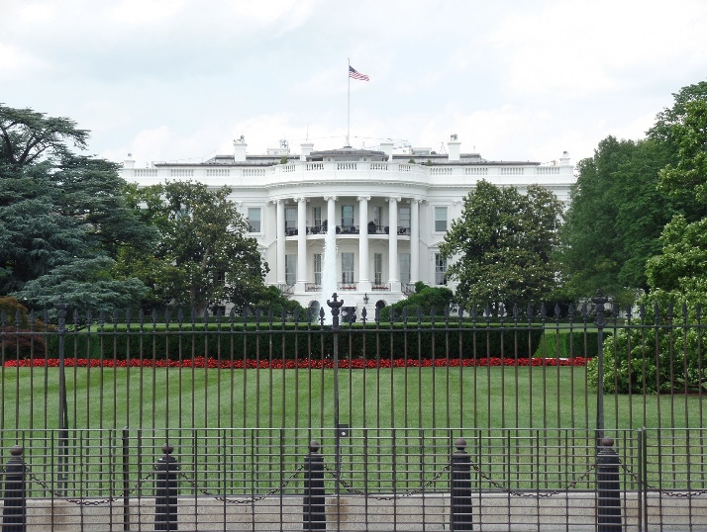

The White House: Presidential Home and Museum of American History

+



Every president since John Adams has occupied the White House, and the history of the building extends far beyond the construction of its walls. From the Ground Floor Corridor rooms, transformed from their early use as service areas, to the State Floor rooms, where countless leaders and dignitaries have been entertained, the White House is both the home of the President of the United States and his family, and a museum of American history.

The White House is a place where history continues to unfold.

Facts about the White House:

* There are 132 rooms, 35 bathrooms, and 6 levels in the Residence. There are also 412 doors, 147 windows, 28 fireplaces, 8 staircases, and 3 elevators.
* The White House kitchen is able to serve dinner to as many as 140 guests and hors d’oeuvres to more than 1,000.
* The White House requires 570 gallons of paint to cover its outside surface.
* At various times in history, the White House has been known as the “President’s Palace,” the “President’s House,” and the “Executive Mansion.”
* President Theodore Roosevelt officially gave the White House its current name in 1901.

Our first president, George Washington, selected the site for the White House in 1791. The cornerstone was laid in 1792 and a competition design submitted by Irish-born architect James Hoban was chosen. After eight years of construction, President John Adams and his wife Abigail moved into the unfinished house in 1800.

During the War of 1812, the British set fire to the President’s House in 1814. James Hoban was appointed to rebuild the house, and President James Monroe moved into the building in 1817. During Monroe’s administration, the South Portico was constructed in 1824, and Andrew Jackson oversaw the addition of the North Portico in 1829. During the late 19th century, various proposals were made to significantly expand the President’s House or to build an entirely new house for the president, but these plans were never realized.

“My new laminate floors in my kitchen and dining room are beautiful. I was treated with respect and courtesy as a single woman raising a daughter. I genuinely felt that Jim Armstrong and his staff display concern for my flooring needs and were a guiding light for me. I recommend his service to anyone looking for a supportive, positive experience.”

~Marsha Avalos, School Teacher, Yuba City

“We Recently went to Jimbo’s Floors for new tile for our bathroom, and we’re thrilled with the results! This is our third time using Jimbo’s. Jim will never make you feel uncomfortable for asking questions and he’ll do anything in his power to accommodate your needs. When you do business with Jim and the staff at Jimbo’s Floors, you will be treated like royalty. Our experience was painless and very professional. Jim is not only our flooring expert, he’s a friend. That’s how he makes you feel.”

~Marvin and Sandy Moeller, owners of Sierra Landscaping, Yuba City

Congratulations to our client of the month,

**Susan Johnson!**

Susan is a 3rd time returning client, and she recently purchased new laminate for her kitchen and dining room. She always has a big smile on her face and is a lot of fun to work with. *Thanks, Susan!*

As always, our clients of the month receive **2 movie passes for Movies-8!**

*Watch for your name here in a coming month!*

Thank You for the Kind Words!



Get a Night Out at the Movies for 2 with my

**Referral Rewards Program**

As you probably know, advertising is very expensive. Instead of paying the newspaper or another place to advertise, we’d rather reward you. So, we’ve assembled the Referral Rewards Program.

Every time you refer someone who becomes a client, we will send you a gift certificate for two passes to the **Movies-8 Cinema.**

And Hey! What’s a movie without popcorn? The gift certificate will also cover a big box of hot, buttered popcorn and sodas!

**Welcome to our new and returning clients!**

Click on the text box and Insert names

**A gigantic THANK YOU to all who referred us last month…**

Insert names

Find the First 44 Presidents!

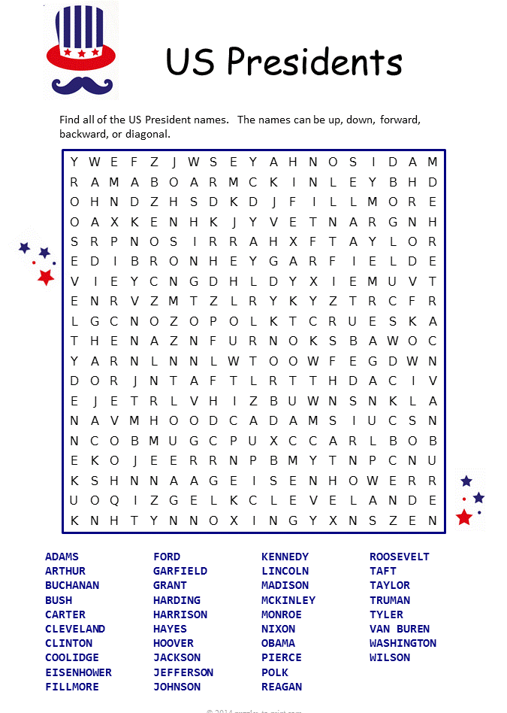

**Be sure to stop by to pick out and schedule   
your new floor installation, and   
from our families to yours have a great month!**

**Your Company Name**

123 Address, Someplace, ZZ 555555

555.555.5555 Phone ⚫ 555.555.5555 Fax

email@yourcompanyname.com

**YourCompanyWebsite.com**