

Reliable news for healthy living, saving money, and having fun!

**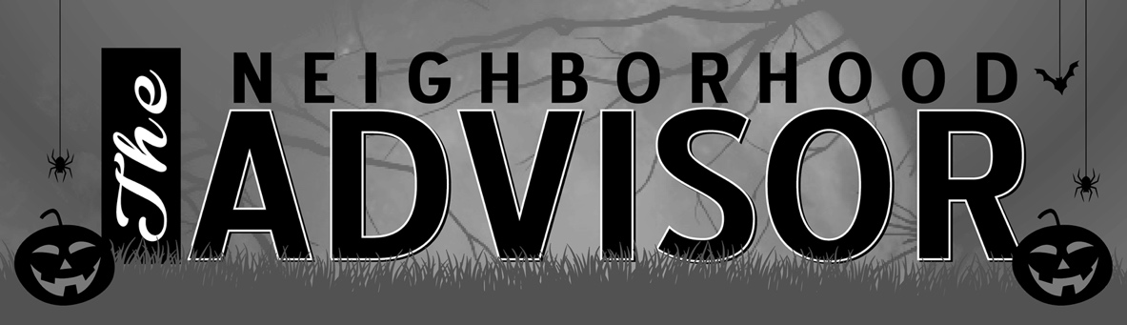******

**Oct. 12**

Indigenous People’s Day

**Oct. 12**

Thanks Giving Day  
(Canada)

**Oct. 16**

Boss’s Day

**Oct. 31**

Halloween



October 2020

**Jimbo’s Floors**

Suzie Smith!

You are this month’s   
Mystery Winner!

We have a   
**$10.00 Starbucks   
gift card**   
reserved just for you!

Come by our store to   
claim your prize!

Inside This Issue…

* Are you this month’s Mystery Winner?
* Month at a Glance
* Patio Trends That Are on Their Way Out
* Mega Trivia Contest
* Did You Know
* Halloween Customs Around the World
* Thank you for the Kind Words
* Client of the Month
* Find the Spooky Words: If you Dare!

Dear Friends,

Your personal message goes here.

The personal message is important because it allows you to connect in a very personal way with your clients. This personal connection is sorely lacking in most businesses. Topic ideas:

Your hobbies

Something interesting happening this month. Wish them “Merry Christmas” or “Happy Thanksgiving.”

A thought from your heart

Appreciation for your clients and their referrals. Remind them that you will bend over backwards to provide their referrals with World Class Service.

Mention that month’s “special offer” insert

Your Friend,

Your Signature

Your Name

Month at a Glance!

Scan to see our website

*“You’ll love your new floors, or I’ll replace them free!”*

~Jim Armstrong   
[www.JimbosFloors.com](http://www.JimbosFloors.com)



Patio Trends That Are on Their Way Out

It’s patio season! Temperatures are cooling down, the mosquitoes are gone and it’s finally comfortable to sit outside in the evening. Having the perfect patio adds value to your home. Conversely, a cluttered, disorganized space doesn’t appeal to prospective buyers. Real estate agents recently shared their thoughts about patios with Apartment Therapy magazine. Here are some things to avoid.

**An Abundance of Potted Plants**

When you walk onto your patio, you don’t necessarily want to feel like you’re walking into a jungle—or like you have to cut your way through plant growth just to get to the chairs. Keep potted plants to a minimum because too many can look cluttered. The pots you do have should be decorative and in sync with each other.

## **Wood-Burning Fire Pits**

## Wood-burning anything can be a real pain. Not only do you have to find logs or chop wood yourself, you need to struggle with lighting it and keeping it lit, and regularly clean out the ash. Wood-burning fire pits for patios are out. Gas is the best option—it’s cleaner and easier.

## **Rounded Furniture**

## When people go out onto a patio now, they want it to be an oasis, a place that mentally takes you far from home while staying close to the door. Square modular furniture is coming in. The minimal “Miami vibe” is incredibly popular.

## **Itty Bitty String Lights**

## Edison bulbs, every hipster restaurateur’s favorite lighting choice, are still in. The trend of smaller bulbs, like Christmas lights or fairy lights, has passed us all by. Ditch those smaller string lights and opt for a bigger, more exposed style.

## **A Shabby-Chic Flea Market Vibe**

## The mismatched feel of flea market decorating is out. Instead of having a ton of things that find beauty in chaos, follow a pattern or theme to sleekly tie everything on your patio together.

Pick a couple of colors and stick to them. Blues, bright oranges and chartreuse are trendy at the moment. Matching wicker furniture with big pops of color are in. That also means you should tuck away excess decorations. Too much is too much.

When you buy floors from us,

you are protected by our Installer Professionalism guarantee! It’s part of our part of Jimbo’s Floors 100% Iron-Clad Triple Guarantee.

Our installers are neat, clean, well-groomed, well-spoken and professional. They are trained and certified. They are guests in your home, and they conduct themselves as such. They respect your home by using wall and corner guards, shoe covers and drop cloths.

You’ll receive the highest-quality installation in the business. And after they’re finished, they will leave your home as neat and clean as when they arrived!

What is the most frequently broken bone in the human body?

A) Femur B) Clavicle

C) Humerus D) Fibula

To enter, go to [www.JimbosFloors.com](http://www.JimbosFloors.com) and click on “Mega Trivia Contest.” Take your best guess…your chances of winning are better than you think!



### Who Else Wants to Win

### Dinner for Two

### at the City Café!

### Take our Trivia Challenge and *you could win too!*

This month’s Mega Trivia question:

**Answer to last month’s question: A) Scottie**

Congratulations to last month’s winner: **Client Name**

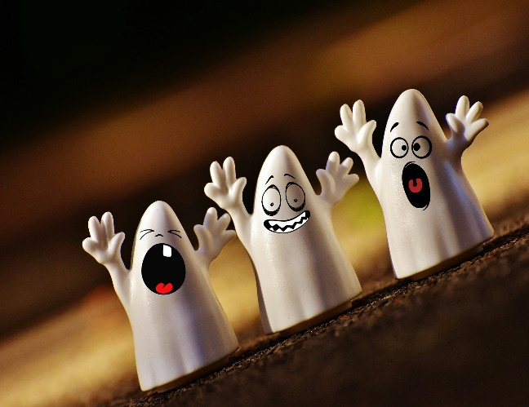

Halloween Customs Around the World



“My new laminate floors in my kitchen and dining room are beautiful. I was treated with respect and courtesy as a single woman raising a daughter. I genuinely felt that Jim Armstrong and his staff display concern for my flooring needs and were a guiding light for me. I recommend his service to anyone looking for a supportive, positive experience.”

~Marsha Avalos, School Teacher, Yuba City

“We Recently went to Jimbo’s Floors for new tile for our bathroom, and we’re thrilled with the results! This is our third time using Jimbo’s. Jim will never make you feel uncomfortable for asking questions and he’ll do anything in his power to accommodate your needs. When you do business with Jim and the staff at Jimbo’s Floors, you will be treated like royalty. Our experience was painless and very professional. Jim is not only our flooring expert, he’s a friend. That’s how he makes you feel.”

~Marvin and Sandy Moeller, owners of Sierra Landscaping, Yuba City

Congratulations to our client of the month,

**Susan Johnson!**

Susan is a 3rd time returning client, and she recently purchased new laminate for her kitchen and dining room. She always has a big smile on her face and is a lot of fun to work with. *Thanks, Susan!*

As always, our clients of the month receive **2 movie passes for Movies-8!**

*Watch for your name here in a coming month!*

Thank You for the Kind Words!

Although it's derived from ancient festivals and religious rituals, Halloween is still widely celebrated today in a number of countries around the globe. In Mexico and other Latin American countries, Día de los Muertos—the Day of the Dead—honors deceased loved ones and ancestors. In England, Guy Fawkes Day, which falls on November 5, is commemorated with bonfires and fireworks.

## **Día de los Muertos**

## In Mexico, Latin America and Spain, All Souls’ Day, which takes place on November 2, is commemorated with a three-day celebration that begins on the evening of October 31. The celebration honors the dead who, it is believed, return to their earthly homes on Halloween. Many families construct an altar to the dead in their homes to honor deceased relatives and decorate it with candy, flowers, photographs, samples of the deceased’s favorite foods and drinks, and fresh water.

Candles and incense are burned to help the deceased find the way home. Relatives also tidy the gravesites of their departed family members. The grave is then decorated with flowers, wreaths or paper streamers. On November 2, relatives gather at the gravesite to picnic and reminisce.

## **Guy Fawkes Day**

## On the evening of November 5, bonfires are lit throughout England. Effigies are burned and fireworks are set off. The English stopped celebrating Halloween as Martin Luther’s Protestant Reformation began to spread. As followers did not believe in saints, they had no reason to celebrate the eve of All Saints’ Day.

On November 5, 1606, Guy Fawkes was executed after being convicted of attempting to blow up England’s parliament building. Fawkes was a member of a Catholic group who wanted to remove the Protestant King James from power. In addition to making effigies to be burned in the fires, children walk the streets carrying an effigy or “guy” and ask for “a penny for the guy,” although they keep the money for themselves. This is as close to the American practice of “trick-or-treating” as can be found in England today.



Get a Night Out at the Movies for 2 with my

**Referral Rewards Program**

As you probably know, advertising is very expensive. Instead of paying the newspaper or another place to advertise, we’d rather reward you. So, we’ve assembled the Referral Rewards Program.

Every time you refer someone who becomes a client, we will send you a gift certificate for two passes to the **Movies-8 Cinema.**

And Hey! What’s a movie without popcorn? The gift certificate will also cover a big box of hot, buttered popcorn and sodas!

**Welcome to our new and returning clients!**

Click on the text box and Insert names

**A gigantic THANK YOU to all who referred us last month…**

Insert names

Find the Spooky Words: If you Dare!

**Be sure to stop by to pick out and schedule   
your new floor installation, and   
from our families to yours have a great month!**

**Your Company Name**

123 Address, Someplace, ZZ 555555

555.555.5555 Phone ⚫ 555.555.5555 Fax

email@yourcompanyname.com

**YourCompanyWebsite.com**