# How Barry & Diana’s

# Installation Nightmare

# Turned Into A Dream Come True!



Dear Friend,

Just a quick note to let you know that we can help you or anyone you know purchase flooring for your new home!

Barry & Diana were buying a new home, but it needed flooring. They called a store they Googled, but they soon ran into problems that caused a lot of delays. Their Realtor, Jan King, referred them to us and we were able to get new hardwood floors installed in time for their move-in date. Here is what Barry & Diana had to say about my service:

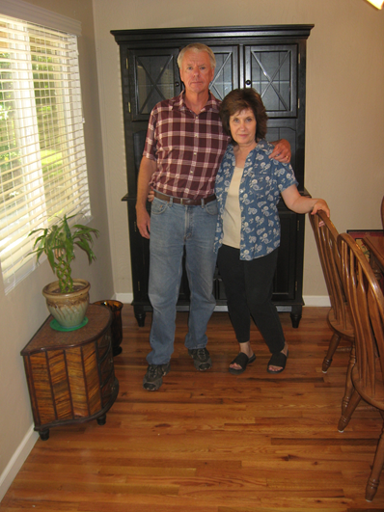“*My husband and I were referred to Jimbo’s by our Realtor after we experienced on going “nightmares” with the flooring store we originally had. We were told that if we wanted someone that was “phenomenal” and that would “hold our hand” and see us through until the very end and she knew the perfect person to do that for us. Roberto Gonzales of Jimbo’s Floors was that perfect person! He turned the nightmare we were having into an enjoyable process in purchasing flooring for our new home. He informed us of things we were completely unaware of and completely demonstrated the true meaning of customer service. He treated us like family and continues to do so even after our new hard wood floors were installed. They look AWESOME! We will be referring everyone we know to Roberto and Jimbo’s Floors!*” -Barry & Diana, Retired, Yuba City

**Barry & Diana on their beautiful new hardwood floors!**

At Your Service,

**Jim Armstrong**

ps**Jimbo’s Floors/530-790-3338**

Who is the next person you know who is thinking of buying a new home and would like beautiful new floos AND a painless installation process? Can I count on you to pass this flyer along to them? You will be doing them a tremendous favor by referring them to a company they can trust!

**Read What Your Friends, Neighbors And Relatives Are Saying About Jimbo’s Floors!**

“Jim—you already know we think you’re great—we refer you all the time and will keep doing so! Our new carpet looks awesome!”

**-Mike & Julie Nickel, Firefighter & Office Manager, Live Oak**

“I recently found the home of my dreams. I was feeling a little overwhelmed trying to decide which kind of floor would be best. Add that to the experience of buying my first home, and I was feeling very stressed. I visted Jimbo’s Floors and met Roberto. He could tell I was stressed, so he took the time to do a Design Audit that helped in picking the right floor. He also kept in touch during the whole installation process as well as Sheryl, the Project Coordinator. Then to top all of this, I received a nice surprise package from Roberto when he visited after I moved in my new house. Roberto and Sheryl are both topnotch professionals. They are detail oriented and handled every step of the buying and installation process as if it was their own. The carpets make the house look brand new…they’re great! I believe in having as stress-free an environment as possible and having Roberto and Sheryl at Jimbo’s Floors handle my flooring was a pleasure. If ever I need flooring, it’s Jimbo’s Floors. Thanks, Roberto and Sheryl. Sincerely,”

**-Jeanne Stiller, Loan Dept. of Bank of America, Yuba City**

“My new laminate floors in my kitchen and dining room are beautiful. I was treated with respect and courtesy as a single woman raising a daughter. I genuinely felt that Jim Armstrong and his staff display concern for my flooring needs and were a guiding light for me. I recommend his service to anyone looking for a supportive, positive experience.”

**-Marsha Avalos, School Teacher, Yuba City**

“Dear Jim, I would like you to know that we were very impressed with the way that you do business. It is literally a throw back to a time when service and professionalism truly meant something and unfortunately, is all but forgotten in today’s business world. Specifically, I would like to thank you for your efforts throughout our entire floor-buying process. Your honesty, quick response, and communication were a welcome change from all of our previous flooring experiences. Please know that my wife and I have spoken of this to everyone we know if the subject arose, and we will continue to do so. You will indeed be our “flooring consultant for life.” Thank you again for reminding me that some people still do business the right way.”

**-Alex & Jennifer Johnson, General Contractor and Home Maker, Marysville**

“We Recently went to Jimbo’s Floors for new tile for our bathroom, and we’re thrilled with the results! This is our third time using Jimbo’s. Jim Armstrong makes you feel like you’ve known him forever, making you feel right at home from the start. Jim will never make you feel uncomfortable for asking questions, and he’ll do anything in his power to accommodate your needs. When you do business with Jim and the staff at Jimbo’s Floors, you will be treated like royalty. Our experience was painless and very professional. Jim is not only our flooring expert; he’s a friend. That’s how he makes you feel. With our sincere Thanks!”

**-Marvin and Sandy Moeller, owners of Sierra Landscaping, Yuba City**