

Reliable news for healthy living, saving money, and having fun!

********



August 2020

**Jimbo’s Floors**

Suzie Smith!

You are this month’s   
Mystery Winner!

We have a   
**$10.00 Starbucks   
gift card**   
reserved just for you!

Come by our store to   
claim your prize!

Inside This Issue…

* Are you this month’s Mystery Winner?
* Month at a Glance
* Does Birth Order Affect Personality?
* Mega Trivia Contest
* Did You Know
* Five Things you didn’t know about the Lincoln Memorial
* Thank you for the Kind Words
* Client of the Month
* Summertime Snacks Word Find!

Dear Friends,

Your personal message goes here.

The personal message is important because it allows you to connect in a very personal way with your clients. This personal connection is sorely lacking in most businesses. Topic ideas:

Your hobbies

Something interesting happening this month. Wish them “Merry Christmas” or “Happy Thanksgiving.”

A thought from your heart

Appreciation for your clients and their referrals. Remind them that you will bend over backwards to provide their referrals with World Class Service.

Mention that month’s “special offer” insert

Your Friend,

Your Signature

Your Name

Month at a Glance!

Scan to see our website

*“You’ll love your new floors, or I’ll replace them free!”*

~Jim Armstrong   
[www.JimbosFloors.com](http://www.JimbosFloors.com)



**Here at**

**Jimbo’s Floors,**

**we pride ourselves on our Lifetime Installation Warranty!**

Buying flooring is not like buying any other piece of interior décor, such as a sofa or a lamp.

Why? Because unlike other products, flooring is installed or “manufactured” in your home. This makes the installation critical. We offer a lifetime installation warranty at Jimbo’s Floors as part of our 100% Iron-Clad Triple Guarantee!

You NEVER have to worry about something going wrong with the installation. If it does, I’ll fix it FREE! And I’ll do it quickly.

Is your oldest sibling bossy? Is your youngest sibling carefree? In spite of sharing genes and environments, siblings are often not as similar in nature as one might think, according to Scientific American. But where do the supposed differences come from? Alfred Adler, a 19th- and early 20th-century Austrian psychotherapist and founder of individual psychology, suspected that birth order leads to differences in siblings.

Adler considered firstborns to be neurotic, because they don’t have to share their parents for years and are essentially dethroned once a sibling comes along. He also considered oldest children dutiful and sometimes conservative. According to Adler, the youngest children are ambitious, while middle children are optimally positioned in the family and are characterized by emotional stability.

A 1968 study showed that, compared with later borns, firstborns are less likely to participate in dangerous sports because of fears of physical injury. And a 1980 study of 170 female and 142 male undergraduates showed lower anxiety and higher ego in firstborns, as measured by the Howarth Personality Questionnaire.

In a 2015 study, which included 377,000 high school students, psychologist Rodica Damian and her colleague Brent W. Roberts discovered that firstborns tended to be more conscientious, extraverted and willing to lead. Contrary to expectations, they were also more tolerant and emotionally stable than adolescents with older siblings. Yet the differences were very small, and the researchers concluded that the importance that is generally attached to sibling position in shaping one’s character is exaggerated.

“It is quite possible that the position in the sibling sequence shapes the personality—but not in every family in the same way,” says Frank Spinath, a psychologist at Saarland University in Germany. “In other words, there may be an influence but not a systematic one . . . other influences weigh more heavily when it comes to the differences in character of siblings. In addition to genes, the environment also plays a role.”



What is Mr. Clean’s first name?

A) Squeaky B) Wendell

C) Eugene D) Veritably

To enter, go to [www.JimbosFloors.com](http://www.JimbosFloors.com) and click on “Mega Trivia Contest.” Take your best guess…your chances of winning are better than you think!

### Who Else Wants to Win

### Dinner for Two

### at the City Café!

### Take our Trivia Challenge and *you could win too!*

This month’s Mega Trivia question:

**Answer to last month’s question: C) Calvin Coolidge**

Congratulations to last month’s winner: **Client Name**

Does Birth Order Affect Personality?

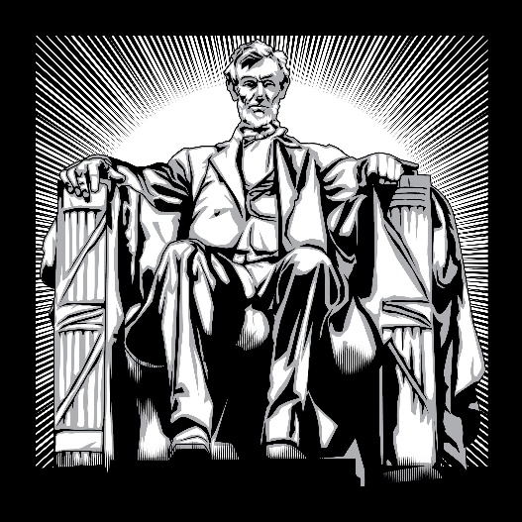

Five Things you didn’t know about the Lincoln Memorial



On May 30, 1922, former President William Howard Taft dedicated the Lincoln Memorial to honor the memory and legacy of Abraham Lincoln. Here are five things *Trivia Today* says you probably didn't know about this iconic monument:

**There Are 36 Columns:** The temple is surrounded by 36 Doric columns, each representing a state in the Union at the time of Lincoln’s assassination. The symbolism being that without the columns, the roof would fall; just like without the states, the nation would fall.

**Urban Legend Says He’s Signing**: Take a good look at Lincoln's hands at the memorial. They appear to be in different positions, and smart visitors have noticed that one hand is in a position that looks like the letter "A" in sign language, while the other looks a lot like the letter "L" -- as in Abraham Lincoln. Officially, this is just a coincidence.

**40% of The Monument is Underground**: When viewers bask in the 99-foot-tall, 202-foot-wide Lincoln Memorial, they’re really only seeing a little more than half of the construction. What many people do not know is that about 40% of the monument is actually underground. The piece’s foundation extends 66 feet into the earth at its deepest point to help support the weight of the massive and heavy memorial site.

**Construction Began on Abe’s Birthday**: The construction took eight years, with work slowing during World War I due to material shortages. The memorial opened in 1922, just in time for a 78-year-old Robert Todd Lincoln -- the president's son -- to see the unveiling.

**Four Score and Seven Steps:** The ascent from the lip of the Reflecting Pool into the temple clocks include exactly 87, marble steps. In other words, “four score and seven” steps, reminiscent of the celebrated start of Lincoln’s Gettysburg Address.

Halfway up the staircase there’s a marked stone where Martin Luther King, Jr. stood while delivering his “I Have a Dream” speech.

“My new laminate floors in my kitchen and dining room are beautiful. I was treated with respect and courtesy as a single woman raising a daughter. I genuinely felt that Jim Armstrong and his staff display concern for my flooring needs and were a guiding light for me. I recommend his service to anyone looking for a supportive, positive experience.”

~Marsha Avalos, School Teacher, Yuba City

“We Recently went to Jimbo’s Floors for new tile for our bathroom, and we’re thrilled with the results! This is our third time using Jimbo’s. Jim will never make you feel uncomfortable for asking questions and he’ll do anything in his power to accommodate your needs. When you do business with Jim and the staff at Jimbo’s Floors, you will be treated like royalty. Our experience was painless and very professional. Jim is not only our flooring expert, he’s a friend. That’s how he makes you feel.”

~Marvin and Sandy Moeller, owners of Sierra Landscaping, Yuba City

Congratulations to our client of the month,

**Susan Johnson!**

Susan is a 3rd time returning client, and she recently purchased new laminate for her kitchen and dining room. She always has a big smile on her face and is a lot of fun to work with. *Thanks, Susan!*

As always, our clients of the month receive **2 movie passes for Movies-8!**

*Watch for your name here in a coming month!*

Thank You for the Kind Words!



**Be sure to stop by to pick out and schedule   
your new floor installation, and   
from our families to yours have a great month!**

Get a Night Out at the Movies for 2 with my

**Referral Rewards Program**

As you probably know, advertising is very expensive. Instead of paying the newspaper or another place to advertise, we’d rather reward you. So, we’ve assembled the Referral Rewards Program.

Every time you refer someone who becomes a client, we will send you a gift certificate for two passes to the **Movies-8 Cinema.**

And Hey! What’s a movie without popcorn? The gift certificate will also cover a big box of hot, buttered popcorn and sodas!

**Welcome to our new and returning clients!**

Click on the text box and Insert names

**A gigantic THANK YOU to all who referred us last month…**

Insert names

Can you find the summertime snacks?

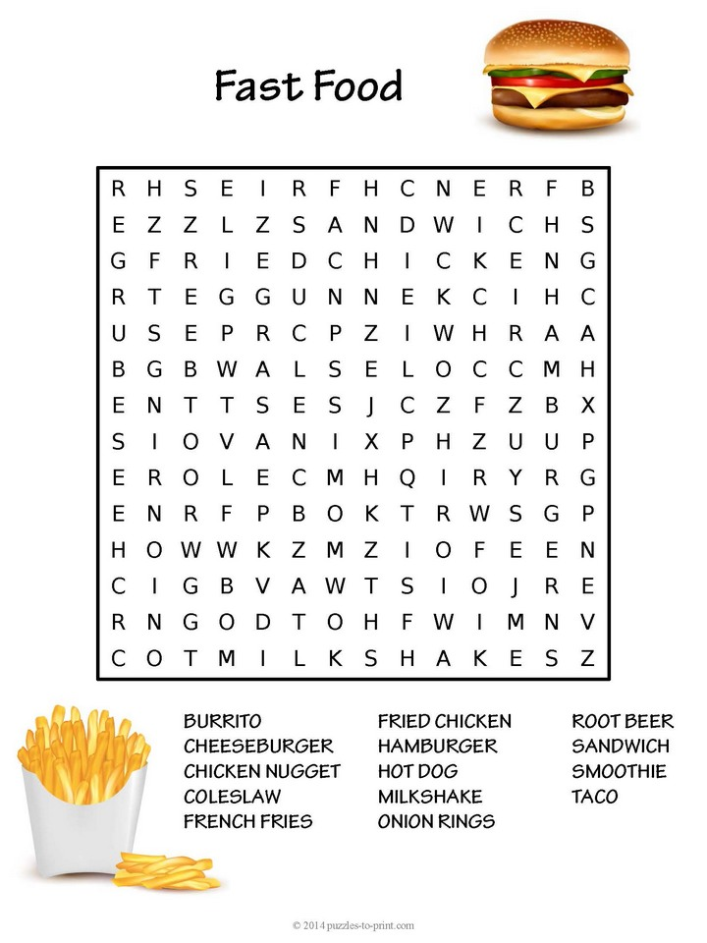

**Your Company Name**

123 Address, Someplace, ZZ 555555

555.555.5555 Phone ⚫ 555.555.5555 Fax

email@yourcompanyname.com

**YourCompanyWebsite.com**