

May 2020

Reliable news for healthy living, saving money, and having fun!

********

**Jimbo’s Floors**

**May 10**

Mother’s Day

**May 5**

Cinco de Mayo

**May 25**

Memorial Day

Inside This Issue…

* Are you this month’s Mystery Winner?
* Month at a Glance
* Things You May Not Know Were Invented by Women
* Mega Trivia Contest
* Did You Know
* Mailed It! The Post Office Celebrates an Anniversary
* Thank you for the Kind Words
* Client of the Month
* Play the Cinco de Mayo Word Scramble!

Month at a Glance!

Suzie Smith!

You are this month’s   
Mystery Winner!

We have a   
**$10.00 Starbucks   
gift card**   
reserved just for you!

Come by our store to   
claim your prize!

Scan to see our website

Dear Friends,

Your personal message goes here.

The personal message is important because it allows you to connect in a very personal way with your clients. This personal connection is sorely lacking in most businesses. Topic ideas:

Your hobbies

Something interesting happening this month. Wish them “Merry Christmas” or “Happy Thanksgiving.”

A thought from your heart

Appreciation for your clients and their referrals. Remind them that you will bend over backwards to provide their referrals with World Class Service.

Mention that month’s “special offer” insert

Your Friend,

Your Signature

Your Name

*“You’ll love your new floors or I’ll replace them free!”*

~Jim Armstrong   
[www.JimbosFloors.com](http://www.JimbosFloors.com)





**Here at Jimbo’s Floors, we want to treat your friends like royalty!**

Not just your friends, but your neighbors, co-workers and relatives too.

For every person you refer who becomes a client, I will send you and a friend to the Movies-8 Cinema AND I’ll spring for the popcorn and soda!

We worked hard to earn your trust, and we take that trust seriously. We’ll provide anyone you send to us with outstanding service and treat them like royalty. And I promise that if you refer someone to Jimbo’s, we will do everything in our power to make sure you look like a hero for referring us!

#### **The Circular Saw** – A weaver named Tabitha Babbitt was the first to suggest that lumber workers use a circular saw instead of the two-man pit saw that only cut when pulled forward. She made a prototype and attached it to her spinning wheel in 1813. Babbitt's Shaker community didn't approve of filing a patent, but they took full advantage of the invention.



#### We all know that our moms know everything. As we celebrate Mother’s Day, it’s fun to take a look at items invented by women. Some, like the disposable diaper and the dishwasher, made a busy homemaker’s life easier. But women are responsible for many items we use today through all walks of life.

#### **The Paper Bag** – America got a brand new paper bag when cotton mill worker Margaret Knight invented a machine to make them with a flat square bottom in 1868. (Paper bags originally looked more like envelopes.) A man named Charles Annan saw her design and tried to patent the idea first. Knight filed a lawsuit and won the patent fair and square in 1871.

#### **Kevlar** – Lightweight, high-tensile Kevlar—five times stronger than steel—will take a bullet for you. DuPont chemist Stephanie Kwolek accidentally invented it while trying to perfect a lighter fiber for car tires and earned a patent in 1966.

#### **Windshield Wipers** – Drivers were skeptical when Mary Anderson invented the first manual windshield wipers in 1903. They thought it was safer to drive with rain and snow obscuring the road than to pull a lever to clear it. (Another woman inventor, Charlotte Bridgwood, invented an automatic version with an electric roller in 1917. It didn't take off, either.) But by the time Anderson's

#### patent expired in 1920, windshield wipers were cleaning up. Cadillac was the first to include them in every car model, and other companies soon followed.

#### **Liquid Paper** – In the days before the delete key, secretary Bette Nesmith Graham secretly used white tempera paint to cover up her typing errors. She spent years perfecting the formula in her kitchen before patenting Liquid Paper in 1958. Gillette bought her company in 1979 for $47.5 million. And that's no typo.

Things You May Not Know Were Invented by Women

The inventor of the Barbie doll was married to the inventor of what toy?

A) Rubik’s Cube B) Magic 8 Ball

C) Slinky D) Hot Wheels

To enter, go to [www.JimbosFloors.com](http://www.JimbosFloors.com) and click on “Mega Trivia Contest.” Take your best guess…your chances of winning are better than you think!



### Who Else Wants to Win

### Dinner for Two

### at the City Café!

### Take our Trivia Challenge and *you could win too!*

This month’s Mega Trivia question:

**Answer to last month’s quiz: C) Eiffel Tower**

Congratulations to last month’s winner: **Client Name**

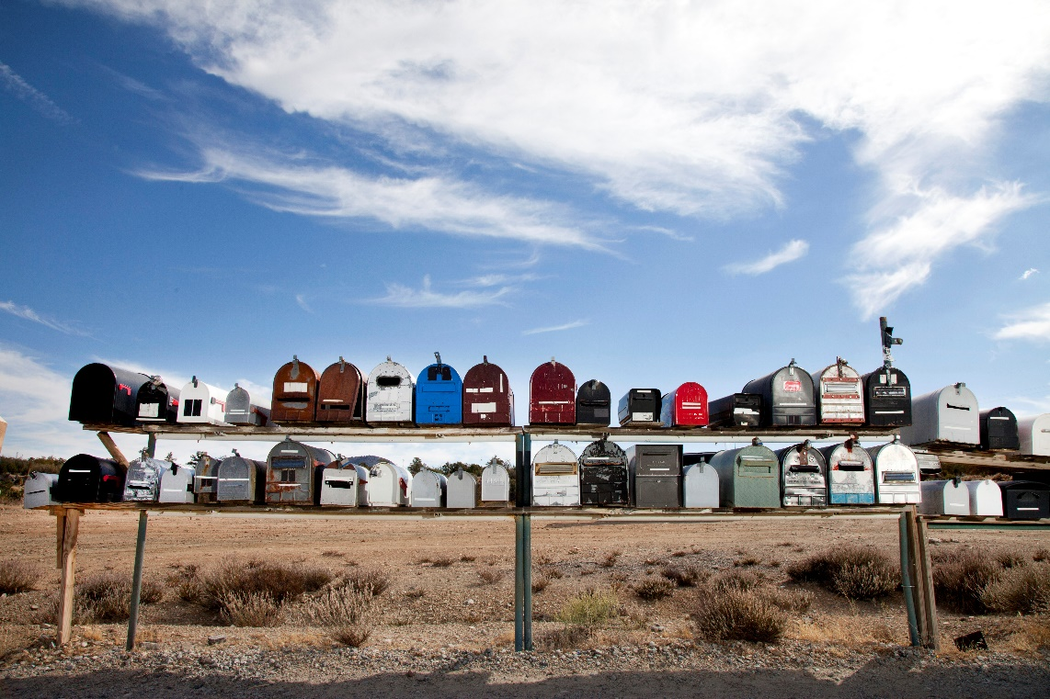

This year the U.S. Postal Service celebrated its 228th birthday. On February 20, 1792, President George Washington signed an act creating the U.S. Post Office.

Trivia Today tells us that there is a history of “celebrity” postmasters, starting with Benjamin Franklin. Other famous postmasters include Bing Crosby, William Faulkner, Walt Disney, Charles Lindbergh and Adlai Stevenson.

The Postmaster General used to be in line of succession to the presidency. President Jackson decided that the Postmaster General should sit in the Cabinet, thereby putting the office on the same level as the Secretaries of War, Treasury and State. Although last in line, it still put the Postmaster in line of succession. The Postmaster was removed from the cabinet and from succession in 1971.

Today, public collection boxes are blue, but that wasn’t always the case. Most were originally painted blue or red, and around 1909 the standard color became a dark green so that the boxes would not be confused with fire or emergency equipment. Following World War I, the boxes changed to a drab olive green because the paint had been donated by the Army.

Mail delivery by mule still exists in one location. Supai, Arizona, lies at the bottom of the Grand Canyon, where members of the Havasupai tribe receive their mail. The route is an eight-mile trip taken by mules and horses.

Most interesting of all, until the mid-19th century, recipients, not senders, paid for postage on letters they received. Prepaid postage stamps weren’t introduced until 1847.

**Mailed It! The Post Office Celebrates an Anniversary**



“My new laminate floors in my kitchen and dining room are beautiful. I was treated with respect and courtesy as a single woman raising a daughter. I genuinely felt that Jim Armstrong and his staff display concern for my flooring needs and were a guiding light for me. I recommend his service to anyone looking for a supportive, positive experience.”

~Marsha Avalos, School Teacher, Yuba City

“We recently went to Jimbo’s Floors for new tile for our bathroom, and we’re thrilled with the results! This is our third time using Jimbo’s. Jim will never make you feel uncomfortable for asking questions and he’ll do anything in his power to accommodate your needs. When you do business with Jim and the staff at Jimbo’s Floors, you will be treated like royalty. Our experience was painless and very professional. Jim is not only our flooring expert, he’s a friend. That’s how he makes you feel.”

~Marvin and Sandy Moeller, owners of Sierra Landscaping, Yuba City

Thank You for the Kind Words!

Congratulations to our client of the month,

**Susan Johnson!**

Susan is a 3rd time returning client, and she recently purchased new laminate for her kitchen and dining room. She always has a big smile on her face and is a lot of fun to work with. *Thanks, Susan!*

As always, our clients of the month receive **2 movie passes for Movies-8!**

*Watch for your name here in a coming month!*

Get a Night Out at the Movies for 2 with my

**Referral Rewards Program**

As you probably know, advertising is very expensive. Instead of paying the newspaper or another place to advertise, we’d rather reward you. So we’ve assembled the Referral Rewards Program.

Every time you refer someone who becomes a client, we will send you a gift certificate for two passes to the **Movies-8 Cinema.**

And hey! What’s a movie without popcorn? The gift certificate will also cover a big box of hot, buttered popcorn and sodas!

**Be sure to stop by to pick out and schedule   
your new floor installation, and   
from our families to yours have a great month!**

1) CACTUS 2) TACO 3) MUSIC 4) SALSA 5) PARADE 6) BATTLE 7) FIESTA 8) TORTILLA 9) GUACAMOLE 10) CASTANETS 11) MEXICO 12) CELEBRATION 13) COMIDA 14) COMBRERO 15) PINATA 16) FLOWERS 17) MARIACHI 18) CONQUEST 19) PUEBLO 20) MARACA

**Welcome to our new and returning clients!**

Click on the text box and Insert names

**A gigantic THANK YOU to all who referred us last month…**

Insert names

Can You Unscramble these Words Associated with Cinco de Mayo?

**Your Company Name**

123 Address, Someplace, ZZ 555555

555.555.5555 Phone ⚫ 555.555.5555 Fax

email@yourcompanyname.com

**YourCompanyWebsite.com**