

Reliable news for healthy living, saving money, and having fun!

**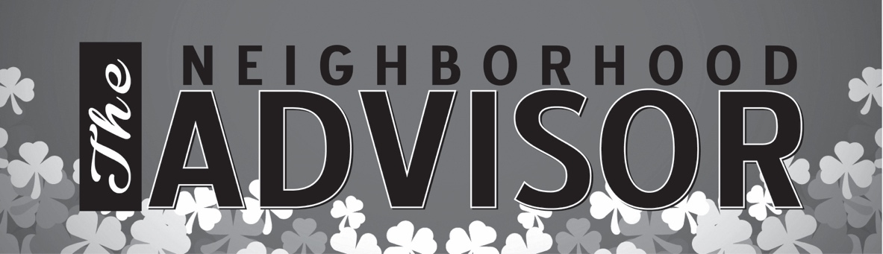****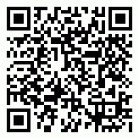**

**March 17**

St. Patrick’s Day

**March 8**

Daylight Savings Time

Inside This Issue…

* Are you this month’s Mystery Winner?
* Month at a Glance
* Smells Like a Memory
* Mega Trivia Contest
* Did You Know
* Sometimes Doing Nothing is the Most Important Thing You Can Do
* Thank you for the Kind Words
* Client of the Month
* Can You Solve the Brain Teasers!

Month at a Glance!

Suzie Smith!

You are this month’s   
Mystery Winner!

We have a   
**$10.00 Starbucks   
gift card**   
reserved just for you!

Come by our store to   
claim your prize!

Scan to see our website

Dear Friends,

Your personal message goes here.

The personal message is important because it allows you to connect in a very personal way with your clients. This personal connection is sorely lacking in most businesses. Topic ideas:

Your hobbies

Something interesting happening this month. Wish them “Merry Christmas” or “Happy Thanksgiving.”

A thought from your heart

Appreciation for your clients and their referrals. Remind them that you will bend over backwards to provide their referrals with World Class Service.

Mention that month’s “special offer” insert

Your Friend,

Your Signature

Your Name

*“You’ll love your new floors or I’ll replace them free!”*

~Jim Armstrong   
[www.JimbosFloors.com](http://www.JimbosFloors.com)

**Jimbo’s Floors**

March 2020



The fresh cut grass that evokes summer. The smell of bacon that brings back Sunday morning breakfasts. The sweet scent of roses from grandma’s garden. Studies have found that smells may trigger memories and emotions better than any of the other senses.

The majority of us clearly rely more on a sense of sight than our sense of smell day-to-day, so what is it about our sense of smell that works to better trigger our memory and our emotions? The link may simply be due to the architectural layout of our brain.

We have at least 1,000 different types of smell receptors but only four types of light sensors and about four types of receptors for touch. Research has shown greater brain activity associated with olfactory stimuli (like the smell of a rose) than with visual stimuli (like the sight of a rose). Clinical case studies have also linked smells to strong negative emotions, a connection which can play a significant role in contributing to posttraumatic stress disorder.

When you see, hear, touch, or taste something, that sensory information first heads to the thalmus, which acts as your brain's relay station. The thalamus then sends that information to the relevant brain areas, including the hippocampus, which is responsible for memory, and the amygdala, which does the emotional processing.

But with smells, it's different. Scents bypass the thalamus and go straight to the brain's smell center, known as the olfactory bulb. The olfactory bulb is directly connected to the amygdala and hippocampus, which might explain why the smell of something can so immediately trigger a detailed memory or even intense emotion.

Smells Like a Memory

What breed of dog does the U.S. Secret Service exclusively use?

A) Pit Bull B) Alaskan Malamute

C) Rottweiler D) Belgian Malinois

To enter, go to [www.JimbosFloors.com](http://www.JimbosFloors.com) and click on “Mega Trivia Contest.” Take your best guess…your chances of winning are better than you think!

Here at Jimbo’s Floors we use a special diagnostic tool called the Design Audit™.

Our free Design Audit™ is carefully crafted to take the headache out of shopping for new floors.  A simple series of questions let my expert floor consultants narrow down the thousands of options to the two or three that exactly match your unique situation.

They’ll provide you with a written, customized “maintenance” plan with their professional recommendations for getting the longest life and beauty out of your floor.

Call or visit us today for your FREE Design Audit!™



### Who Else Wants to Win

### Dinner for Two

### at the City Café!

### Take our Trivia Challenge and *you could win too!*

This month’s Mega Trivia question:

**Answer to last month’s quiz: B) Harry Truman**

Congratulations to last month’s winner: **Client Name**

A.A. Milne, the English author best known for his series of Winnie the Pooh books, said, “Don't underestimate the value of Doing Nothing, of just going along, listening to all the things you can't hear, and not bothering.”

We are fortunate to live in an age when we are constantly connected: to each other, to work, to the world. Having a phone in your pocket makes you accessible anytime, anywhere. It’s a miracle, and it’s a menace. As our work and our personal identities are becoming more and more entwined, we begin to believe that being idle is a threat to our success.

But working harder is not necessarily working smarter. In fact, slacking off and setting aside regular periods of ‘doing nothing’ may be the best thing we can do to induce states of mind that nurture our imagination and improve our mental health.

We associate idle time with irresponsibility, wasting our life. Most of us feel guilty if we don’t have something to do. We get a buzz when we feel really busy. Distraction-inducing behaviors like constantly checking email stimulate the brain to shoot dopamine into the bloodstream giving us a rush that can make stopping so much harder.

The danger is we may lose our connections, not just with one another but with ourselves. If we don’t allow ourselves periods of uninterrupted, freely associated thought then personal growth, insight and creativity are less likely to emerge, according to Manfred Kets De Vries, INSEAD Distinguished Professor of Leadership Development & Organizational Change. The best thing for our mental health, doing nothing – or slacking off – may turn out to be the best way to resolve complex issues. A walk around outside or time spent with your feet on the desk, can be more productive than working through a lunch break.

It seems ironic, but the best way to improve our connections may be to break our addiction to being connected.

**Sometimes doing nothing is the most important thing you can do**



Thank You for the Kind Words!

“My new laminate floors in my kitchen and dining room are beautiful. I was treated with respect and courtesy as a single woman raising a daughter. I genuinely felt that Jim Armstrong and his staff display concern for my flooring needs and were a guiding light for me. I recommend his service to anyone looking for a supportive, positive experience.”

~Marsha Avalos, School Teacher, Yuba City

“We Recently went to Jimbo’s Floors for new tile for our bathroom, and we’re thrilled with the results! This is our third time using Jimbo’s. Jim will never make you feel uncomfortable for asking questions and he’ll do anything in his power to accommodate your needs. When you do business with Jim and the staff at Jimbo’s Floors, you will be treated like royalty. Our experience was painless and very professional. Jim is not only our flooring expert, he’s a friend. That’s how he makes you feel.”

~Marvin and Sandy Moeller, owners of Sierra Landscaping, Yuba City

Congratulations to our client of the month,

**Susan Johnson!**

Susan is a 3rd time returning client, and she recently purchased new laminate for her kitchen and dining room. She always has a big smile on her face and is a lot of fun to work with. *Thanks, Susan!*

As always, our clients of the month receive **2 movie passes for Movies-8!**

*Watch for your name here in a coming month!*

|  |  |
| --- | --- |
| 1 | What can be seen once in a minute, twice in a moment and never in a thousand years? |
| 2 | Which tire doesn’t move when a car turns right? |
| 3 | I’m not alive, but I have five fingers. What am I? |
| 4 | Which word is written incorrectly in a dictionary? |
| 5 | A truck drove to a village and met four cars. How many vehicles were going to the village? |
| 6 | People buy me to eat, but never eat me. What am I? |
| 7 | We kill, and we give life. We are either poison or fruit. You choose. What are we? |
| 8 | Which hand is best for stirring sugar into a cup of tea? |
| 9 | Feed me, and you will give me life. But give me a drink and I will die. What am I? |
| 10 | What gets wet when drying? |

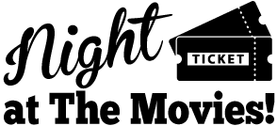

**Your Company Name**

123 Address, Someplace, ZZ 555555

555.555.5555 Phone ⚫ 555.555.5555 Fax

email@yourcompanyname.com

**YourCompanyWebsite.com**

**Be sure to stop by to pick out and schedule   
your new floor installation, and   
from our families to yours have a great month!**

1) The letter M. 2) The spare tire. 3) A glove. 4) The word “incorrectly.” 5) One truck. 6) A plate.

7) Words. 8) It’s best to use a spoon. 9) Fire. 10) A towel.

Get a Night Out at the Movies for 2 with my

**Referral Rewards Program**

As you probably know, advertising is very expensive. Instead of paying the newspaper or another place to advertise, we’d rather reward you. So we’ve assembled the Referral Rewards Program.

Every time you refer someone who becomes a client, we will send you a gift certificate for two passes to the **Movies-8 Cinema.**

And hey! What’s a movie without popcorn? The gift certificate will also cover a big box of hot, buttered popcorn and sodas!

**Welcome to our new and returning clients!**

Click on the text box and Insert names

**A gigantic THANK YOU to all who referred us last month…**

Insert names

Can you solve these brain teasers?