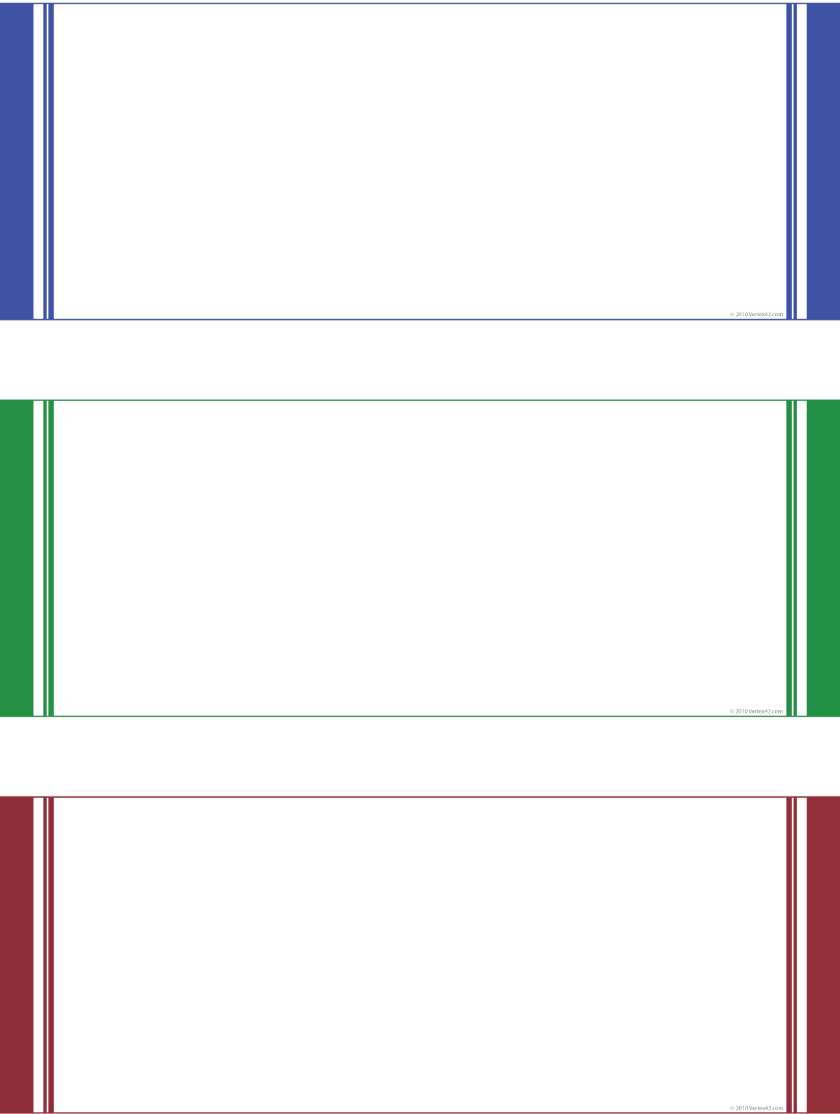

|  |  |  |  |  |  |
| --- | --- | --- | --- | --- | --- |
| Gift Certificate | | | | | Insert Logo Here  ADDRESS | CITY, ST | ZIP  PHONE | WEBSITE |
| **To** | **First Name Last Name** | | | | |
| **Value $** | | | **200.00** | | |
| **From** | | Client First Name Client Last Name | | | |
| **Expires On DATE** | | | |
| This gift certificate is good for any purchase over $2,500. If your purchase is from $1,000- $2,499, you’ll get dinner for two at ***Restaurant***. Under $1,000 and you’ll get a gift card to Starbucks and a FREE spotting kit. | | | | | |